**Recovery of rare earth elements from geothermal fluids through bacterial cell surface adsorption**

For submission to *Environmental Science and Technology*

Aaron Brewer1,2, Elliot Chang3, Dan M. Park1, Tianyi Kou4, Yat Li4, Laura N. Lammers3, and Yongqin Jiao1\*

1Physical and Life Science Directorate, Lawrence Livermore National Laboratory, Livermore, California 94550; 2Department of Earth and Space Sciences, University of Washington, Seattle, Washington 98185; 3Department of Environmental Science, Policy, and Management, University of California Berkeley, Berkeley, California 94270; 4Chemistry and Biochemistry Department, University of California Santa Cruz, Santa Cruz, California 95064.

\* corresponding author: jiao1@llnl.gov

**Keywords:** biosorption, bioadsorption, rare earth elements, REE, lanthanide binding tag, LBT, geothermal fluids, geofluids

**Abstract**

Rare earth elements (REEs) are in increasing demand in the modern economy and yet meaningful REE production is limited to only a few locations worldwide, which motivates the development of novel strategies to enable cost-effective REE recovery from non-traditional feedstocks. We investigate biosorption as a potential means of recovering REEs from geothermal fluids, a low-grade but abundant REE source. We have previously engineered *E. coli* to express lanthanide binding tags (LBTs) on the cell surface and the resulting strain showed an increase in both REE adsorption capacity and selectivity. Here we examined how REE adsorption by the engineered *E. coli* is affected by various geochemical factors relevant to geothermal fluids, including total dissolved solids (TDS), temperature, pH, and the presence of competing trace metals. REE biosorption is robust to high TDS concentrations, with high extraction efficiency and selectivity observed in geofluids containing REE concentrations as low as 100 ppb and TDS as high as 165,000 ppm. Among several specific metals tested, U, Al, and Pb were found to be the most competitive, causing significant reductions (>25%) in REE biosorption when present in concentrations ~3 to 11-fold higher than the REEs. Optimal REE biosorption occurs between pH 5-6, with significant loss in sorption capacity (~65%) as pH decreases from 6 to 2. REE extraction efficiency and selectivity increase as a function of temperature up to ~70°C, which can be explained by the thermodynamic properties of metal complexation on the bacterial surface. Together, these data demonstrate the potential utility of biosorption for selective REE recovery from geothermal fluids by defining the optimal and boundary conditions for this extraction technology.

**Introduction**

Rare earth elements (REEs) are becoming increasingly significant to the international economy with the emergence and development of new technologies, particularly in the area of clean energy. Common applications of REEs include automotive and industrial catalysts, metallurgical additives, permanent magnets, and electronics. However, the supply of these metals is uncertain and potentially at risk globally. As of 2011, more than 95% of REE production came from China, even though there are significant reserves worldwide, including in the United States.1 Five REEs (Tb, Dy, Eu, Nd, and Y) have been identified as particularly critical by the U.S. Department of Energy based on both their supply risk and their importance to the modern economy.1 Given the limited sources of REE production and the increasing demand for these metals around the world, it is crucial to explore new REE feedstocks and to develop new and improved methods of REE extraction.1-5

Biosorption has gained increasing interest in recent years as a potential clean, sustainable method for REE recovery and purification. The high binding affinity of the native cell surface for REEs relative to most non-REEs permits selective extraction of these valuable metals from non-traditional low-grade feedstocks.4, 6-8 Microbes are relatively inexpensive to produce in large quantities, and native biomass has a naturally high capacity for REE adsorption.4, 9-13 Cell surfaces can withstand multiple cycles of adsorption and desorption, enabling reuse of biomass.14 Furthermore, biosorption processes are not expected to contribute hazardous chemical wastes to a REE extraction scheme, unlike some conventional methods such as solvent extraction.15, 16 Once properly developed, microbial surface adsorption could present a clean and effective means of REE recovery from a variety of feedstocks, including those that are low-grade and traditionally unexploited.

We have previously bioengineered *Escherichia coli* to express lanthanide binding tags (LBTs) on the cell surface to enhance their natural adsorptive properties, improving both extraction efficiency and selectivity for REEs.17 LBT display increased REE adsorption capacity from ~13 to ~28 mg Tb / g dry cell weight in a simple buffer solution, and also improved REE binding selectivity 2 to 10-fold over most non-REE metals present in mine tailing leachates.17 The native cell surface functional groups, primarily carboxylate and phosphate,18-21 do continue to play a major role in REE recovery with the LBT-displayed cells. In this study, we investigate the REE adsorption performance of the engineered LBT-displayed strain of *E. coli* under various geochemical conditions characteristic of geothermal fluids.

Geothermal fluids are abundant, low-grade feedstocks that are currently being investigated as a potential source of REEs.4, 6, 22, 23 Heated by natural terrestrial processes, for example by circulation through magmatically active zones, geothermal fluids leach material from the surrounding rock, becoming enriched in various metals. Total REE concentrations reported in geothermal fluids range from sub-ppb to low-ppm levels,24 which are considered low-grade REE feedstocks. The REE concentration in geothermal fluids is inversely correlated with pH, and fluids with REE concentrations at ppb levels or higher are nearly always acidic (pH <3.5), likely due to increased metal leaching at lower pH.22, 24 Optimal REE biosorption typically occurs at pH ~6 and decreases at more acidic pH, and therefore pH adjustment may be required for the acidic REE-rich feedstocks.14, 25, 26 The temperature of geofluids varies greatly, and previous studies have demonstrated that elevated temperatures as high as 80°C have led to increased REE adsorption onto organic surfaces.26-28 Depending on pH and temperature, as well as the lithology of the rocks exposed to the fluids, total dissolved solids (TDS) in geofluids can be high, ranging from hundreds to hundreds of thousands of ppm, several orders of magnitude higher than the REEs.24 The anion composition of REE-rich geothermal fluids, primarily sulfate and chloride,24, 29 are known to have a minimal effect on biosorption.21 Aqueous metal cations, on the other hand, may compete with the REEs for surface binding sites, limiting REE extraction efficiency and purity. The major elements, such as Na and Mg, have low affinities for cell surface binding sites compared to the REEs but are present at such high concentrations that they may still be competitive. On the other hand, some trace metals, such as U and Pb, although present at much lower concentrations, will likely be competitive because they have high affinities for the surface sites, similar to the REEs.17

Although they have relatively low REE concentrations, geothermal fluids are abundant and have the advantage of requiring minimal pretreatment prior to REE extraction, unlike solid feedstocks such as ion adsorption clays, mine tailings, and fly ash, where chemical leaching is generally required.17, 23, 30 The geochemical characteristic of geothermal fluids, such as elevated temperatures, non-optimal pH, and high TDS can have a major impact on REE biosorption. Herein, we systematically examined the effects of these factors on REE extraction efficiency and purity. Results define the geochemical boundary conditions that are amenable to REE biosorption, information that is key to the future development of a high-performance biosorption technology for REE recovery from geothermal fluids.

**Methods**

*Bacterial strains and growth conditions*

The *E. coli* strain harboring a *lpp-ompA*-dLBT expression plasmid was grown in LB media supplemented with 50 μg/mL ampicillin. Expression of lpp-ompA-dLBT was induced at mid-exponential phase using 0.002% arabinose for 3 h at 37 °C. For a full description of plasmid construction and LBT expression see Park et al. (2016) and (2017).14, 17 Briefly, eight adjacent copies of a double lanthanide binding tag31 were anchored to amino acid position 159 of *ompA* (outer membrane protein A) and placed under the control of the arabinose inducible promoter PBAD.32 Cells were harvested, washed once in 10 mM MES (2-(N-morpholino)-ethanesulfonic acid) pH 6.0, normalized by OD600, and used in biosorption experiments.

*Blue Mountain geofluid biosorption experiment*

A natural geothermal fluid (pH = ~6) from the Blue Mountain geothermal area (BMG, Table 1) was obtained from AltaRock Energy Inc (WA, USA) for biosorption tests. Since the REE concentrations in the BMG are below detection limit (< 10 ppt), Tb was spiked in at 10 ppb from a 50 mM TbCl3 stock solution prepared in 1% nitric acid. LBT-displayed cells were added to ~1x108 cells/ml in 700 μl total volume. After 30 min incubation with the BMG, cells were pelleted by centrifugation at 20,000 x *g* for 5 min and the supernatant was removed. To ensure removal of residual BMG, cells were washed in an equal volume of 10 mM MES pH 6 and the supernatant was removed following centrifugation. Finally, the cells were resuspended in an equal volume of 5 mM citrate pH 6 for 60 min to desorb the surface-bound metals. The supernatant was collected following centrifugation at 20,000 x *g* for 8 min and metal contents were quantified by ICP-MS. Results are reported as extraction efficiency, the percent Tb recovered by one cycle of biosorption and elution, as well as REE purity increase, defined as (μM Tb/μM total metals)eluent/(μM Tb/μM total metals)initial.

*Great Salt Lake total dissolved solids biosorption assay*

A synthetic geofluid was created to resemble the cation concentrations of the Great Salt Lake brine (GSL), but 2x more concentrated (Table 1), and used for testing the geochemical variables relevant to REE biosorption: TDS, pH, and temperature. For the TDS test, aliquots of this 2x GSL solution were diluted 3-, 10-, 100-, and 1000-fold using 10 mM MES buffer pH 6. Tb, from the 50 mM TbCl3 stock solution, was added to each solution to 100 ppb. LBT-displayed cells were incubated at ~1x108 cells/ml in 500 μl of spiked brine (adjusted to pH 6 with 10 mM MES buffer) for 30 min prior to centrifugation at 20,000 x *g* for 15 min and the supernatant was removed. To ensure removal of residual GSL, cells were washed in an equal volume of 10 mM MES pH 6 and the supernatant was removed following centrifugation. Finally, the cells were resuspended in an equal volume of 5 mM citrate pH 6 for 60 min to desorb the surface-bound metals. The supernatant was collected following centrifugation at 20,000 x *g* for 5 min and metal contents were quantified by ICP-MS. Control experiments with no cells revealed <2% Tb extraction for initial Tb concentrations at ~100 ppb.

*GSL pH assay*

Synthetic GSL solution, diluted 2-fold, was spiked to a final Tb concentration of ~16 ppm (~100 μM) and adjusted to an initial pH of 2, 3, 4, 5, or 6 using 10 M NaOH prior to cell exposure. To minimize changes in solution pH following cell addition, LBT-displayed cells were pelleted at 6000 x *g* for 5 min, washed once with 10 mM MES buffer, and resuspended at ~1x109 cells/ml in 700 μl of the respective pH-adjusted GSL feedstock. Following a 30 min incubation, aliquots of the cell suspension was transferred to cellulose acetate centrifuge tube filters (Costar) and spun at 6000 x *g* for 5 min to collect the cells. The cells on the filters were then washed once in equal volume 10 mM MES pH 6 and exposed to 5 mM citrate for 60 min to desorb the surface-bound metals. The cellulose acetate filters extracted <4% Tb at all tested conditions with the GSL feedstock.

*GSL temperature assay*

The GSL solution was diluted 2-fold and adjusted to pH 6 using 10 mM MES buffer. Tb was added to ~48 ppm (~300 μM) and LBT-displayed cells were incubated at ~1x109 cells/ml in 700 μl of the Tb-spiked brine for 25 min at room temperature (~24°C), 40°C, or 70°C. Cells were collected, washed, and desorbed at room temperature using centrifuge tube filters as described above for the pH experiments.

*Low-TDS temperature assays*

Two additional temperature experiments were conducted in the low-TDS 10 mM MES buffer pH 6. First, LBT-displayed cells (~1x109 cells/ml) were heated to 70°C and cooled back to room temperature or exposed to UV radiation before being exposed to ~48 ppm (300 μM) Tb and analyzed for Tb adsorption. Second, LBT-displayed cells (~1x109 cells/ml) were exposed to mono-element solutions containing ~48 ppm (300 μM) of an individual meal (Tb, Cu, Mg, K, or Ca) in the 10 mM MES pH 6 matrix at a range of temperatures from 24°C to 70°C, and assessed for metal adsorption.

*Metal competition experiments*

Metal competition experiments were conducted in 10 mM MES buffer pH 6 by mixing a fixed concentration of 50 μM Tb (~8 ppm) with different concentrations of the competing metals, including up to 5000 μM copper (Cu), 300 μM aluminum (Al), 500 μM lead (Pb), 1000 μM uranium (U), 100 μM thorium (Th), 250 mM magnesium (Mg), or 2000 mM sodium (Na). The range of competing metal concentrations was selected based on concentrations commonly found in geofluids (Table 1).24 LBT-displayed cells were incubated at ~1x109 cells/ml in 500 μl of the metal solution at room temperature for 25 min before being pelleted by centrifugation at 20,000 x *g* for 5 min. The supernatant was collected and metal contents were quantified by ICP-MS.

*ICP-MS analysis*

All GSL brine and metal competition samples were diluted in 2% (v/v) nitric acid (trace metal grade) and spiked with an internal holmium standard. All analyses were performed using a Thermo XSeriesII ICP-MS run in standard mode at UC Santa Cruz. The sample introduction system was an ESI PFA-ST nebulizer pumped at 120 μl/min. The BMG samples were diluted in a 2% (v/v) trace metal grade nitric acid background and 0.5% (v/v) trace metal grade hydrochloric acid. Analyses were conducted at Duke University on an Agilent 7900 ICP-MS run in either hydrogen (Ca) or helium gas modes to reduce common interferences from oxides and chlorides.

*Thermodynamic analysis*

Fein et al. (2001) demonstrated that the cell surface complexation thermodynamics of numerous metals, including REEs, can be described by a linear free energy relationship (LFER) that relates aqueous metal-acetate stability constants to calculated metal-bacterial stability constants.33 We apply a similar method to evaluate the temperature dependence of metal complexation with the bacterial cell surface. Temperature dependent metal-bacteria stability constants are not available for the vast majority of metals, so we use available data for Zn(II), Cd(II), and Pb(II) complexation with acetate34 and *Penicillium simplicissimum35* at 20, 30, and 40°C to calibrate T-dependent LFERs (Figure S1). We note that these LFERs maintain high linear correlation coefficients (0.992-0.999) within this temperature range, and that the slopes of the LFERs become steeper at elevated temperatures (Figure S1). At 20°C, metal-bacteria stability constants obtained from the LFER are higher than their metal-acetate stability constants. At 30 and 40°C, the difference between metal-acetate and metal-bacteria logKs increases. La-acetate,36 Na-acetate,37 Cu-acetate,34 and UO2-acetate38 stability constants were input into each temperature-dependent LFER to obtain approximate values for the corresponding metal-bacteria stability constants (Figure S1). We restrict our analysis to between 20 and 40°C because metal-bacterial stability constants are not yet available for higher temperatures.

Heats of reaction were evaluated using Van’t Hoff plots, which relate thermodynamic stability constants to reaction free energies based on the relationship,

,

where *ΔG* is the Gibbs free energy of reaction, *ΔS* is the change in entropy, $∆H$ is the change in enthalpy, R is the gas constant, and T is temperature in degrees Kelvin. Endothermic reactions result in Van’t Hoff plots with a negative slope.

**Results and Discussion**

*REE recovery from Blue Mountain geothermal fluids*

The low REE concentrations present in most geothermal fluids is a major potential obstacle to economic recovery of REEs from these feedstocks. A natural solution (BMG, pH ~6) from the Blue Mountain geothermal area in Nevada, USA (Table 1) was selected to test the performance of REE biosorption from geothermal fluids with low REE contents. Because the natural REE concentrations in the BMG are below detection limits (< 10 ppt), we spiked the solution with a low concentration (10 ppb) of Tb, a REE of high criticality. Given the low REE concentration, a relatively low cell density (~1x108 cells/ml) was used. The results reported here and throughout this study describe the metals recovered during a single adsorption/desorption cycle. Since 5 mM citrate is known to enable complete elution of adsorbed REEs,14 the extraction efficiencies and purities are controlled by adsorption rather than desorption behavior.

LBT-displayed *E. coli* cells31 extracted ~76% of the available Tb from the BMG spiked with 10 ppb Tb (Figure 1a), and extracted <1% of the Na, Li, and Rb and none of the K, Ca, As, Cs, Ba, or W, whose concentrations in the eluent were below the instrumental detection limits (Figure 1a, Table S1). Among the non-REEs, the biosorption process resulted in >1% extraction for only a few elements, Fe (~29%), Mg (~5%), Mn (~9%), and Sr (~2%) (Figure 1, Table S1). Compared to the feedstock prior to adsorption, the Tb purity in the eluent increased by >100-fold. The purity is defined as the molar ratio of the target metal relative to the total concentration of Na, Mg, K, Ca, and Tb, which approximates the total metals present. The few non-REE metals that showed an increase in purity were Fe (~40-fold), Mg (~10-fold), Mn (~10-fold), and Sr (~3-fold), largely due to the more effective removal of other metal ions (Figure 1b). These data demonstrate effective and selective recovery of low concentrations of REEs from a complex geothermal fluid solution matrix. Next, we describe a systematic investigation into the effects of several geochemical variables on REE recovery.

*Effects of high TDS*

The high ratio of total dissolved solids (TDS) to REEs, which in some cases can be on the order of 100,000:1, is a major potential challenge facing efficient recovery of REEs from geothermal brines.24 The Great Salt Lake (Utah, USA) is a terminal lake which, due to evaporation, contains among the highest TDS commonly found in natural geofluids. To test the effects of TDS on REE adsorption, we performed REE recovery experiments with a synthetic Great Salt Lake brine (GSL, ~165,000 ppm TDS) that was used either at full strength or diluted 3-, 10-, 100-, and 1000-fold, covering a wide TDS range relevant to geothermal fluids (Table 1). Tb was added to a final concentration of 100 ppb, which falls on the high end of REE concentrations in natural geothermal fluids (Table 1).24 Cell density was maintained at ~1.2x108 cells/ml to ensure an excess of surface sites for REE adsorption.

REE recovery by the LBT-displayed cells was largely unaffected by TDS under these experimental conditions. At low TDS conditions (~5.4 ppm), the LBT-displayed cells extracted ~81.5 ± 4.8% of the available Tb (Figure 2). A slight increase in Tb recovery was observed at elevated TDS, with ~95.1 ± 5.6% Tb extracted in the concentrated GSL brine (~165,000 ppm; Figure 2). Minimal major element recovery was observed; Na, K, and Ca were not extracted from the initial feedstock across the tested TDS range, although some Na was contributed by the sodium citrate eluent (Table S2). A small amount Mg was extracted across the tested TDS range (Table S2). The observed strong cell surface preference for REEs over the major non-REEs in the GSL brine is consistent with previous studies with other feedstock types, demonstrating the efficacy of biosorption for REE recovery from complex solutions matrices.10, 12, 39

Previous reports have found that high TDS can have variable effects on metal adsorption onto a variety of surfaces.40, 41 Increasing TDS has been shown to decrease REE adsorption onto mineral surfaces, likely due to competition effects from low affinity cations present at high concentrations.40, 41 High TDS is also expected to increase surface charge, weakening the electrostatic attraction between the surface and aqueous metals and decreasing metal adsorption.42-44 However, in contrast to many divalent ions,40, 41 several studies have observed that changes in ionic strength do not affect REE adsorption onto organic/inorganic surfaces including chelating polysaccharides,45 clays,46 and mesoporous silica.47 It has been suggested that REE adsorption is dominated by inner sphere complexation at high affinity sites rather than outer sphere complexation; therefore, the REEs cannot be easily displaced by low affinity ions that constitute most of the TDS.47 Based on our findings, at circumneutral pH, the TDS levels typical of geothermal fluids do not strongly affect REE extraction by LBT-displayed *E. coli* cells.

*Effects of competing metals*

In addition to high TDS, which is primarily contributed by a few major elements present at high concentrations, REE extraction efficiency may also be affected by the presence of trace metals with a high affinity for the cell surface. Previous experiments with mine tailing leachates identified certain metals, such as Cu, Al, and Pb, that are adsorbed onto the LBT-displayed cell surface alongside the REEs, reducing REE purity in the eluent.17 In addition, uranium and thorium are cogenetic elements during rare earth mineralization and are thus commonly found in REE-bearing minerals.48, 49 These five potentially competitive metals (Cu, Al, Pb, U, and Th) were selected for analysis in a series of competition experiments. Sodium (Na) and magnesium (Mg) were also included for comparison, given their abundance in natural geofluids.

In these two-element competition experiments, a fixed concentration of Tb (~8 ppm) was mixed with the individual metal in question at varying concentrations and the amount of Tb adsorbed was compared to conditions without the competing metal. The data for each competing metal was fit by a three-parameter log-logistic function to approximate the competing metal to Tb concentration ratio (x/Tb25) at which Tb adsorption is decreased by 25% (Figure 3). We found that U and Al were the most competitive, with x/Tb25 values of 3.85 and 4.81, respectively. Pb and Cu were less competitive, with x/Tb25 values of 10.83 and 63.72, respectively. In contrast, Na (x/Tb25 = 32,532) and Mg (x/Tb25 = 1351) were much less competitive. Tb adsorption was not affected by Th at the tested concentrations, which cover the range of Th found in most geothermal fluids (Table 1).

The mechanism by which competitive metals displace REEs during adsorption is likely distinct from that of major electrolyte ions (e.g., TDS) because these competitive metals have similar affinities for the same cell surface sites as the REEs. Using the known LFER relating metal-acetate and metal-bacteria stability constants shown (Figure S1), we found that the stability constant for cell surface complexation at 20°C for La, a model REE, is similar in magnitude to that of U(VI), ~10-40% higher than for Pb(II) and Cu(II), and >1300% higher than for Na(I). When ranked in order of decreasing metal competitiveness for bacterial surface sites, La(III) ≈ U(VI) > Pb(II) > Cu(II) >> Na(I). These results illustrate that the influence of Na and other weakly adsorbing metals, which constitute the majority of TDS, is clearly distinguishable from the effect of specifically competitive metals.

*Effects of pH*

The geofluids with higher total REE concentrations (e.g., >100 ppb) are typically acidic, often with a pH below 3.5, so a biosorbent that can function at lower pH is advantageous.24 To test the effect of pH on REE biosorption, we conducted a series of Tb adsorption experiments with the GSL brine adjusted to an initial pH between 2 and 6. Higher pH conditions were not tested due to limited REE solubility.7, 14, 25, 50, 51 Tb was added in excess to avoid undersaturation of cell surface binding sites at all pH conditions. We observed an increase in Tb extraction efficiency with increasing pH, peaking at ~36.9 ± 10.3% at pH 6, and dropping to ~12.5 ± 1.3% at pH 2 (Figure 4). As in the TDS experiments, the concentrations of major elements (Na, Mg, K, and Ca) in the eluent are low, generally <2% of those present in the initial GSL brine, without significant change in extraction efficiency within the tested pH range (Figure 4). At pH 6, there was a ~20-fold increase in REE purity in the eluent compared to the initial feedstock, which dropped to ~9-fold at pH 2 due to a decrease in Tb adsorption. Consistent with previous studies50-54, we conclude that pH 5-6 is optimal for REE biosorption, providing a balance between extraction efficiency and REE solubility.

Likely factors contributing to suppressed REE adsorption at lower pH include the protonation of cell surface binding sites and an increase in overall cell surface charge. The primary native cell surface functional groups involved in REE adsorption are carboxyl (pKa, 4.3 and 5.5) and phosphoryl (pKa, 2.2 and 6.9).18-21 At low <4, phosphoryl ligands are expected to exert a dominant control on REE adsorption, and carboxyl ligands play a larger role as pH increases,55 which is reflected in the REE adsorption data in which adsorption decreases with pH, especially below pH 4. At pH > 6, while adsorption efficiency may be increased, soluble REE concentrations is limited by REE precipitation.17 We conclude that the optimal REE adsorption by the LBT-displayed strain of *E. coli* occurs at pH 5-6.

*Effects of temperature*

Since geothermal fluids range from ambient temperatures to hundreds of degrees Celsius, we examined REE extraction efficiency as a function of temperature. A series of adsorption experiments with the synthetic GSL brine were conducted at 24, 40, and 70°C. A high Tb concentration (~48 ppm) was set to exceed the apparent adsorption capacity of the cells at room temperature. Although cells are no longer viable at 70°C, they appear to remain structurally intact as examined via light microscopy (Figure S2). While there was minimal change in Tb adsorption from 24 to 40°C in the high TDS GSL brine, REE adsorption nearly tripled (~2.9-fold) from 40 to 70°C (Figure 5a). Further temperature increase to 100°C did not yield further improvement in extraction efficiency (Figure S3). The increase in purity improved from ~15-fold at room temperature to ~60-fold at 70°C. In contrast to Tb, there was no change in major non-REE extraction efficiency within the tested temperature range, with <1% of the major elements recovered at all temperatures (Figure 5b). The increase in the extraction efficiency of REEs but not major elements suggests that a biosorption operation at elevated temperatures (e.g., 70°C) can improve REE extraction efficiency without compromising REE purity, at least with respect to the major elements. Given this intriguing result, we performed a series of experiments and constructed a theoretical model to better understand REE biosorption behavior at elevated temperatures.

To determine if the temperature dependence of Tb adsorption was impacted by the high TDS in the GSL brine or was an innate feature of the cell surface, we conducted mono-element biosorption experiments in the low TDS buffer solution (10 mM MES pH 6) at 24, 40, and 70°C. Tb adsorption in MES buffer exhibited an approximately linear increase in extraction efficiency with increasing temperature, with a smaller increase (~1.6-fold) compared to the GSL brine (~2.9-fold) from 24 to 70°C (Figure 5c). Prior studies have similarly revealed that temperature dependence of Mg and Ca adsorption onto mineral surfaces was variably affected by ionic strength.56, 57 Major element (Mg, K, Ca) adsorption in the buffer solution exhibited no systematic change with temperature (Figure 5c); Na was not tested due to the non-negligible Na present in MES. The increased Tb extraction efficiency and selectivity with increasing temperature is therefore not likely controlled by the aqueous speciation in the GSL feedstock, but rather is characteristic of the cell surface.

To examine whether the temperature dependence of REE adsorption is caused by a temporary, reversible change in adsorption behavior or a permanent change in cell envelope structure, we analyzed the REE extraction efficiency of cells that were heated to 70°C then cooled to 24°C prior to REE exposure. These cells exhibited the same extraction efficiency as unheated cells, indicating that the increased Tb adsorption at elevated temperatures is reversible (Figure 5d). Moreover, UV-killed cells exhibited the same Tb extraction efficiency as live cells, further suggesting that cell vitality has no effect on REE adsorption (Figure 5d). A change in adsorption kinetics is also unlikely to explain the temperature dependence since maximum adsorption occurs within 5 min at room temperature (Table S3), and the incubation time of 25 min ensured that equilibrium was reached for all experiments. Together, these observations provide strong evidence that the observed increase in REE extraction efficiency and selectivity with increasing temperature likely results from innate thermodynamic properties of cell surface functional groups.

*Thermodynamic analysis of temperature-dependent biosorption*

Changes in temperature have been shown to directly impact the thermodynamics of metal complexation by surface ligands. For example, surface complexation of many metals by carboxylate complexes on biological surfaces tends to be endothermic, resulting in enhanced metal adsorption at higher temperatures.58 This behavior has been attributed to changes in metal-bacteria stability constants with temperature caused by a reversible increase in the enthalpy of REE inner sphere complexation with cell surface functional groups.26-28

Fein et al. (2001) constructed a linear free energy relationship (LFER) at ambient temperature to relate metal-acetate and metal-*Bacillus subtilis* complexation stability constants, reporting a high 0.97 linear correlation coefficient for numerous metals including neodymium (Nd), a critical REE. The stability of aqueous REE-acetate complexes is known to increase with temperature in the range tested (24 - 70°C),34 but the corresponding REE-bacteria stability constants are unknown at elevated temperatures. We developed a series of temperature-dependent LFERs based on available metal-bacteria stability constants for *Penicillium simplicissimum* biosorption of Zn(II), Cd(II), and Pb(II) at 24, 30, and 40°C. The slopes of these LFERs steepen with increasing temperature, indicating that metal-bacteria stability constants increase more quickly with temperature than the corresponding metal-acetate stability constants (Figure S1).35 A Van’t Hoff plot for aqueous REE-acetate complexation stability constants is given in Figure 6a using thermodynamic data from Ding and Wood (2002).36 The slope of the Van’t Hoff plot gives a positive La-Acetate of 24.8 kJ/mol, indicating an endothermic reaction. Based on the temperature dependence of calculated LFERs, the slope of the REE-bacteria Van’t Hoff plot is expected to be steeper (*i.e.,* more negative) than its corresponding REE-acetate plot (Figure 6a), which strongly suggests that REE-bacterial surface complexation reactions are even more endothermic. We conclude that the strong positive temperature dependence of REE biosorption is likely controlled by the increased REE affinity for carboxylate functional groups on the cell surface.

The same LFER analysis can be used to evaluate the influence of temperature on bacterial surface selectivity for various metals. At higher temperatures, La-bacteria stability constants increase more dramatically than those of the competitive metals included for comparison (Na, Zn, Cd, Cu, and Pb, Figure 6b). Thus, increasing temperature is expected to cause both increased REE adsorption and increased surface selectivity for the REEs. Of the metals considered here, only U(IV) exhibits similar stability constants to La, consistent with the single metal competition experiment results discussed above (Figure 3). This analysis predicts that U will be the most competitive among the tested metals for REE adsorption at all temperatures, followed by Pb, Cu, and finally Na, which mirrors the trends observed in the competition experiments (Figures 3 and 6b). The apparent increase in surface selectivity for REEs with respect to the competitive metals in the GSL brine can be explained by the proportionally greater increase in REE-surface site affinity compared with non-REEs with increasing temperature, as indicated in Figure 6b. Based on the good agreement between the experimental data and the theoretical thermodynamic behavior, we conclude that the observed increase in Tb adsorption with increasing temperature is likely a thermodynamic effect, although reversible, temperature-mediated changes to the cell surface cannot be conclusively ruled out. Elevated temperatures are expected to improve product purity by increasing REE adsorption onto the cell surface to a greater degree than even the highly competitive metals.

*Implications for REE extraction*

Given the high recovery efficiency and selectivity shown above with the Blue Mountain and Great Salt Lake solutions, biosorption with LBT-displayed *E. coli* shows promise as the primary REE extraction step for REE recovery from geothermal fluids (Figure 7). In the overall REE recovery process, the first step would be preconditioning of the geothermal fluid to optimal conditions for biosorption with pH and temperature adjustments. For most geothermal fluids, this preconditioning will involve cooling (e.g., to 70°C) and adjustment to pH 5-6. As a result of the temperature and pH changes, the solubility of some competitive metals, particularly Al and Pb, will be limited. Therefore, the removal of precipitates prior to biosorption may help to eliminate these contaminants. Following preconditioning, selective biosorption will deliver an enriched and purified REE eluent, and the aqueous REEs can be precipitated as REE minerals by adding oxalate or carbonate. Unlike REEs, some metals, such as U and Th, will remain in solution during this precipitation step, improving REE purity.15, 48 Finally, the REE precipitates can be roasted to produce total rare earth oxides. These results demonstrate the potential of biosorption using bioengineered microbes as an effective platform for extracting valuable metals, including REEs, from geothermal fluids and other non-traditional, low-grade feedstocks. Overall, this study contributes to the development of innovative approaches for clean mining technologies.

**Acknowledgements**

We thank Geoffrey Garrison at AltaRock for providing the Blue Mountain geothermal fluid and Hari Neupane at Idaho National Laboratory for providing the Great Salt Lake brine. This research is supported by the U.S. Department of Energy, Office of Energy Efficiency and Renewable Energy, Geothermal Office. AB acknowledges funding from the Livermore Graduate Scholar Program from Lawrence Livermore National Laboratory. This work was performed under the auspices of the U.S. Department of Energy by Lawrence Livermore National Laboratory under Contract DEAC52-07NA27344 (LLNL-JRNL-751666).

**Supporting Information.** Tables S1, comparison of the metal concentration profile of the BMG before and after biosorption; Table S2, Tb, Mg, and Na recovery from the GSL brine at different TDS; Table S3, Tb biosorption kinetics by LBT-displayed *E. coli*; Figure S1, modeled linear free energy relationship dependence on temperature for metal-cell surface and metal-acetate complexation; Figure S2, Live/Dead staining of heated and cooled LBT-displayed *E. coli*; Figure S3, temperature dependence of REE recovery up to 100°C**.**

**Tables and Figures**

**Table 1:** Chemical composition of several geofluids.Data not available is reported as ‘n/a’, and below detection limit is reported as ‘bd’.

|  |  |  |  |  |  |  |  |  |  |  |  |
| --- | --- | --- | --- | --- | --- | --- | --- | --- | --- | --- | --- |
|  | **Total REEs (ppb)** | **Na (ppm)** | **Mg (ppm)** | **K (ppm)** | **Ca (ppm)** | **Cu (ppb)** | **Pb (ppb)** | **U (ppb)** | **Th (ppt)** | **Al (ppb)** | **pH** |
| *Sangan Thermal Spring, Iran59* | 3166 | 882 | 152 | 477 | 752 | n/a | n/a | n/a | n/a | 2420 | 1.2 |
| *Obuki Hot Spring, Japan60* | 220.4 | 34 | 32.8 | 31 | 104 | n/a | n/a | n/a | n/a | 95 | 1.35 |
| *Dagunguo Spring, China61* | 87.694 | 1823 | 0.07 | 744.9 | 1.26 | 1.16 | 3.13 | 0.19 | 0.21 | 0.16752 | 8.27 |
| *Valles Caldera, USA62* | 338.98 | 12.2 | n/a | 81 | 115 | n/a | n/a | n/a | n/a | 170 | 1.33 |
| *Salton Sea, USA62* | 1.3218 | 60500 | n/a | 18800 | 31100 | n/a | n/a | n/a | n/a | bd | 5.70 |
| *Blue Mountain Geofluid, USA* | bd | 1370 | 2.06 | 150 | 21.6 | 0.25 | bd | bd | bd | 105 | 6.15 |
| *Great Salt Lake, USA* | 0.3904 | 25665 | 2585 | 2051 | 162 | n/a | n/a | 5.835 | 6.595 | 164 | 7.92 |

**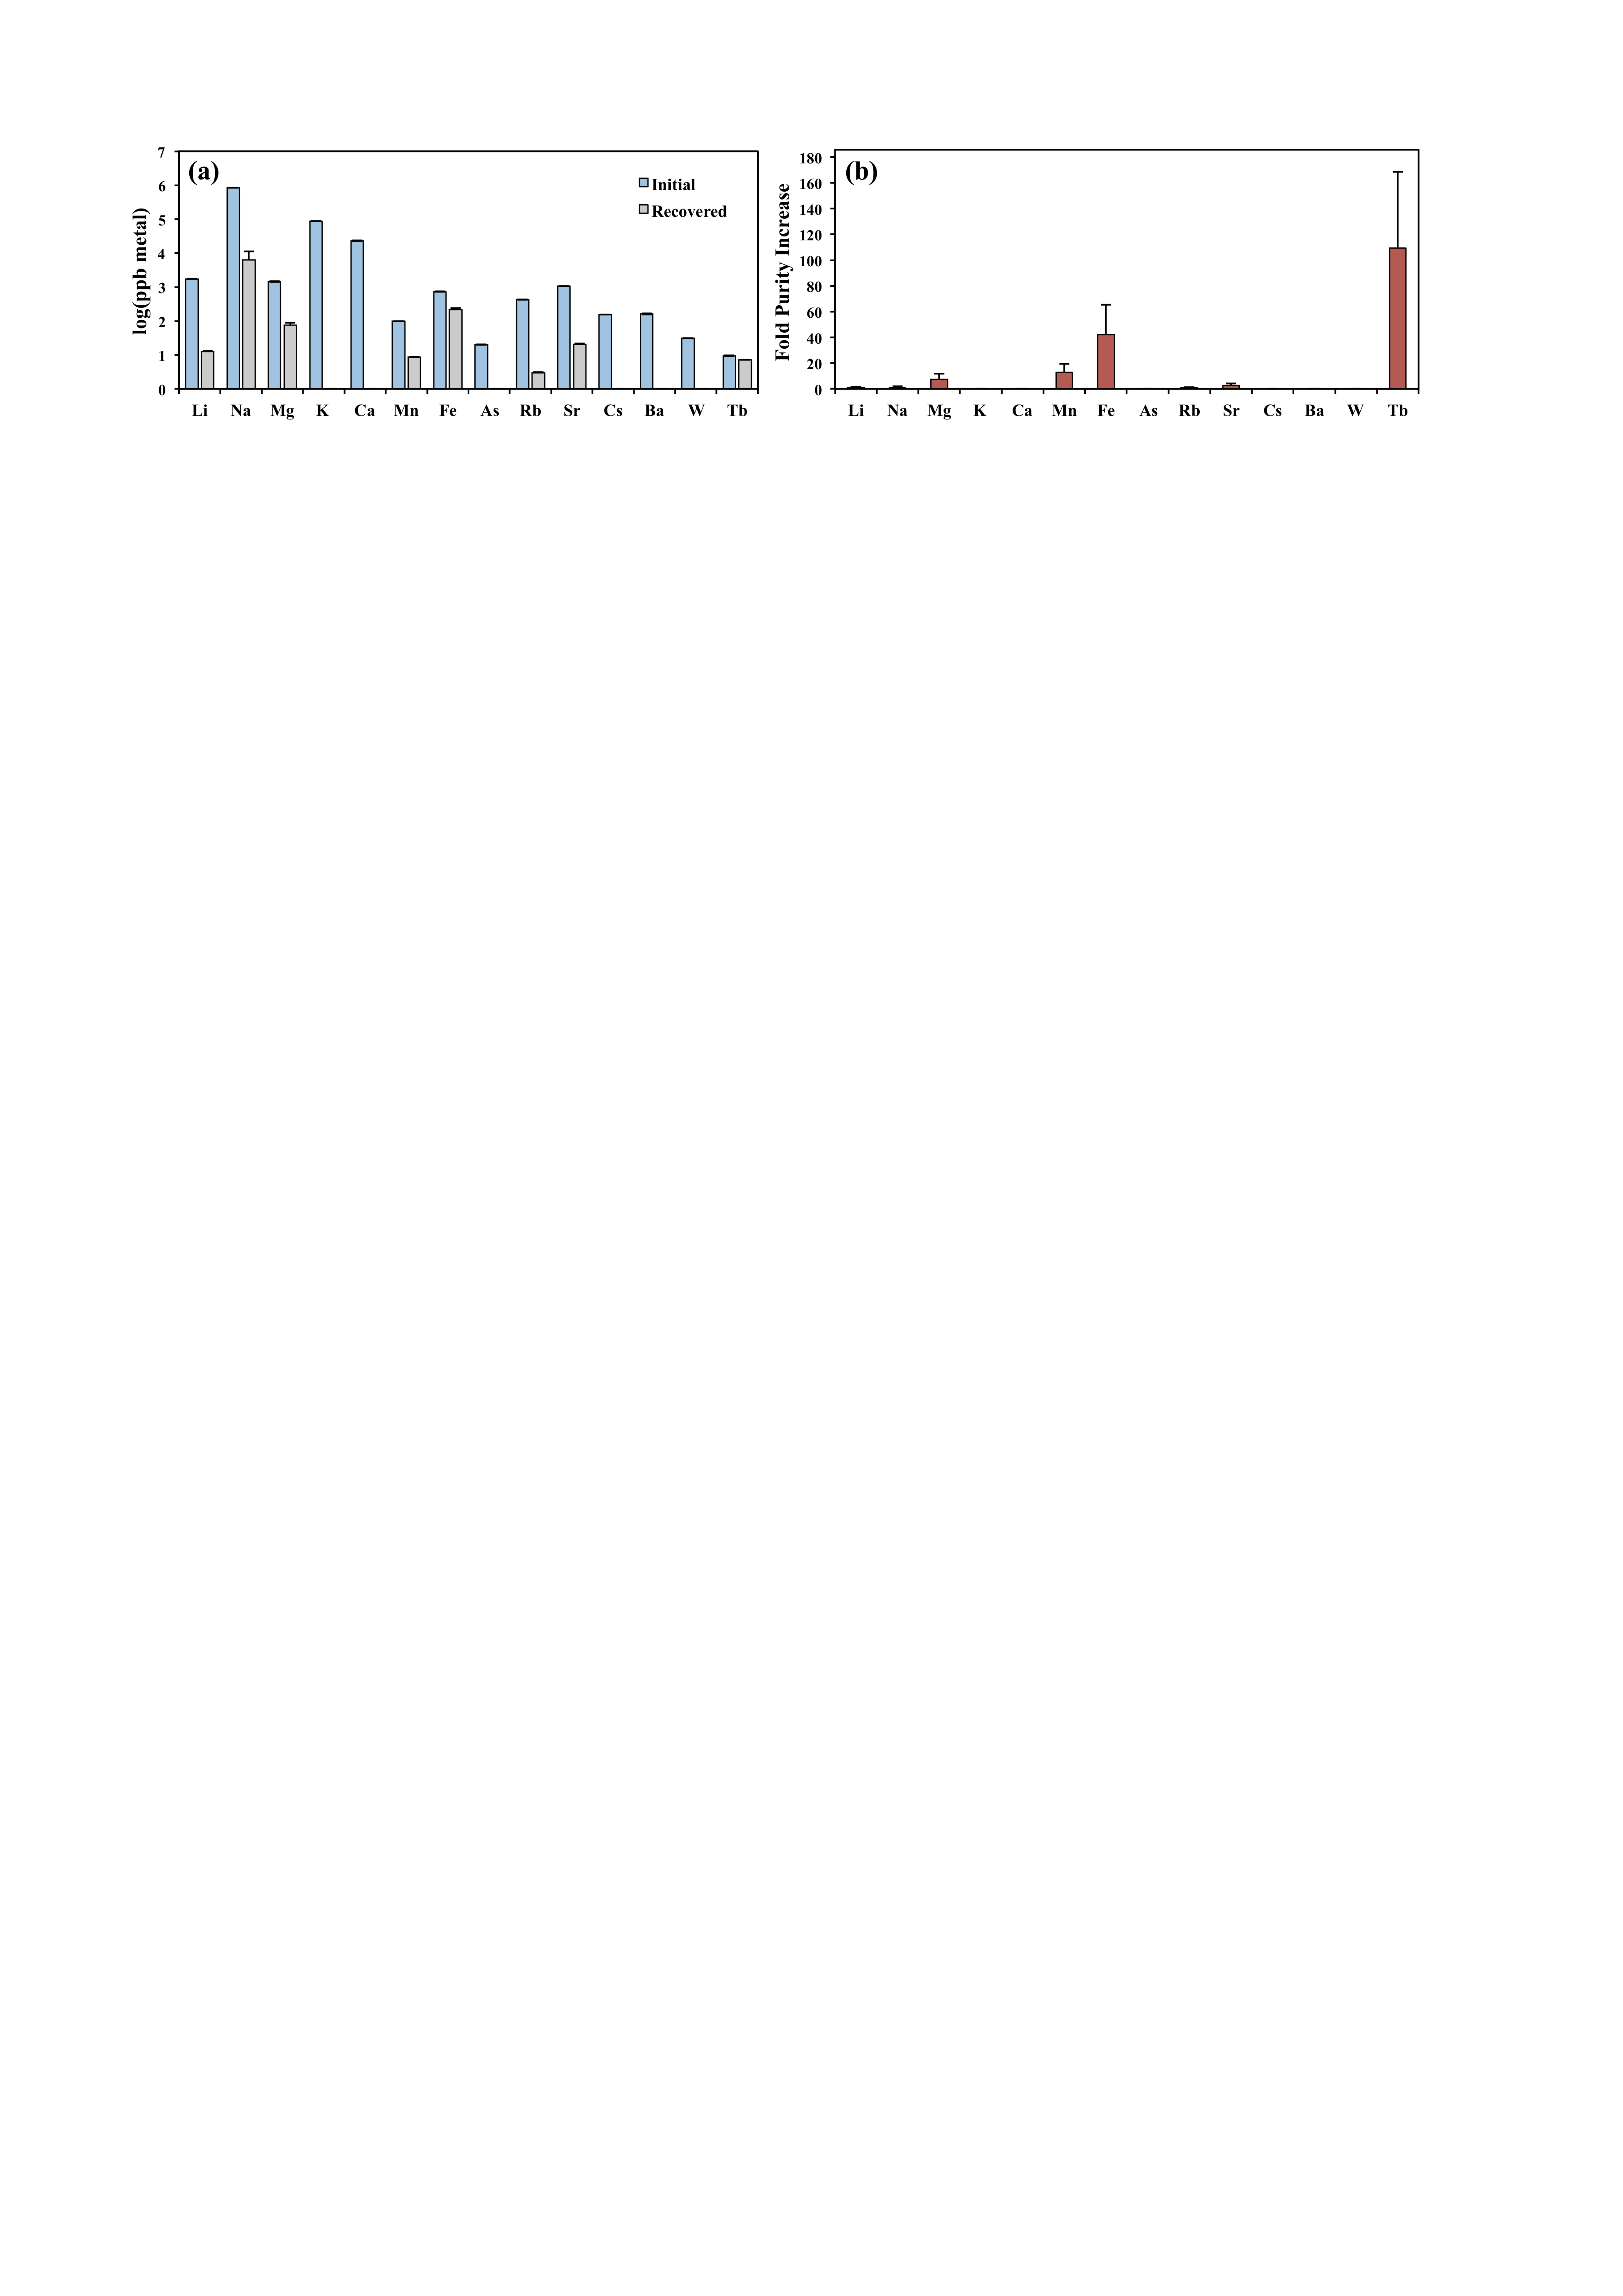**

**Figure 1:** (a) Metal concentrations of the initial REE-spiked Blue Mountain geofluid (blue) and the recovered eluent following one adsorption/desorption cycle using LBT-displayed *E. coli* (grey). (b) Fold purity increase for each metal, which is defined for metal x relative to total metals as (xeluent/Totaleluent)/(xfeedstock/Totalfeedstock). The initial Tb concentration was 10 ppb and cell concentration was at ~1.2x108 cells/ml. The error bars represent the standard deviations of biological triplicates.

**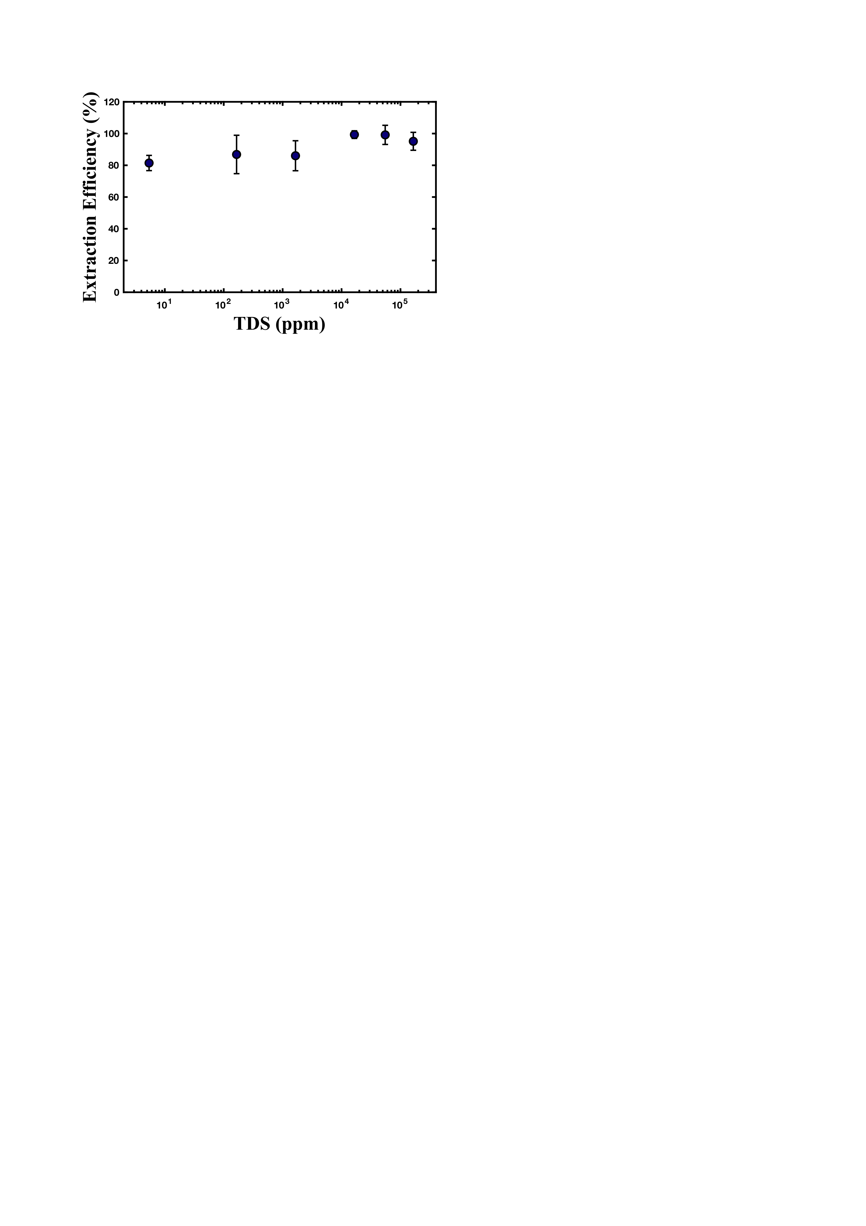**

**Figure 2:** (a)REE adsorption efficiency by LBT-displayed *E. coli* at different total dissolved solid (TDS) concentrations. GSL solution was used at full strength (~165,000 ppm) or diluted 3-, 10-, 100-, 1000-fold. The low salt solution (10 mM MES buffer pH 6, ~5.4 ppm) was included for comparison. The initial Tb concentration was 100 ppb and cell concentration was ~1.2x108 cells/ml. The error bars represent the standard deviations of biological triplicates.

**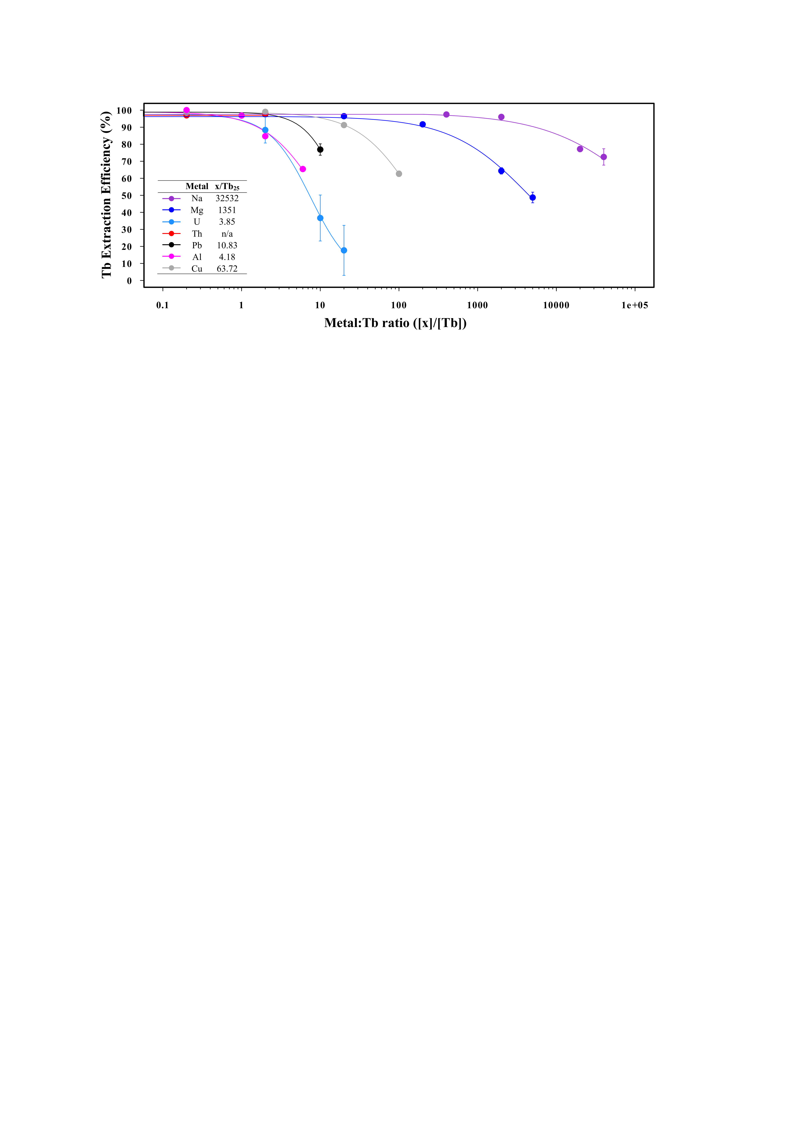**

**Figure 3:** The fraction of terbium (Tb) adsorbed in the presence of a competing metal in buffer solution (10 mM MES pH 6). Individual metals were added at a range of concentrations to assess the effect of competition on Tb adsorption. Initial Tb concentration was fixed at ~8 ppm (50 μM) and cell concentration was fixed at ~1.2x109 cells/ml. The data for each competing metal was fit by a three-parameter log-logistic function using the drc (dose response curve) package in R. [x]/[Tb] represents the ratio of the concentration of the competing metal to that of Tb and x/Tb25 refers to the value at which Tb adsorption decreases by 25% from that observed in the absence of any competing metal. The error bars represent the standard deviations of biological triplicates.

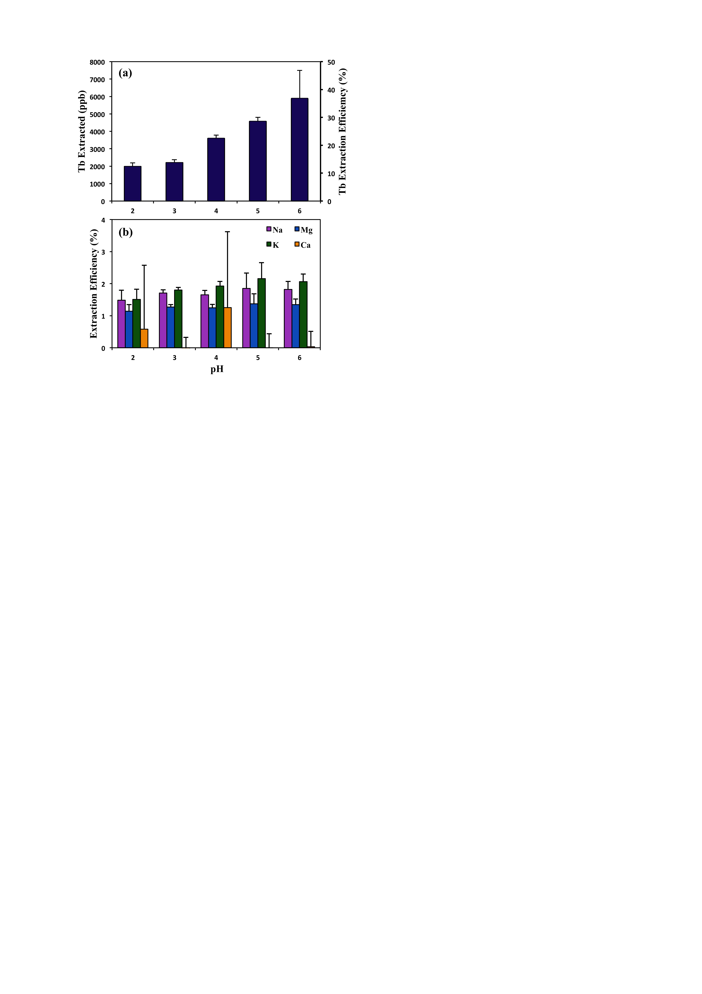

**Figure 4:** REE biosorption performance from the GSL brine at pH 2-6. Initial Tb concentration was fixed at ~16 ppm (100 μM) and cell concentration at ~1.2x109 cells/ml. (a) The amount of Tb recovered (ppb) and Tb extraction efficiency (%) increase with increasing pH (2-6). Less than 4% Tb loss was observed for abiotic controls at all tested pH conditions. (b) Extraction efficiency of major metals is <3% and shows no significant change over pH 2-6. The error bars represent the standard deviations of biological triplicates.

**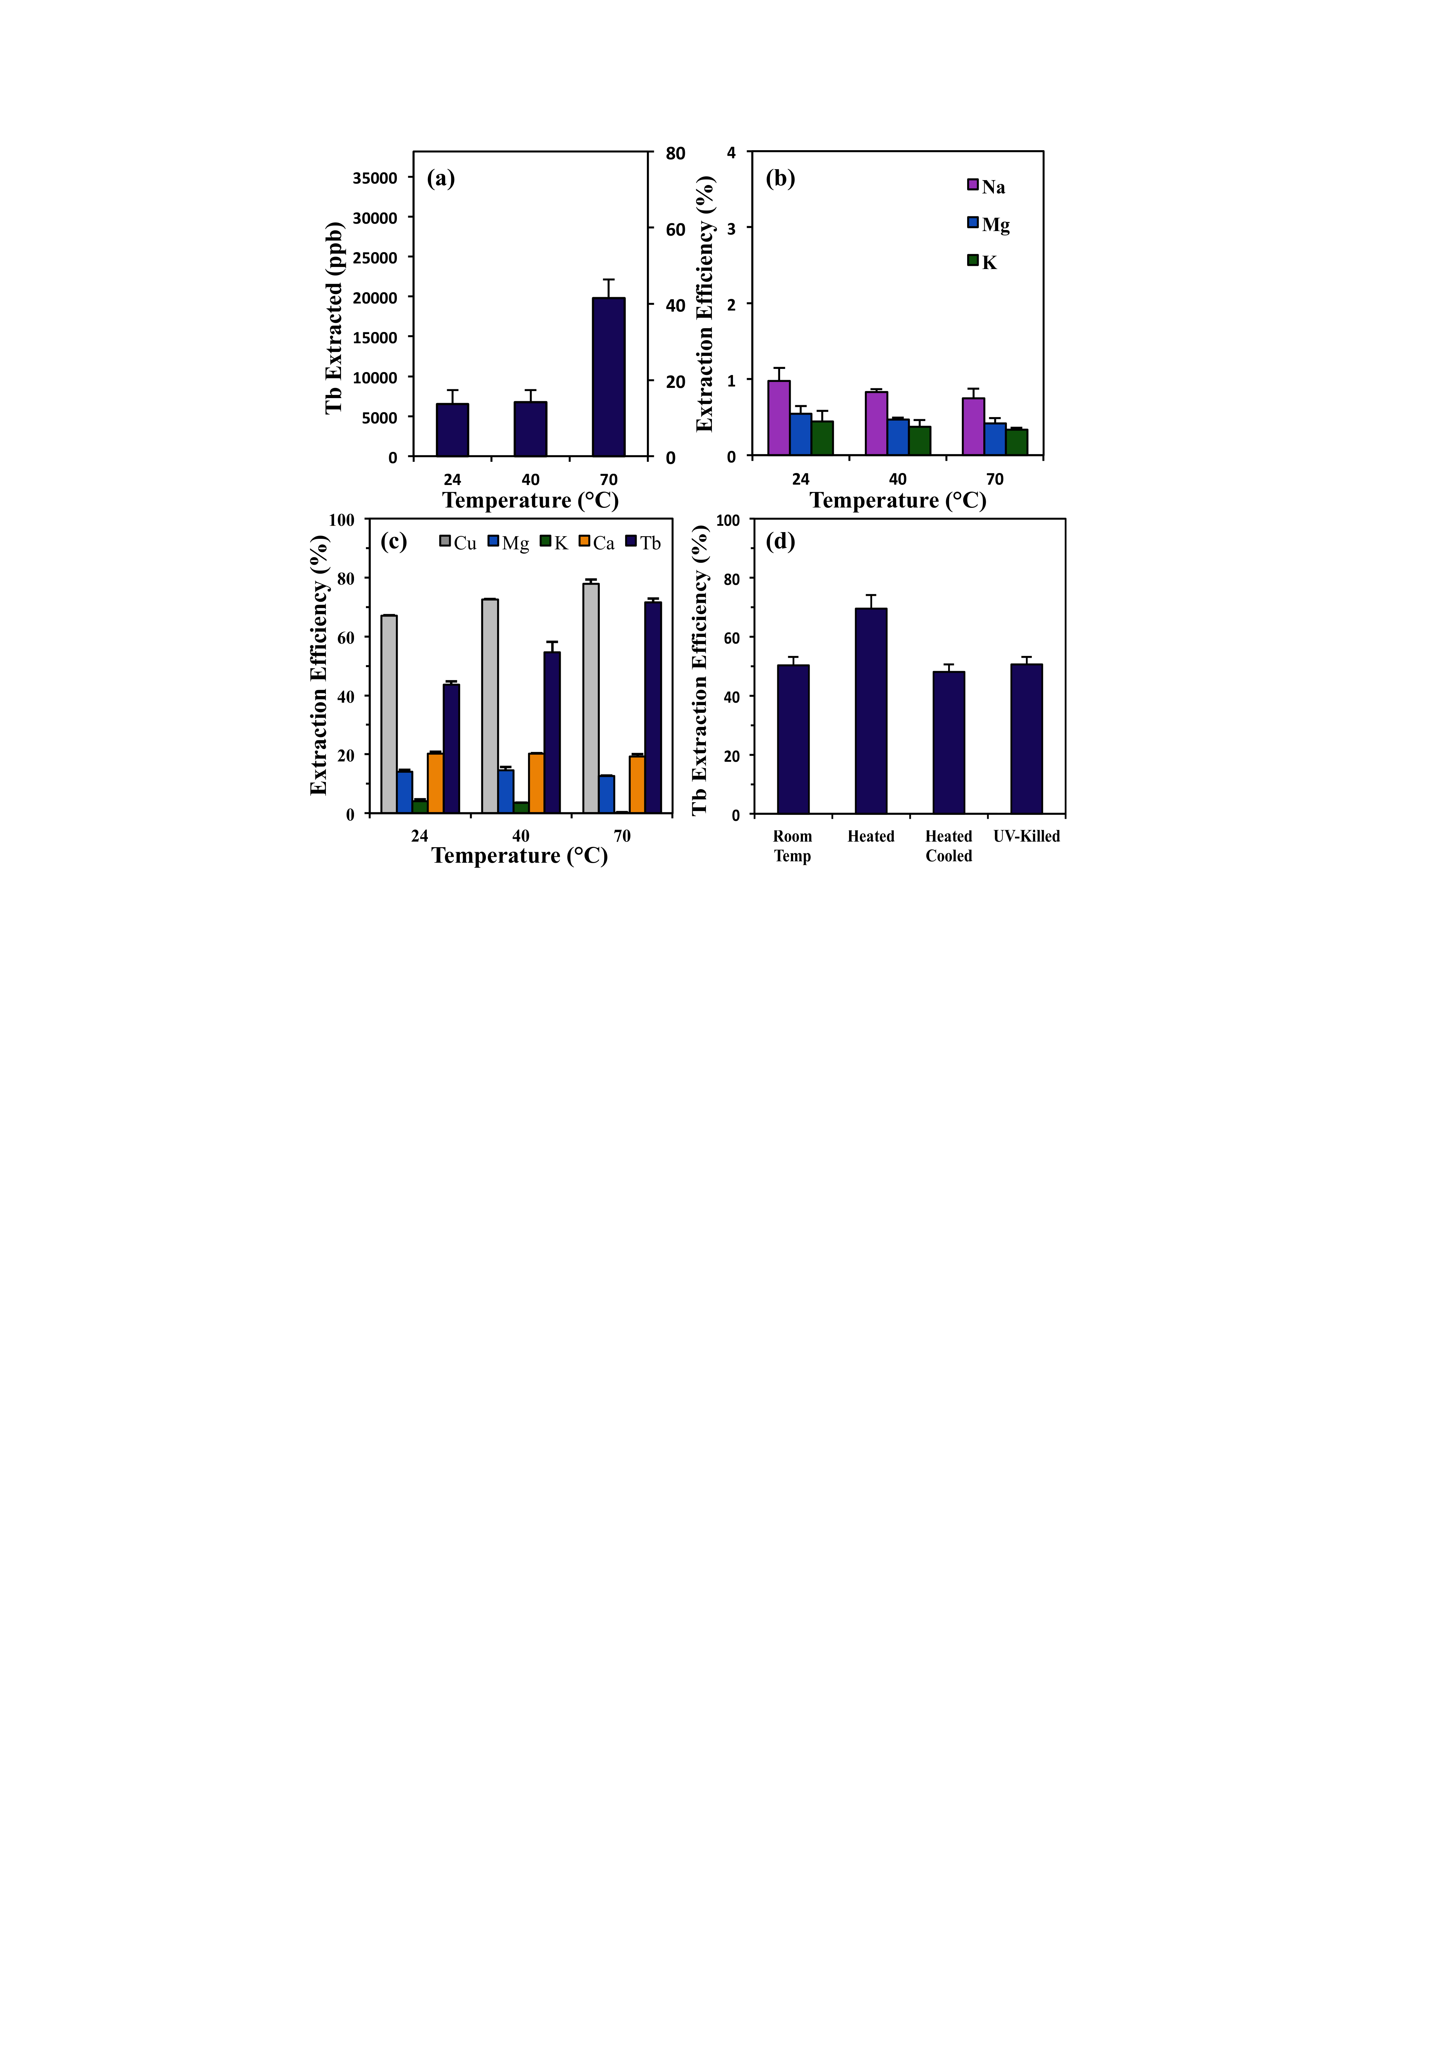**

**Figure 5:** (a) REEs extracted (ppb) and extraction efficiency (%) increase as temperature increases from 40-70°C. The initial Tb concentration was ~48 ppm (300 μM) and the cell concentration was ~1.2x109 cells/ml. Less than 3% Tb loss was observed for abiotic controls at all temperatures. (b) Extraction efficiency (%) remains <2% for the major metals at all tested temperatures. (c) Tb and Cu extraction efficiencies increase with temperature from 24-70°C in low salt buffer solution (10 mM MES pH 6), while Mg, K, and Ca exhibit no change with temperature. (d) Comparison of Tb extraction efficiency (%) in buffer solution (10 mM MES pH 6) at room temperature (24°C), heated (70°C), heated to 70°C then cooled to 24°C before exposure to Tb, and UV-killed cells at room temperature.

/Users/ElliotChang/Dropbox (AW Chang Group)/BILL&EPP FOLDER/Elliot/RESEARCH/UCB_REE_Research/REE_Extraction/Analysis/Thermo_Experiment/Final_Manuscript/Combined_Plots.pdf**Figure 6:** (a) Van’t Hoff plots of lanthanum-acetate and projected lanthanum-bacteria complexation. La-Acetate = 24.80 kJ/mol indicates an endothermic reaction as complexation increases at elevated temperatures. The lanthanum-bacteria ln(K) vs 1/T plot is a qualitative dashed line indicating a steeper negative slope than lanthanum-acetate given that the lanthanum-bacteria stability constant is higher than its lanthanum-acetate counterpart at elevated temperatures. (b) Metal-bacteria stability constants (logK) as a function of temperature. Stability constants for La, U(VI), Cu, and Na (closed symbols) were calculated based on a temperature-dependent linear free energy relationship (Figure S1) generated from Zn, Cd, and Pb-acetate34 and bacteria (open symbol) stability constant data.35



**Figure 7:** Schematic showing a process flow for integrating the LBT-displayed *E. coli* biosorption system for REE recovery from geothermal fluids.

**References**

1. DOE, Critical Materials Strategy. In 2011.

2. Zhuang, W. Q.; Fitts, J. P.; Ajo-Franklin, C. M.; Maes, S.; Alvarez-Cohen, L.; Hennebel, T., Recovery of critical metals using biometallurgy. *Curr Opin Biotech* **2015,** *33*, 327-335.

3. Hennebel, T.; Boon, N.; Maes, S.; Lenz, M., Biotechnologies for critical raw material recovery from primary and secondary sources: R&D priorities and future perspectives. *New Biotechnol* **2015,** *32*, (1), 121-127.

4. Dodson, J. R.; Parker, H. L.; Garcia, A. M.; Hicken, A.; Asemave, K.; Farmer, T. J.; He, H.; Clark, J. H.; Hunt, A. J., Bio-derived materials as a green route for precious & critical metal recovery and re-use. *Green Chem* **2015,** *17*, (4), 1951-1965.

5. Eggert, R. W., C.; Anderson, C.; Bauer, D.; Fields, F.; Meinert, L.; Taylor, P., Rare Earths: Market disruption, innovation, and global supply chains. *Annu. Rev. Environ. Resour.* **2016,** *41*, 199-222.

6. Jacinto, J.; Henriques, B.; Duarte, A. C.; Vale, C.; Pereira, E., Removal and recovery of Critical Rare Elements from contaminated waters by living Gracilaria gracilis. *J Hazard Mater* **2018,** *344*, 531-538.

7. Kucuker, M. A.; Wieczorek, N.; Kuchta, K.; Copty, N. K., Biosorption of neodymium on Chlorella vulgaris in aqueous solution obtained from hard disk drive magnets. *PLoS One* **2017,** *12*, (4), e0175255.

8. Lo, Y. C.; Cheng, C. L.; Han, Y. L.; Chen, B. Y.; Chang, J. S., Recovery of high-value metals from geothermal sites by biosorption and bioaccumulation. *Bioresource Technol* **2014,** *160*, 182-190.

9. Jiang, M. Y.; Ohnuki, T.; Tanaka, K.; Kozai, N.; Kamiishi, E.; Utsunomiya, S., Post-adsorption process of Yb phosphate nano-particle formation by Saccharomyces cerevisiae. *Geochim Cosmochim Ac* **2012,** *93*, 30-46.

10. Moriwaki, H.; Yamamoto, H., Interactions of microorganisms with rare earth ions and their utilization for separation and environmental technology. *Appl Microbiol Biot* **2013,** *97*, (1), 1-8.

11. Ozaki, T.; Gillow, J. B.; Kimura, T.; Ohnuki, T.; Yoshida, Z.; Francis, A. J., Sorption behavior of europium(III) and curium(III) on the cell surfaces of microorganisms. *Radiochim Acta* **2004,** *92*, (9-11), 741-748.

12. Texier, A. C.; Andres, Y.; Le Cloirec, P., Selective biosorption of lanthanide (La, Eu, Yb) ions by Pseudomonas aeruginosa. *Environ Sci Technol* **1999,** *33*, (3), 489-495.

13. Tsuruta, T., Accumulation of rare earth elements in various microorganisms. *J Rare Earth* **2007,** *25*, (5), 526-532.

14. Park, D. M.; Reed, D. W.; Yung, M. C.; Eslamimanesh, A.; Lencka, M. M.; Anderko, A.; Fujita, Y.; Riman, R. E.; Navrotsky, A.; Jiao, Y. Q., Bioadsorption of Rare Earth Elements through Cell Surface Display of Lanthanide Binding Tags. *Environ Sci Technol* **2016,** *50*, (5), 2735-2742.

15. Nash, K. L.; Jensen, M. P., Analytical-scale separations of the lanthanides: A review of techniques and fundamentals. *Sep Sci Technol* **2001,** *36*, (5-6), 1257-1282.

16. Xie, F.; Zhang, T. A.; Dreisinger, D.; Doyle, F., A critical review on solvent extraction of rare earths from aqueous solutions. *Miner Eng* **2014,** *56*, 10-28.

17. Park, D. M.; Brewer, A.; Reed, D. W.; Lammers, L. N.; Jiao, Y., Recovery of Rare Earth Elements from Low-Grade Feedstock Leachates Using Engineered Bacteria. *Environ Sci Technol* **2017,** *51*, (22), 13471-13480.

18. Ngwenya, B. T.; Magennis, M.; Olive, V.; Mosselmans, J. F.; Ellam, R. M., Discrete site surface complexation constants for lanthanide adsorption to bacteria as determined by experiments and linear free energy relationships. *Environ Sci Technol* **2010,** *44*, (2), 650-6.

19. Martinez, R. E. P., O.; Takahashi, Y., Modeling rare earth element sorption to the Gram positive Bacillus subtilis bacteria surface. *J Colloid Interf Sci* **2014,** *413*, 106-111.

20. Markai, S. A., Y.; Montavon, G.; Grambow, B., Study of the interaction between europium (III) and Bacillus subtilis: fixation sites, biosorption modeling and reversibility. *J Colloid Interf Sci* **2003,** *262*, 351-361.

21. Texier, A. C. A., Y.; Illemassene, M.; Le Cloirec, P., Characterization of lanthanide ions binding sites in the cell wall of Pseudomonas aeruginosa. *Environ Sci Technol* **2000,** *34*, (4), 610-615.

22. Smith, Y. R.; Kumar, P.; McLennan, J. D., On the Extraction of Rare Earth Elements from Geothermal Brines. *Resources-Basel* **2017,** *6*, (3).

23. Jin, H. Y.; Park, D. M.; Gupta, M.; Brewer, A. W.; Ho, L.; Singer, S. L.; Bourcier, W. L.; Woods, S.; Reed, D. W.; Lammers, L. N.; Sutherland, J. W.; Jiao, Y. Q., Techno-economic Assessment for Integrating Biosorption into Rare Earth Recovery Process. *Acs Sustain Chem Eng* **2017,** *5*, (11), 10148-10155.

24. Wood, S. A., Behavior of rare earth elements in geothermal systems: A new exploration/exploitation tool? In DOE, Ed. Geothermal Reservoir Technology Research: 2001.

25. Bonificio, W. D.; Clarke, D. R., Rare-Earth Separation Using Bacteria. *Environ Sci Tech Let* **2016,** *3*, (4), 180-184.

26. Takahashi, Y.; Chatellier, X.; Hattori, K. H.; Kato, K.; Fortin, D., Adsorption of rare earth elements onto bacterial cell walls and its implication for REE sorption onto natural microbial mats. *Chem Geol* **2005,** *219*, (1-4), 53-67.

27. Smith, Y. R.; Bhattacharyya, D.; Willhard, T.; Misra, M., Adsorption of aqueous rare earth elements using carbon black derived from recycled tires. *Chem Eng J* **2016,** *296*, 102-111.

28. Xu, S. X.; Wang, Z. W.; Gao, Y. Q.; Zhang, S. M.; Wu, K., Adsorption of Rare Earths(III) Using an Efficient Sodium Alginate Hydrogel Cross-Linked with Poly-gamma-Glutamate. *Plos One* **2015,** *10*, (5).

29. Wood, S. A., Rare earth element systematics of acidic geothermal waters from the Taupo Volcanic Zone, New Zealand. *J Geochem Explor* **2006,** *89*, (1-3), 424-427.

30. Muravyov, M. I.; Bulaev, A. G.; Melamud, V. S.; Kondrat'eva, T. F., [Leaching of Rare Earth Elements from Coal Ashes Using Acidophilic Chemolithotrophic Microbial Communities]. *Mikrobiologiia* **2015,** *84*, (2), 216-24.

31. Martin, L. J.; Hahnke, M. J.; Nitz, M.; Wohnert, J.; Silvaggi, N. R.; Allen, K. N.; Schwalbe, H.; Imperiali, B., Double-lanthanide-binding tags: Design, photophysical properties, and NMR applications. *J Am Chem Soc* **2007,** *129*, (22), 7106-7113.

32. Wei, W.; Liu, X. Z.; Sun, P. Q.; Wang, X.; Zhu, H.; Hong, M.; Mao, Z. W.; Zhao, J., Simple Whole-Cell Biodetection and Bioremediation of Heavy Metals Based on an Engineered Lead-Specific Operon. *Environ Sci Technol* **2014,** *48*, (6), 3363-3371.

33. Fein, J. B.; Martin, A. M.; Wightman, P. G., Metal adsorption onto bacterial surfaces: Development of a predictive approach. *Geochim Cosmochim Ac* **2001,** *65*, (23), 4267-4273.

34. Shock, E. L. K., C. M., Metal-organic complexes in geochemical processes: Calculation of standard partial molal thermodynamic properties of aqueous acetate complexes at high pressures and temepratures. *Geochim Cosmochim Ac* **1993,** *57*, 4899-4922.

35. Fan, T.; Liu, Y.; Feng, B.; Zeng, G.; Yang, C.; Zhou, M.; Zhou, H.; Tan, Z.; Wang, X., Biosorption of cadmium(II), zinc(II) and lead(II) by Penicillium simplicissimum: Isotherms, kinetics and thermodynamics. *J Hazard Mater* **2008,** *160*, (2-3), 655-61.

36. Ding, R. W., S. A., The aqueous geochemistry of the rare earth elements and yttrium. Part X. Potentiometric determination of stability constants of acetate complexes of La3+, Nd3+, Gd3+, and Yb3+ at 25-70°C and 1 bar. In *Water-rock interactions, ore deposits, and environmental geochemistry: A tribute to David A. Crerar*, R. Hellmann, S. A. W., Ed. The Geochemical Society: 2002; pp 209-227.

37. Fournier, P.; Oelkers, E. H.; Gout, R.; Pokrovski, G., Experimental determination of aqueous sodium-acetate dissociation constants at temperatures from 20 to 240 degrees C. *Chem Geol* **1998,** *151*, (1-4), 69-84.

38. Jiang, J. R., L.; Di Bernardo, P.; Zanonato, P. L.; Bismondo, A., Complexation of uranium(VI) with acetate at variable temperatures. *Journal of the Chemical Society, Dalton Transactions* **2002**, (8), 1832-1838.

39. Ngwenya, B. T.; Mosselmans, J. F. W.; Magennis, M.; Atkinson, K. D.; Tourney, J.; Olive, V.; Ellam, R. M., Macroscopic and spectroscopic analysis of lanthanide adsorption to bacterial cells. *Geochim Cosmochim Ac* **2009,** *73*, (11), 3134-3147.

40. Tang, J. W.; Johannesson, K. H., Rare earth elements adsorption onto Carrizo sand: Influence of strong solution complexation. *Chem Geol* **2010,** *279*, (3-4), 120-133.

41. Munemoto, T.; Ohmori, K.; Iwatsuki, T., Rare earth elements (REE) in deep groundwater from granite and fracture-filling calcite in the Tono area, central Japan: Prediction of REE fractionation in paleo- to present-day groundwater. *Chem Geol* **2015,** *417*, 58-67.

42. Small, T. D.; Warren, L. A.; Ferris, F. G., Influence of ionic strength on strontium sorption to bacteria, Fe(III) oxide, and composite bacteria-Fe(III) oxide surfaces. *Appl Geochem* **2001,** *16*, (7-8), 939-946.

43. Borrok, D. M.; Fein, J. B., The impact of ionic strength on the adsorption of protons, Pb, Cd, and Sr onto the surfaces of Gram negative bacteria: testing non-electro static, diffuse, and triple-layer models. *J Colloid Interf Sci* **2005,** *286*, (1), 110-126.

44. Daughney, C. J.; Fein, J. B., The effect of ionic strength on the adsorption of H+, Cd2+, Pb2+, and Cu2+ by Bacillus subtilis and Bacillus licheniformis: A surface complexation model. *J Colloid Interf Sci* **1998,** *198*, (1), 53-77.

45. Elsalamouny, A. R.; Desouky, O. A.; Mohamed, S. A.; Galhoum, A. A.; Guibal, E., Uranium and neodymium biosorption using novel chelating polysaccharide. *Int J Biol Macromol* **2017,** *104*, (Pt A), 963-968.

46. Poetsch, M.; Lippold, H., Effects of ionic strength and fulvic acid on adsorption of Tb(III) and Eu(III) onto clay. *J Contam Hydrol* **2016,** *192*, 146-151.

47. Dolatyari, L. Y., M. R.; Rostamnia, S., Adsorption characteristics of Eu(III) and Th(IV) ions onto modified mesoporous silica SBA-15 materials. *Journal of the Taiwan Institute of Chemical Engineers* **2016,** *60*, 174-184.

48. Zhu, Z. P., Y.; Cheng, C. Y., Separation of uranium and thorium from rare earths for rare earth production - A review. *Miner Eng* **2015,** *77*, 185-196.

49. Mashkovtsev, M. B., M.; Smyshlyaev, D.; Pajarre, R.; Kangas, P.; Rychkov, V.; Koukkari, P., Pilot-scale recovery of rare earths and scandium from phosphogypsum and uranium leachates. *E3S Web of Conferences* **2016,** *8*, (01026).

50. Hosomomi, Y.; Wakabayashi, R.; Kubota, F.; Kamiya, N.; Goto, M., Diglycolic amic acid-modified E. coli as a biosorbent for the recovery of rare earth elements. *Biochem Eng J* **2016,** *113*, 102-106.

51. Vijayaraghavan, K.; Sathishkumar, M.; Balasubramanian, R., Interaction of rare earth elements with a brown marine alga in multi-component solutions. *Desalination* **2011,** *265*, (1-3), 54-59.

52. Mosbah, R.; Sahmoune, M. N., Biosorption of heavy metals by Streptomyces species - an overview. *Cent Eur J Chem* **2013,** *11*, (9), 1412-1422.

53. Pacheco, P. H.; Gil, R. A.; Cerutti, S. E.; Smichowski, P.; Martinez, L. D., Biosorption: A new rise for elemental solid phase extraction methods. *Talanta* **2011,** *85*, (5), 2290-2300.

54. Xu, S. X.; Zhang, S. M.; Chen, K.; Han, J. F.; Liu, H. S.; Wu, K., Biosorption of La3+ and Ce3+ by Agrobacterium sp HN1. *J Rare Earth* **2011,** *29*, (3), 265-270.

55. Takahashi, Y. Y., M.; Yamamoto, Y.; Tanaka, K., EXAFS study on the cause of enrichment of heavy REEs on bacterial surfaces. *Geochim Cosmochim Ac* **2010,** *74*, 5443-5462.

56. Ridley, M. K. M., M. L.; Wesolowski, D. J.; Palmer, D. A., Calcium adsorption at the rutile-water interface: A potentiometric study in NaCl media to 250C. *Geochim Cosmochim Ac* **1999,** *63*, 3087-3096.

57. Katz, L. E.; Criscenti, L. J.; Chen, C. C.; Larentzos, J. P.; Liljestrand, H. M., Temperature effects on alkaline earth metal ions adsorption on gibbsite: approaches from macroscopic sorption experiments and molecular dynamics simulations. *J Colloid Interface Sci* **2013,** *399*, 68-76.

58. Sag, Y. K., T., Determination of the biosorption heats of heavy metal ions on *Zoogloea ramigera* and *Rhizopus arrhizus*. *Biochem Eng J* **2000,** *6*, 145-151.

59. Shakeri, A.; Ghoreyshinia, S.; Mehrabi, B.; Delavari, M., Rare earth elements geochemistry in springs from Taftan geothermal area SE Iran. *J Volcanol Geoth Res* **2015,** *304*, 49-61.

60. Sanada, T.; Takamatsu, N.; Yoshiike, Y., Geochemical interpretation of long-term variations in rare earth element concentrations in acidic hot spring waters from the Tamagawa geothermal area, Japan. *Geothermics* **2006,** *35*, (2), 141-155.

61. Zhang, Y. T., H.; Zhang, W.; Wei, H.; Dong, T., Geochemical constraint on origin and evolution of solutes in geothermal springs in western Yunnan, China. *Chemie der Erde* **2016,** *76*, 63-75.

62. Michard, A., Rare earth element systematics in hydrothermal fluids. *Geochim Cosmochim Ac* **1989,** *53*, 745-750.