The tube wave based seismic reflection method was tested at the field scale during the last quarter. This test was conducted at the Chevron Cymric oilfield in the California central valley near Bakersfield (Figure 1). Both single and 3-component geophones were used for the survey. The layout of the tests and example datasets are shown in Figure 2.
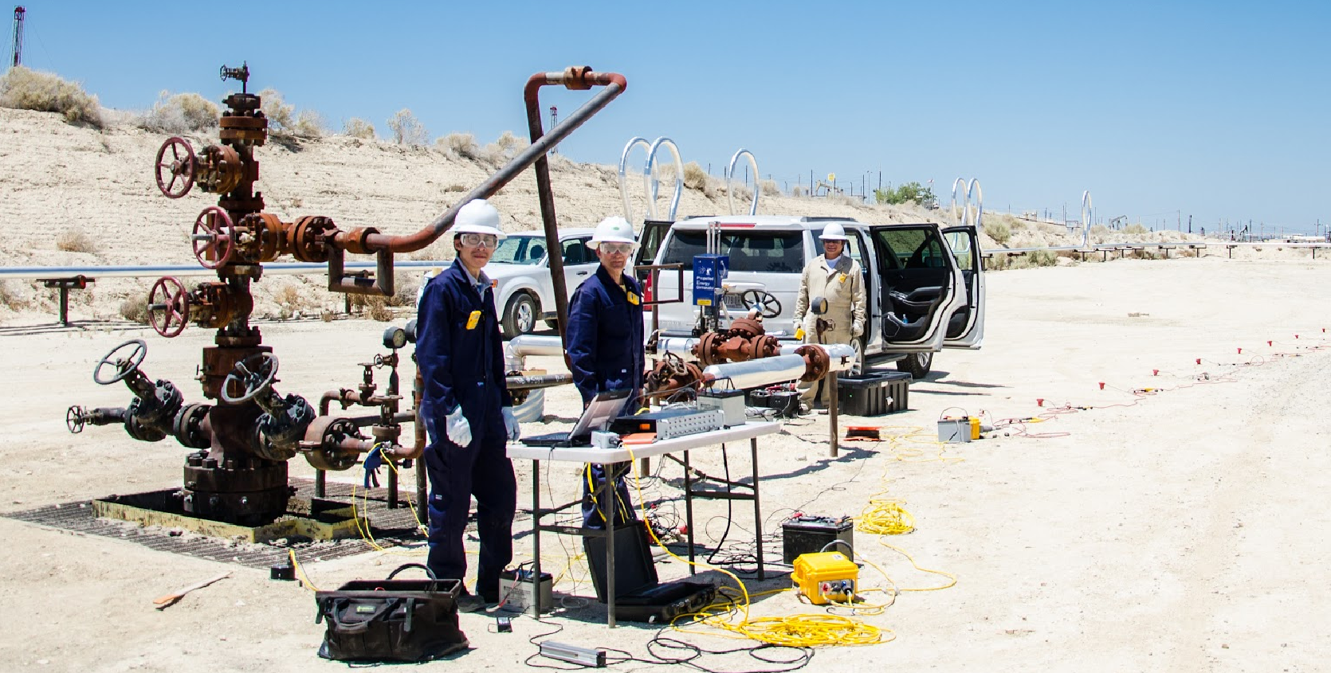
Figure 1. Tube wave reflectometry field borehole test at Cymric oilfield near Bakersfield.
As can be seen from Figure 2, a reflected seismic signal was observed in all three components (x, y, z) of the 3-component Episensor geophone, as well as all phones on the single component array. The arrival time of the reflected seismic signal matches calculations based on a reasonable velocity model (~650 m/s).
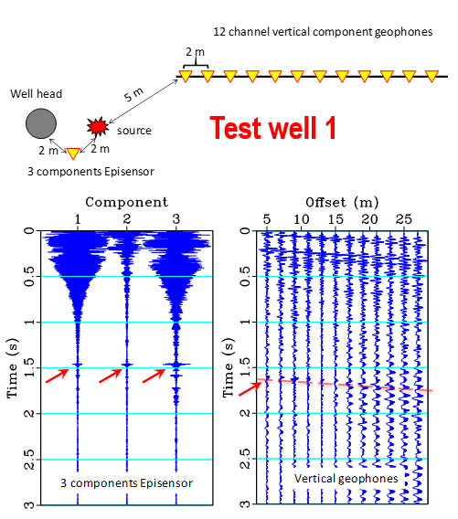
Figure 2. Seismic tube wave reflectometry field test lay out and data on test well #1. Red arrows indicate the arrival of the reflected wave at the surface.

