For the model calculation we applied EM3D using completion diagram of CaMI site and a background resistivity consistent with the borehole logs. It was also important to use the accurate position of the return electrode. We note that for the data fit the code also incorporated well casings for well INJ and the other observation well, either OB1 or OB2, in the calculation.

The fit of the observed data to the calculated response is impressively close considering the approximate knowledge of the background resistivity. We note that several of the excursions, especially at longer offsets were not fit mainly because the infrastructure that likely caused them was not well mapped.

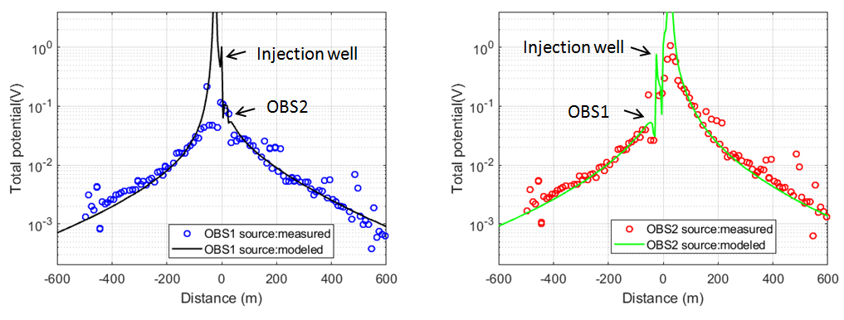

**Figure 1.** Fit of numerical data to field results at the CMC site.

*DC model (Sandia) simulation of the CaMI field data:* The DC simulation code from Sandia was also tested on the CaMI data. The comparison between the electrostatic response and the low frequency field data is generally favorable (Figure 2). Outliers from the generally smooth response decays are present in the data, and it remains to be determined whether these signals represent noise or the presence of conductivity features not considered by our model. Furthermore, we note that the field data are electric fields measured by 10 m electrode spacing, whereas the model results assume 1 m spacing – hence the measured data are (expectedly) smoother than the modeled data. In summary, we demonstrate here, for this particular case, that the DC results may be a reasonable approximation to the low frequency EM data collected at CAMI. If this approximation continues to hold, then the extreme computational efficiency offered by the hierarchical modeling used in the DC simulations will permit us to explore far more model complexity, especially the pervasive and troublesome data artifacts that arise when doing EM surveys in mature, culturally developed sites.

../Data/Wilt/obs1.pdf

../Data/Wilt/obs2.pdf

**Figure 2.** Magnitude of electrostatic field along the measurement profile for excitation of OBS1 (top) and OBS2 (bottom) wells. Model results (left) for each well excitation clearly show a significant “casing effect”, thus justifying its inclusion in the calculation. These anthropogenic artifacts are present in the data (right) and strong agreement is evident between the electrostatic fields (lines) and the low-frequency 5 Hz data (symbols).

In Brief, both the low frequency and DC simulation codes provided very consistent results that match the field data really well, indicating their capability to help monitoring borehole integrity with the low frequency EM method.