FIELD SITE PERFORMANCE, PROCEDURES, AND PROBLEMS OF THE FLOW SYSTEMS
During Bio-sampling – One of the very first steps in the field is setting up 4 containers to collect water samples from the flowing boreholes that consist of PB, PI, PST, and PDT. A water sample from the Injectate (Mine water) is also collected. The collection of water from PB, PST, and PDT was merely placing the container underneath the outflow tubes of the flowmeters and did not require disturbing the flow to the flowmeters (see picture below).
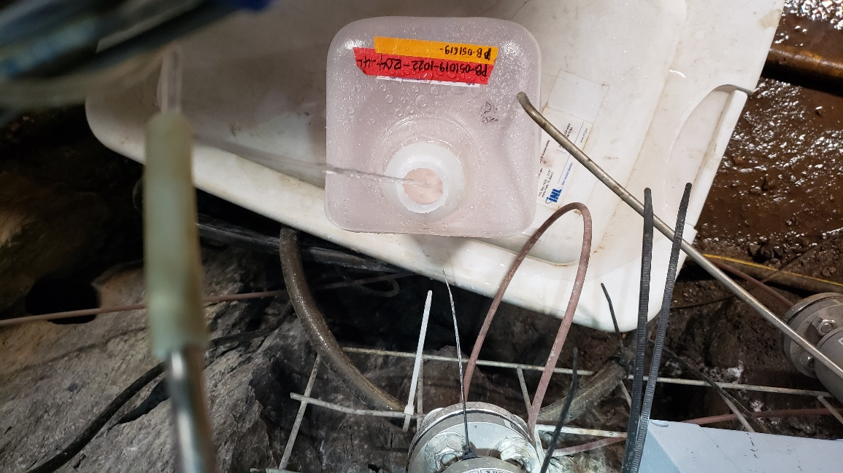
Meanwhile, the collection of water from PI involves attaching a silicone tube to the outflow tube of the flowmeter that redirects the flow to the container. Filling up the container usually takes 20 mins. (see picture below).
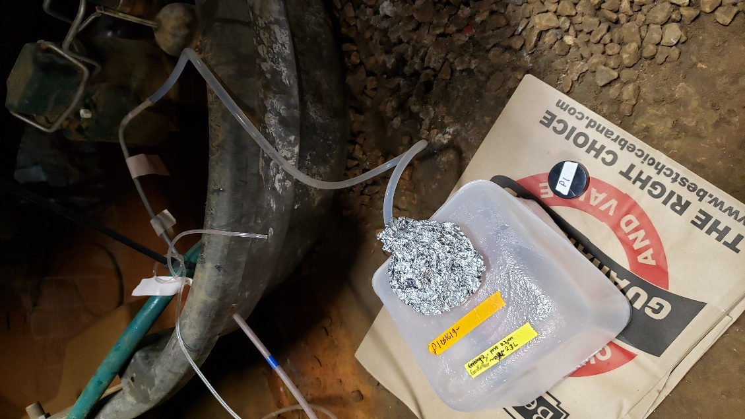
Overall, any noise/disturbance that might arise in the data from performing bio-sampling will most likely come from the Production Interval (PI) flowmeter.
During tracer testing – Water samples are collected via 15 mL conical tubes from the 4 flowing boreholes (PB, PI, PST, & PDT). When collecting water from PB and PI, a conical tube is placed directly underneath the outflow tube of the flowmeter to catch the water. This, in turn, should not cause any disturbance to the flowrate measurement data. Meanwhile, collecting water from PST and PDT involves placing the conical tube directly on top of the funnel and under the borehole collar. Disturbance in the flowrate is likely observable. It takes about 2-5 minutes to fill the conical tube when collecting from PST and PDT. Collection of water is done in ½ hour to 1-hour intervals throughout a 12-hour shift.
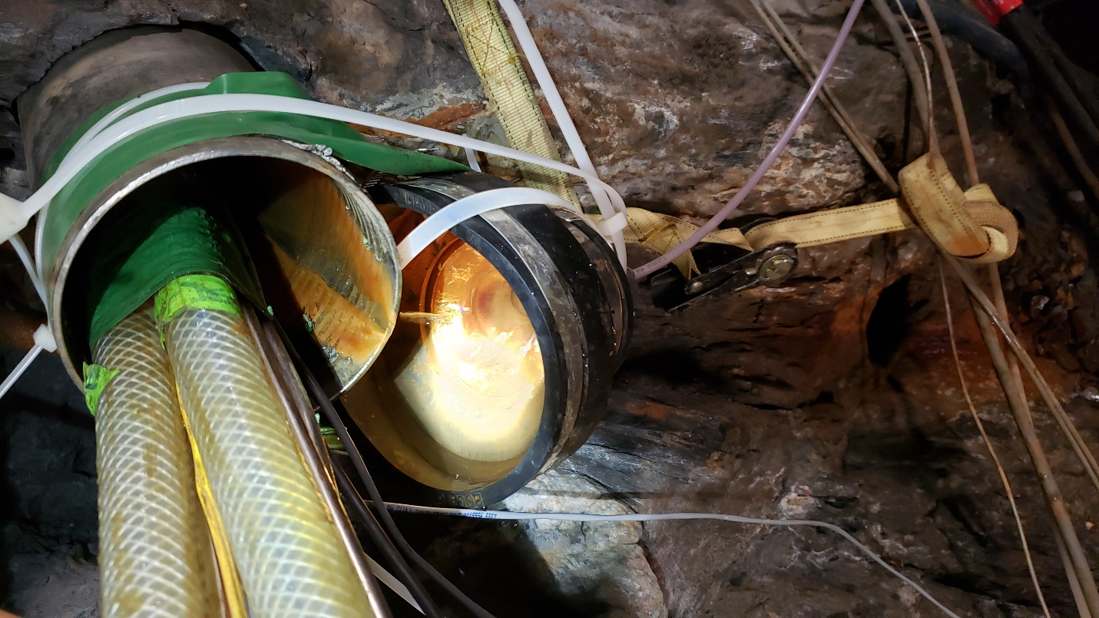
A conical tube is placed underneath the collar when collecting water from PST and PDT.
Problems with funnels/flowmeters – Occasionally, funnels/tubing/flowmeters would get clogged with crud or debris from the boreholes. When this happens, the funnel is disconnected from the tubing that connects it to the flowmeter. This would show a sharp dip in the flowrate plot. The funnel is then rinsed with water to remove any debris. Afterward, a 60 mL syringe with a silicone attachment is used to pump water through the tubing and the flowmeter. This helps flush the debris/crud out. Flushing of water with the syringe is done multiple times. It’s also done from both the inflow and outflow tubing of the flowmeter. This would show spikes in the plot data.
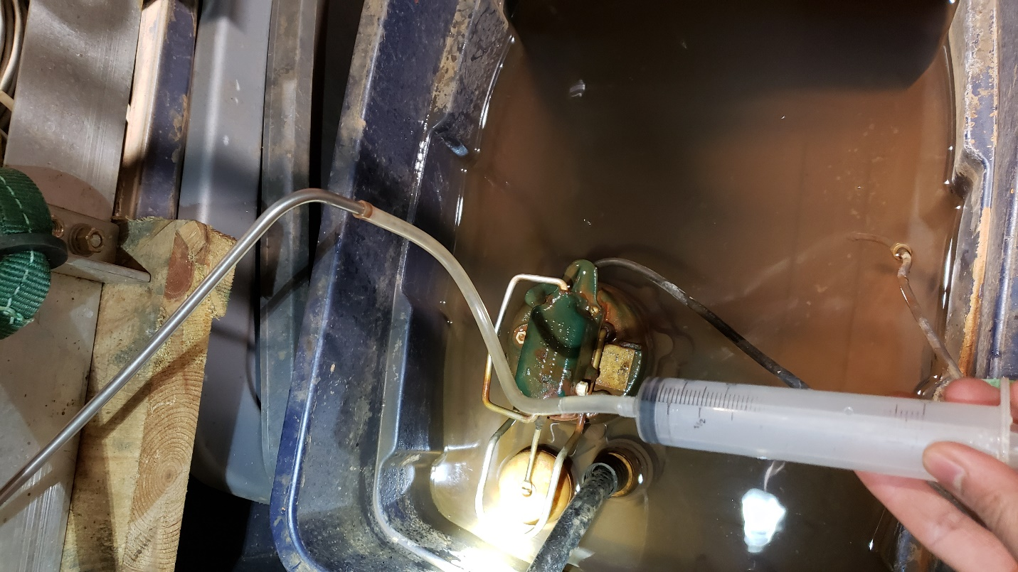
After that, everything is connected back in place. The final step that is done is pouring water on the funnel to make sure that there is no remaining crud and to rid any air pockets inside the flowmeter that might affect the rate of flow. This is also done multiple times. This should show as spikes in the flow data.

