Detailed information about thermistors installed week of 12/17/19

We have built 6 thermistor assemblies that are fully encapsulated with stainless steel tubing to minimize the chance that water can penetrate into the assembly and affect the sensors. The lab testing we did here immersed all six into a water chiller/heater recirculating flow through chamber (see photo). A precision reference thermistor was also placed in the chamber. Each of the thermistor assemblies were measured by a Fluke handheld multimeter, an Agilent LCR meter at three frequencies (100Hz, 120Hz, and 1000Hz), and the same DAQ that is being used at SURF (measuring nominally at 2Hz). The stainless tubes were all electrically connected to both the LCR and DAQ chassis ground and the impedances between either lead and the tube body were measured at each temperature during the test. At ~100Hz, lead-to-body impedances of no less than 400 kohm were observed which was at least 20 times higher than the thermistor resistance. In short below 120Hz, errors due to the reactance portion of the probes was small (<0.1C). Not too surprising, at 1000Hz the errors are large (>1C) but we should never be operating near this frequency.

Five (three 1/8” OD lower zone design, and two 3/16” OD interval design) of the six thermistor assemblies calibrated well and no significant differences between the Fluke, LCR, and DAQ were recorded. One of the thermistors (#5) did not respond well during the test and we will not install it. A comparison of all the data (all five working thermistors) to the reference thermistor is included below. The probes were also left in the test chamber overnight at 35C and no measurable drift in the response was observed.

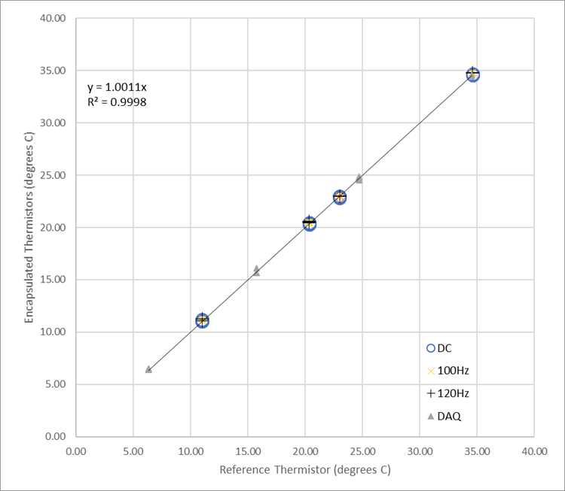

To give an idea of the temporal response, a plot is included showing the recorded probe temperatures during one portion of the chiller/heater steps.

