DCIF_Task2-1_WesterlyB_Intact_AElocation.txt
Column#(s) | Title | Description
1 | Time(s) | Logging time ¹⁾
2 | T0offset(s) | Determined source time against trigger time
3-5 | x(m) y(m) z(m) | Source location
6 | Error(s) | Location error in travel time (RMS)
7-9 | X Y Z | Ohtsu’s moment tensor classification parameters  (computed from a moment tensor) ²⁾
10 | RelativeAmp | Absolute value of the largest moment tensor eigenvalue
¹⁾ Time stamp offset : 118 s (Liquid nitrogen poured at T=118s in the file)
²⁾ J. Geol. Res. 96, B4, 6211-6221, 1991
DCIF_Task2-1_WesterlyB_Intact_AEmovie.avi
Animation of located AE events in the sample over time. This also shows tomographically determined seismic (P-wave) velocity distribution using the SIRT method.
DCIF_Task2-1_WesterlyB_Intact_AEmovieColorbar.tif
Velocity scale for tomography

DCIF_Task2-1_WesterlyB_Intact_Thermocouple.TXT
Thermocouple temperature readings as a function of time. Time T=0s is when liquid nitrogen was poured.
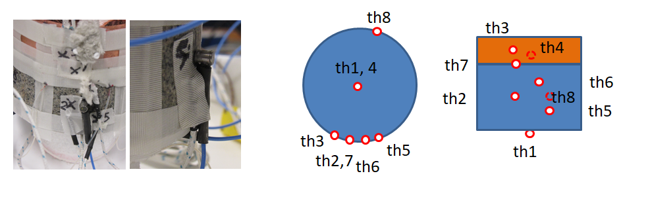
Column#(s) | Title | Description
1 | Time(s) | Logging time
2-9 | Th1… Th8 | Thermocouple temperature (degree C)

DCIF_Task2-1_WesterlyB_Intact_Thermocouple.TIF
Graphical presentation of the thermocouple readings

