LAND SUBSIDENCE FOR BRADYS’ SITE: INITIAL FINDINGS
Introduction
Availability of the radar, laser, satellite and unmanned vehicle images, recent technological development in Remote Sensing (RS) and Geographic Information system (GIS) promise reliable, accurate and high performance analysis opportunity with image processing techniques. In addition to these tools, technologies and techniques, Interferometric Synthetic Aperture Radar (InSAR) technology now provides reliable data with its temporal and spatial resolutions such as Sentinel 1, Radarsat, ERS SAR and techniques such as SqueeSAR (Raspini et al., 2015) to analyze and understand the landslide, seismic activities, mining activities. For that reason, these data with various tools and techniques have been applied to analyze, monitor and control different fields for different purposes. The type of data (e.g. radar, laser, optic), radiometric resolution (e.g. 8 bit, 16 bit), spatial resolution (e.g.1 cm, 10 m) provide meaningful information for different type of field such as mine, geothermal, dam, highways and urban for monitoring, controlling and risk mitigation purposes. These type of data with recent advanced techniques can provide analysis of landslide (Cigna et al. 2013; Bardi et al., 2016), monitoring (Komac et al. 2015; Carlà et al. 2016) , natural hazard and risk analysis (Lu et al. 2014), deformation analysis and time-series analysis (Tomás et al. 2016). The usage of these techniques and data are not limited for these purposes. More specifically, radar data and related tools and techniques provide highly accurate results, such as deformation caused by earthquakes (Massonnet et al., 1993) and volcanoes (Jonsson et al., 1999), groundwater pumping (Sneed et al., 2001), mining deformations, landslide, subsidence (Carnec and Delacourt, 2000; Barra et al., 2016), the reclamation of coastal land (Kim et al., 2005) and water level changes (Alsdorf et al., 2000). However, there are not enough studies on geothermal site and deformation caused by the production on the field. The type and speed of motion on the field depends on the activity on related areas. Since the geothermal areas have slow motion displacement, the data and techniques should be selected carefully. Geoscientist have been recently using SAR type of data and its specific components (e.g. amplitude or phase) to analyze and monitor slow motion displacement caused by activities (Colesanti and Wasowski, 2006; García-Davalillo et al., 2014; Tomás et al., 2015). Therefore, similar methodology, algorithms, tools and techniques have been applied to monitor and control deformation caused by geothermal production activities. For that, there are several researches on different geothermal sites like Brady-USA (Ali et al., 2016) , Landau-Germany (Heimlich et al., 2015), Euganean-Italy (Strozzi et al., 2000), Merangin Jambi-Indonesia (Nouban and Abazid, 2017), Cerro Prieto and Heber-USA (Mellors et al., 2018) and Acapulco-Mexico (Cigna et al., 2019).
In this study, based on the strong support from the literature about the techniques, we used a unique algorithm and methodology to analyze and monitor Bradys’ Hot Spring Geothermal field’s deformation. We have applied unique and state-of-art DInSAR (Differential Synthetic Aperture Radar Interferometry) and PSI (Persistent Scatterer Interferometry) methodologies to analyze the deformation created by Brady’s Hot Spring Geothermal on related fields. The analysis result is reported in mm accuracy with thematic maps. The result were verified with different geometry, orbital file and former researches. SNAP, Cygwin, SARPROZ, ENVI and ArcGIS 10.4 software were used for visualization, reporting and analysis purposes. DInSAR and PSI methods both were used to compare the results and for verification. In this way, we evaluate the relationship of the deformation and geothermal field. We improve the result by using two different well-known unique algorithm on the same site with the same date. The results also were verified form the literature which was carried on the same field with different data and methodologies.

Data and Methodology

Analysis are applied on Single Look Complex (SLC) Interferometric Wide (IW) C-band of SAR 1A images. Deformation analysis was performed specifically in the VV polarization due to having better result than HH polarization (Vaka, Sharma and Rao, 2017) and achieved millimeter-level accuracy. Specifacally, 7 and 8 burst of 2nd sub-swath has been used for AOI (Figure 1). Figure 2 shows the AIO in more detail with wells locations and fault’s lines. Since phase contribution of the SAR is more suitable for slow motion displacement and for PSI technique phase values have been used instead of amplitude. The data was downloaded from the web site for 2019, for both the ascending and descending geometries in different orbital files. Because of the availability of the data, it is possible to use more images to analyze the deformation of the site in higher accuracy, this allowed us also to use the PSI algorithms. We downloaded 18 ascending 64 orbit geometry and 15 descending 144 orbit SAR images, and then used for PSI analysis. One pair of images has been selected on these two geometry data for DInSAR analysis, in addition. The orbital file and DEM creation for related data have been downloaded online while processing data. Table 1 shows the set of SAR data which is used for PSI and DInSAR analysis techniques.
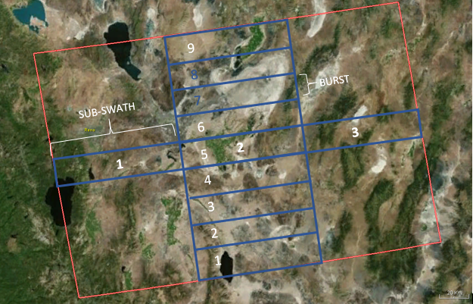
Figure 1. IW SLC Bursts andSub-Swaths

Analysis are applied on Single Look Complex (SLC) Interferometric Wide (IW) C-band of SAR 1A images. Deformation analysis was performed specifically in the VV polarization due to having better result than HH polarization (Vaka, Sharma and Rao, 2017) and achieved millimeter-level accuracy. Specifically, 7 and 8 burst of 2nd sub-swath has been used for AOI. Since phase contribution of the SAR is more suitable for slow motion displacement and for PSI technique phase values have been used instead of amplitude. The data was downloaded from the web site for 2019, for both the ascending and descending geometries in different orbital files. Because of the availability of the data, it is possible to use more images to analyze the deformation of the site in higher accuracy, this allowed us also to use the PSI algorithms. We downloaded 18 ascending 64 orbit geometry and 15 descending 144 orbit SAR images, and then used for PSI analysis. One pair of images has been selected on these two geometry data for DInSAR analysis, in addition. The orbital file and DEM creation for related data have been downloaded online while processing data. Table 1 shows the set of SAR data which is used for PSI and DInSAR analysis techniques.
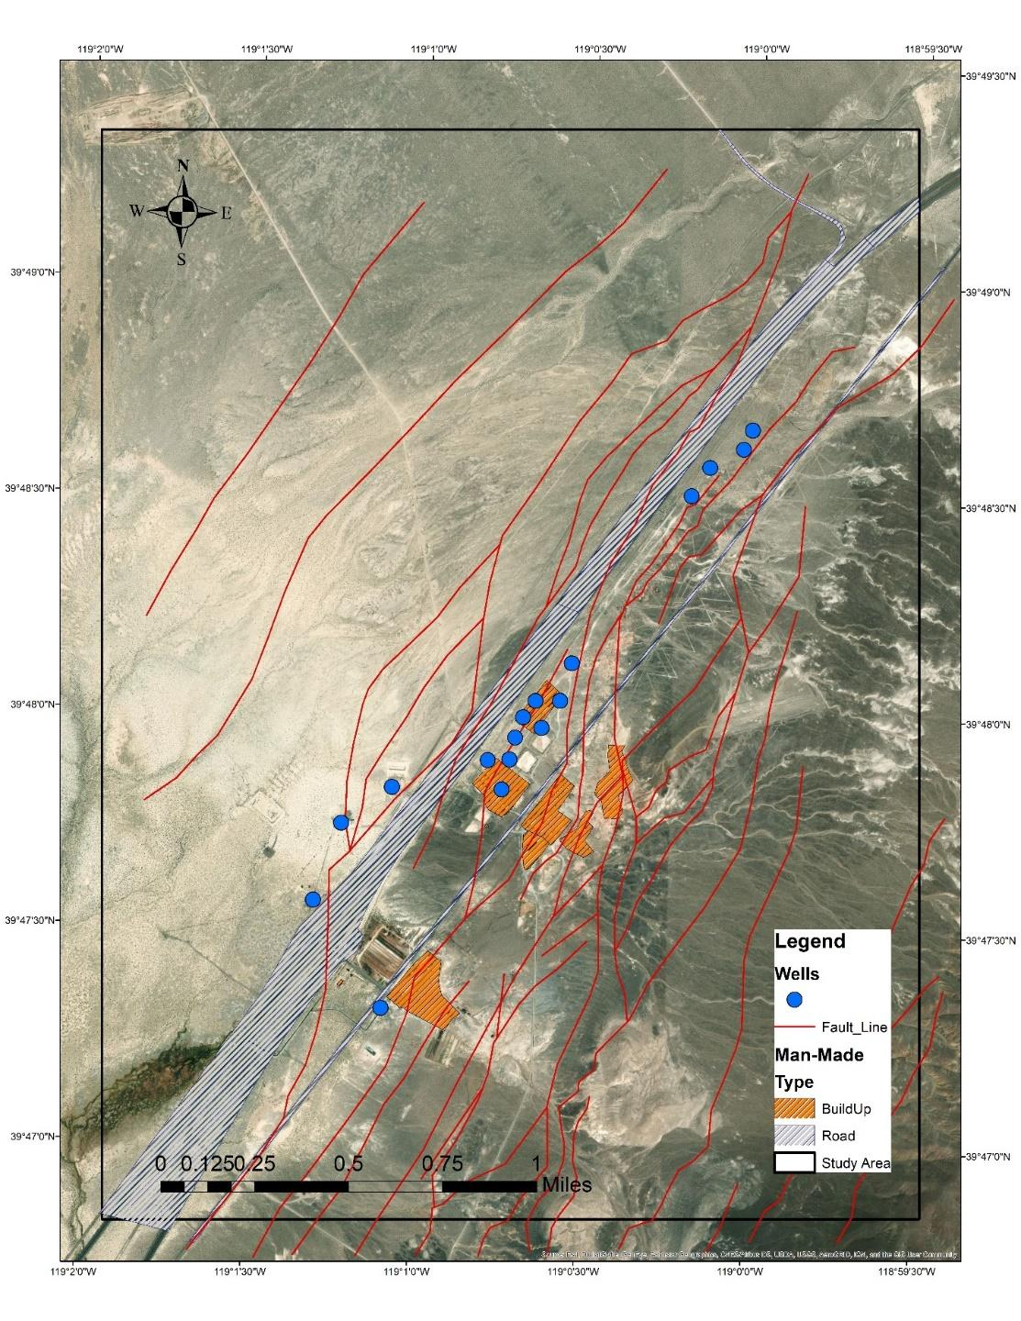
Figure 2. Brady Hot Spring Geothermals Study Area

Table 1. Dataset used for DInSAR and PSI Analysis
Time Series | Period  (yyyy-mm-dd) | Days | Master Scene Acquisition Date  (yyyy-mm-dd) | Track | Pass | Number of Images
A | 2019-07-09 TO 2019-12-24 | 168 |  | 144 | Descending | 15
B | 2019-04-11 TO 2019-10-18 | 190 |  | 64 | Ascending | 18
C | 2017-02-01 TO 2019-12-24 | 1056 |  | 144 | Descending | 59
D | 2019-07-09 AND 2019-12-24 | 168 | 2019-07-09 | 144 | Descending | 2
E | 2019-04-11 AND 2019-10-18 | 190 | 2019-04-11 | 64 | Ascending | 2

To understand the effects of natural and human activities and their negative effect on nature, various type of algorithms with different reliability/performance and advantages/disadvantages have been applied for different cases. The area and the type of the field, the quality of the data and the required analysis define the algorithm which should be applied on site.
InSAR (Interferometric Synthetic Aperture Radar) is one of the basic algorithms that is applied to two SAR data at different times in order to measure the phase difference. DInSAR is an advanced type of InSAR algorithm, which is suited for long term and slow surface deformation analysis (Rodriguez et al., 1992, Carnec et al., 1996). PSI is a more advanced and reliable algorithm, but requires more images to provide reliable and accurate results.
DInSAR was applied on the 2014 data, since there is a limited number of datapoints for this year. The main methodology applied for analysis is shown in Figure 3.
For 2019, because of the availability of the data, it is possible to use more images to analyze the deformation of the site in higher accuracy, this allowed us to use the PSI algorithms. We downloaded 15 ascending geometry SAR images, and them used for PSI analysis. Deformation analysis was performed in the vertical direction and achieved millimeter-level accuracy. The main methodology applied for analysis is shown in Figure 4.

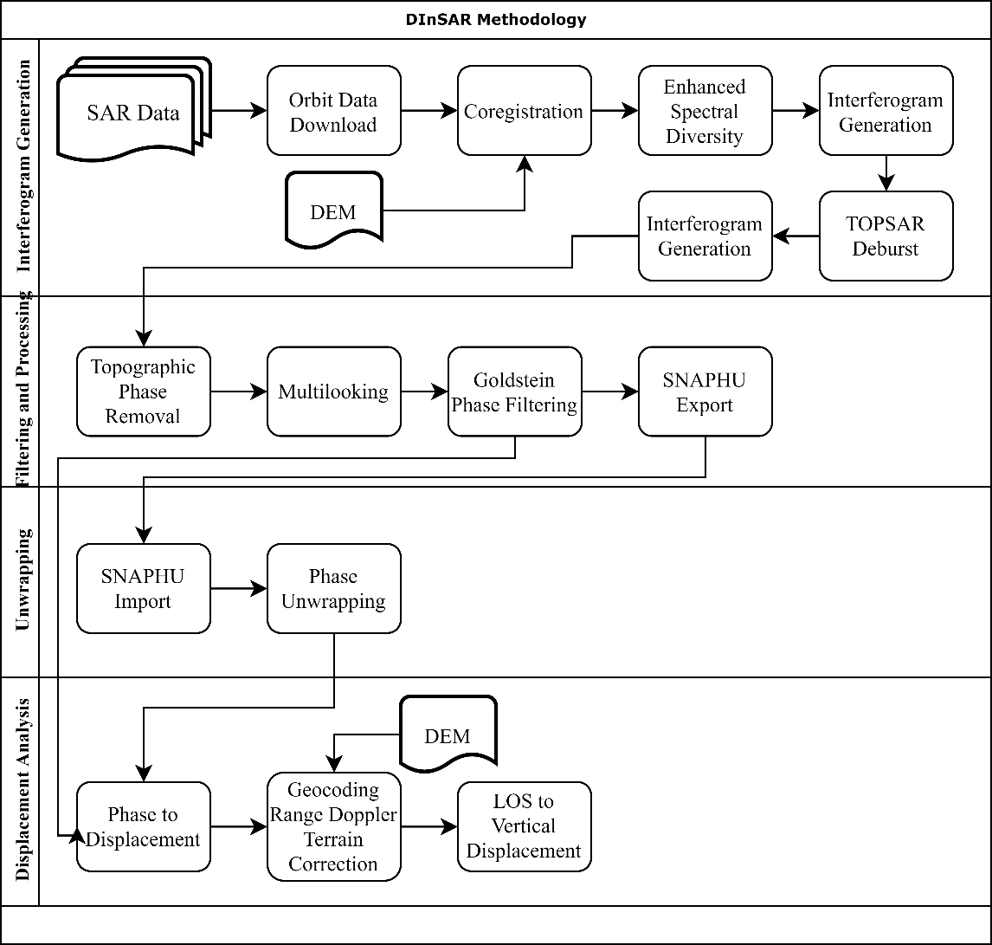
Figure 3. DInSAR Methodology Applied for Deformation Analysis for Brady
The method of DInSAR can be divided in four main parts:
- Data Preparation and Interferogram Generation
- Filtering and Processing
- Unwrapping of Interferograms
- Displacement Calculation and Visualization

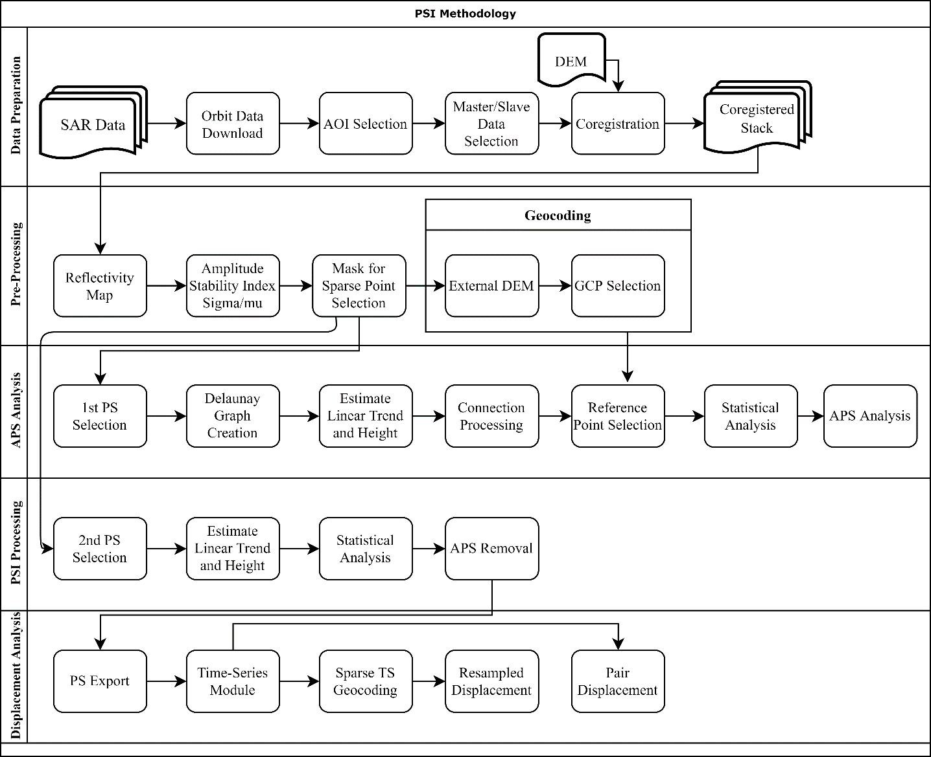
Figure 4. PSI Methodology Applied for Deformation Analysis for Brady

The main methodology applied for PSI which is shown in Figure 4 is more advanced techniques than DInSAR with respect to reliability and accuracy. PSI methodology use the idea of the PSInSAR^{©TM} which is explained by Feretti et al. (2001).
The method of PSI can be divided in five main parts:
- Data Preparation
- Pre-Processing and Coregistration
- APS Analysis
- PSI Analysis

Results
Displacement occurred in geothermal sites has already been analysed by using InSAR techniques recently, the number of the researchers have not been enough to understand the nature of the deformation (uplift/subsidence). Also, it is essential to use these techniques for the analysis of geothermal for maturity of the techniques especially in these type of areas. Brady Geothermal site have been researched by several scientists (Ali et al., 2016; Mellors et al., 2018; Reinisch, Cardiff and Feigl, 2018) recently by using similar techniques and data recently. In this section, we will explain and discuss the result of DInSAR and PSI in more detail. In addition to that, we will compare the results with former researches. DInSAR is the initial technique that was used to see the result of deformation on site in a rough manner. Figure 5 shows the result of DInSAR technique.
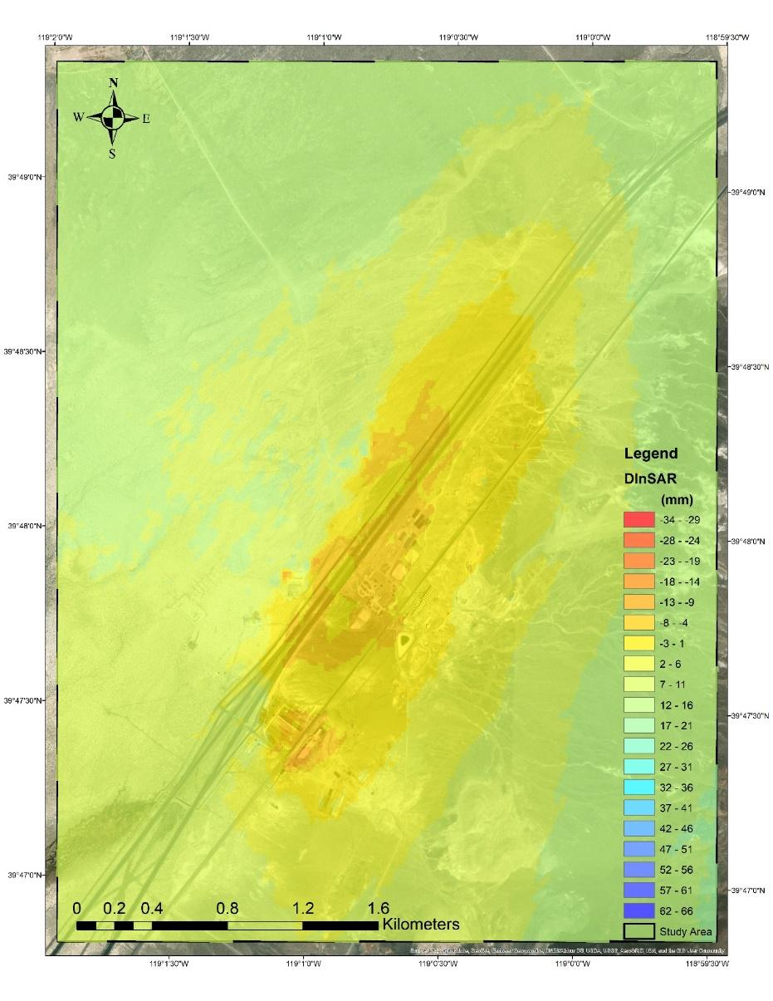
Figure 5. DInSAR Analysis Result for Brady Site
In Figure 5, the average deformation is 9 mm/yr; min deformation is 21 mm/yr and max deformation is -13 mm. However, it is between -1 - -13 mm/yr specifically for the geothermal site.
The PSI technique has been used for the same data with higher temporal data for comparison and verification. In order to verify and see the difference of the number of images used for PSI, we have used same parameters with the 15 images taken in 2019 and 59 images for the same area taken from 2017 to 2019.
Figure 6 shows the result of PSI technique applied for 15 images taken 2019 for Brady site.
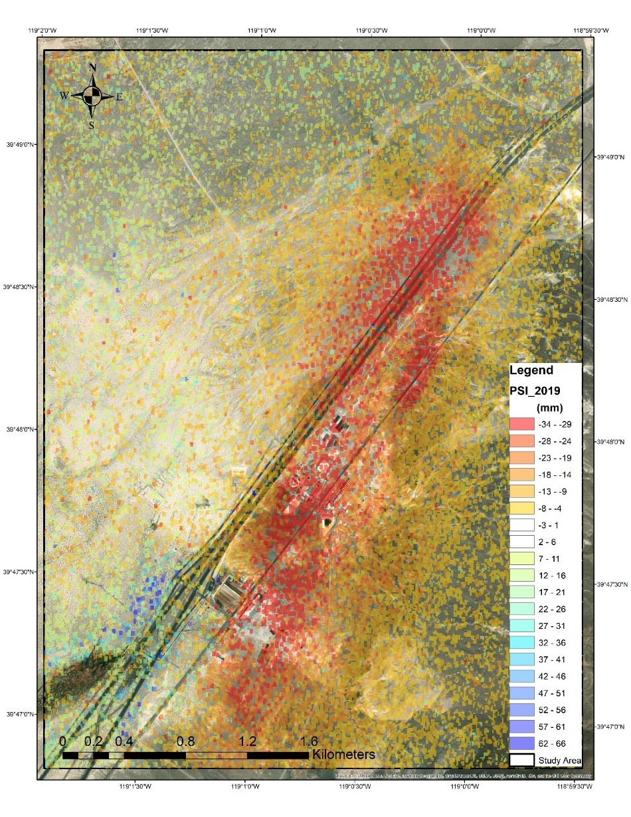
Figure 6. PSI Analysis for Bradys’ site with 15 images.
In Figure 6, the average deformation is -5 mm/yr; min deformation is 40 mm/yr and max deformation is -50 mm. However, it is between -14 - -40 mm/yr specifically for the geothermal site.
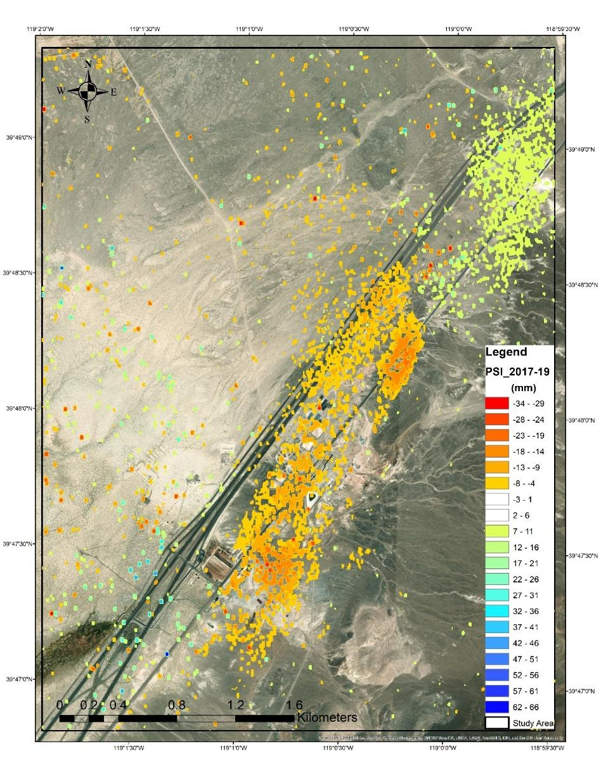
Figure 7. PSI Analysis for Bradys’ site with 59 images.

In Figure 7, the average deformation is 5 mm/yr; min deformation is -34 mm/yr and max deformation is 61 mm. However, it is between -4 - -19 mm/yr sepecifacally for the geothermal site.

In Figure 8, the blue color indicates the subsidence, the red color indicates the uplift, and the yellow color indicates no changes. From the map, it is clear that the subsidence of the field is mostly between 20-40, mm and there are really a small number of pixels in red color indicating uplifting in the site.

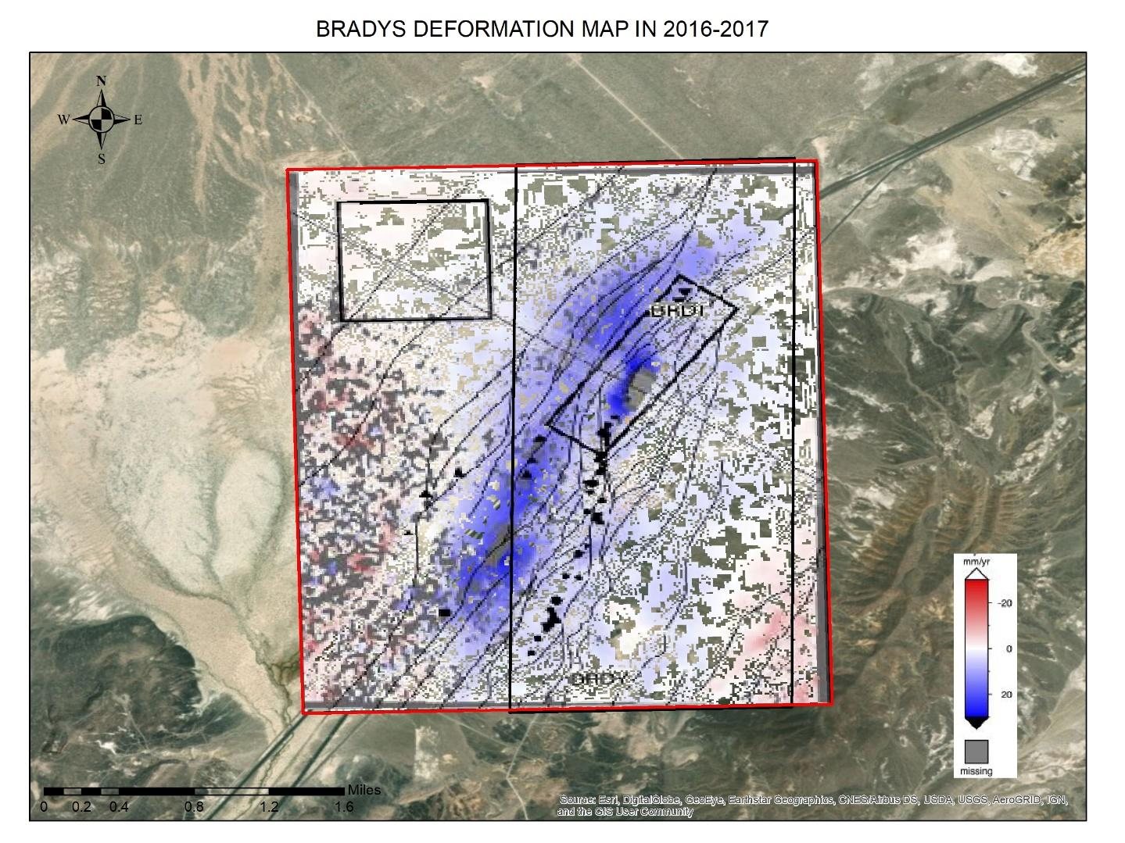
Figure 8. Deformation Analysis for Bradys’ for 2016-2017.
This analysis was also applied to the data between July 2016 and August 2017, and the results can be seen in Figure 8. Once again, blue color indicates subsidence and red color indicates uplifting. The range for the deformation is between -40 – 40 mm.

To compare these two analysis results in orintetation, direction and size, both analyses are shown in Figure 9, but in different colors.

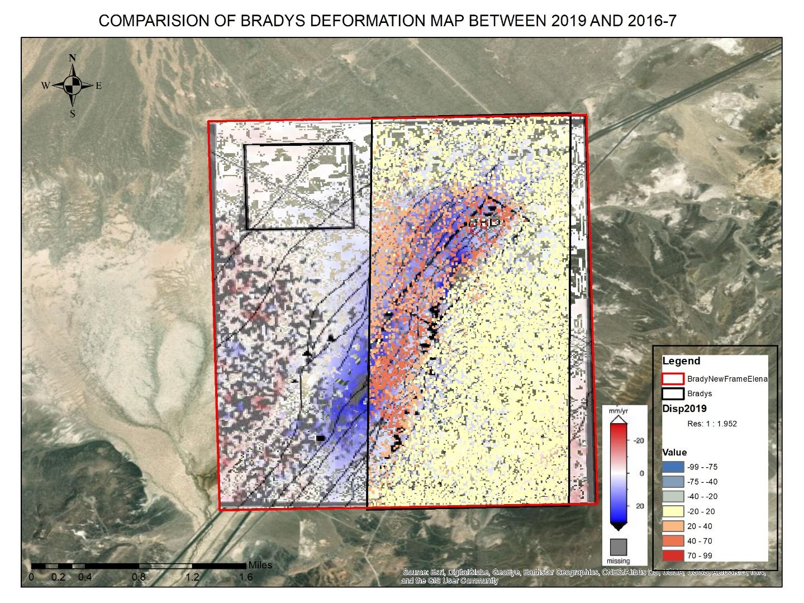
Figure 9. Comparison of 2016-7 and 2019 Analysis for Bradys.
As stated above, the direction of both analyses is NNE as expected. The deformation size may change for various reasons for different years. The average deformation in 2016-7 (Reinisch et al., 2015) is 9.9 ± 3.3 mm/yr but it is 9 mm/yr in DInSAR, -5 mm/yr in PSI and 5 mm/yr in PSI on merge data. We can say that even if the results promise the mm accuracy, it has ± 5-10 mm error tolerance in his type of analysis. Analysis should be verified from ground truth and validated with this way. The analysis carried out in 2016-17 were verified by 2 different methods other than SAR image analysis. Even the deformation is 9.9 ± 3.3 mm/yr in SAR analysis, it is 13.5 ± 2.9 mm/yr in GPS techniques, and it is 3.6 ± 4.4 mm/yr in DIFF technique. This verification reveals that there is an error tolerance in this type of analysis. In our SAR displacement analysis is between ± 5.0 mm/yr .
Table 2. Comparison range change values estimated from GPS and observed by InSAR (Reinisch et al., 2015).
As a result, the deformation analysis of 2019 and merge of 2017-2019 are satisfactory and the result is supported by two different types of research carried out by different scientists, even if both analyses were carried out using two different algorithms and tools. Also, the result was improved by using different techniques and different number of images with different parameters indicating the success of the analysis and techniques.

REFERENCES
Ali, S. T., Davatzes, N. C., Feigl, K. L., Wang, H. F., Foxall, W., Mellors, R. J., & Akerley, J. (2015). Deformation at Brady Hot Springs geothermal field measured by time series analysis of InSAR data. Proceedings of the Fourtieth Workshop on Geothermal Reservoir Engineering, 1–5.
Carnec, C., Delacourt, C., 2000. Three years of mining subsidence monitored by SAR interferometry, near Gardanne, France. Journal of Applied Geophysics 43, 43–54.
Reinisch, E. C., Cardiff, M., & Feigl, K. L. (2018). Characterizing volumetric strain at Brady Hot Springs, Nevada, USA using geodetic data, numerical models and prior information. Geophysical Journal International, 215(2), 1501–1513. https://doi.org/10.1093/GJI/GGY347
Rodriguez, E. and J. Martin, 1992. Theory and design of interferometric synthetic aperture radars. IEE Proceedings F (Radar and Signal Processing), IET.
Ali, S. T. et al. (2016) ‘Time-series analysis of surface deformation at Brady Hot Springs geothermal field (Nevada) using interferometric synthetic aperture radar’, Geothermics. CNR-Istituto di Geoscienze e Georisorse, 61, pp. 114–120. doi: 10.1016/j.geothermics.2016.01.008.
Andrianaivo, L. (2015) ‘Relations between drainage pattern and fracture trend in the Itasy geothermal Relations between drainage pattern and fracture trend in the Itasy geothermal prospect , central Madagascar’, (July).
Berardino, P. et al. (2002) ‘A New Algorithm for Surface Deformation Monitoring Based on Small Baseline Differential SAR Interferograms’, 40(11), pp. 2375–2383.
Cigna, F. et al. (2019) ‘Wide-area InSAR survey of surface deformation in urban areas and geothermal fields in the eastern Trans-Mexican Volcanic Belt, Mexico’, Remote Sensing, 11(20), pp. 1–33. doi: 10.3390/rs11202341.
Crosetto, M. et al. (2005) ‘State-of-the-art of Land DeformationMonitoring using Differential SAR Interferometry’, Proceedings of the ISPRS Workshop 2005, pp. 1–12. doi: 10.1021/la201273x.
Fárová, K. et al. (2019) ‘Klárov 3, 118 21 Prague 1, Czech Republic; jan.jelenek@geology.cz’, Czech Geological Survey, pp. 1–23. doi: 10.3390/rs11222670.
Ferretti, A., Prati, C. and Rocca, F. (2001) ‘Permanent scatterers in SAR interferometry’, IEEE Transactions on Geoscience and Remote Sensing, 39(1), pp. 8–20. doi: 10.1109/36.898661.
Heimlich, C. et al. (2015) ‘Uplift around the geothermal power plant of Landau (Germany) as observed by InSAR monitoring’, Geothermal Energy. Geothermal Energy, 3(1), pp. 1–12. doi: 10.1186/s40517-014-0024-y.
Hooper, A., Segall, P. and Zebker, H. (2007) ‘Persistent scatterer interferometric synthetic aperture radar for crustal deformation analysis, with application to Volcán Alcedo, Galápagos’, Journal of Geophysical Research: Solid Earth, 112(7), pp. 1–21. doi: 10.1029/2006JB004763.
Mellors, R. J. et al. (2018) ‘New Potential of InSAR for Geothermal Systems’, 43rd Workshop on Geothermal Reservoir Engineering, pp. 1–4.
Nouban, F. and Abazid, M. (2017) ‘Plastic degrading fungi Trichoderma viride and Aspergillus nomius isolated fromNouban, F. and Abazid, M. (2017) “Plastic degrading fungi Trichoderma viride and Aspergillus nomius isolated from local landfill soil in Medan”, Iopscience.Iop.Org, 8(February ’, Iopscience.Iop.Org, 8(February 2018), pp. 68–74. doi: 10.1088/1755-1315.
Perissin, D., Wang, Z. and Wang, T. (2011) ‘The SARPROZ InSAR tool for urban subsidence/manmade structure stability monitoring in China’, 34th International Symposium on Remote Sensing of Environment - The GEOSS Era: Towards Operational Environmental Monitoring, (October).
Raspini, F. et al. (2015) ‘Exploitation of Amplitude and Phase of Satellite SAR Images for Landslide Mapping: The Case of Montescaglioso (South Italy)’, (November). doi: 10.3390/rs71114576.
Singh Virk, A., Singh, A. and Mittal, S. K. (2018) ‘Advanced MT-InSAR Landslide Monitoring: Methods and Trends’, Journal of Remote Sensing & GIS, 07(01), pp. 1–6. doi: 10.4172/2469-4134.1000225.
Strozzi, T. et al. (2000) ‘Monitoring Land Subsidence in the Euganean Geothermal Basin with Differential SAR Interferometry’, European Space Agency, (Special Publication) ESA SP, (478), pp. 167–176.
Vaka, D. S., Sharma, S. and Rao, Y. S. (2017) ‘Comparison of HH and VV Polarizations for Deformation Estimation using Persistent Scatterer Interferometry’, 38th Asian Conference on Remote Sensing - Space Applications: Touching Human Lives, ACRS 2017, 2017-Octob(October).

