The following design can be applied for three sites Brady’s, DP and SS. There are mainly three types of data which are raster, vector, and field data. The database design is created with respect to these three types of data. For the Raster type of data Raster Catalog will created and 6 types of the raster data classes are created under this raster catalog. For the vector type of data, Feature Dataset is created again for these 6 classes of vector data. Finally, for the table type of data or field data, Table type of top folder is created. Table 1 shows these three types of data in the geodatabase.
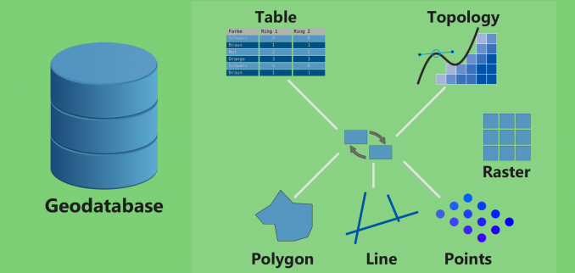
Table 1. Type of Data in Geodatabase.

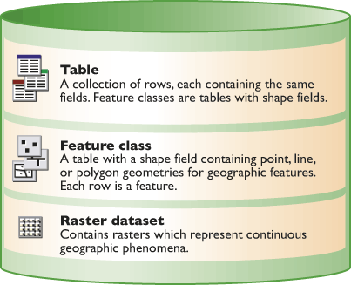
Table 2. Types of data for geodatabase.
As indicated above, Table, Feature class and Raster Dataset are the main types of geodatabase. On the root folder of this geodatabase, there will be three main folders, one for each site: Brady, Desert Peak and Salton Sea. The topmost folder is the DOE folder including these three folders.

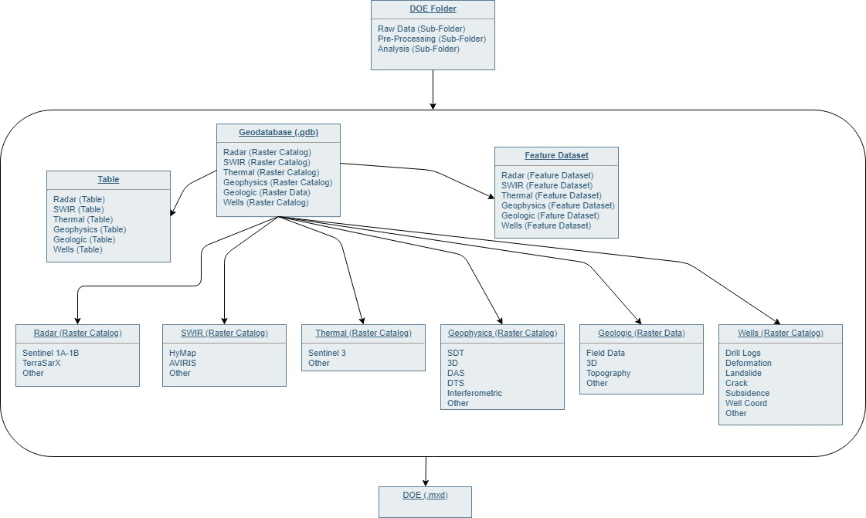
Figure 1. Geodatabase Design for DOE Project.

Topmost folder is DOE Folder. Under this folder, Data, Pre-processing and Analysis sub-folders are created. The design for these three folders is shown in Figure 1. Under the topmost folder, Geodatabase (.gdb) is the root file of its type. Table Feature Dataset is one class of the geodatabase. Other than these two types, six additional types of Raster Catalog (Radar, SWIR, Thermal, Geophysics, Geology and Wells) are created. All these geodatabases are saved as DOE (mxd) Project.
Initially, we can build 3 top folders for each site, creating a geodatabase for each site later. The lowest level for the sites can be layer. After the analysis, we can provide the data and analysis as a server-driven database.
For that we need
- Main computer
- 20 TB space (at least)
- Username/password for each user in central computer
BradysData(Folder) ---- in a local computer or external harddrive
- RadarTerraSarX (Raster Catalog)
- RadarSentinell1 (Raster Catalog)
- RadarOther (Raster Catalog)
- SWIRHyMap (Raster Catalog)
- SWIRAVIRIS (Raster Catalog)
- SWIRSEBASS (Raster Catalog)
- SWIROther (Raster Catalog)
- Geology1/12000wc (Raster Catalog)
- Geology 1/24000wc (Raster Catalog)
- Geology1/10000ws (Raster Catalog)
- Geology Other (Raster Catalog)
- GeophyscialSDT (Raster Catalog)
- GeophyscialDAS (Raster Catalog)
- GeophyscialDTS (Raster Catalog)
- GeophyscialInterferometric (Raster Catalog)
- GeophyscialOther (Raster Catalog)
- WellDataDrill_Logs (Raster Catalog)
- WellDataDeformations (Raster Catalog)
- WellDataOther (Raster Catalog)
- ThermalData (raster catalog)
- Other (Raster Catalog)

- FeatureDataSet for Vector Data
  - Point
  - Line
  - Polygon
- Table
  - Field
  - Other

