LAND SURFACE TEMPARATURE | Abstract  Land surface temperature (LST) is one of the important indicators for geothermal site exploration. For that reason, we have used Sentinel 3, Aster and Landsat 8 data and RX algorithm of anomaly detection. Then, we develop a unique methodology to find a pattern indicating geothermal site. Time-series analysis with K-Means algorithm shows a pattern due to geothermal activities.  10/24/2020

Contents
1. INTORDUCTION 1
2. DATA 2
2.1. Sentinel 3 Data 2
2.2. Aster Data 4
2.3. Landsat 8 Data 6
2.3.1. Brady and Desert Peak Landsat Data 6
2.3.2. Salton Sea Landsat Data 10
3. METHODOLOGY 12
a. Sentinel and Aster Data Analysis Methodology 12
b. Landsat Data Analysis Methodology 13
c. Pattern Recognition Method by Using K-Means Algorithm 14
4. RESULTS 15
4.1. LST for Brady 16
4.2. LST for Desert Peak 22
4.3. LST for Salton Sea 26
5. CONCLUSION 29
REFERENCES 30

- INTORDUCTION
Land Surface Temperature (LST) is one of the indicators that is selected as input for Artificial Intelligence (AI) algorithm. We planned to use anomaly detection algorithms (R and kernel R) to detect anomalies in both the hyperspectral data and the geophysical and geological data sets. This will reveal possible relations between the detected anomalies in the image data cubes and geological and geophysical data sets. However, the fumerals size on the geothermal site is mostly in several meters. Therefore, the spatial resolution of the raw data for LST is critical and important for successful analysis.
For this purpose, we use RX anomaly detection algorithm on Sentinel 3, Aster and Landsat satellite images.

- DATA
As it was mentioned above, the spatial resolution of data is important for anomaly detection algorithm. Therefore, we started to search available free and high spatial resolution satellite images for this purpose. We have found three different data available as free. These are Sentinel 3, Aster and Landsat 8 satellite images. We use all these three types of images for anomaly detection and LST analysis. All analysis results have been resampled to 3x3 m resolution in order to be consistent and use them as input for SOM, SVM and AI algorithms. In the following section, we explain these analyses in detail.

  - Sentinel 3 Data
Sentinel 3 data is for measuring surface topography, sea and land surface temperature and ocean and land surface color for forecasting systems, environmental monitoring and climate monitoring. Figure 1 shows the structure and main instruments carried by Sentinel 3. Since it is for sea and land surface temperature, we used SLSTR instrument data for LST analysis (Sentinel.esa.int). We use 10/24/2019 and 09/27/2019 date of Sentinel 3 data for LST analysis.

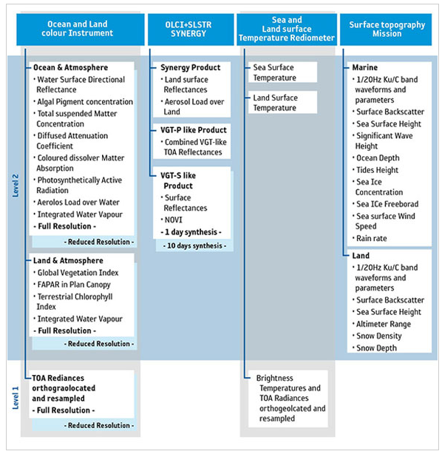
Figure 1. SENTINEL-3 Products Structure (Credit: ESA) (Sentinel.esa.int).

Table 1 shows the main characteristics of the SLSTR data in more detail.
Table 1. The main characteristics of the SLSTR (Sentinel.esa.int).
Name | Specification
Swath width | dual view scan, 1 420 km (nadir) / 750 km (backwards)
Spatial sampling | 500 m (VIS, SWIR), 1 km (MWIR, TIR)
Spectrum | nine bands [0.55-12] µm
Noise equivalent dT | 50 m K (TIR) at 270 K
Data Link | https://scihub.copernicus.eu/dhus/#/home

Table 1 indicates the spatial resolution of the data which is 500 m. We downloaded Sentinel data from the link provided in this table.

  - Aster Data
This is another data that is used for LST analysis. The methodology which is used for different data is clearly different. shows the specification of the Aster data which is used in the project. We use 04/28/2019 and 02/08/2019 date of Aster data for LST analysis. Table 2 shows some features of the Aster data.
Table 2. Aster Data Specification (ASTER Satellite Sensor Specifications | Satellite Imaging Corp, 2020).
Instrument | VNIR | SWIR | TIR
Bands | 1-3 | 4-9 | 10-14
Spatial Resolution | 15m | 30m | 90m
Swath Width | 60km | 60km | 60km
Cross Track Pointing | ± 318km (± 24 deg) | ± 116km (± 8.55 deg) | ± 116km (± 8.55 deg)
Quantization (bits) | 8 | 8 | 12
Download Link | https://search.earthdata.nasa.gov/search?q=C1299783630-LPDAAC_ECS
ASTER has 14 bands of information and Table 3 shows the detail information about these bands.
Table 3. Aster Bands Information ((Fujisada, 1995; Yamaguchi et al., 1999)
Band | Label | Wavelength | Resolution | Nadir or | Description
 |  | (µm) | (m) | Backward
B1 | VNIR_Band1 | 0.520 - 0.60 | 15 | Nadir | Visible green/yellow
B2 | VNIR_Band2 | 0.630 - 0.690 | 15 | Nadir | Visible red
B3N | VNIR_Band3N | 0.760–0.860 | 15 | Nadir | Near infrared
B3B | VNIR_Band3B | 0.760–0.860 | 15 | Backward
B4 | SWIR_Band4 | 1.600–1.700 | 30 | Nadir | Short-wave infrared
B5 | SWIR_Band5 | 2.145–2.185 | 30 | Nadir
B6 | SWIR_Band6 | 2.185–2.225 | 30 | Nadir
B7 | SWIR_Band7 | 2.235–2.285 | 30 | Nadir
B8 | SWIR_Band8 | 2.295–2.365 | 30 | Nadir
B9 | SWIR_Band9 | 2.360–2.430 | 30 | Nadir
B10 | TIR_Band10 | 8.125–8.475 | 90 | Nadir | Long-wave infrared  or thermal IR
B11 | TIR_Band11 | 8.475–8.825 | 90 | Nadir
B12 | TIR_Band12 | 8.925–9.275 | 90 | Nadir
B13 | TIR_Band13 | 10.250–10.950 | 90 | Nadir
B14 | TIR_Band14 | 10.950–11.650 | 90 | Nadir

The ASTER instrument consists of three separate instrument subsystems:
VNIR (Visible Near Infrared), a backward-looking telescope which is only used to acquire a stereo pair image
SWIR (Shortwave Infrared), a single field aspheric refracting telescope
TIR (Thermal Infrared)

  - Landsat 8 Data
Landsat 8 was launched on 11/02/2013 which is the called Landsat Data Continuity Mission (LDCM). NASA and the United States Geological Survey (USGS) has been managing and controlling the satellite and products together (Landsat 8, 2020). The thermal bands are band 10 and band 11 in Landsat 8 products (Table 11). Therefore, we used these bands for LST analysis and anomaly detection. The data that we use from Landsat is between 02/14/2019 and 11/29/2019.
    - Brady and Desert Peak Landsat Data
We downloaded 86 images for Brady and Desert Peak from websites, however, many of them are useless because they are composed from patch. The patch type of images does not cover the whole Area of Interest (AIO) in the geothermal site. Therefore, the patch type of images has been removed from the analysis stack. We used 25 of the data which covers the area given in Table 4. Then, we statistically analyzed the data stack and eliminate the outlier from the stack as shown in Table 5. The images whose maximum temperature under the zero Celsius degrees has been eliminated from the stack. Also, images whose standard deviation higher than 4 have been eliminated from the stack. The last threshold is about the range of the data itself. If the range is lower than 10 is also another threshold to remove the data from the stack. We keep the data for further analysis with respect to those thresholds mentioned above. The yellow colored row has been removed from the stack for further analysis.
Table 4. Landsat data stack used for LST analysis for Brady.
Landsat Image Dates
LST_20191129_20191218.tif | LST_20190622_20190707.tif
LST_20191120_20191204.tif | LST_20190613_20190621.tif
LST_20191113_20191204.tif | LST_20190606_20190621.tif
LST_20191028_20191116.tif | LST_20190528_20190607.tif
LST_20191019_20191103.tif | LST_20190521_20190607.tif
LST_20191012_20191020.tif | LST_20190505_20190523.tif
LST_20191003_20191020.tif | LST_20190419_20190612.tif
LST_20190926_20191022.tif | LST_20190410_20190612.tif
LST_20190917_20191001.tif | LST_20190403_20190612.tif
LST_20190910_20190919.tif | LST_20190325_20190613.tif
LST_20190901_20190919.tif | LST_20190318_20190613.tif
LST_20190629_20190707.tif | LST_20190214_20190613.tif
LST_20190825_20190905.tif

Table 5. Brady Landsat Data Stack after First Threshold.
Date | Avg | Min | Max | Stddev | Range | Keep
191129 | -28.9 | -38.6 | -21.8 | 3.57 | 16.8 | FALSE
191120 | -13.3 | -15.3 | -9.7 | 1.03 | 5.6 | FALSE
191113 | 24.6 | 20.1 | 27 | 0.89 | 6.9 | TRUE
191028 | -4 | -17 | 11.7 | 7.02 | 28.7 | FALSE
191019 | 23.1 | 16 | 26.7 | 1.66 | 10.7 | TRUE
191012 | 31.4 | 26.2 | 33.8 | 0.95 | 7.6 | TRUE
191003 | 34.8 | 27.4 | 37.5 | 1.07 | 10.1 | TRUE
190926 | 43.9 | 38.3 | 45.8 | 1.04 | 7.6 | TRUE
190917 | 37.8 | 32.4 | 40.4 | 1.08 | 8 | TRUE
190910 | 27.2 | 1 | 40.5 | 9.63 | 39.6 | FALSE
190901 | 52.7 | 46.1 | 54.9 | 1.06 | 8.8 | TRUE
190825 | 54.1 | 48.5 | 56.5 | 0.97 | 8 | TRUE
190629 | 34.7 | 18.1 | 46.8 | 5.74 | 28.7 | FALSE
190622 | 48.2 | 42 | 51.1 | 1.3 | 9.2 | TRUE
190613 | 56.3 | 50.9 | 58.8 | 1.1 | 7.9 | TRUE
190606 | 36.7 | 25.8 | 42.7 | 2.94 | 17 | TRUE
190528 | 1.2 | -6.3 | 21.3 | 7.59 | 27.6 | FALSE
190521 | -26.6 | -33.5 | -15.4 | 3.49 | 18.1 | FALSE
190505 | 47.8 | 42.2 | 50.4 | 1.1 | 8.2 | TRUE
190419 | 36.7 | 27.3 | 43.3 | 3.69 | 16 | TRUE
190410 | 27.8 | 17.5 | 32.1 | 2.39 | 14.7 | TRUE
190403 | 23.3 | 11 | 26 | 1.52 | 15 | TRUE
190325 | -26 | -41.4 | -12.1 | 8.04 | 29.3 | FALSE
190318 | 29 | 23.8 | 31.7 | 1.05 | 7.9 | TRUE
190214 | -46.6 | -48.1 | -44.9 | 0.6 | 3.2 | FALSE

Table 6 shows the final list after final threshold applied on the list shown in Table 5. We apply the similar statistical analysis to get the final stack of images for LST analysis. In the “Keep” column, “FALSE” labelled data row has been removed from the stack. The threshold is as follow;
- Eliminated images that were too cool (below 0°C maximum Temp)
- Eliminated images with temperature ranges above 1 standard dev
- Range >= 5 (at least 1°C span for each cluster)

Table 6. Brady Landsat Data Stack after Final Threshold.
Date | Avg | Min | Max | Stddev | Range
191113 | 24.6 | 20.08 | 26.96 | 0.89 | 6.88
191019 | 23.08 | 16.03 | 26.72 | 1.66 | 10.69
191012 | 31.44 | 26.18 | 33.79 | 0.95 | 7.6
191003 | 34.81 | 27.41 | 37.54 | 1.07 | 10.13
190926 | 43.91 | 38.29 | 45.84 | 1.04 | 7.55
190917 | 37.78 | 32.42 | 40.44 | 1.08 | 8.02
190901 | 52.68 | 46.11 | 54.94 | 1.06 | 8.83
190825 | 54.11 | 48.54 | 56.51 | 0.97 | 7.97
190622 | 48.25 | 41.97 | 51.15 | 1.3 | 9.18
190613 | 56.33 | 50.9 | 58.84 | 1.1 | 7.95
190606 | 36.72 | 25.75 | 42.72 | 2.94 | 16.97
190505 | 47.81 | 42.23 | 50.45 | 1.1 | 8.21
190419 | 36.73 | 27.27 | 43.31 | 3.69 | 16.04
190410 | 27.81 | 17.47 | 32.14 | 2.39 | 14.67
190403 | 23.31 | 10.95 | 25.98 | 1.52 | 15.03
190318 | 29.02 | 23.81 | 31.7 | 1.05 | 7.89

Table 8 shows the final list after final threshold applied on the list shown in Table 7. We apply the similar statistical analysis to get the final stack of images for LST analysis. In the “Keep” column, “FALSE” labelled data row has been removed from the stack. The threshold is as follow;
- Eliminated images that were too cool (below 0°C maximum Temp)
- Eliminated of Std Dev > 8
- Range <= 10 (none)

Table 7. Desert Peak Landsat Initial Data Stack after First Threshold.
Date | Avg | Min | Max | Stddev | Range | Keep
190214 | -45.1346 | -50.25 | -19.95 | 2.878997 | 30.3 | FALSE
190318 | 29.7306 | 12.55 | 41.75 | 3.135376 | 29.2 | TRUE
190325 | -20.4935 | -48.35 | 11.85 | 10.9902 | 60.2 | FALSE
190403 | 12.11416 | -14.75 | 33.25 | 11.40722 | 48 | FALSE
190410 | 27.36176 | -10.05 | 39.25 | 4.625651 | 49.3 | TRUE
190419 | 31.15613 | -24.65 | 48.35 | 12.64876 | 73 | FALSE
190505 | 47.11331 | 11.85 | 54.95 | 3.993649 | 43.1 | TRUE
190521 | -14.8732 | -38.45 | 32.05 | 14.46359 | 70.5 | FALSE
190528 | -0.69023 | -8.65 | 33.65 | 8.332927 | 42.3 | FALSE
190606 | 24.60728 | -21.95 | 47.85 | 10.72584 | 69.8 | FALSE
190622 | 47.46842 | 24.25 | 55.85 | 3.658751 | 31.6 | TRUE
190629 | 34.26864 | -28.55 | 57.65 | 16.28032 | 86.2 | FALSE
190825 | 53.35107 | 34.45 | 62.55 | 2.97631 | 28.1 | TRUE
190901 | 52.1608 | 30.95 | 60.55 | 2.988482 | 29.6 | TRUE
190910 | 24.90426 | -11.05 | 44.15 | 15.3072 | 55.2 | FALSE
190917 | 37.25789 | 19.95 | 47.15 | 2.82565 | 27.2 | TRUE
190926 | 43.32593 | 26.05 | 54.55 | 3.066057 | 28.5 | TRUE
191003 | 31.60558 | -8.35 | 45.15 | 5.243985 | 53.5 | TRUE
191012 | 31.00423 | 12.85 | 44.15 | 2.910906 | 31.3 | TRUE
191019 | 7.234144 | -58.15 | 28.05 | 19.31602 | 86.2 | FALSE
191028 | 5.707581 | -32.65 | 27.35 | 11.88319 | 60 | FALSE
191113 | 24.3494 | 8.75 | 37.05 | 2.625378 | 28.3 | TRUE
191120 | -10.8589 | -23.05 | 7.95 | 4.68465 | 31 | TRUE
191129 | -25.1626 | -42.35 | 5.65 | 9.026914 | 48 | FALSE
191004 | 23.1606 | -6.75 | 38.95 | 9.31964 | 45.7 | FALSE

Table 8 shows the final data stack after first threshold. We apply K-Means clustering algorithm on this stack of images. After these thresholds, we use 12 images for further analysis.
Table 8. Desert Peak Landsat Data Stack after Final Threshold.
Date | Avg | Min | Max | Stddev | Range
190318 | 29.7306 | 12.55 | 41.75 | 3.135376 | 29.2
190410 | 27.36176 | -10.05 | 39.25 | 4.625651 | 49.3
190505 | 47.11331 | 11.85 | 54.95 | 3.993649 | 43.1
190622 | 47.46842 | 24.25 | 55.85 | 3.658751 | 31.6
190825 | 53.35107 | 34.45 | 62.55 | 2.97631 | 28.1
190901 | 52.1608 | 30.95 | 60.55 | 2.988482 | 29.6
190917 | 37.25789 | 19.95 | 47.15 | 2.82565 | 27.2
190926 | 43.32593 | 26.05 | 54.55 | 3.066057 | 28.5
191003 | 31.60558 | -8.35 | 45.15 | 5.243985 | 53.5
191012 | 31.00423 | 12.85 | 44.15 | 2.910906 | 31.3
191113 | 24.3494 | 8.75 | 37.05 | 2.625378 | 28.3
191120 | -10.8589 | -23.05 | 7.95 | 4.68465 | 31

    - Salton Sea Landsat Data
We used 21 images for Salton Sea downloaded from websites given in Table 12. The patch type of images does not cover the whole Area of Interest (AIO) in the geothermal site. Therefore, the patch type of images has been removed from the analysis stack. We keep the images after application of the defined filters for further analysis.
Table 10 shows the final list after final threshold applied on the list shown in Table 9. We apply the similar statistical analysis to get the final stack of images for LST analysis. In the “Keep” column, “FALSE” labelled data row has been removed from the stack. The threshold is as follow;
- Eliminated images that were too cool (below 0°C maximum Temp)
- Eliminated of Std Dev > 8
- Range <= 10 (none)
After the final threshold, we used 18 images for further analysis.
Table 9. Initial Stack of Images for Salton Sea After Application of the Filters.
Date | Avg | Min | Max | Stddev | Range | Keep
190108 | 16.21811 | 2.33 | -0.25 | 21.95 | 22.2 | TRUE
190124 | 20.25437 | 3.38 | 12.35 | 28.95 | 16.6 | TRUE
190225 | 24.89596 | 5.09 | 13.95 | 38.15 | 24.2 | TRUE
190313 | 26.34609 | 4.98 | 15.55 | 39.85 | 24.3 | TRUE
190329 | 32.75924 | 5.68 | 20.65 | 47.75 | 27.1 | TRUE
190414 | 13.11683 | 10.2 | -14.15 | 38.65 | 52.8 | FALSE
190430 | 36.96479 | 6.76 | 22.65 | 54.75 | 32.1 | TRUE
190516 | 34.78319 | 5.87 | 23.45 | 49.35 | 25.9 | TRUE
190601 | 38.19536 | 7.16 | 23.45 | 55.35 | 31.9 | TRUE
190617 | 44.38039 | 8.25 | 29.05 | 64.05 | 35 | TRUE
190703 | 45.24123 | 8.22 | 28.05 | 63.75 | 35.7 | TRUE
190719 | 47.92968 | 8.51 | 29.85 | 67.95 | 38.1 | TRUE
190804 | 48.11746 | 10.1 | 21.85 | 69.05 | 47.2 | FALSE
190820 | 47.28685 | 7.97 | 30.85 | 65.55 | 34.7 | TRUE
190905 | 48.12348 | 7.7 | -15.25 | 65.35 | 80.6 | FALSE
190921 | 42.25175 | 7.21 | 25.95 | 57.75 | 31.8 | TRUE
191007 | 38.6551 | 6.04 | 25.05 | 53.35 | 28.3 | TRUE
191023 | 35.78322 | 5.63 | 22.55 | 49.95 | 27.4 | TRUE
191108 | 31.10042 | 4.88 | 19.75 | 43.65 | 23.9 | TRUE
191124 | 22.95963 | 3.93 | -8.25 | 33.65 | 41.9 | TRUE
191210 | 21.21848 | 2.51 | 15.65 | 29.15 | 13.5 | TRUE

Table 10. Salton Sea Landsat Data Stack after Final Threshold.
Date | Avg | Min | Max | Stddev | Range
190108 | 16.21811 | 2.33 | -0.25 | 21.95 | 22.2
190124 | 20.25437 | 3.38 | 12.35 | 28.95 | 16.6
190225 | 24.89596 | 5.09 | 13.95 | 38.15 | 24.2
190313 | 26.34609 | 4.98 | 15.55 | 39.85 | 24.3
190329 | 32.75924 | 5.68 | 20.65 | 47.75 | 27.1
190430 | 36.96479 | 6.76 | 22.65 | 54.75 | 32.1
190516 | 34.78319 | 5.87 | 23.45 | 49.35 | 25.9
190601 | 38.19536 | 7.16 | 23.45 | 55.35 | 31.9
190617 | 44.38039 | 8.25 | 29.05 | 64.05 | 35
190703 | 45.24123 | 8.22 | 28.05 | 63.75 | 35.7
190719 | 47.92968 | 8.51 | 29.85 | 67.95 | 38.1
190820 | 47.28685 | 7.97 | 30.85 | 65.55 | 34.7
190921 | 42.25175 | 7.21 | 25.95 | 57.75 | 31.8
191007 | 38.6551 | 6.04 | 25.05 | 53.35 | 28.3
191023 | 35.78322 | 5.63 | 22.55 | 49.95 | 27.4
191108 | 31.10042 | 4.88 | 19.75 | 43.65 | 23.9
191124 | 22.95963 | 3.93 | -8.25 | 33.65 | 41.9
191210 | 21.21848 | 2.51 | 15.65 | 29.15 | 13.5

Table 11 and Table 12 shows the detail specification of the Landsat 8 Satellite Image Data.
Table 11. Landsat 8 Bands Specifications (Jeevalakshmi, Narayana Reddy and Manikiam, 2017)
Bands | Wavelength | Resolution
 | (micrometers) | (meters)
Band 1 - Coastal aerosol | 0.43-0.45 | 30
Band 2 - Blue | 0.45-0.51 | 30
Band 3 - Green | 0.53-0.59 | 30
Band 5 - Near Infrared (NIR) | 0.85-0.88 | 30
Band 6 - SWIR 1 | 1.57-1.65 | 30
Band 7 - SWIR 2 | 2.11-2.29 | 30
Band 8 - Panchromatic | 0.50-0.68 | 15
Band 9 - Cirrus | 1.36-1.38 | 30
Band 10 - Thermal Infrared (TIRS) 1 | 10.6-11.19 | 100
Band 11 - Thermal Infrared (TIRS) 2 | 11.5-12.51 | 100

Table 12. Landsat 8 Specifications.
Name | Specification
Pixel size | 15 meters/30 meters/100 meters (panchromatic/multispectral/thermal)
Map projection | UTM (Polar Stereographic for Antarctica)
Datum | WGS 84
OLI | 12 meters circular error, 90% confidence
TIRS | 41 meters circular error, 90% confidence
Product type | Level 1T (terrain corrected)
Download Link(s) | https://glovis.usgs.gov  https://eartheplorer.usgs.gov  https://ers.cr.usgs.gov/login?RET_ADDR=https%3A%2F%2Fdds.cr.usgs.gov%2Fbulk

- METHODOLOGY
First, we analyzed Sentinels 3 for extraction of anomaly. However, the spatial resolution of Sentinels 3 data is 500 m and is not satisfactory to extract anomaly on such a low-resolution data and its result. Since each type of data has its own specific features and bands, we use the different methodology for the anomaly detection of the Sentinel 3, Aster and Landsat 8 data.
For LST analysis, we used ENVI software. We used R Script to develop K-Means Algorithm and Pattern Extraction. K-Means code for LST analysis can be downloaded from https://github.com/jmoraga-mines/doe-r. ArcGIS and MATLAB are used for RX anomaly detection. ArcGIS, ENVI and R are used for visualization purposes.

  - Sentinel and Aster Data Analysis Methodology
Sentinel 3 data includes the LST analysis band in the stack. We extracted the LST band and apply RX anomaly detection algorithm in order to see the LST anomaly. However, 500 m resolution could not give detailed information about the land surface temperature. Then, we continue to analyze Aster data for LST analysis. As it is stated above, the resolution of the Aster data is not good enough again to extract the anomaly. The methodology applied for LST analysis by using Aster images is shown in Figure 2. We have applied Rx anomaly detection algorithm after LST analysis.
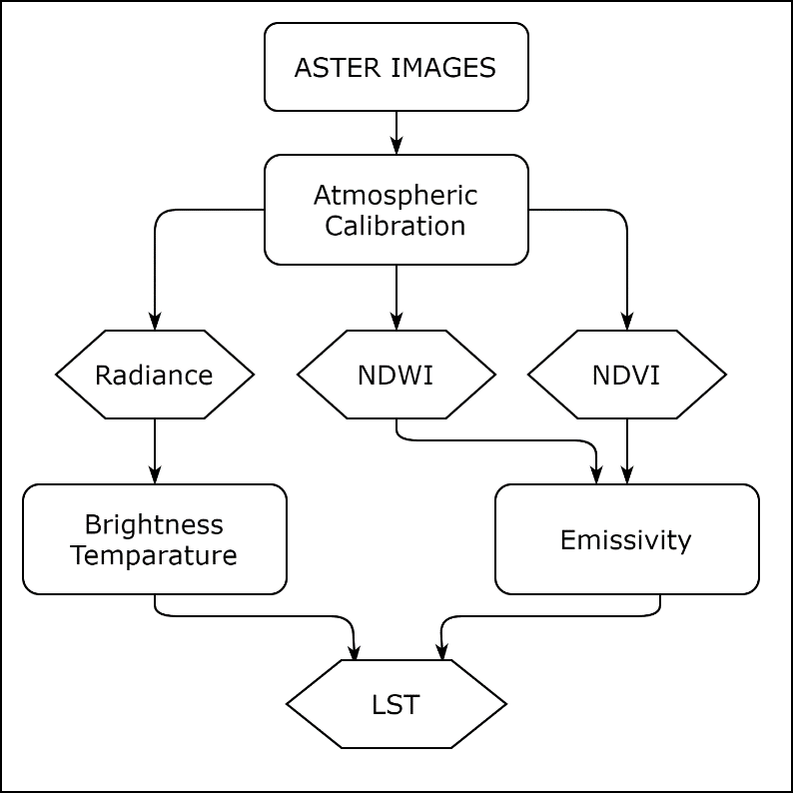
Figure 2. ASTER LST Analysis Methodology.
We have selected Aster and Landsat images for LST analysis in order to compare and validate their results. We continued to analyses Aster data first by using the methodology mentioned above.

  - Landsat Data Analysis Methodology
Finally, we have selected the Landsat 8 data for LST analysis. The main methodology is shown in Figure 3. Again, we have applied Rx anomaly detection algorithm after LST analysis.

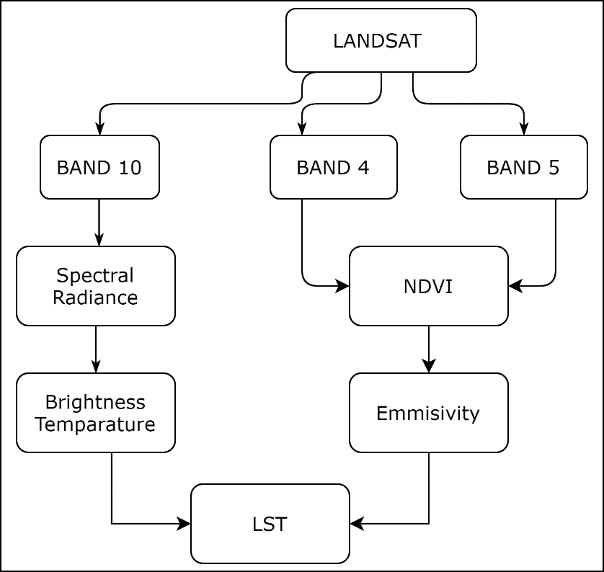
Figure 3. LANDSAT LST Analysis Methodology.

We have applied the same anomaly detection methodology that was promised in the project proposal. However, the spatial resolution of the Landsat 8 data (30 m) is not satisfactory to extract several meters of fumerals on the site, so does the anomaly create by these fumerals.

  - Pattern Recognition Method by Using K-Means Algorithm
After all anomaly detection attempts by using different data and methods, we see the resolution of freely available data are not enough to extract the meaningful information and detect the anomaly. Therefore, we decided to apply a unique and new approach to see the LST due to geothermal on the site. Instead of analysis one image for temperature anomaly on the site, we started to analyses more images to see the time-series effects of the geothermal on the site. This aims to see whether there is a seasonality or not. Another purpose of this analysis is to see the results of more images and increase the precision and accuracy of the LST map. The main methodology is explained in Figure 4.
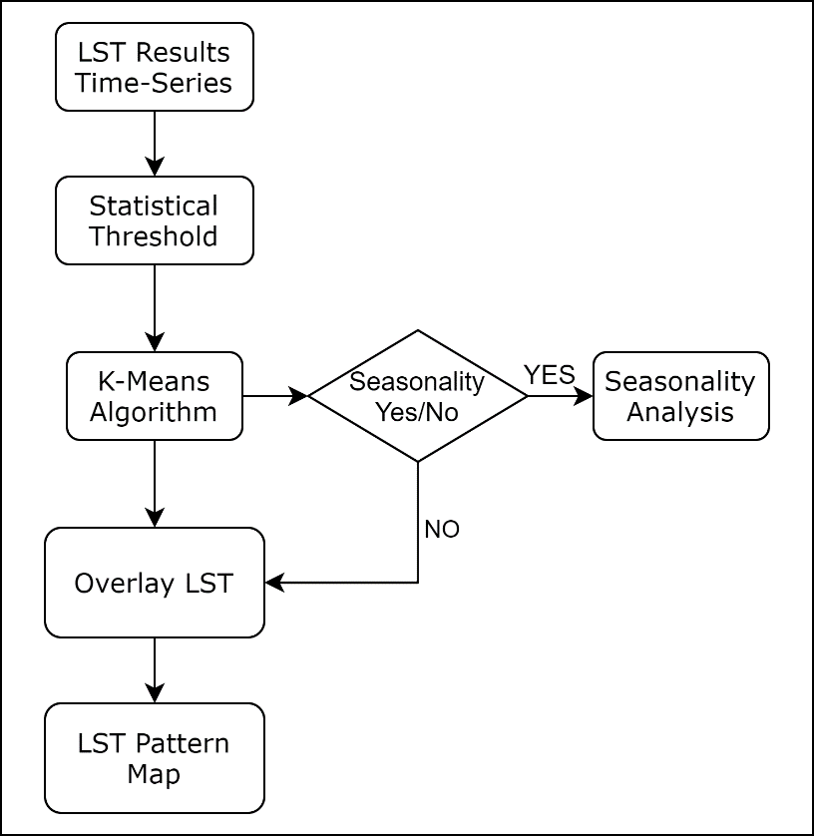
Figure 4. LST Pattern Detection Methodology.
We have downloaded all LST analysis results from the websites given in Table 12. All analysis results were provided by using the same methodology that we applied on the Landsat Data. We removed the data which were corrupted from the list. We statistically analyzed the remaining data after first and final threshold. Then, we applied K-Means Clustering algorithm to see the clusters whether they delineate a pattern or not. In addition, we look for the seasonality of the data by analyzing these time-series data in time. If there is no seasonality, we continue to analyze the whole stack of images to understand the pattern whether they are overlapped with the rest of the layers (e.g. displacement, fault, fumerals, DTS, wells, minerals).

- RESULTS
Since we have used three different data to extract the LST anomaly, we discussed all these three analysis results here. After that, we develop a new and unique methodology to find a pattern created by LST analysis in time. We evaluated and discussed the developed methodology results in more detail.
  - LST for Brady
First analysis is done with Sentinel 3 data which is shown in Figure 5.
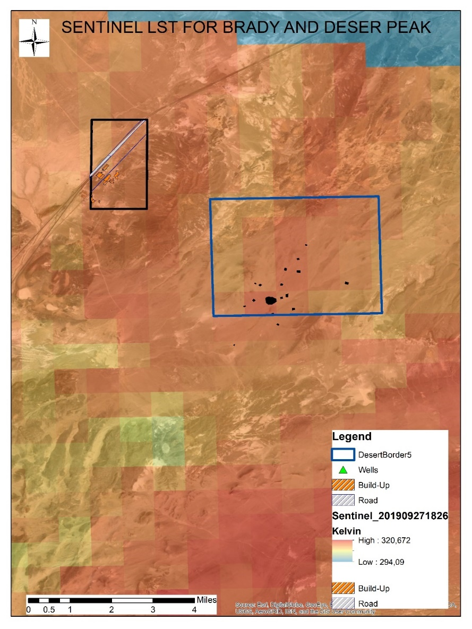
Figure 5. Sentinel Analysis Result (09/27/2019) for Brady and Desert Peak.
The Figure 5 shows the result of Sentinel analysis but the resolution of the data was not enough to extract the LST anomaly. Therefore, we continue to analyze the Aster data for LST anomaly detection.
As mentioned above in the data section, the resolution of the Aster is 90 meter and better than the Sentinel data. Therefore, we expect to see some anomaly on the site because of surface temperature. However, we take the difference of the day and night to see the anomaly on the site instead using directly night or day images alone. Although, the LST analysis is matching with the result of the Landsat, it is still does not enough to exactly extract the LST anomaly on the site. Figure 6 shows the one of the aster analysis result. It is the difference of the day and night LST analysis result. LST is higher the area which geothermal production is active.
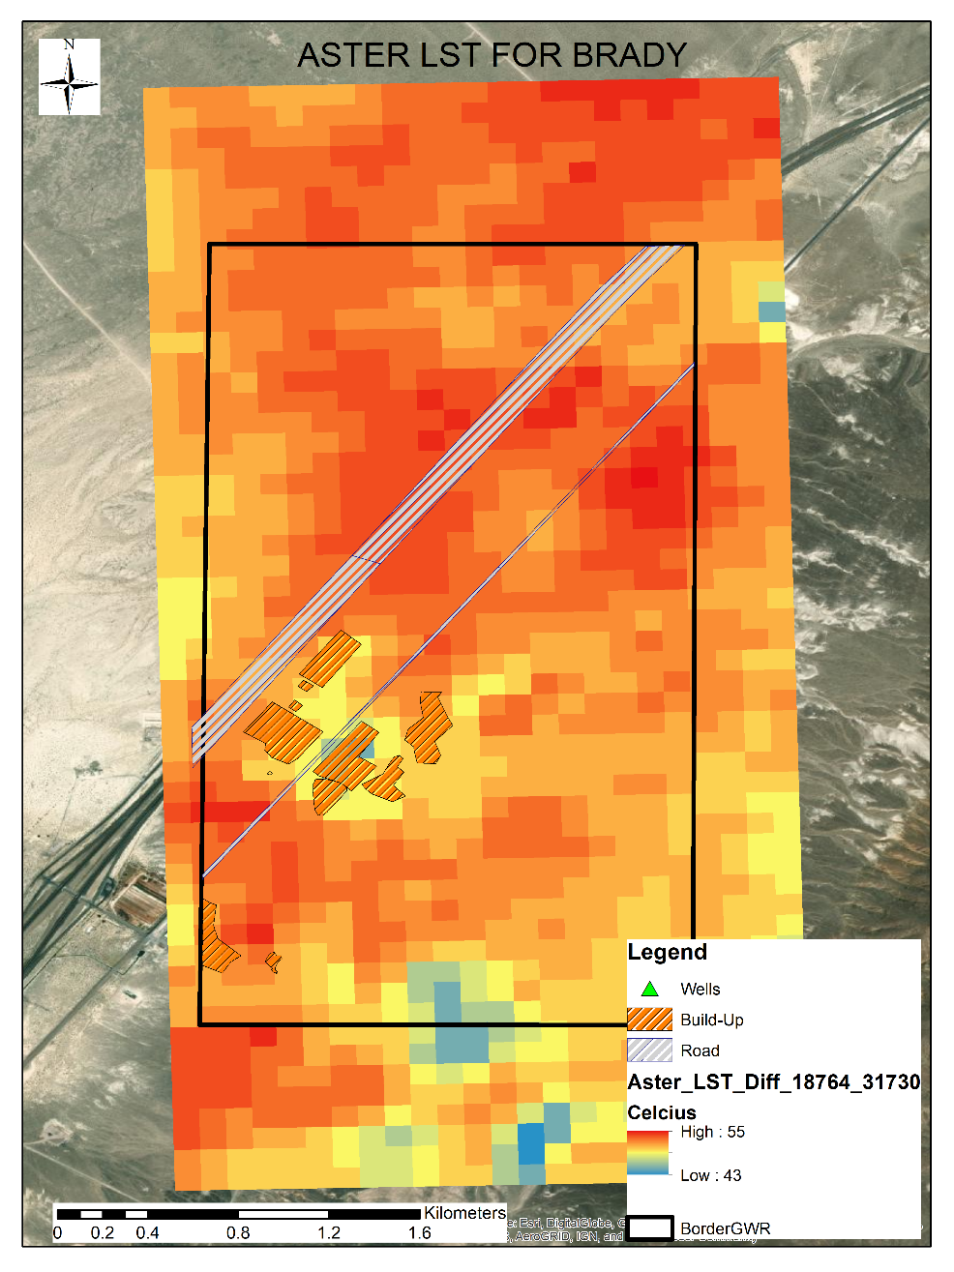
Figure 6. Aster Analysis Result (04/28/2019-02/08/2019) for Brady.
Finally, since it has better resolution and ready-to-use database on the website mentioned before. We decided to continue to analyze the Landsat 8 data. It would be also better to compare these three results for verification at least. Therefore, we analyzed the Landsat 8 images for this purpose. The database which provide LST analysis for North America is matching with the result of our analysis. Then, all analysis results downloaded from the website given in data section. However, most of them were patch type of data and did not cover the AOI. We eliminated those patches from the stack. After that we applied a statistical threshold to eliminate the outlier images form the stack again shown in Table 5. After the statistical threshold elimination, we apply K-Means Clustering Algorithm into 3, 4, and 5 Clusters. It is observed that the 5 Cluster is better to separate the intervals and show the pattern overlapped on the site.
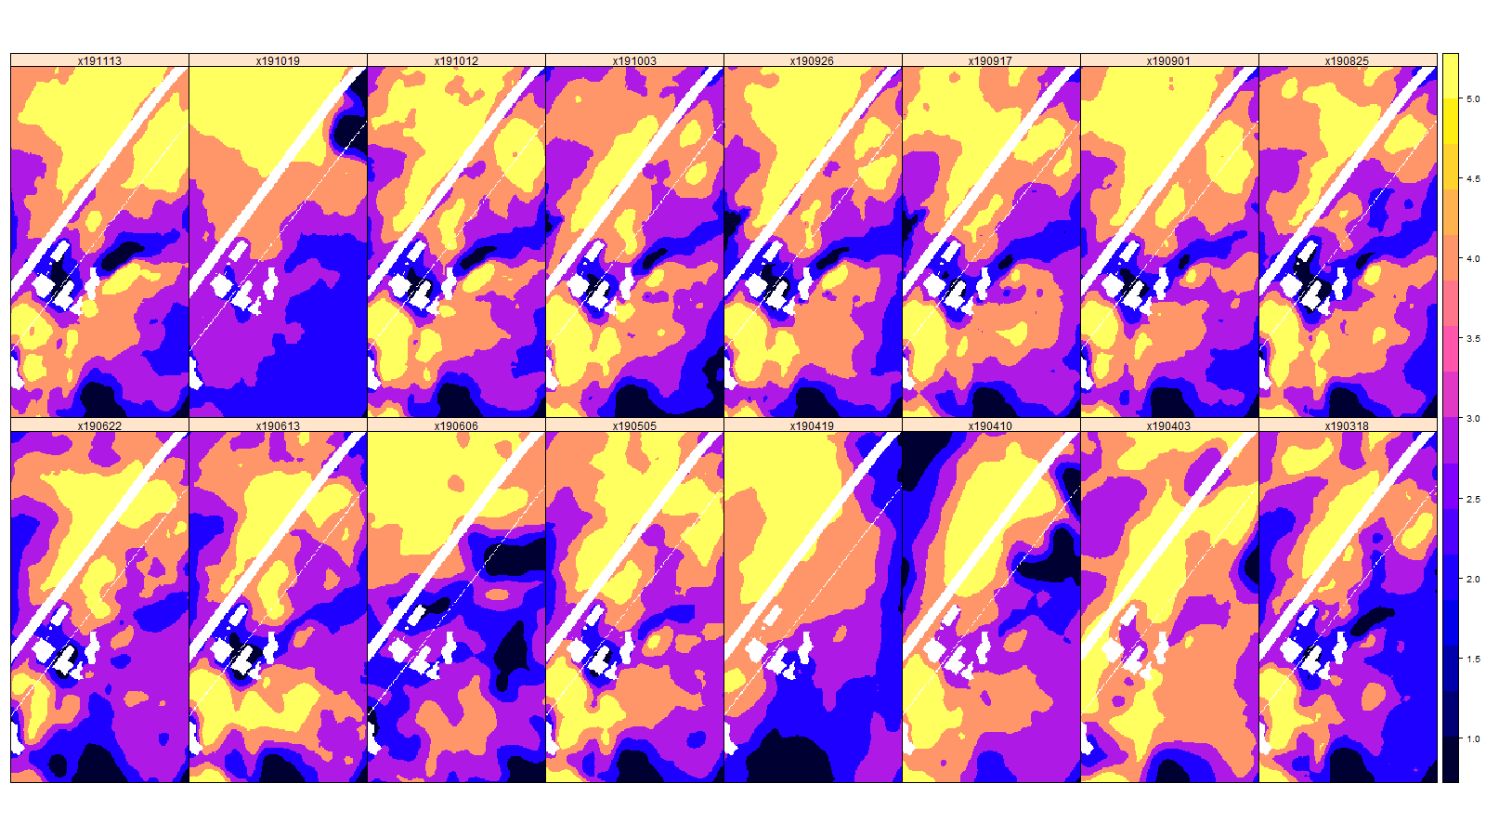
Figure 7. K-Means Result for Brady on the Selected Data Stack After the Statistical Threshold (Light Color (Yellow) Hot; Dark Color (Black) Cold).

K-Means Cluster shows that Cluster 5 are overlapping on the hot areas. Also, some part of the Cluster 4 also is overlapping on these hot areas. Table 9 shows the K-Means Cluster statistics about each one. As expected, the mean, min and max temperature values grow from Cluster 1 to Cluster 5. Also, both range and standard deviation are within a similar range for most clusters.

Table 13. K-Means Cluster Statistics
 | Cluster 1 | Cluster 2 | Cluster 3 | Cluster 4 | Cluster 5
Avg | 33.9 | 36.3 | 37.6 | 38.7 | 39.9
Min | 31.0 | 35.1 | 36.9 | 38.1 | 39.3
Max | 35.1 | 36.9 | 38.1 | 39.3 | 41.2
Stddev | 0.88 | 0.47 | 0.33 | 0.33 | 0.40
Range | 4.2 | 1.8 | 1.2 | 1.2 | 1.9

In all analysis, we selected the number of images of 75% representativeness of Cluster 5 and 95% representativeness of Cluster 4. The number of overlapped images for Cluster 5 is 9 whereas it is 13 for Cluster 4 as shown in Figure 8.

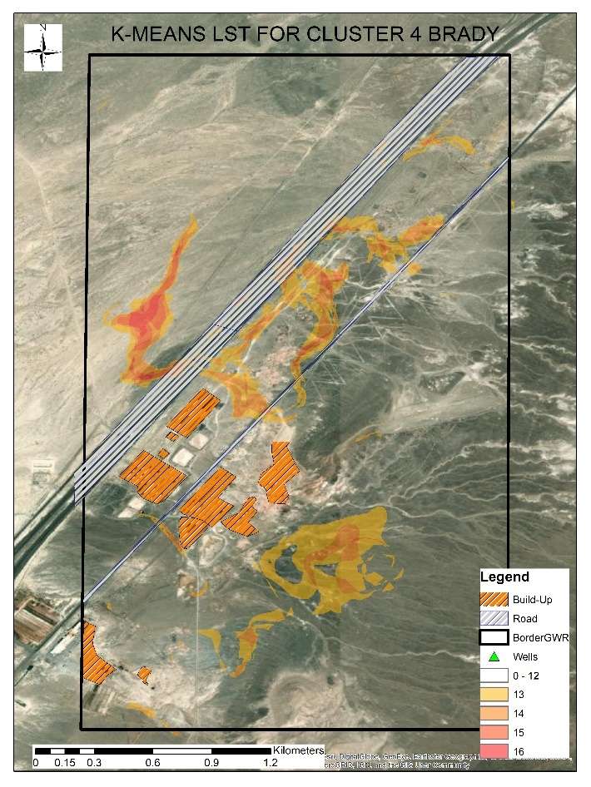 | 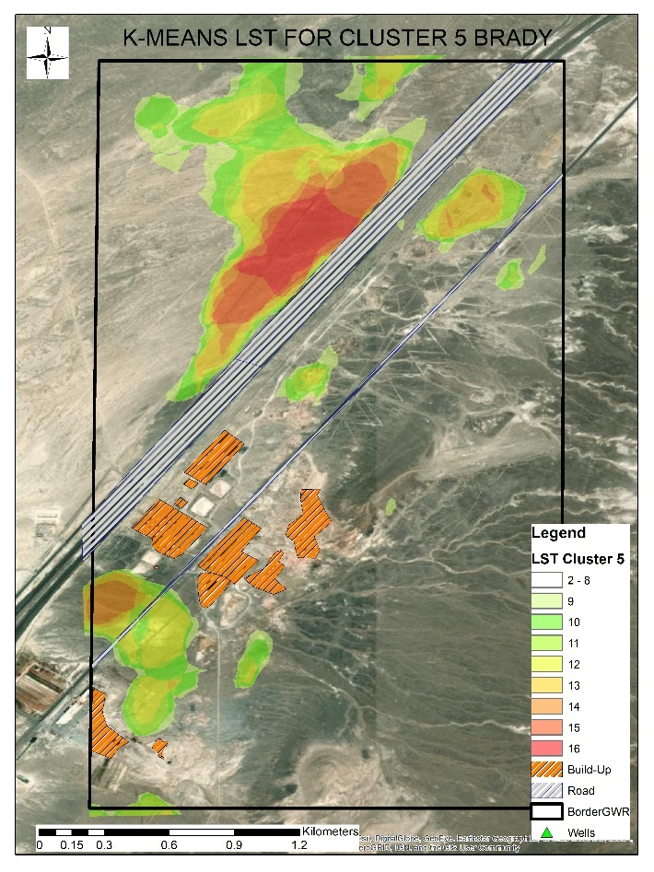
- Cluster 4 | - Cluster 5
Figure 8. Cluster 4 and Cluster 5 for Brady.

Figure 9 shows the result of the Landsat LST analysis. It is clear that LST results are overlapped with the geothermal area.
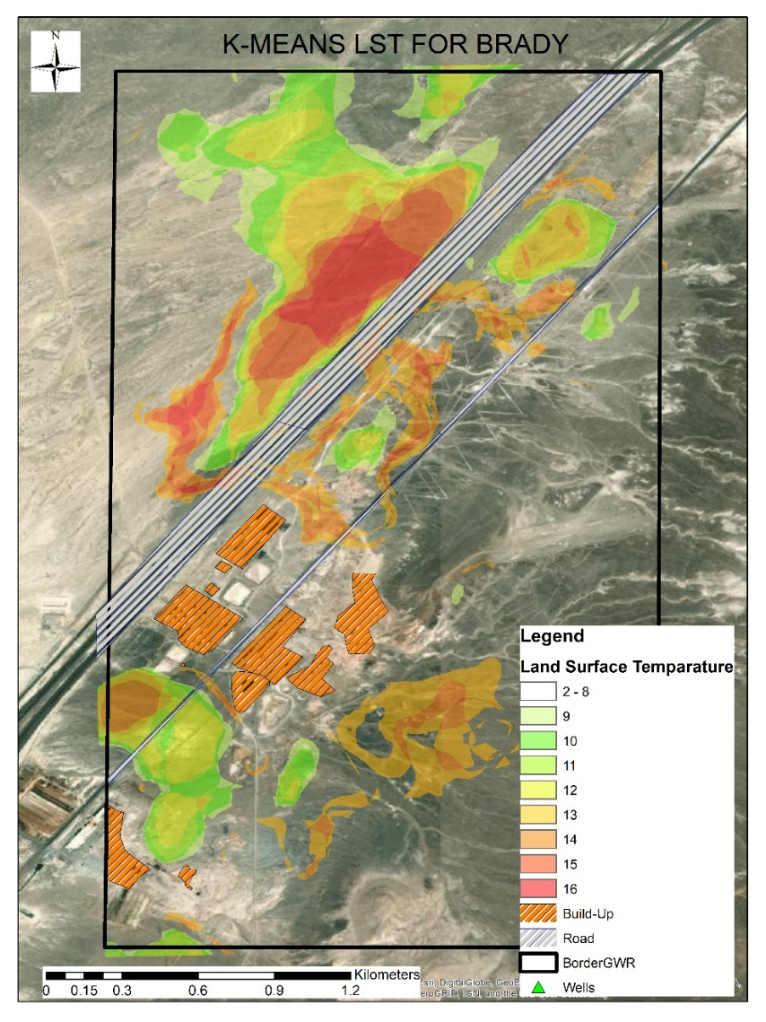
Figure 9. Landsat Analysis Result for Brady.

  - LST for Desert Peak
After the final threshold, we have 14 images for Desert Peak LST analysis. The stack of images is shown in Figure 10. We observed a pattern on this stack of images. Therefore, we continue to apply K-Means Clustering analysis on this stack.
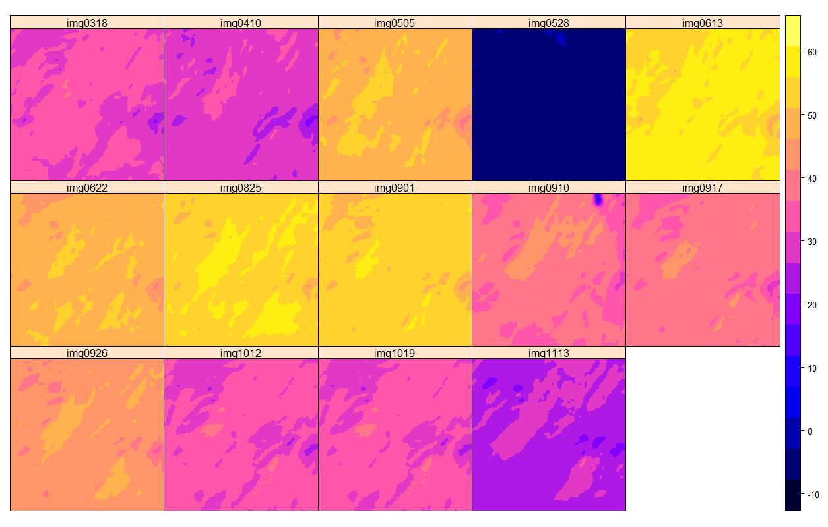
Figure 10. LST Result Desert Peak on the Selected Data Stack After the Statistical Threshold (Light Color (Yellow) Hot; Dark Color (Black) Cold).

Figure 11 shows the K-Means Clustering analysis result. Cluster 4 and Cluster 5 are representative for this site. K-Means algorithm shows the pattern better than LST analysis. Again, Cluster 5 is the most representative one to show the hot zones in the field.
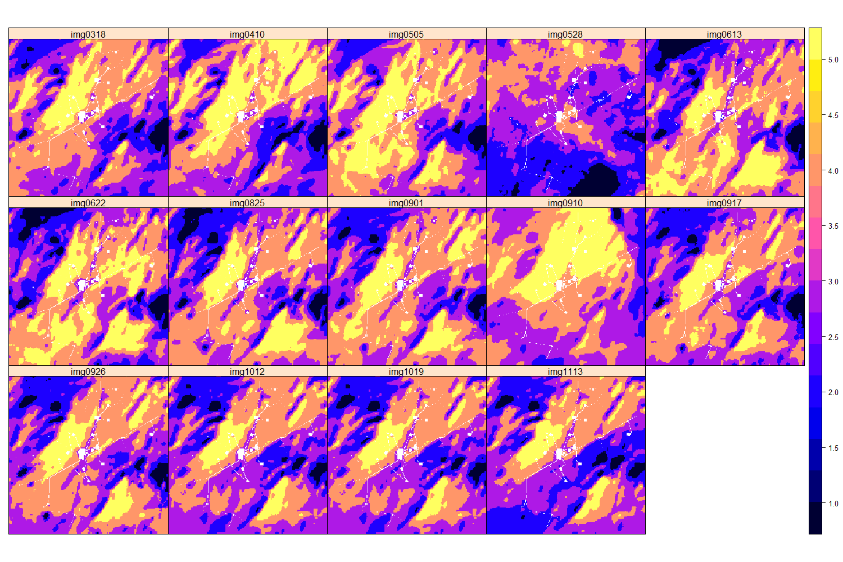
Figure 11. K-Means Result for Desert Peak on the Selected Data Stack After the Statistical Threshold (Light Color (Yellow) Hot; Dark Color (Black) Cold).

Cluster 4 with 9 overlapped images represents 95% of stack of images and Cluster 5 with 7 overlapped images represents 75% of stack of images after statistical analysis of K-Means Result.
Table 14. Statistics about Overlapped Clusters for Desert Peak
 | 0% | 50% | 75% | 95% | 100%
Cluster4 | 0 | 4 | 7 | 9 | 11
Cluster5 | 0 | 2 | 7 | 11 | 11

Figure 12 shows the Cluster 4 and Cluster 5 separately.
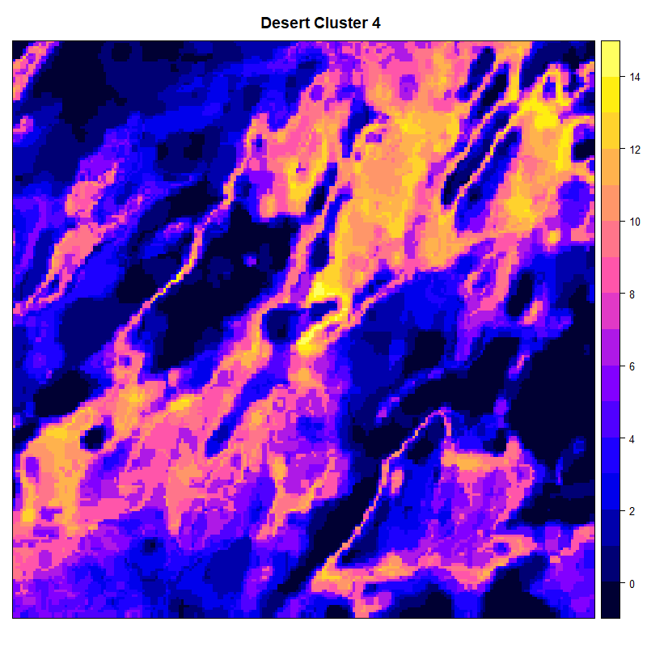 | 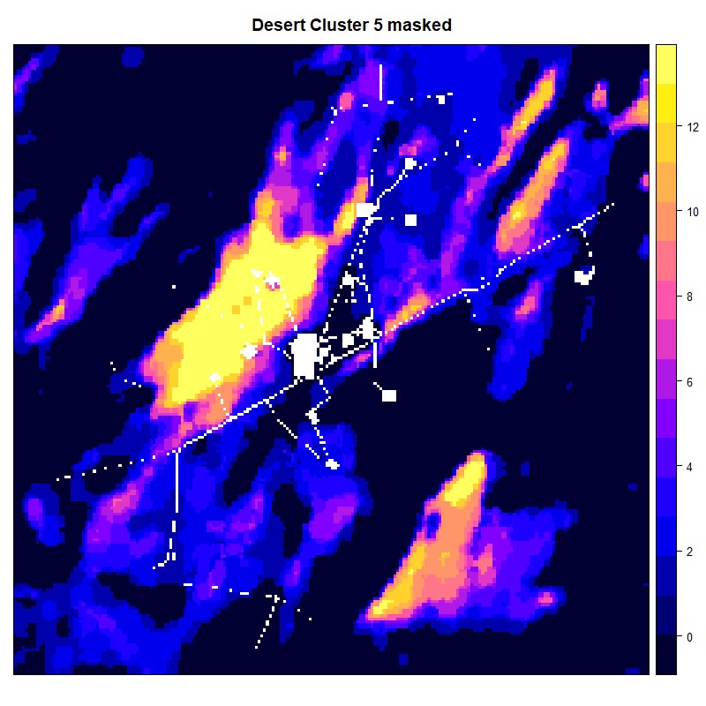
- Cluster 4 | - Cluster 5
Figure 12. Cluster 4 and Cluster 5 for Desert Peak.

Figure 13 shows the merge of Cluster 4 and Cluster 5 (Figure 12) and accepted as the final input for AI algorithm.
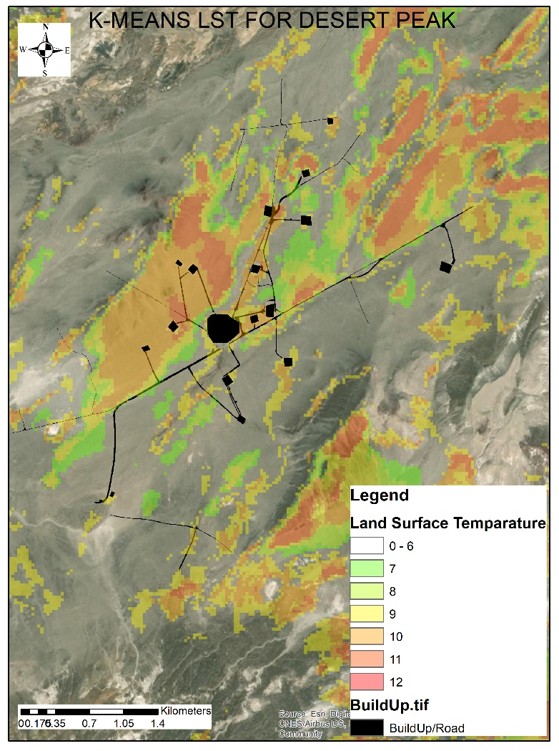
Figure 13. Landsat Analysis Result for Desert Peak.

  - LST for Salton Sea
After the final threshold, we have 18 images for Salton Sea LST analysis. The stack of images is shown in Figure 14. We observed a pattern on this stack of images. Therefore, we continue to apply K-Means Clustering analysis on this stack.
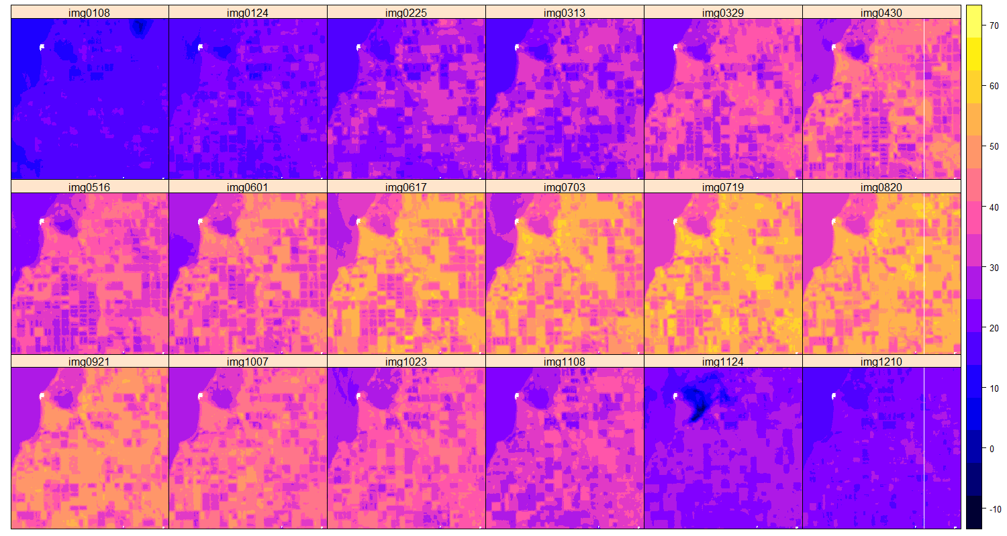
Figure 14. LST Result for Salton Sea on the Selected Data Stack After the Statistical Threshold (Light Color (Yellow) Hot; Dark Color (Black) Cold).

Figure 15 shows the K-Means Clustering analysis result. Cluster 4 and Cluster 5 are representative for this site.
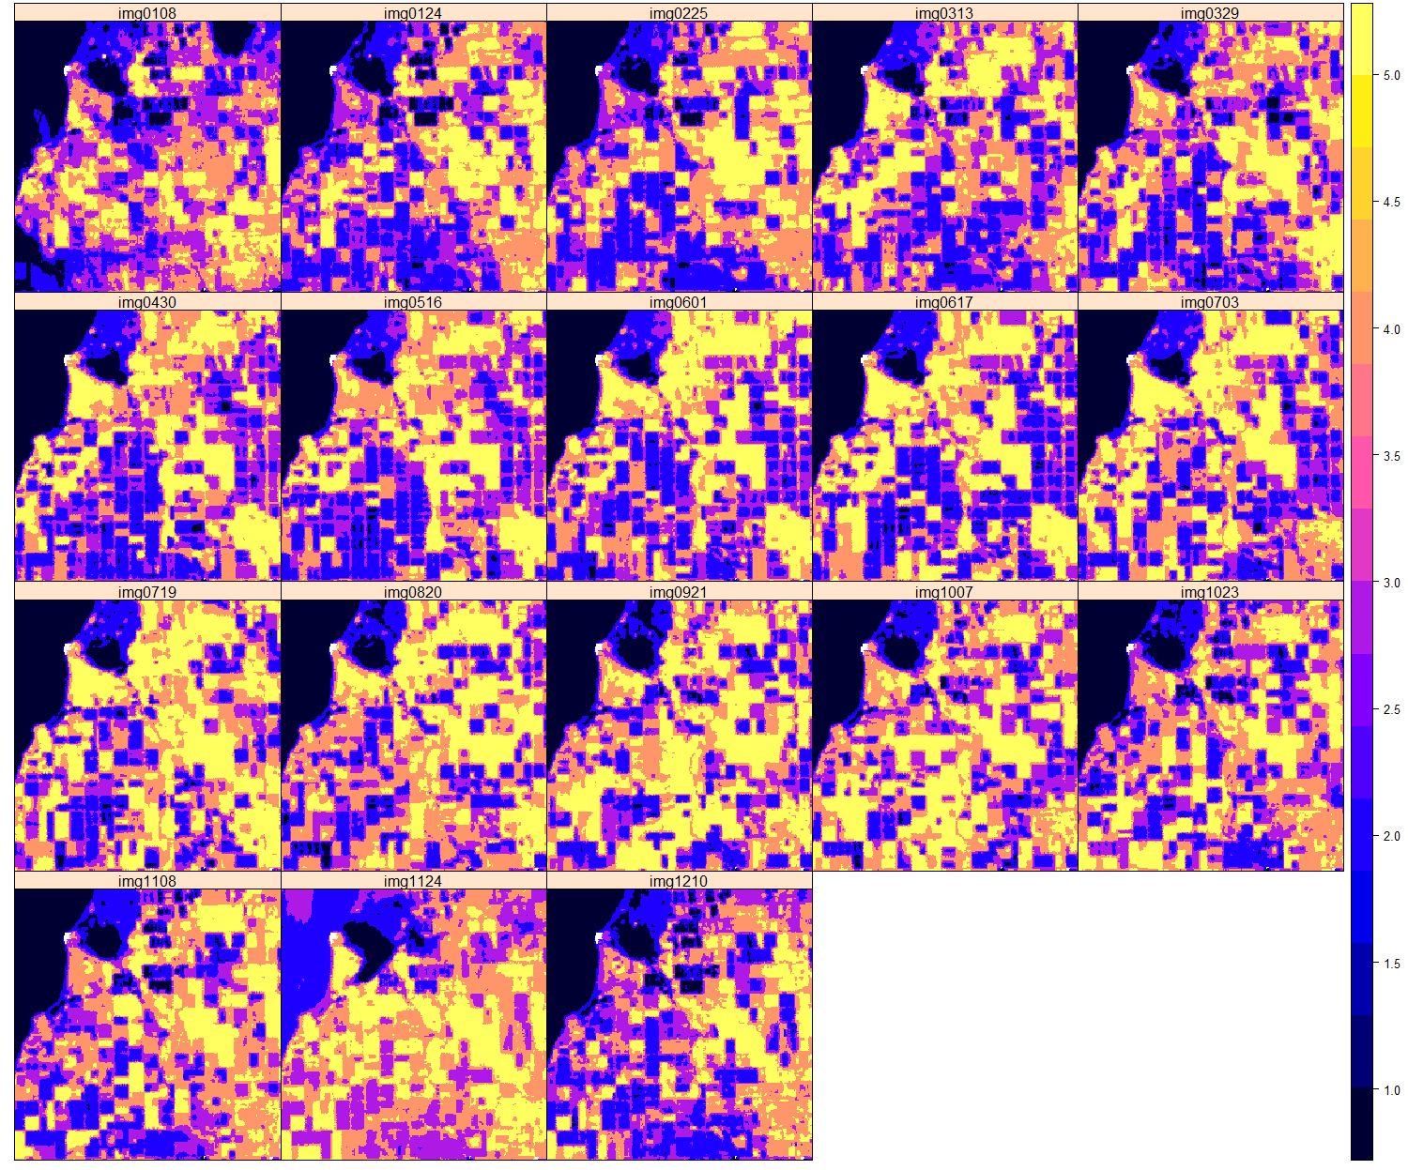
Figure 15. K-Means Result for Salton Sea on the Selected Data Stack After the Statistical Threshold (Light Color (Yellow) Hot; Dark Color (Black) Cold).
Cluster 4 with 14 overlapped images represents 95% of stack of images and Cluster 5 with 7 overlapped images represents 75% of stack of images after statistical analysis of K-Means Result.

 | 0% | 50% | 75% | 95% | 100%
Cluster4 | 0 | 3 | 6 | 14 | 18
Cluster5 | 0 | 4 | 7 | 11 | 18
Figure 16 shows the Cluster 4 and Cluster 5 separately.
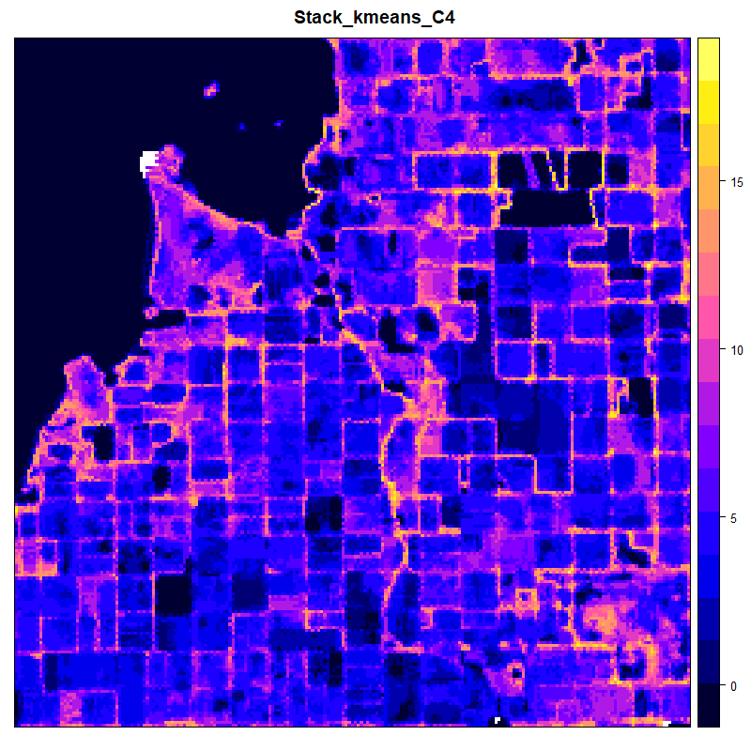 | 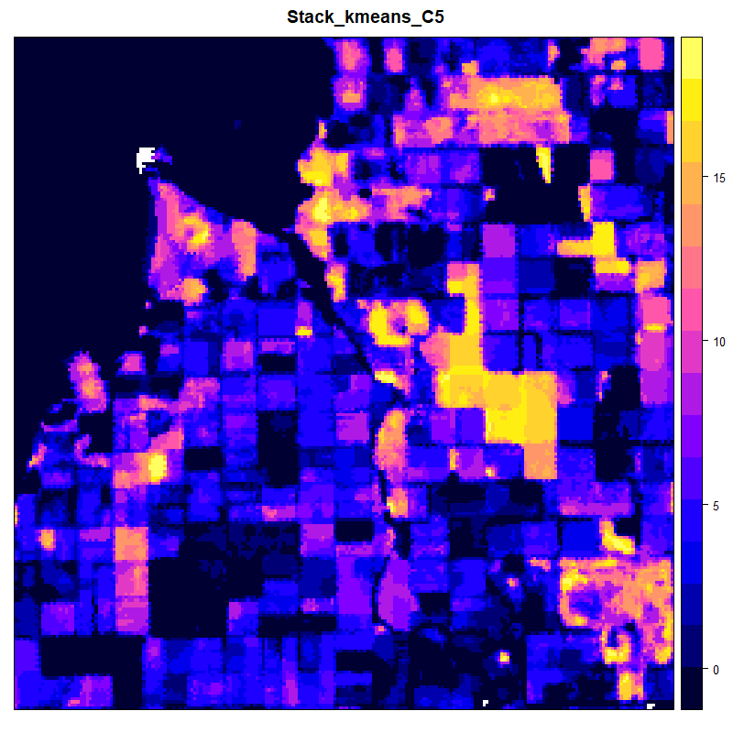
- Cluster 4 | - Cluster 5
Figure 16. Cluster 4 and Cluster 5 for Salton Sea.

Figure 17 shows the merge of Cluster 4 and Cluster 5 (Figure 16) and accepted as the final input for AI algorithm. The temperature map is overlapping on the geothermal field and build-up areas. The problem about Salton Sea is the whole area is vegetated and watery area. This affects the result of LST negatively. Therefore, we could not totally rely on the result of LST for Salton Sea.
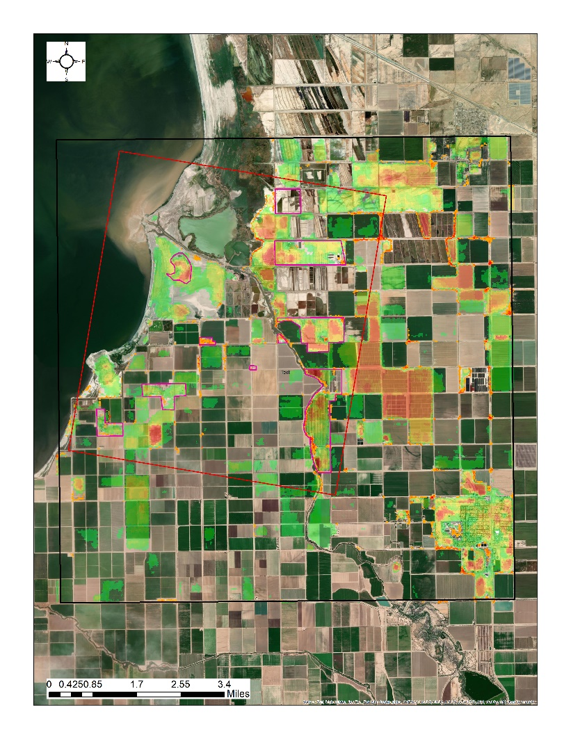
Figure 17. Landsat Analysis Result for Salton Sea.

- CONCLUSION
LST analysis is critical and important indicator for detection of geothermal site together with some other indicators. Because, geothermal field create hot zones with the fumerals and hot waters on the field with respect to its environment and it is expected to create temperature anomaly on the site. Using remote sensing images and algorithms in order to find these anomalies will be a representative indicator for exploration of the geothermal sites by using AI. However, finding LST anomalies on the site depend on the quality of the satellite images. Therefore, we should be careful to select the satellite data before analysis. For that purpose, we have selected Sentinel 3, Aster and Landsat 8 data for analysis because they are all free and publicly available. We analyze all this type of data one by one. Sentinel and Aster analysis quality are not enough to show the anomaly. Even Landsat 8 analysis result is not also enough to show the anomaly by using RX algorithm, we decided to continue to study on this analysis for further analysis. Therefore, we applied different and unique methodology to extract temperature pattern created on the site because of geothermal activities like injection and production. For that, we analyze the data in time-series in order to see is there any seasonality or pattern on site. And then, we applied K-Means algorithm in order to see that clusters create a pattern on site or not. This method works successfully.
We have used this method for three sites which are Brady, Desert Peak and Salton Sea. Brady and Desert Peak have the same natural environment and respectively dry. Therefore, the methodology and analysis results are successfully for these two sites. On the other hand, Salton Sea has a different and wet environment and it affects the quality of the satellite images, so do results. Therefore, LST indicators for Brady and Desert Peak are good and representative but it is nor good and representative for Salton Sea.
Shortly, LST for Brady and Desert Peak can be used as input for AI. The methodology is successful and unique.

REFERENCES
- Fujisada H. Design and performance of ASTER instrument. In: Breckinridge JB, editor. Proceedings of International Society of Optical Engineering 2583. 1995. pp. 16–25.
- Yamaguchi YI, Fujisada H, Kudoh M, Kawakami T, Tsu H, Kahle AB, Pniel M. ASTER instrument characterization and operation scnorio. Adv Space Res. 1999;23(8):1415–1424. doi: 10.1016/S0273-1177(99)00293-8.
- Sentinel.esa.int. 2020. Sentinel-3 - Instrument Payload - SLSTR - Sentinel Online. [online] Available at: <https://sentinel.esa.int/web/sentinel/missions/sentinel-3/instrument-payload/slstr> [Accessed 21 October 2020].
- Satimagingcorp.com. 2020. ASTER Satellite Sensor Specifications | Satellite Imaging Corp. [online] Available at: <https://www.satimagingcorp.com/satellite-sensors/other-satellite-sensors/aster/> [Accessed 21 October 2020].
- En.wikipedia.org. 2020. Landsat 8. [online] Available at: <https://en.wikipedia.org/wiki/Landsat_8> [Accessed 21 October 2020].

