Mineral Markers | Jim Moraga  DOE Final Report

Contents
1. Introduction 2
2. Data 3
2.1. Satellite Data 3
2.2. HyMap 6
2.3. Spectral Data 6
3. Methodology 12
3.1. Pre-processing 12
3.2. Processing 13
3.3. Post-processing 17
4. Results 19
4.1. Mineral markers map for Brady 19
4.2. Mineral markers map for Desert Peak 19
4.3. Mineral markers map for Salton Sea 19
References 20
Appendix 25
Target detection results for Brady 25
Target detection results for Desert Peak 25
Target detection results for Salton Sea 25

- Introduction
Geothermal systems can be characterized in different ways, one of the surface signs of a geothermal field are minerals that are formed during the process of water heating and surge of water and vapors that interact with minerals and metals (Browne 1978). Finding these “Mineral Markers’ is a way to show the potential of an area to be a Geothermal field and this has been done, traditionally, through site observation and sampling (Calvin and Pace 2016).
Several remote sensing techniques exist and have been applied to this problem in this site (Kratt, Calvin and Coolbaugh 2006) and surrounding areas (Kratt, Calvin and Coolbaugh 2010), and the approach selected was using Satellite and Airplane mounted multi-spectral cameras, coupled with known target detector algorithms. In our study, we find and map these markers in our area of interest (AOI), the Brady Hot Springs, Desert Peak and Salton Sea.
It’s important to note that we have changed the list of spectral target detection algorithms from our proposal due to the finding better suited methods for our purposes. Initially, it consisted of spectral matched filter (SMF), Desired Target Detection and Classification Algorithm (DTDCA), Correlation and Normalized Correlation (NC) operations and Spectral Angle Mapping (SAM) algorithms to map minerals and, while we kept SAM, we replaced the rest with 7 additional algorithms: Adaptive Coherence Estimator (ACE), Constrained Energy Minimization (CEM), Orthogonal Subspace Projection (OSP), Matched Filtering (MF), Mixture Tuned Matched Filtering (MTMF), Mixture Tuned Target-Constrained Interference-Minimized Filter (MTTCIMF), and Target-Constrained Interference-Minimized Filter (TCIMF).
- Data
Several approaches were used to collect data from the site, including freely available Satellite data, and the results of private a spectral survey.
In the case of Satellite data, we used AVIRIS, and the provider of closed data was HyVista. During our data search, we found other sources like Sentinel-2 and ASTER, but the number of images, resolution or bands were not suitable for target detection.
In the case of Salton Sea, we were able to obtain pre-processed data from a previous study (D. M. Tratt 2016, August) and (P. M. Adams 2017)
For mineral samples, we did a literature search and created Spectral Libraries based on marker minerals and the corresponding spectra from the USGS database.
  - Satellite Data
The Airborne Visible InfraRed Imaging Spectrometer (AVIRIS) is a is an instrument used in Earth Remote Sensing, and consist of a spectrometer mounted in high altitude aircraft managed by NASA, these aircraft are NASA's ER-2 jet, Twin Otter International's turboprop, Scaled Composites' Proteus, and NASA's WB-57. The optical sensor mounted in these platforms, delivers calibrated images of the upwelling spectral radiance in 224 spectral channels, with wavelengths from 400 to 2500 nanometers (nm). AVIRIS has flown North America, Europe, portions of South America, and Argentina. The main objective of the platform is to study the global environment and climate change (Vane, et al. 1993).
For our project, we collected samples from AVIRIS inside a box defined in WGS-84 11N UTM coordinates starting in x=323628.710, y=4412727.694 and of size 757 by 582 cells of 1.43 by 1.43 mts.
Sentinel-2 is a different spectral sensor platform, launched in June 2015 and part of the European Space Agency (ESA) Copernicus Sentinel Program. The objective of Sentinel-2 is land monitoring, and the mission consists of two polar-orbiting satellites, capturing and providing freely high-resolution optical imagery for research purposes, especially on vegetation, soil and coastal areas (Drusch, et al. 2012).
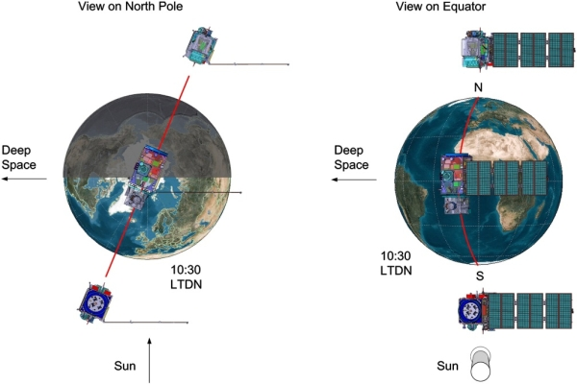
Sentinel-2 polar-orbiting satellite configuration

Sentinel-2 provides images in several resolutions (10, 20 and 60m), and the instrument delivers data for 12 bands from 400 to 2200.4 nm.
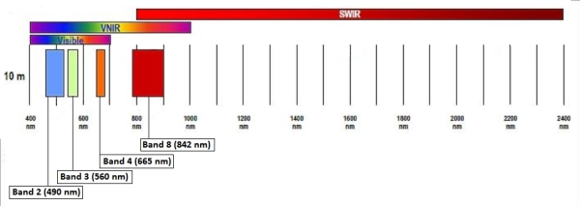
Band resolution for 10m product

Although we found high quality and frequent data for this area, the low number of bands and the part of the spectrum captured (Visible+VNIR at 10m, SWIR at 20 and 60m) were not suitable for our purposes in the end.
Finally, ASTER was also evaluated, but only 2 images were available and the resolution was over 30, for SWIR data (Baldridge, et al. 2009).
Aster Data Specification (Satellite Imaging Corp 2020).
Instrument | VNIR | SWIR | TIR
Bands | 1-3 | 4-9 | 10-14
Spatial Resolution | 15m | 30m | 90m
Swath Width | 60km | 60km | 60km
Cross Track Pointing | ± 318km (± 24 deg) | ± 116km (± 8.55 deg) | ± 116km (± 8.55 deg)
Quantization (bits) | 8 | 8 | 12
Download Link | https://search.earthdata.nasa.gov/search?q=C1299783630-LPDAAC_ECS

Aster Bands (Abrams, Hook and Ramachandran 2002).
Subsystem | Band No. | Spectral Range (μm) | Spatial Resolution, m | Quantization Levels
VNIR | 1 | 0.52-0.60 | 15 | 8 bits
 | 2 | 0.63-0.69
 | 3N | 0.78-0.86
 | 3B | 0.78-0.86
SWIR | 4 | 1.60-1.70 | 30 | 8 bits
 | 5 | 2.145-2.185
 | 6 | 2.185-2.225
 | 7 | 2.235-2.285
 | 8 | 2.295-2.365
 | 9 | 2.360-2.430
TIR | 10 | 8.125-8.475 | 90 | 12 bits
 | 11 | 8.475-8.825
 | 12 | 8.925-9.275
 | 13 | 10.25-10.95
 | 14 | 10.95-11.65

The ASTER instrument consists of three separate instrument subsystems:
VNIR (Visible Near Infrared), a backward-looking telescope which is only used to acquire a stereo pair image
SWIR (Shortwave Infrared), a single fixed aspheric refracting telescope
TIR (Thermal Infrared)
  - HyMap
HyMap is a product of HyVista corporation. HyVista did a multi-spectral survey of Brady and Desert Peak in 2003, and provides a resolution of 3m for this area. This is possible because the instrument is more precise and the flight is performed at a lower altitude in a Cessna 402 (Kruse, Boardman and Lefkoff, et al. 2000). The HyMap sensor covers the spectrum from 400 to 2500 nm in 126 spectral bands of, approximately, 15 nm each (Cocks, et al. 1998).
The product was acquired by our group, and we received the 10GB atmospherically corrected reflectance data, which is measured in units from 0-10,000 (corresponding to standardized values from 0 to 1). The image covers both Brady and Desert peak and, except for some saturated points due to human-made surface anomalies (pixels that were masked out for our analysis) provides excellent quality and high-resolution data for the AOI.
  - Spectral Data
The minerals associated with geothermal fields are a consequence
Of the earth’s internal hear moving towards the surface through conductive and convective processes. Near diverging tectonic plates (like in active rift systems such as the mid-Atlantic rift and the East African rift), converging plate boundaries (subduction zones; Indonesia, Philippines, Chile), and along recent volcanic in intraplate settings (Hawaii, Yellowstone/US) volcanic activity results in temperature gradients as high as 150 °C per kilometer depth, because magma conduits trigger fluid circulation from fresh water from precipitation, ground water, lake water intrusion (meteoric water) which results in hot springs, steam vents. The amount of heat flow (heat flowing by conduction through a unit area in mW/m2) is dependent on the temperature gradient and the thermal conductivity (in W/m °C) of the medium (rock, water) (van der Meer, et al. 2014).
Geothermal systems can be classified in hydrothermal (water or vapor/steam dominated), hot dry rock (HDR), geopressured and magmatic (Barbier 2002). Hot dry rock (HDR) are dry and impermeable hot rocks where by means of hydraulic fracturing (‘fracking’) a man-made reservoir is created, geopressured reservoirs are deep (4–5 km) reservoirs in sedimentary basins that contain hot water under pressure, while magmatic refers to energy stored in magma bodies (van der Meer, et al. 2014).
Minerals in the crust, or dissolved in water, suffer the heat and pressure cased by the interaction of the hot rock and water, and are brought to the surface by the hydrothermal systems. These discharges typically occur in areas that are hydrothermally altered: Hot springs, fumaroles and mud spots.
These mineral alterations, can reflect or indicate the temperature and chemistry of geothermal waters and composition of the surrounding bedrock. Minerals displaying diagnostic absorption features that occur in and typify hydrothermal alteration systems include hydroxyl bearing clays, sulfates, carbonates, and sinters (Huntington 2007).
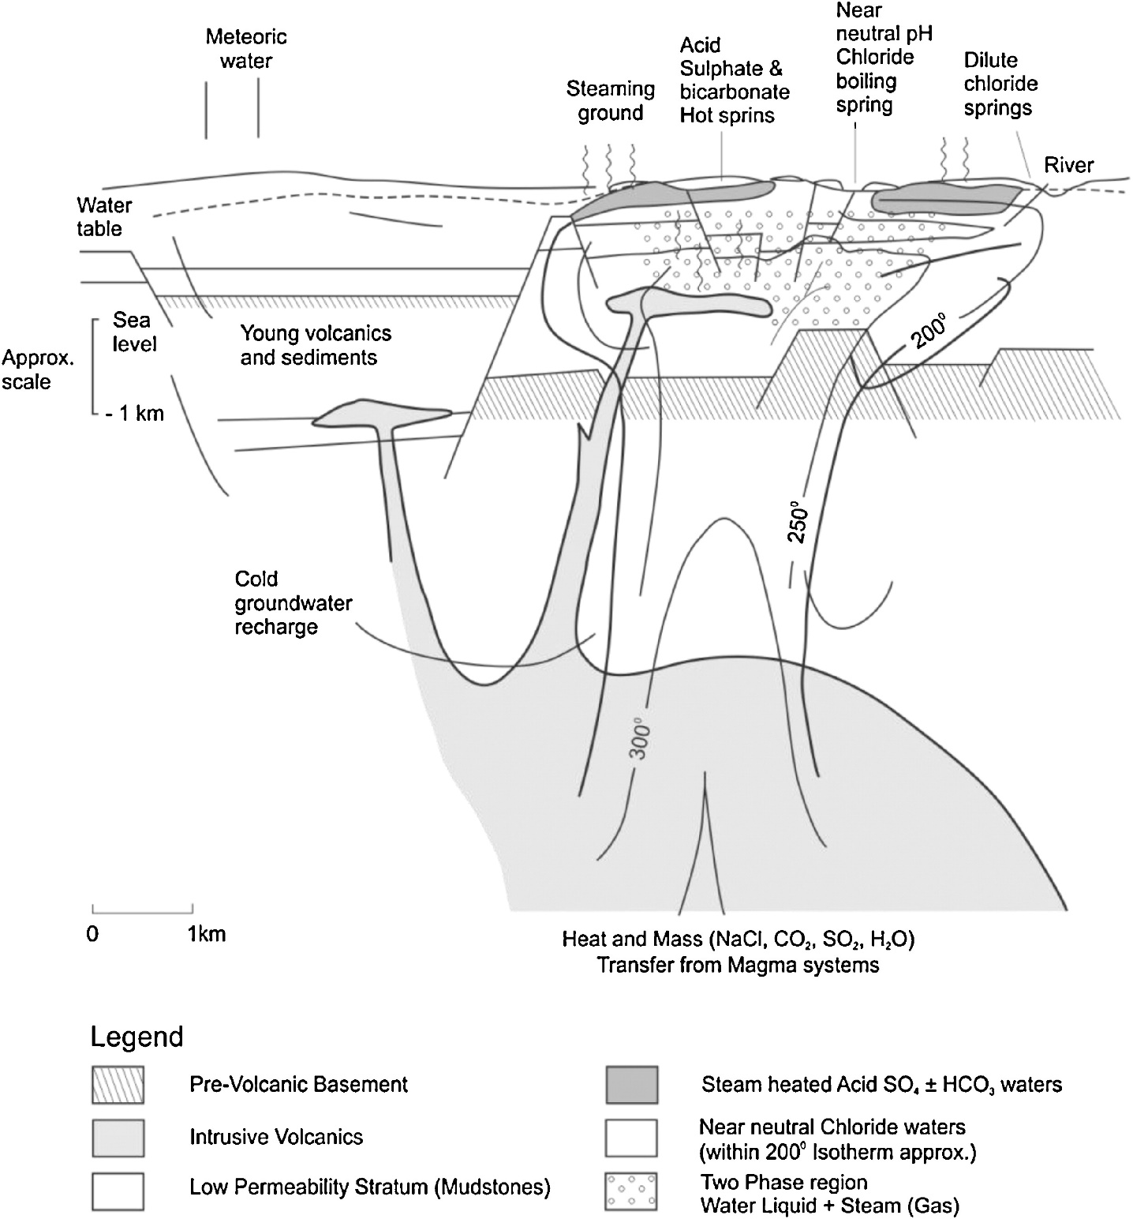
Conceptual geologic model of a volcanic geothermal system from (van der Meer, et al. 2014); adapted from (Henley and Ellis 1983)

Surface discharge of geothermal fluids forms mineral deposits (Kesler 2005):
- Siliceous sinters encompassing various forms of silica deposited by high-temperature fluids (>175 °C)
- Travertine, which is mainly calcium carbonate deposited by lower temperature geothermal fluids
- Borates (Helvacı 2015), sulfates, and chlorides (Pirajno 2020)
These minerals are present based on temperature of the system:
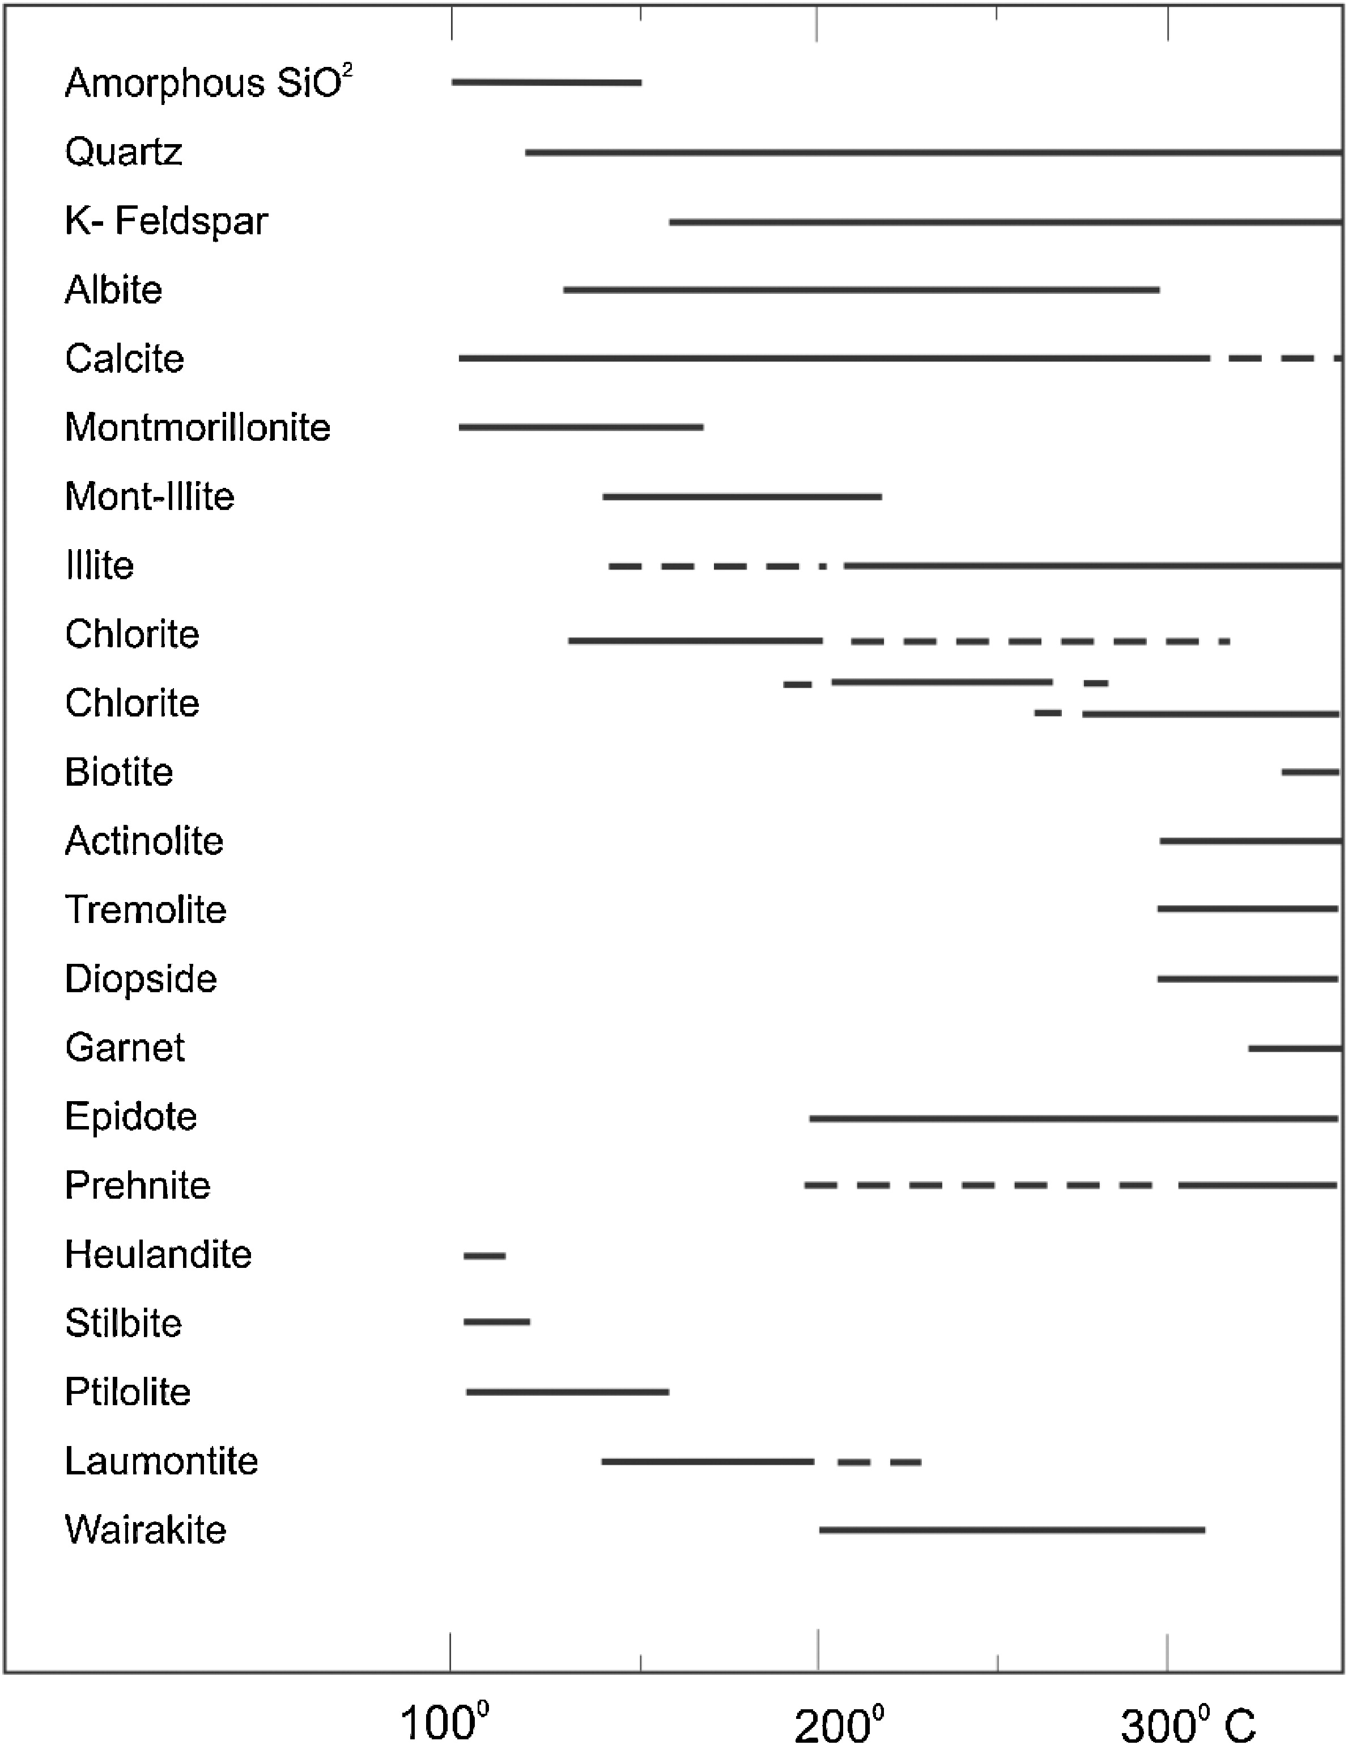
Adapted from (Henley and Ellis 1983)

In the Grand Basin, typical minerals include (Littlefield and Calvin 2014):
- Alunite, kaolinite, calcite, carbonate
  - Alunite can indicate alteration of potassium feldspars as a reaction with sulfuric acid or it may form from fumarolic activity.
  - Kaolinite may be a product of argillic alteration of feldspars, a low temperature reaction which may result from acidic thermal fluids moving through the rock, or chemical weathering.
  - Calcite (or aragonite) can be an important geothermal indicator as it may represent travertine and tufa deposits (through calcium carbonate precipitation).
- Muscovite, Smectite (montmorillonite, nontronite, vermiculite and saponite), chlorites, gypsum, and tincalconite.
  - Muscovite and montmorillonite may be related to geothermal activity or weathering and cannot be used as decisive indicators of hydrothermal alteration.
  - Chlorites may be a product of propylitic alteration of amphibole, pyroxene, and biotite.
- Sinter deposits, opal: Opal is an amorphous silica gel deposited in low temperature environments; it may fill fractures or form siliceous sinter deposits surrounding hot springs. Through temperature and pressure in hydrothermal systems (Okamoto, et al. 2010), or diagenetic changes, the non-crystalline opal changes to crystalline quartz (Herdianita, et al. 2000):
  - Opal-A (SiO2*nH2O) (Primary mineral in siliceous sinters)
  - Opal-CT
  - Chalcedony
  - Quartz
- Hematite, including hematitically stained kaolinite
- Sulfates
  - Gypsum and tincalconite: evaporites deposited by sulfur- and borate-rich springs, respectively.
  - Anhydrite
  - Epsomite
Of these, a sub-set was selected for the Brady and Desert Peak sites, based on availability of ground-truth from observations and samples in the field (Kratt, Calvin and Coolbaugh 2006):
- Chalcedony and Opal sample from Brady (this will be explained below)
- Kaolinite
- Gypsum
- Hematite
- Epsomite. Although it is not included in the Kratt 2006 paper, it is another marker in the region (Kratt, Calvin and Coolbaugh 2010) and (Reath and Ramsey 2013)
All the minerals were found and the spectra collected from the latest available Spectrum Library from USGS version 7 (Kokaly, et al. 2017), and then resampled to coincide with the bands for each instrument (AVIRIS or HyMap).
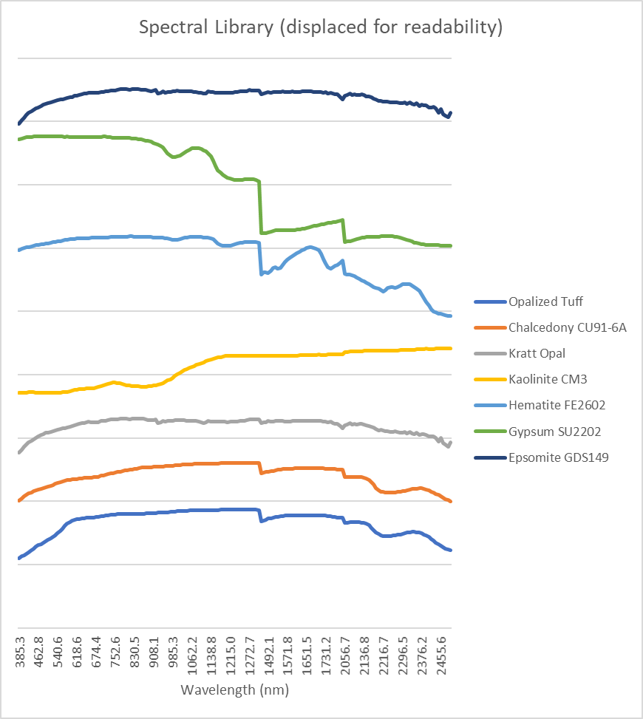
Brady and Desert Peak Spectral Library

Additionally, from the (Kratt, Calvin and Coolbaugh 2006) paper we knew that south of the Brady Geothermal plant facilities there was a region with high concentrations of chalcedony and opal, and we found this place, taking a pixel as reference for the “Kratt Opal” we included this spectral signature in our library.
- Methodology
To perform the analysis, we took three steps: pre-processing, target detection, and post-processing. The preprocess consisted of cropping the area of interest (AOI), creating masks for unusable bands or pixels, collection of relevant minerals, and creation of a spectral library with those minerals
Processing included performing target detection through several methods, selection of thresholds for each mineral and method, collection of sample pixels from the cleaned-up data to add into the Spectral Library, and rerunning the process if required.
Our initial proposal included SMF, DTDCA, NC operations and SAM algorithms to map minerals. Nevertheless, we found the use of ENVI’s target detection methods, which include SAM, to be more suitable and effective than those algorithms. The methods added are detailed in the Processing subsection.
Post-processing consisted in collating the results in a format manageable for the rest of the algorithms (SVM, ANNs, and other as required). This format is explained in our Machine Learning Report.
  - Pre-processing
The preprocessing was done for both sources of data for Brady and Desert Peak (AVIRIS and HyMap), it included:
- Cropping the data to the AOI
- Cleaning up the data to remove or mask anomalous bands (e.g. for AVIRIS, bands 104-113 or 102-121, and 154-169 or 154-179, and also band 95 for one test)
- Masking out anomalous pixels (e.g. because of data being outside the valid range)
- Masking of build-up and roads
Additionally, the Spectral Libraries were adjusted to fit the number of bands and band wavelength of each data source.
As a result of those changes, all the bands from HyMap, and only 188 bands from AVIRIS were used for the end product of the analysis (bands 104-113 and 154-179 were excluded).
  - Processing
To process the data, the software ENVI was used (Exelis Visual Information Solutions 2010). Specifically, the target detector algorithms (L3Harris Geospatial Solutions 2020) of the latest version, which include:
- Adaptive Coherence Estimator (Kraut, Scharf and Butler 2005): Derived from the Generalized Likelihood Ratio (GLR) (Kelly 1986) approach, ACE is invariant to relative scaling of input spectra and has a Constant False Alarm Rate (CFAR) with respect to such scaling. As with CEM and MF, ACE does not require knowledge of all the endmembers within a scene.
- Constrained Energy Minimization (Chang, Liu, et al. 2000): Similar to ACE and MF, CEM does not require knowledge of all the endmembers within a scene. Using a specific constraint, CEM uses a finite impulse response (FIR) filter to pass through the desired target while minimizing its output energy resulting from backgrounds other than the desired targets. A correlation or covariance matrix is used to characterize the composite unknown background. In a mathematical sense, MF is a mean-centered version of CEM, where the data mean is subtracted from all pixel vectors.
- Orthogonal Subspace Projection (Chang, Hyperspectral imaging: techniques for spectral detection and classification 2003): OSP first designs an orthogonal subspace projector to eliminate the response of non-targets, then applies MF to match the desired target from the data. OSP is efficient and effective when target signatures are distinct. When the spectral angle between the target signature and the non-target signature is small, the attenuation of the target signal is dramatic and the performance of OSP could be poor. This method is only available if you define more than one target spectra, or include non-target spectra in the analysis.
- Spectral Angle Mapper (Kruse, et al. 1992): Matches image spectra to reference target spectra in n dimensions. SAM compares the angle between the target spectrum (considered an n-dimensional vector, where n is the number of bands) and each pixel vector in n-dimensional space. Smaller angles represent closer matches to the reference spectrum. When used on calibrated data, this technique is relatively insensitive to illumination and albedo effects.
  - Note: Lower values in SAM rule images represent closer matches to the target spectrum and higher probability of being a target.
- Matched Filtering (Turin 1960): Finds the abundance of targets using a partial unmixing algorithm. This technique maximizes the response of the known spectra and suppresses the response of the composite unknown background, therefore matching the known signature. It provides a rapid means of detecting specific materials based on matches to target spectra and does not require knowledge of all the endmembers within an image scene.
- Mixture Tuned Matched Filtering (Boardman 1998): MTMF uses an MNF transform input file to perform MF, and it adds an infeasibility image to the results. The infeasibility image is used to reduce the number of false positives that are sometimes found when using MF alone. Pixels with a high infeasibility are likely to be MF false positives. Correctly mapped pixels will have an MF score above the background distribution around zero and a low infeasibility value. The infeasibility values are in noise sigma units that vary in DN scale with an MF score. This method requires application on an MNF transform.
- Mixture Tuned Target-Constrained Interference-Minimized Filter (Ren and Chang 2000): This method combines the Mixture Tuned technique and TCIMF target detector. It uses a Minimum Noise Fraction (MNF) transform input file to perform TCIMF, and it adds an infeasibility image to the results. The infeasibility image is used to reduce the number of false positives that are sometimes found when using TCIMF alone. The output of MTTCIMF is a set of rule images corresponding to TCIMF scores and a set of images corresponding to infeasibility values. The infeasibility results are in noise sigma units and indicate the feasibility of the TCIMF result. Correctly mapped pixels have a high TCIMF score and a low infeasibility value. If non-target spectra were specified, MTTCIMF can potentially reduce the number of false positives over MTMF. This method is only available if you provided more than one target spectra or you provided non-target spectra (like OSP), and you applied the MNF transform as with MTMF.
- Target-Constrained Interference-Minimized Filter (Johnson 2003): TCIMF detects the desired targets, eliminates non-targets, and minimizes interfering effects in one operation. TCIMF is constrained to eliminate the response of non-targets rather than minimizing their energy, just like other interferences in CEM. Previous studies show that if the spectral angle between the target and the non-target is significant, TCIMF can potentially reduce the number of false positives over CEM results. This method is only available if you provide more than one target spectra, or you provide non-target spectra (like OSP).
To process the data, the 8 algorithms were used, with a Spectral Library of the 5 minerals described above. To create the MNF analysis, co-variance was used.
Examples of processed results for Gypsum, Kaolinite and Opal for each method:

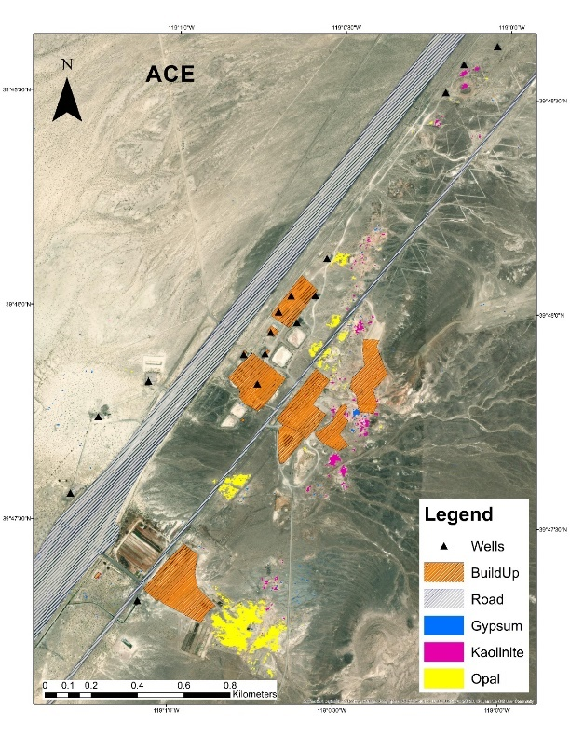 | 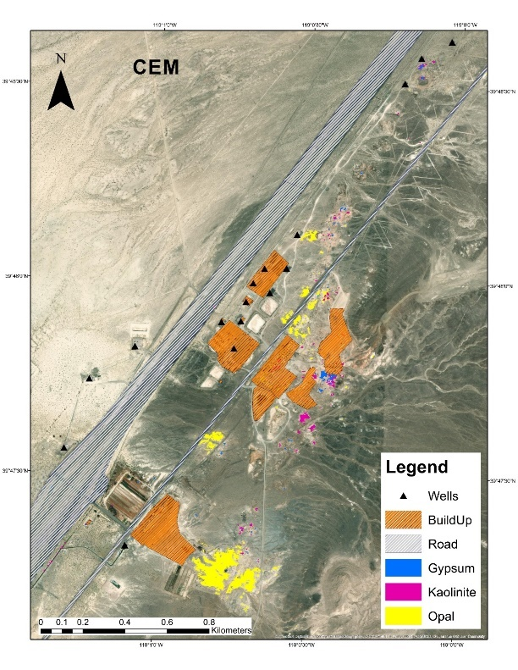
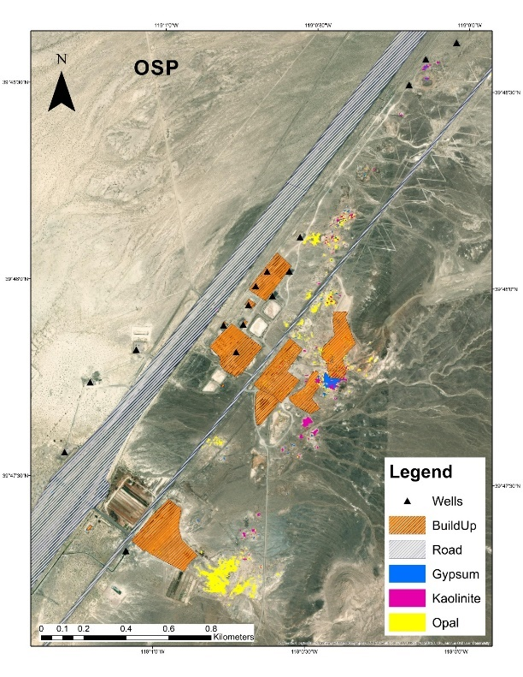 | 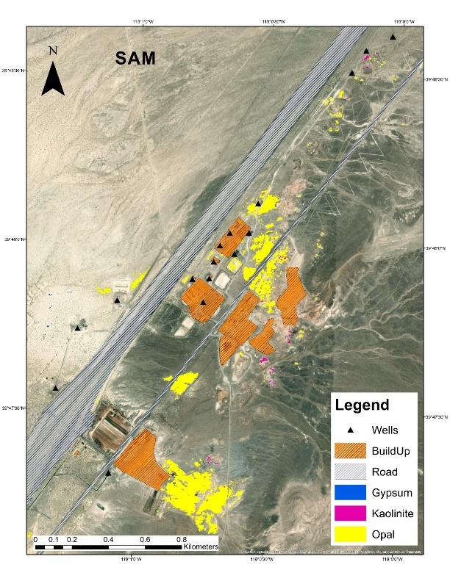
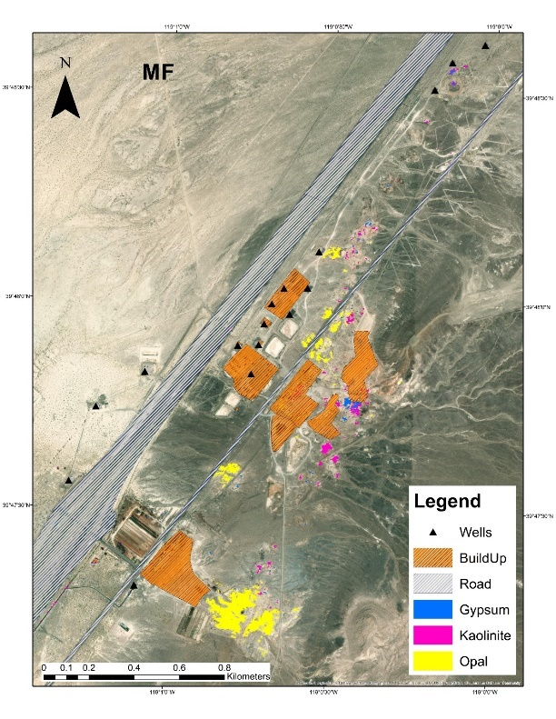 | 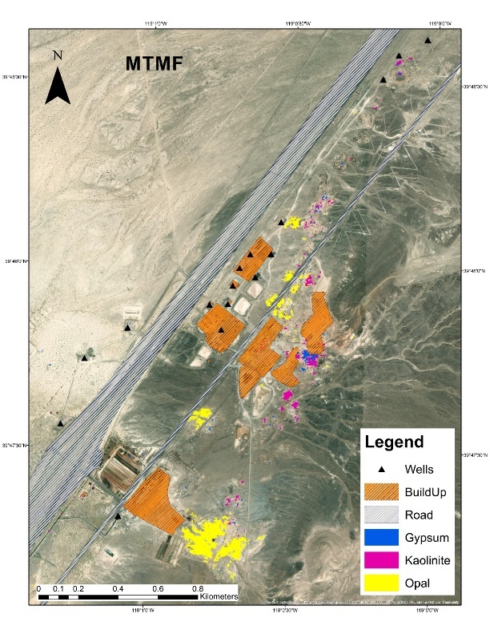
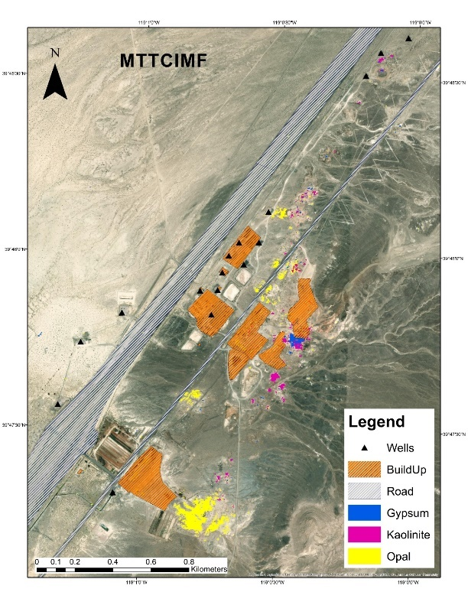 | 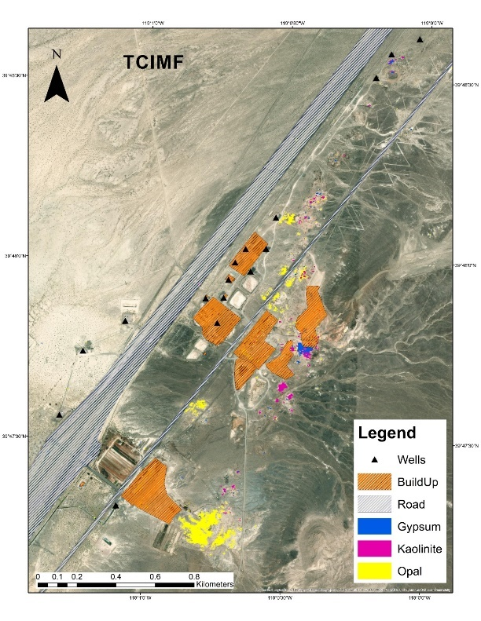

  - Post-processing
The post-processing was done for all the outputs of the analysis, and included:
- Elimination of isolated pixels: all pixels in a neighborhood kernel of 3 by 3 pixels must have at least a second pixel in the neighborhood to be accepted
- Selection of thresholds for the detection density maps (in the case of MTMF and MTTCIMF, points were selected based on high detection value and low infeasibility score)
- Comparison of all the algorithms for each specific mineral, correcting for outlier pixels or anomalous results. This was especially true on some of the SAM results as compared wit ACE, CEM and MF, where groups of markers would be present on just one or a subset of the algorithms
- Selection of consolidated or best result of the analysis: in some cases, a specific algorithm’s results were superior to the rest, (mainly CEM/MF or MTMF) but in other occasions a mix or voting of the different results was selected
- Collating of all the results of all the minerals in a single image: Having 2 or more mineral markers in a region increases the probability of the area being geothermal, therefore, all the results were consolidated by addition
- Creating areas of influence: a gaussian kernel was applied to each pixel, to create “areas of effect” of around 30 meters. This is done because a geothermal area covers a larger region than the markers found, and the gaussian kernel will reduce the effect as the distance from the marker increases
- Finally, standardization of the softened curves to values between 0 and 1

- Results
The following results correspond to the data inputs used for labeling and the AI’s in our analysis.
  - Mineral markers map for Brady

  - Mineral markers map for Desert Peak

  - Mineral markers map for Salton Sea

References
Abrams, Michael, Simon Hook, and Bhaskar Ramachandran. 2002. "ASTER user handbook, version 2." Jet propulsion laboratory 4800: 135.
Adams, P. M., Lynch, D. K., Buckland, K. N., Johnson, P. D., & Tratt, D. M. 2017. "Sulfate mineralogy of fumaroles in the Salton Sea Geothermal Field, Imperial County, California." Journal of Volcanology and Geothermal Research, 347 15-43.
Baldridge, A. M., S. J. Hook, C. I. Grove, and G. Rivera. 2009. "The ASTER spectral library version 2.0." Remote Sensing of Environment 113: 711–715. doi:10.1016/j.rse.2008.11.007.
Barbier, Enrico. 2002. "Geothermal energy technology and current status: an overview." Renewable and Sustainable Energy Reviews 6: 3–65. doi:10.1016/S1364-0321(02)00002-3.
Boardman, J. 1998. "Leveraging the High Dimensionality of AVIRIS Data for Improved Sub - Pixel Target Unmixing and Rejection of False Positives: Mixture Tuned Matched Filtering." Proceedings of the Seventh JPL Airborne Earth Science Workshop, JPL Publication 97-21.
Browne, P. R. L. 1978. "Hydrothermal Alteration in Active Geothermal Fields." Annual Review of Earth and Planetary Sciences 6: 229–248.
Calvin, Wendy M., and Elizabeth L. Pace. 2016. "Mapping alteration in geothermal drill core using a field portable spectroradiometer." Geothermics 61: 12–23. doi:10.1016/j.geothermics.2016.01.005.
Chang, Chein-I. 2003. Hyperspectral imaging: techniques for spectral detection and classification. Vol. 1. Springer Science & Business Media.
Chang, Chein-I., JihMing Liu, BinChang Chieu, Hsuan Ren, ChuinMu Wang, ChienShun Lo, Pau-Choo Chung, Ching-Wen Yang, and DyeJyun Ma. 2000. "Generalized constrained energy minimization approach to subpixel target detection for multispectral imagery." Optical Engineering 39. doi:10.1117/1.602486.
Cocks, T., R. Jenssen, A. Stewart, I. Wilson, and T. Shields. 1998. "The HyMapTM airborne hyperspectral sensor: the system, calibration and performance." Proceedings of the 1st EARSeL workshop on Imaging Spectroscopy. 37–42.
Drusch, M., U. Del Bello, S. Carlier, O. Colin, V. Fernandez, F. Gascon, B. Hoersch, et al. 2012. "Sentinel-2: ESA's Optical High-Resolution Mission for GMES Operational Services." Remote Sensing of Environment 120: 25–36. doi:10.1016/j.rse.2011.11.026.
Exelis Visual Information Solutions. 2010. ENVI Manual. Boulder, Colorado: Exelis Visual Information Solutions.
Helvacı, Cahit. 2015. "Geological features of Neogene basins hosting borate deposits: an overview of deposits and future forecast, Turkey." Bulletin of the Mineral Research and Exploration 151: 169–215.
Henley, R. W., and A. J. Ellis. 1983. "Geothermal systems ancient and modern: a geochemical review." Earth-Science Reviews 19: 1–50. doi:10.1016/0012-8252(83)90075-2.
Herdianita, Rina, P. R. L. Browne, K. A. Rodgers, and Kathleen Campbell. 2000. "Mineralogical and textural changes accompanying ageing of silica sinter." Mineralium Deposita 35: 48–62. doi:10.1007/s001260050005.
Huntington, Jonathan F. 2007. "The Role of Remote Sensing in Finding Hydrothermal Mineral Deposits on Earth." In Ciba Foundation Symposium 202 - Evolution of Hydrothermal Ecosystems on Earth (And Mars?), 214–235. John Wiley & Sons, Ltd. doi:10.1002/9780470514986.ch12.
Johnson, Steven E. 2003. "Constrained energy minimization and the target-constrained interference-minimized filter." Optical Engineering 42: 1850–1854. doi:10.1117/1.1571062.
Kelly, E. J. 1986. "An Adaptive Detection Algorithm." IEEE Transactions on Aerospace and Electronic Systems AES-22 (2): 115-127. doi:10.1109/TAES.1986.310745.
Kesler, Stephen E. 2005. "Ore-Forming Fluids." Elements 1: 13–18. doi:10.2113/gselements.1.1.13.
Kokaly, Raymond F., Roger N. Clark, Gregg A. Swayze, K. Eric Livo, Todd M. Hoefen, Neil C. Pearson, Richard A. Wise, William M. Benzel, Heather A. Lowers, and Rhonda L. Driscoll. 2017. "USGS spectral library version 7." USGS spectral library version 7.
Kratt, Chris, Wendy Calvin, and Mark Coolbaugh. 2006. "Geothermal exploration with Hymap hyperspectral data at Brady–Desert Peak, Nevada." Remote Sensing of Environment 104: 313–324. doi:10.1016/j.rse.2006.05.005.
Kratt, Christopher, Wendy M. Calvin, and Mark F. Coolbaugh. 2010. "Mineral mapping in the Pyramid Lake basin: Hydrothermal alteration, chemical precipitates and geothermal energy potential." Remote Sensing of Environment 114: 2297–2304. doi:10.1016/j.rse.2010.05.006.
Kraut, S., L. L. Scharf, and R. W. Butler. 2005. "The adaptive coherence estimator: a uniformly most-powerful-invariant adaptive detection statistic." IEEE Transactions on Signal Processing 53: 427–438. doi:10.1109/TSP.2004.840823.
Kruse, F. A., J. W. Boardman, A. B. Lefkoff, J. M. Young, K. S. Kierein-Young, T. D. Cocks, R. Jensen, and P. A. Cocks. 2000. "HyMap: an Australian hyperspectral sensor solving global problems-results from USA HyMap data acquisitions." Proc. of the 10th Australasian Remote Sensing and Photogrammetry Conference. 18–23.
Kruse, FA, AB Lefkoff, JW Boardman, KB Heidebrecht, AT Shapiro, PJ Barloon, and AFH Goetz. 1992. "The Spectral Image Processing System (SIPS): Software for integrated analysis of AVIRIS data."
L3Harris Geospatial Solutions. 2020. Target Detection Wizard. Accessed 10 28, 2020. https://www.harrisgeospatial.com/docs/targetdetectionwizard.html.
Littlefield, Elizabeth F., and Wendy M. Calvin. 2014. "Geothermal exploration using imaging spectrometer data over Fish Lake Valley, Nevada." Remote Sensing of Environment 140: 509–518. doi:10.1016/j.rse.2013.09.007.
Okamoto, Atsushi, Hanae Saishu, Nobuo Hirano, and Noriyoshi Tsuchiya. 2010. "Mineralogical and textural variation of silica minerals in hydrothermal flow-through experiments: Implications for quartz vein formation." Geochimica et Cosmochimica Acta 74: 3692–3706. doi:10.1016/j.gca.2010.03.031.
Pirajno, Franco. 2020. "Subaerial hot springs and near-surface hydrothermal mineral systems past and present, and possible extraterrestrial analogues." Geoscience Frontiers 11: 1549–1569. doi:10.1016/j.gsf.2020.04.001.
Reath, Kevin A., and Michael S. Ramsey. 2013. "Exploration of geothermal systems using hyperspectral thermal infrared remote sensing." Journal of Volcanology and Geothermal Research 265: 27–38. doi:10.1016/j.jvolgeores.2013.08.007.
Ren, Hsuan, and Chein-I. Chang. 2000. "Target-constrained interference-minimized approach to subpixel target detection for hyperspectral images." Optical Engineering 39: 3138–3145. doi:10.1117/1.1327499.
Satellite Imaging Corp. 2020. ASTER Satellite Sensor Specifications. Accessed 10 28, 2020. https://www.satimagingcorp.com/satellite-sensors/other-satellite-sensors/aster/.
Tratt, D. M., Young, S. J., Johnson, P. D., Buckland, K. N., & Lynch, D. K. 2016, August. "Multi-year study of remotely-sensed ammonia emission from fumaroles in the Salton Sea Geothermal Field." 2016 8th Workshop on Hyperspectral Image and Signal Processing: Evolution in Remote Sensing (WHISPERS). IEEE. 1-5.
Turin, G. 1960. "An introduction to matched filters." IRE Transactions on Information Theory 6 (3): 311-329. doi:10.1109/TIT.1960.1057571.
van der Meer, Freek, Christoph Hecker, Frank van Ruitenbeek, Harald van der Werff, Charlotte de Wijkerslooth, and Carolina Wechsler. 2014. "Geologic remote sensing for geothermal exploration: A review." International Journal of Applied Earth Observation and Geoinformation 33: 255–269. doi:10.1016/j.jag.2014.05.007.
Vane, Gregg, Robert O. Green, Thomas G. Chrien, Harry T. Enmark, Earl G. Hansen, and Wallace M. Porter. 1993. "The airborne visible/infrared imaging spectrometer (AVIRIS)." Remote Sensing of Environment 44: 127–143. doi:10.1016/0034-4257(93)90012-M.

Appendix

Target detection results for Brady
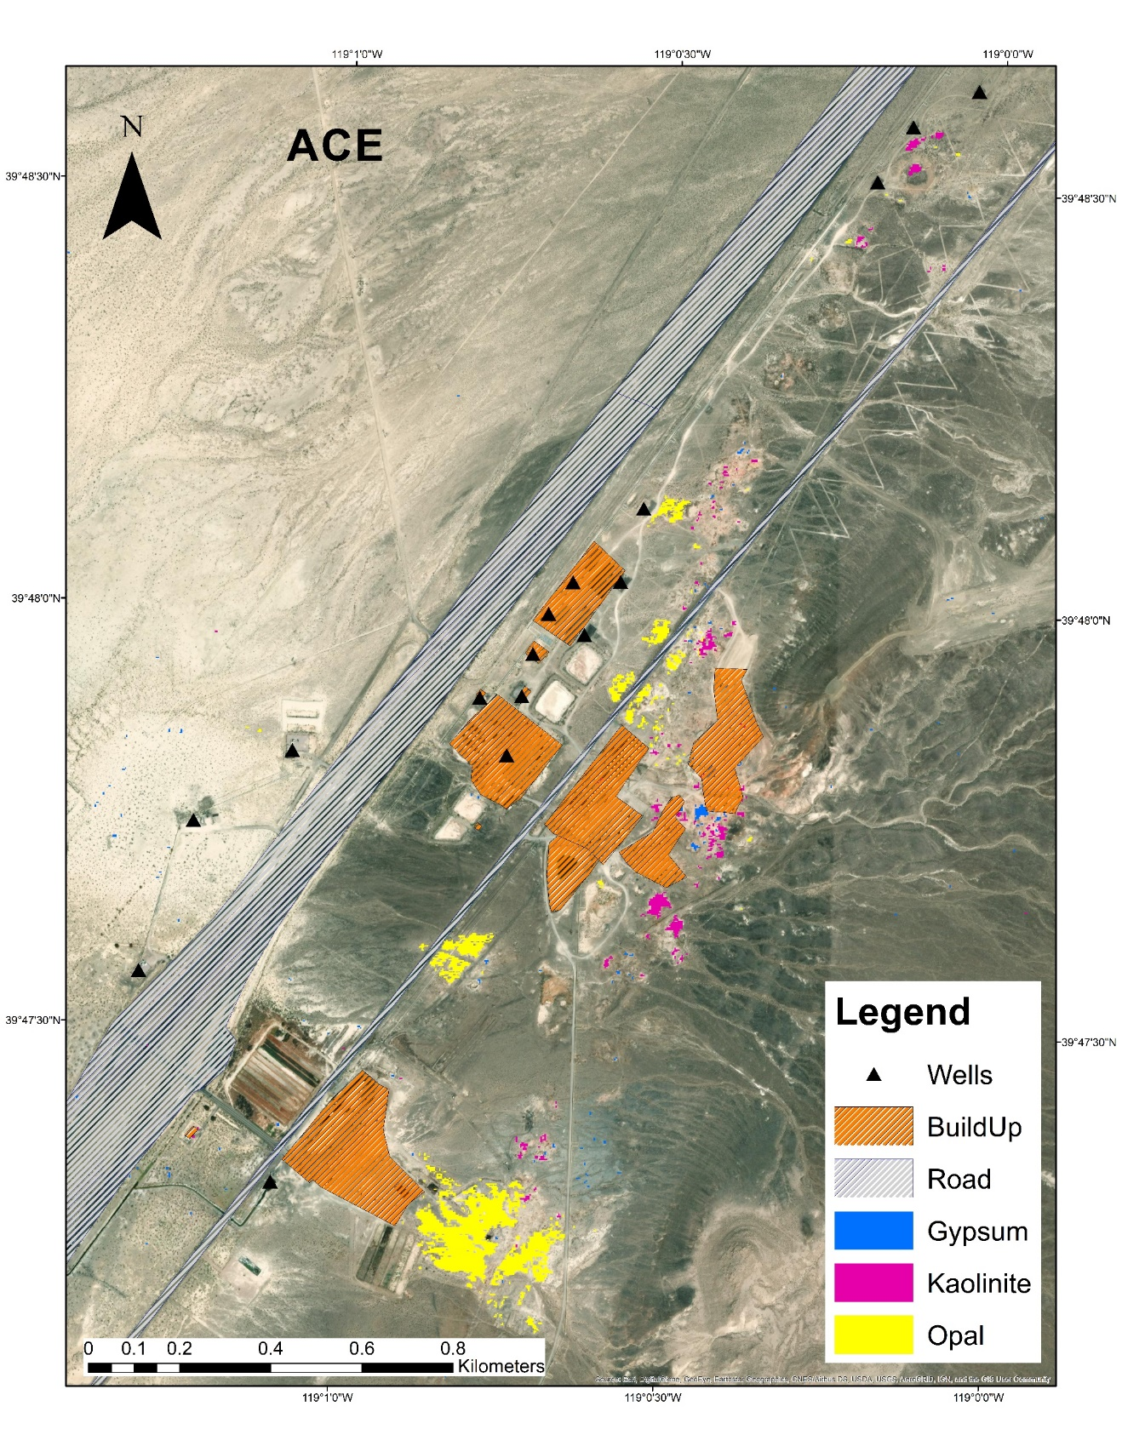
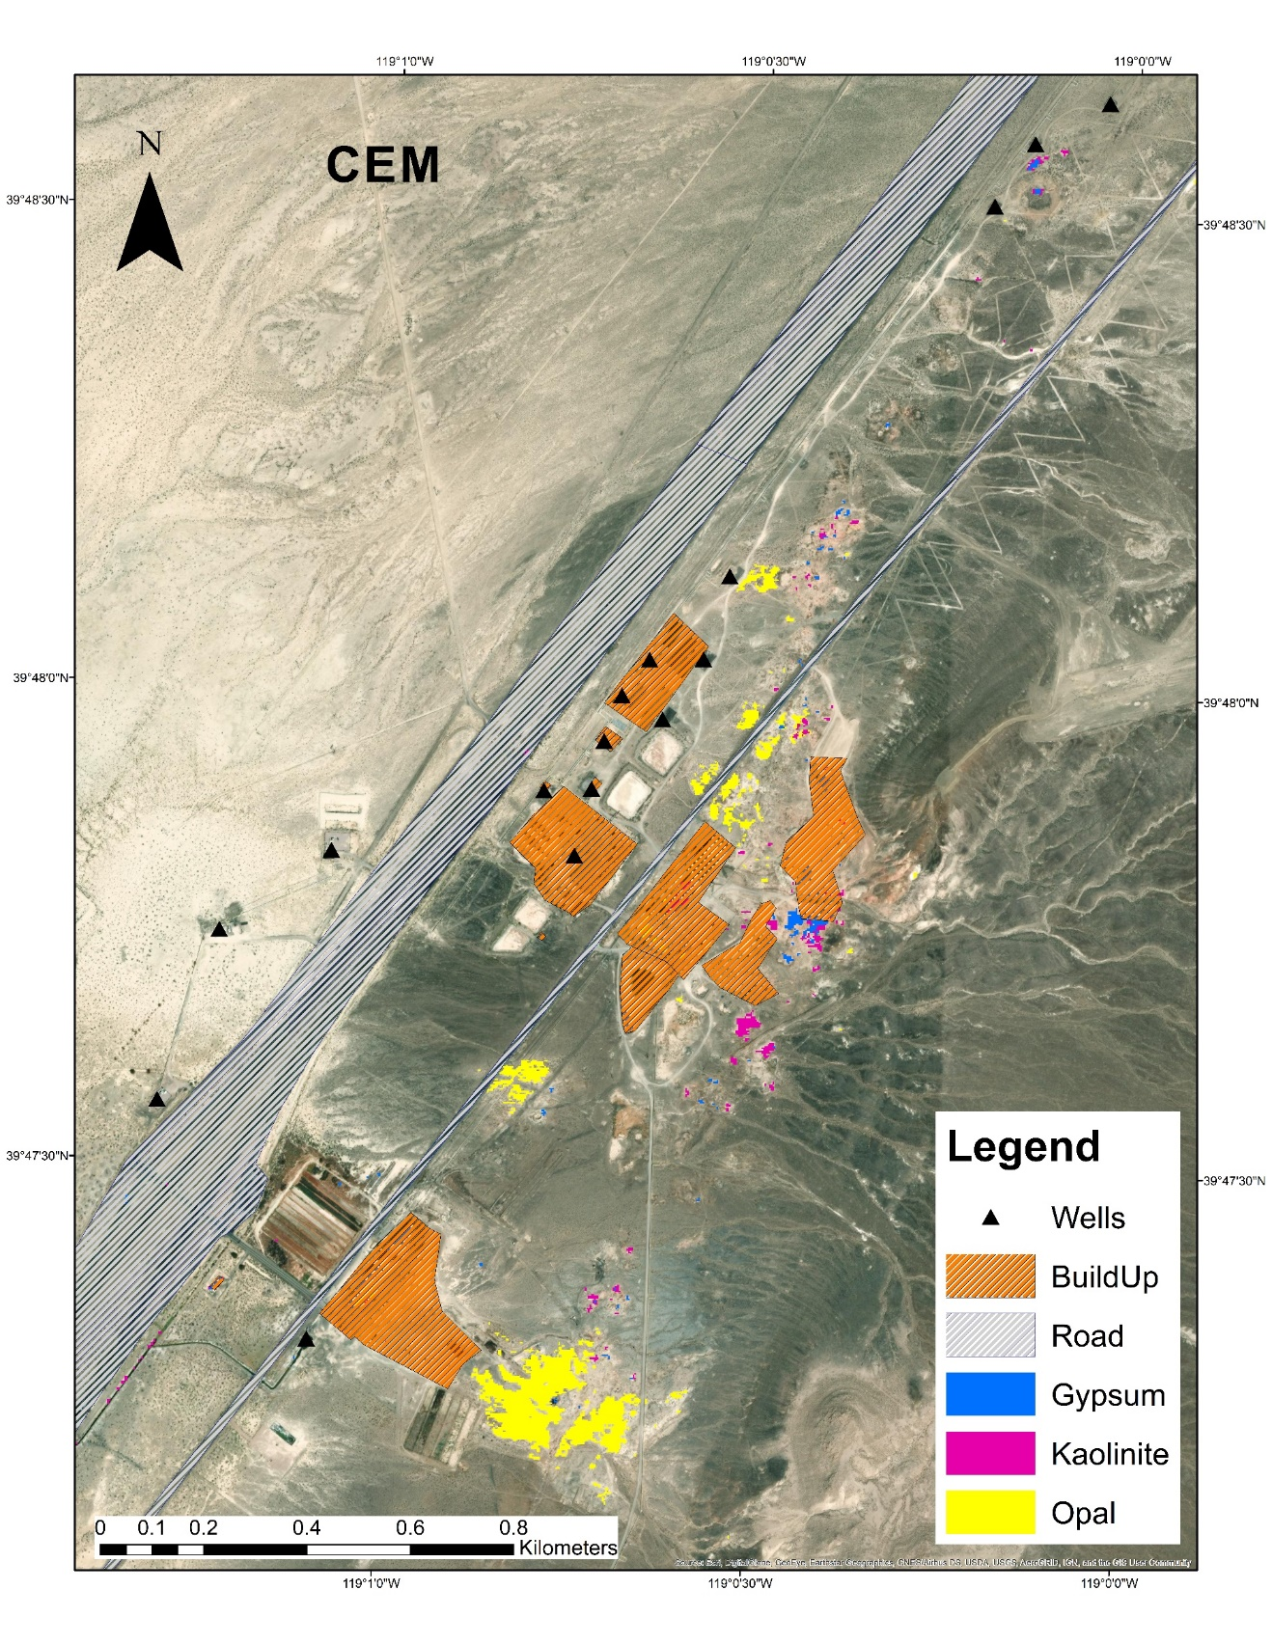
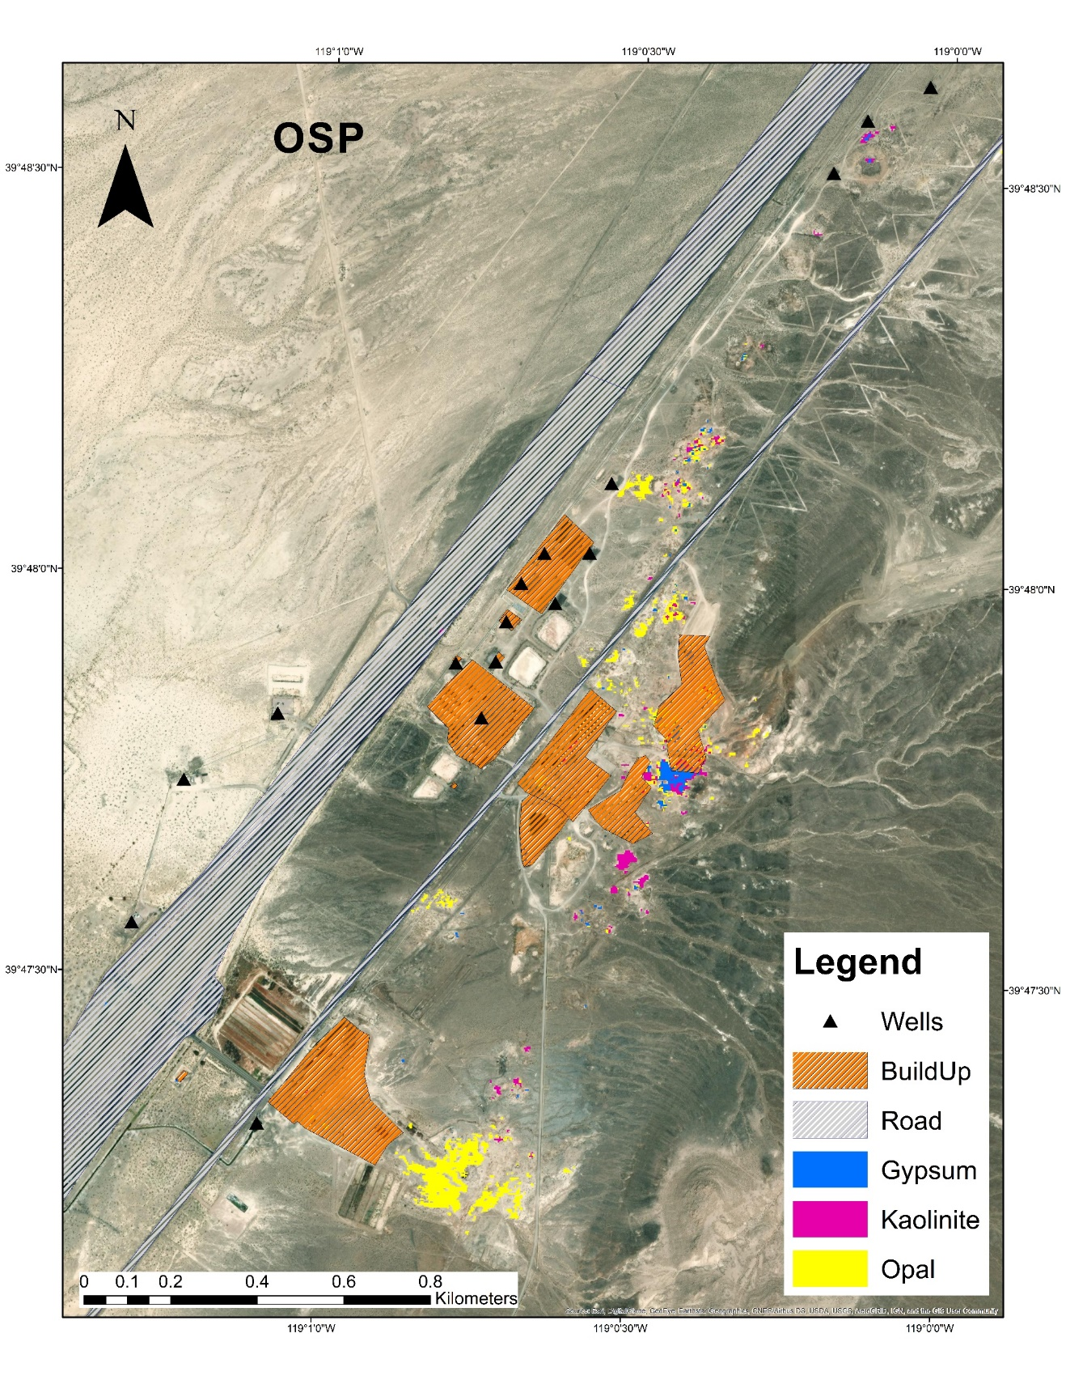
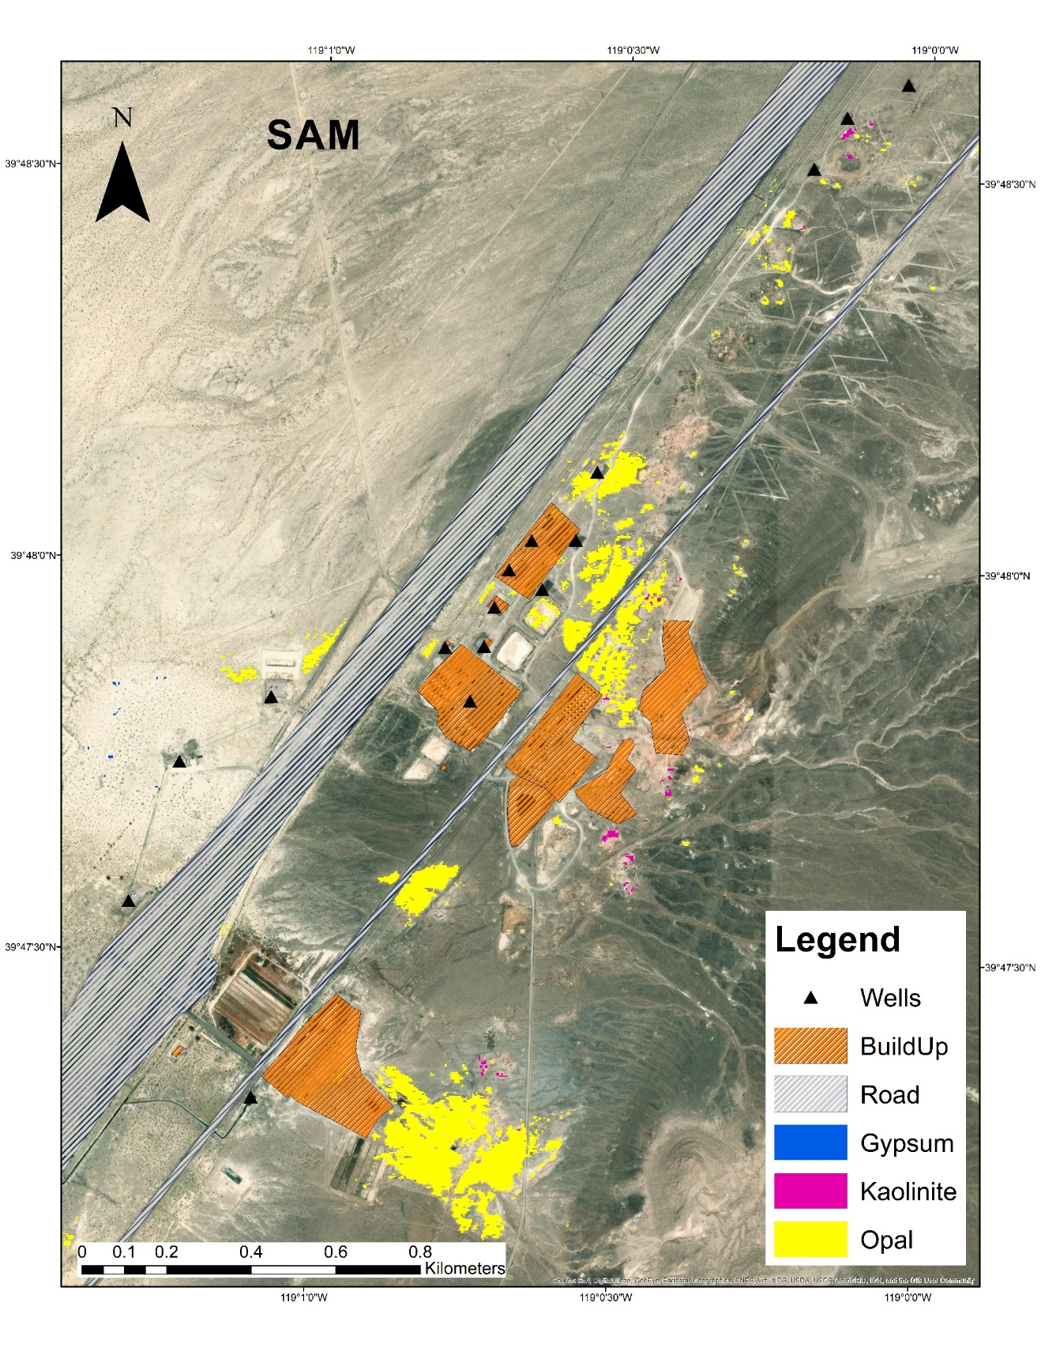
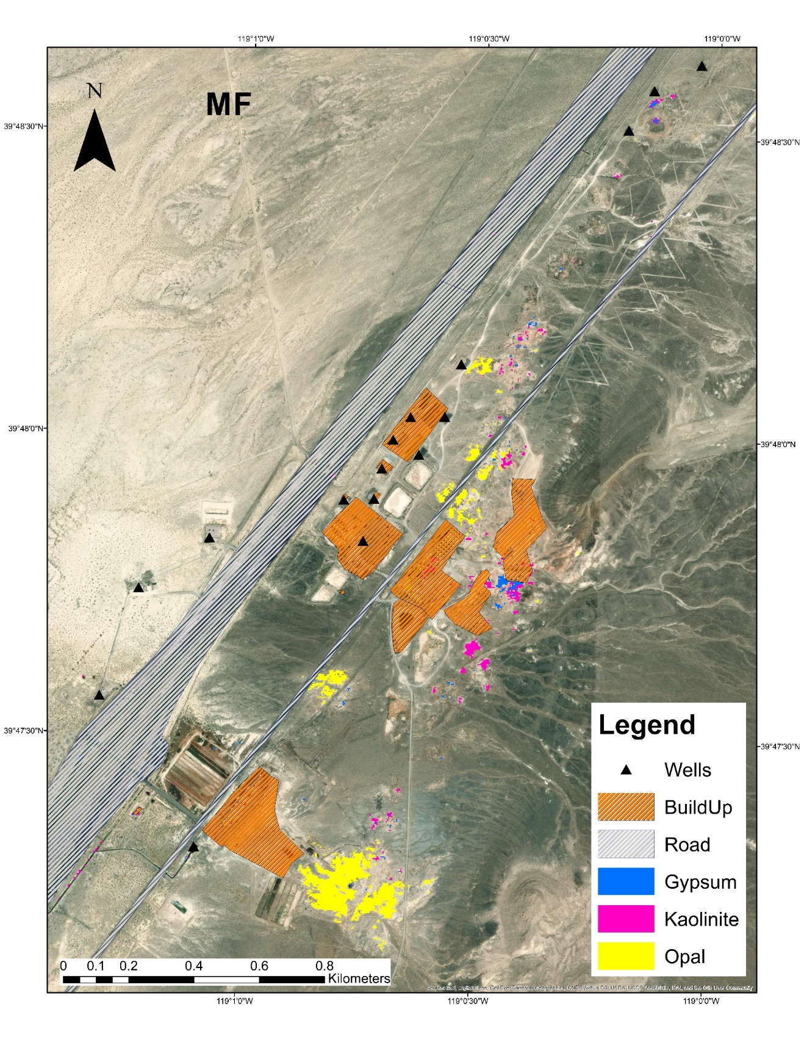
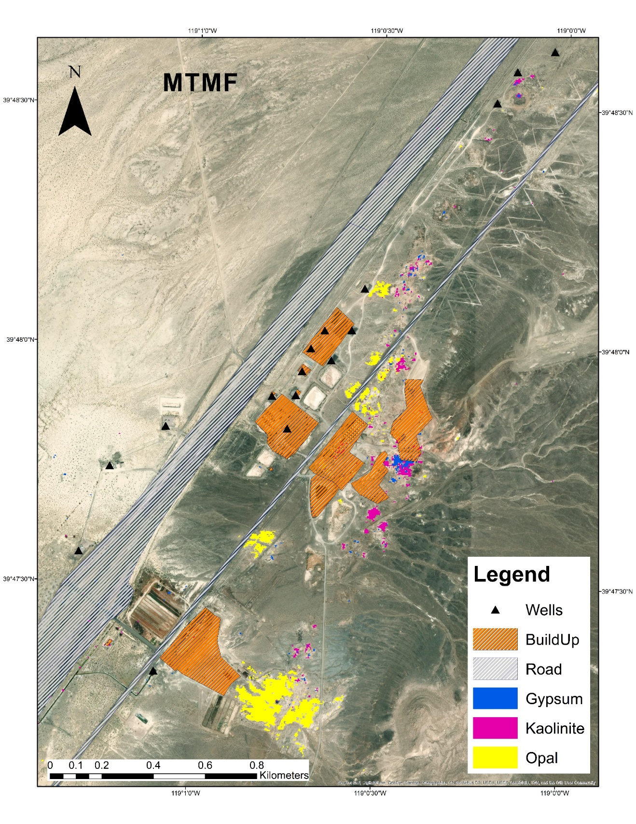
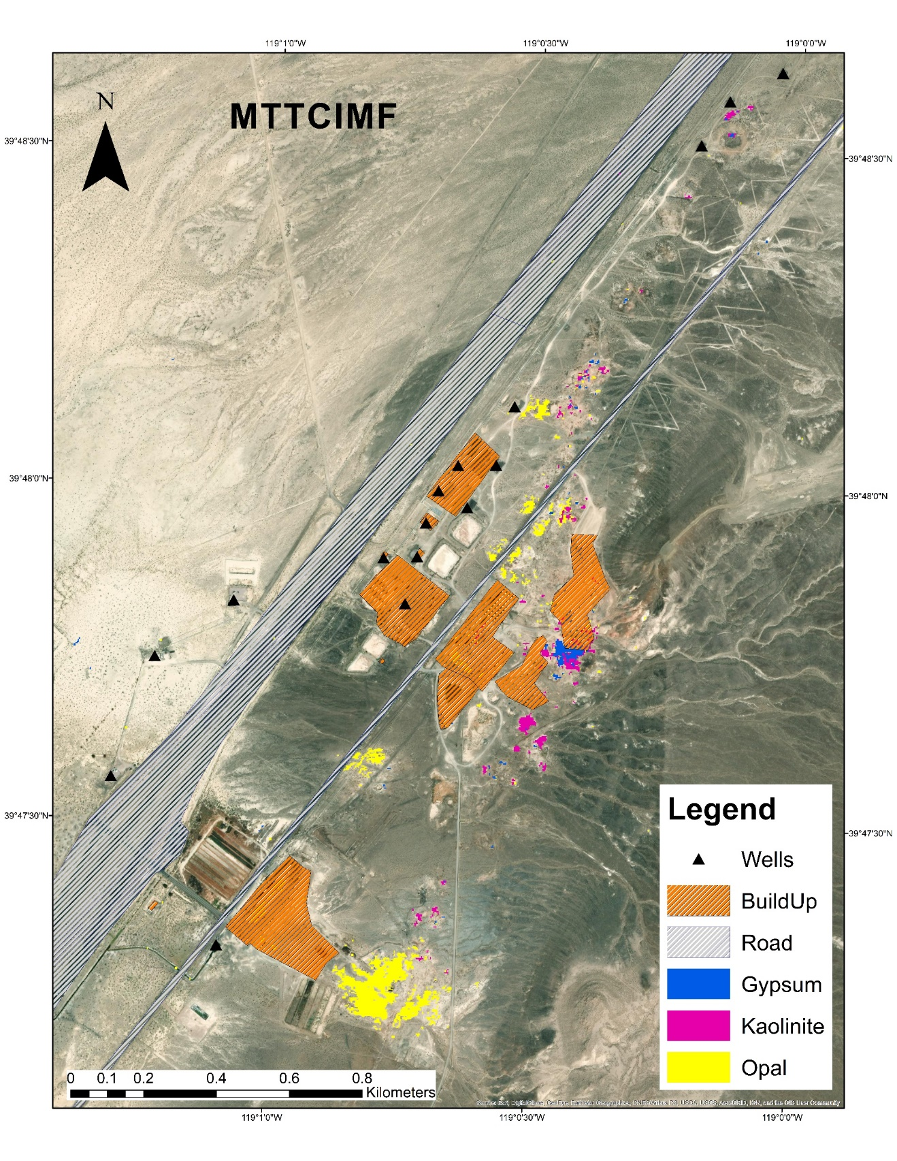
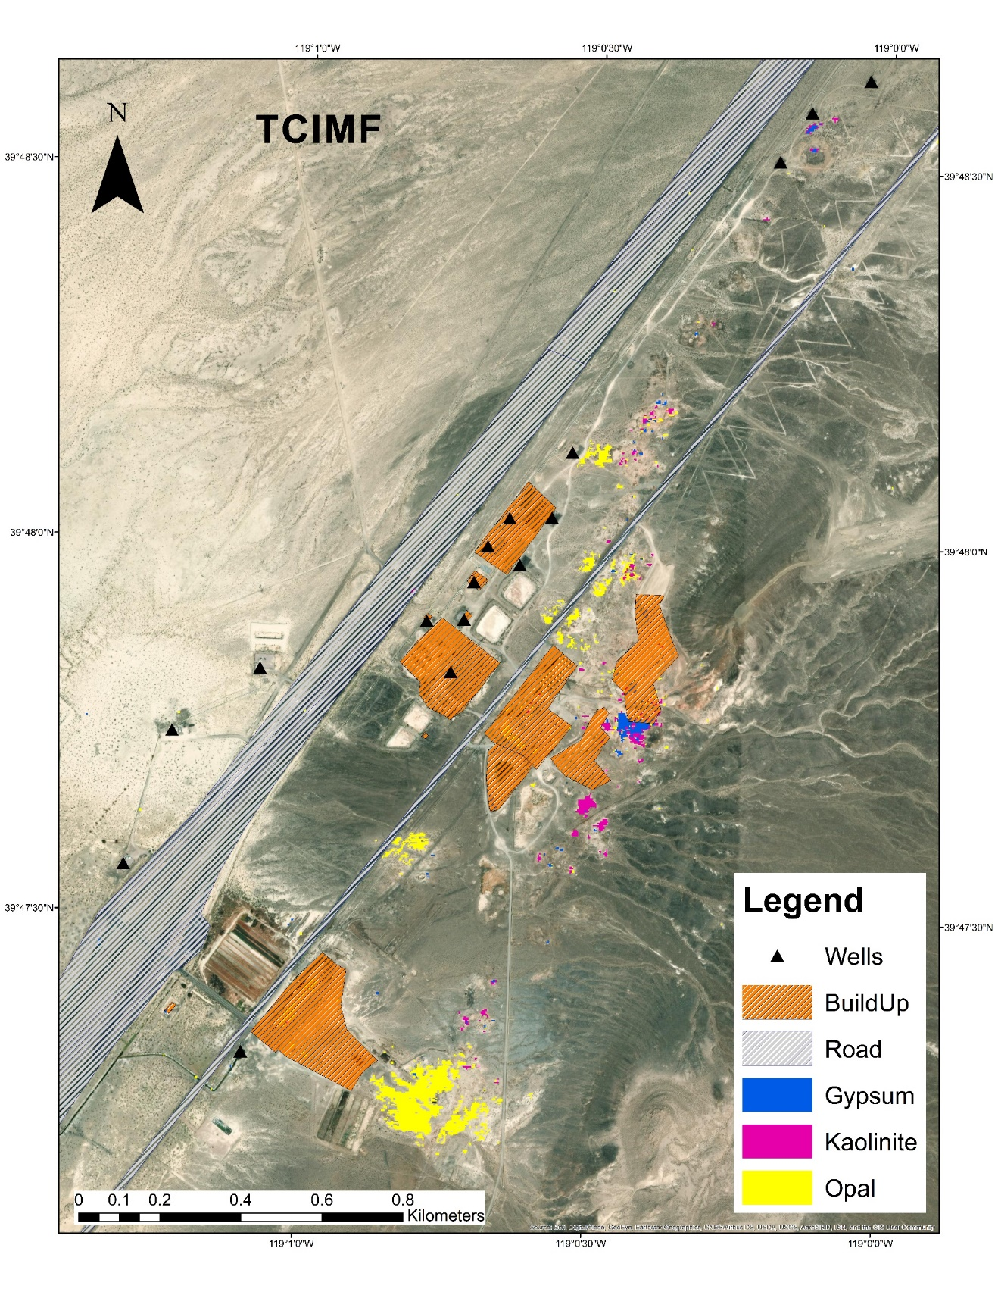

Target detection results for Desert Peak

Target detection results for Salton Sea

