Mineral Alterations Due to Geothermal Activity
Geothermal resources are located in the regions of high crustal heat flow, which might be associated with existing young igneous bodies or hot rocks in deep crust (van Der Meer et al., 2014). Through the remote sensing applications, geothermal mapping is implemented by incorporating surface deformations, gaseous emissions, structural analysis linked with stratigraphy, mineral mapping, vegetation stress as well as temperature mapping & heat flux measurements. Surface temperature variations correlated with geothermal heat, heat flux maps for determining geothermal anomalies as well as vegetation stress due to the accumulation of geothermal gases (SO₂, H₂S, CO₂) and are some examples as to why/how remote sensing could be instrumental in the context of geothermal systems (van Der Meer et al., 2014). In addition, surface deformation mapping with SAR interferometry is also a good indicator as it relates to geothermal activity in the site of interest that is perceivable by sensors.
Hyperspectral imaging sensors collect high spectral/spatial information, which is significantly essential for the identification of materials in the captured scene. According to Huntington (1996), the typical hydrothermal systems accommodate hydroxyl bearing clays, sulfate, carbonates, and sinters, all of which have diagnostic absorption feature in the captured imaging spectrum. As the geothermal fluids circulates through the openings (i.e. cracks), the minerals along their way are dissolved. This dissolved load is precipitated with the cooling of geothermal water as the circulation reaches to surface, generating the potential for formation of new alteration minerals (Glassley 2010). These minerals are listed as:
- Siliceous sinters encompassing various forms of silica deposited by high-temperature fluids (>175 ⁰C);
- Travertine, which is mainly calcium carbonate deposited by lower temperature geothermal fluids;
- Borates, sulfates, and chlorides (Glassley 2010).
The manifestation of alunite, kaolinite and iron oxides along with some pyrite occurrences are listed as some of the most common minerals observed in the steam-heated surface of geothermal systems. Carbonate-low anomalies occurring due to oxidizing environment in the near surface are also mentioned as an indicator of geothermal resources (van Der Meer et al., 2014).
In the same manner, thermal hyperspectral images are utilized for detecting altered minerals, by utilizing the absorption features of emissivity signatures, which are also called ‘restrahlen’ features. Due to the inherent molecular vibrations of anion groups, silicates, carbonates, sulfates, phosphates, and hydroxides include aforementioned emissivity minima, which make them detectable also in long wave infrared region (LWIR) of electromagnetic spectrum (EMS). Riley et al. (2008) mentions that the complementary utilization of visible (VIS), short wave infrared (SWIR) and long wave infrared (LWIR) provides a great opportunity for mapping indicator mineral related to geothermal systems unambiguously. In Figure 1, minerals of interest for geothermal mapping together with their occurrence temperatures are presented.

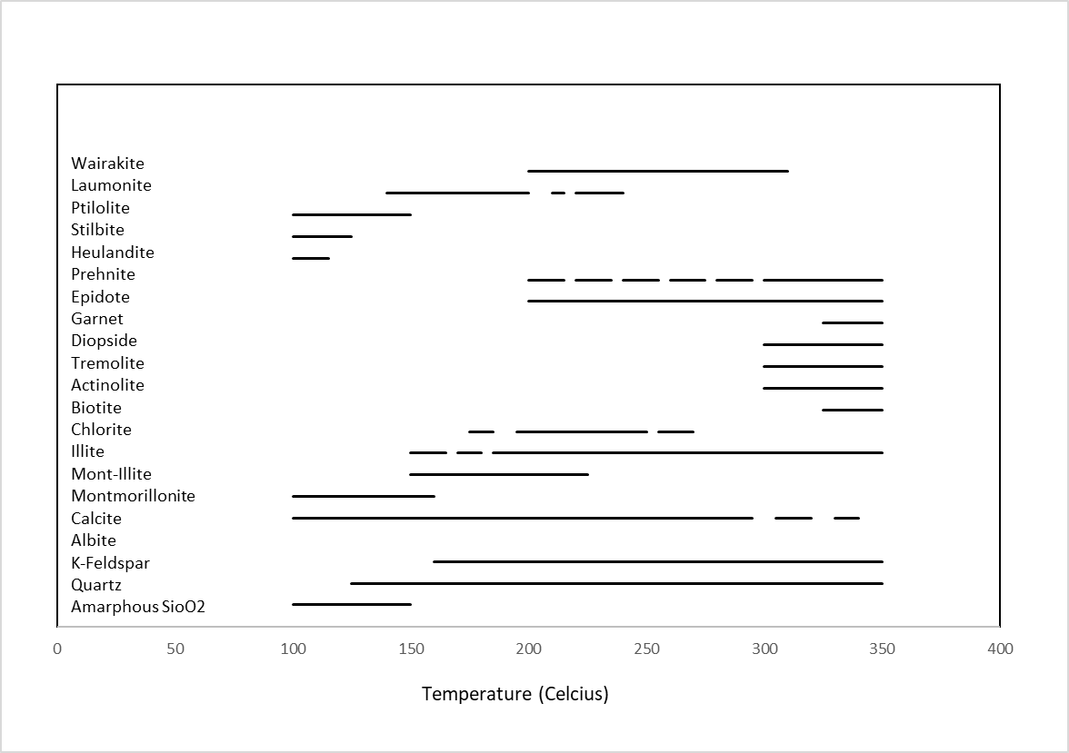
Figure 1 Key alteration minerals associated with geothermal systems and their temperature stability (Modified from Henley and Ellis (1983))
In the studies of Browne (1978) and Henley and Ellis (1986), the mineral alterations are associated with the temperature stability of geothermal systems. Some key mineral alterations in relation with the temperature are stated as below:
- In the lower ranges (below 100 °C), temperature ranges zeolites and montmorillonite is stable (Henley and Ellis, 1986).
- At 200◦C illite appears and at temperature in the range of 300°C waikarite appears (Henley and Ellis, 1986).
- In calcite-rich systems, above 250◦C epidote appears while above 300◦C calcite is altered to actinolite and diopside (Henley and Ellis, 1986).
- Detrital montmorillonite below 100 °C converts to illite, montmorillonite and then to K -mica below 210°C (Browne, 1978).
- Ankerite can form as low as 120°C, and chlorite, calcite, and CO2 are produced below 180°C in response to reaction between dolomite, ankerite, and kaolinite plus Fe²⁺ added from the brine.
- Fe epidote and K-feldspar are abundant above 290°C, but calcite disappears at about this temperature (Browne, 1978).
- Detrital quartz, calcite, K-feldspar, plagioclase, montmorillonite, illite, dolomite, and kaolinite,
is mentioned to gradually convert, in response to increasing temperatures, to an assemblage above 300°C of quartz, Fe-epidote, chlorite, K-feldspar, albite ± K-mica, pyrite, sphene, sphalerite, and hematite (Browne, 1978).
In Littlefield and Calvin’s study (2014), geothermal mineral indicators in the Nevada Great Basin are stated as alunite, kaolinite, opal, calcite, muscovite, montmorillonite, chlorites, gypsum and tincalconite. Here are some critical information about the minerals and their indications with geothermal activity.
- Alunite can indicate alteration of potassium feldspars as a reaction with sulfuric acid or it may form from fumarolic activity.
- Kaolinite may be a product of argillic alteration of feldspars, a low temperature reaction which may result from acidic thermal fluids moving through the rock, or chemical weathering.
- Opal is an amorphous silica gel deposited in low temperature environments; it may fill fractures or form siliceous sinter deposits surrounding hot springs.
- Calcite (or aragonite) can be an important geothermal indicator as it may represent travertine and tufa deposits.
- Muscovite and montmorillonite may be related to geothermal activity or weathering and cannot be used as decisive indicators of hydrothermal alteration.
- Chlorites may be a product of propylitic alteration of amphibole, pyroxene, and biotite.
- Gypsum and tincalconite are evaporites deposited by sulfur- and borate-rich springs, respectively.

Study Areas
Determining the geometry, pattern, segments and kinematics of fault structure is of primary importance to locate geothermal field as they are significantly controlling the geothermal activities. Not only this knowledge will help to identify potential/hidden sources or to aid exploratory drilling operations but also selecting the best fields for enhanced geothermal systems (Faulds et al., 2010).
Salton Sea
With its plate/tectonic and geological structure, Salton Sea geothermal field (SSGF) has been studied in the literature extensively. The region is a well-known geothermal field due to its peculiar structural setting, located in Salton Trough basin, which is identified as a tectonically active pull-apart sedimentary basin. These tectonic movements have caused complex structural settings including rising/subsidizing zones in different sides of the fields, rhyolitic domes, different geological structures, strike-slip faults or geochemical anomalies (Kaspereit et al., 2016). SSGF reaches around 20 km² area (Reath and Ramsey, 2013), with a power generation potential of 2330 MW_{e}, putting it as the largest geothermal field in the United States (Hulen et al., 2002). High temperature geothermal heat resources are identified as gabbroic, with granitic sources in the upper crust as significant candidate that should also be taken into consideration. The production fluids are stated as brines, which has resulted from dissolution during the flooding of the basin by Colorado river as well as the salinization due to the evaporation in Salton sea or the prior water body in the area (Hulen et al., 2002). In the field, new geothermal areas are exposed due to the decrease in the Salton Sea level.

The Salton Sea geothermal system, a sediment filled rift valley, is identified as unusually hot, high-temperatures reaching up to at least 390°C at 2 km depth, hypersaline with values up to 26 wt.%, and metalliferous, including Fe, Zn, Pb, Cu. The reservoir system has an average depth of 1750 m, with geothermal features such as hot springs, mud pots, mud pools, and mud volcanoes. The permeable faults, porous sandstones in alluvial and sedimentary layers in Salton Trough as well as existing fracture sturctures allow in-system circulations. The reservoir field was developed in early 80s, reaching to the northwest beneath the Salton Sea. Within the Salton trough, extension zones among active right-stepping right-lateral strike-slip faults cause mantle-derived magmas intrusion to the sedimentary sequence, serving as heat sources to drive hydrothermal systems (Younker et al., 1982; Hulen et al., 2003).
Brady’s
The Brady Hot Springs geothermal area is in the Hot Spring Mountains of north-western Nevada, 80 km east-northeast of Reno. This Great Basin is well-known for hosting several geothermal fields, including major the Brady’s, Desert Peak, and Desert Queen geothermal fields (Faulds et al., 2010; Ali et al., 2016). These regions are of high proximity to each other by equally interleaved, steeply dipping, en echelon NNE-striking normal fault zones. Although the Desert Peak and Desert Queen are identified as blind systems, and geochemical analysis suggest that each system is independent from the other, it’s reported that Desert Peak and Brady’s are linked with thermal plumes at lower/shallow depths (Faulds et al., 2010). The production (15 MW power capacity) has been continuing at Brady’s since 1992, from the with six wells lying over the normal fault system (Faulds et al., 2010; Ali et al., 2016) form depths of 400 – 1850 meters. Both Desert Peak and Brady’s are identified as high enthalpy systems (175-215°C) with operating power plants (Witter et al., 2016).
The region is comprised of late Oligocene to late Miocene volcanic and sedimentary rocks that rest directly on Mesozoic metamorphic and granitic basement (Faulds et al., 2010). The Brady’s Geothermal field is located in layered Tertiary volcanic rocks including rhyolite, welded tuff and meta-sediments that overly noncomformably the Mezosoic sediments (Ali et al., 2016). As mentioned earlier, the Hot Spring Mountains are separated by NNE-striking normal fault systems, each of which is interrelated to a separate geothermal anomaly. In contrast to mentioned blind reserves, Brady’s is reported to have surface expressions for 4-km-long, NNE-trending zone of extensive sinter, warm ground, fumaroles, and mud pots along the Brady’s fault (Coolbaugh et al. 2004; Faulds et al., 2010). According to Winters et al. (2016)., the north-northeast striking, west-northwest-dipping Brady’s fault zone is pointed out as the controlling structure for the Brady’s geothermal field (Faulds et al. 2004).
Desert Peak
As mentinoned earlier, Desert Peak geothermal field is a blind geothermal system that has no surface hot springs or fumaroles, in contrast to Bradys. The temperature of the water in the production wells is reported be around 215°C, matches its geochemical thermometers indicating the upwelling zone has successfully been tapped. Theresercoir is classified as a moderated temperature one,with an average depth of 1021 m, with relict hydrothermal alterations. The Desert Peak area is again dominated by the aforementioned NNE-trending gently to moderately ESE-tilted fault blocks bounded by moderately to steeply WNW-dipping normal faults. For the geothermal activity, Rhyolite Ridge fault zone (WNW), which consists of several strands and steps to the left in the vicinity of the geothermal field, is referred as the most influential fault system, whose displacement reaches southward as much as 840 m. In addition, there appears to be no surface evidence for a horst block in the Desert Peak area and the major left step in the Rhyolite Ridge fault zone is responsible for the geothermal field at Desert Peak. The productuion wells are located along this region that possibly has high-fracture density subvertical cunduits, improving the fluid flow and the rise of thermal plumes located at greater depths. In addition, NNE striking fault zone is located orthogonal to the WNW extension direction and is again facilitates the fluid flow to the surface (Faulds et al., 2010; Faulder and Johnson, 1987).
Remote Sensing Applications in the Focused Sites
Imaging spectrometers make available narrow, hundreds of bands collected over the electromagnetic spectrum, providing detailed information for identification of materials. The reflective and emissivity properties of the materials are recorded collected via hyperspectral sensors in visible, short wave and long wave infrared regions of the spectrum. Identification of targets within the collected imageries can be applied as in binary classification, identifying each pixel in the scene as target or background. The assessment techniques differ than regular classification instances, as only some number of pixels are labeled as the anomalies or target within the scene. This condition in fact relies on the Neyman–Pearson criterion that maximizes the detection rate for any fixed false alarm rate (Nasrabadi, 2014).
Apart from mineral mapping, surface anomalies can also be highlighted in the fields of interest with the help of thermal imageries collected within the range of 8–14 μm wavelength region. The interpretation can simply be conducted with visual assessments by using different thresholds as well as with anomaly detection techniques. The potential applications of LWIR images to determine temperature anomalies in geothermal fields can put forward the hot rocks lying over the faults, hot waters and springs.
A recent study conducted by Reath and Ramsey (2011) makes use of a high spectral/spatial resolution hyperspectral images (SEBASS) to map the surface mineral anomalies related to the geothermal field in Salton Sea. The thermal mineral signatures of quartz, gypsum, microcline, anhydrite, smectite, epsomite are investigated with an additional unknown spectra extracted through the analysis. The unknown mineral is associated with the surface and ground water activity, and identified as a Mg-sulfate with a changing nature. Davis-Schrimp geothermal field covering mud pots, volcano like gryphones and Sandbar geothermal field are analyzed within the scope of this research. Tratt et al. (2011) also studied in the same region for mapping ammonia emission from the fumarolic vents with the help of thermal SEBASS data as well. According to the generated outputs, authors indicate the compatibility between the emission of free ammonia due to geothermal activity and thermal hot spots associated with fumaroles along a known fault line.
In the same manner, Adams et al. (2016) have utilized another LWIR hyperspectral sensor (MAKO) to map the distribution of sulfates emitting ammonia in the newly exposed fumaroles. The concentration of some minerals similar to a discontinuous ring shape has made their detection more effective. The distribution of the identified minerals from outwards to inwards are mascagnite/boussingaultite, gypsum, nitratine and bloedite. The authors report the high compatibility between the ground truth data and research outputs.
In the study conducted by Kratt et al., (2006) in the Brady’s site, carbonate minerals, kaolinite, opal/chalcedony, siliceous deposits and sinter are elaborated in detail as being minerals identified in relation with geothermal activities. Out of several geothermal-related minerals (sinter, tufa, and sulfates) that have diagnostic features in visible and short wave infrared, they were able to map occurrences of gypsum, calcium–carbonate, hematite, and opaline silica. These minerals were found in both of the studied regions, one having surface anomalies such as fumaroles/mud pots and the other one with no surficial expressions. Detectability of these minerals via short wave and long-wave imaging spectrometer data as well as benefiting from auxiliary field information is stated to facilitate locating the geothermal systems. The identified indicators for Brady–Desert Peak geothermal fields are also associated with structural units of faults/faults segments that also made it possible to set the relations between them.
Coolbaugh et al., (2007) also worked in the same area to map surface temperature anomalies, which are related to geothermal activities in the region with the help of Advanced Space borne Thermal Emission and Reflection Radiometer (ASTER) thermal infrared (TIR) image. In order to differentiate the geothermal activity related anomalies, the image is processed for thermal inertia corrections by removing diurnal heating, topographical and albedo effects. These operations decreased the temperature variability (30-50 %) in the background, while keeping the geothermal anomalies stable.
As mentioned earlier, Littlefield and Calvin (2014) described the geothermal mineral indicators in the Nevada Great Basin as alunite, kaolinite, opal, calcite, muscovite, montmorillonite, chlorites, gypsum and tincalconite. Among these, kaolinite and opal is attributed to low temperature environments due to acidic thermal fluid movements, forming sinters around hot springs respectively. Calcite is pointed out as a significant a significant indication of geothermal activity, showing itself with travertine and tufa deposits.

