DCIF_Task3-1_StressTest_Westerly_Metadata.txt
Location Datafiles
File Name | X-direction stress | Y-direction stress
DCIF_Task3-1_Location_blockC.TXT | 11.6 MPa | 11.6 MPa
DCIF_Task3-1_Location_blockD.TXT | 5.8 MPa | 5.8 MPa
DCIF_Task3-1_Location_blockE.TXT | 2.9 MPa | 2.9 MPa
DCIF_Task3-1_Location_blockF.TXT | 5.8 MPa | 11.6 MPa

File content descriptions
Column#(s) | Title | Description
1 | Time(s) | Logging time ¹⁾
2 | T0offset(s) | Determined source time against trigger time
3-5 | x(m) y(m) z(m) | Source location
6 | Error(s) | Location error in travel time (RMS)
7-9 | X Y Z | Ohtsu’s moment tensor classification parameters  (computed from a moment tensor) ²⁾
10 | RelativeAmp | Absolute value of the largest moment tensor eigenvalue
¹⁾ Time stamp offset : 180s (Liquid nitrogen poured at T=180s in the file)
²⁾ J. Geol. Res. 96, B4, 6211-6221, 1991

DCIF_Task3-1_Westerly_blockC_AEmovie.avi
DCIF_Task3-1_Westerly_blockD_AEmovie.avi
DCIF_Task3-1_Westerly_blockE_AEmovie.avi
DCIF_Task3-1_Westerly_blockF_AEmovie.avi
Animation of located AE events in the sample over time.

DCIF_Task3-1_blockC_Thermocouple.TXT
Thermocouple temperature readings as a function of time. Time T=0s is when liquid nitrogen was poured.
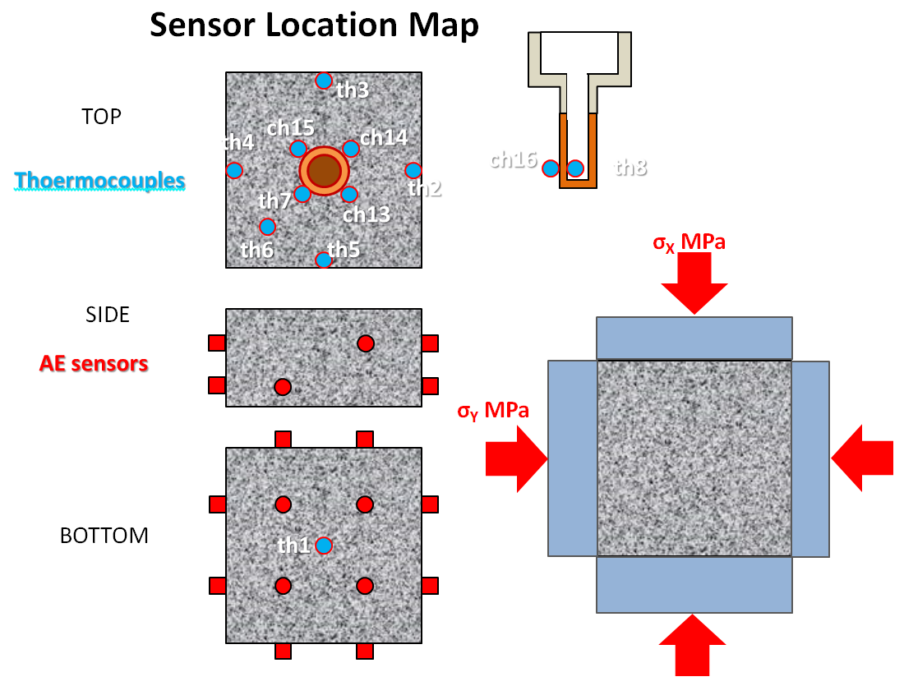
Column#(s) | Title | Description
1 | Time(s) | Logging time
2 | Date&Time | Date and Time
3-14 | th1 th2 th3 th4 ch5 ch6 ch7 ch8 th13 th14 th15 th16 | Thermocouple channel readings (in degree C)

DCIF_Task3-1_Time vs AE rate summary.TIF
Graphical presentation of the time vs AE rate
DCIF_Task3-1_Time vs cumulative AE count summary.TIF
Graphical presentation of the temperature vs cumulative AE counts

