DCIF_Task3-0_BoreholeDamageTest_Westerly_Metadata.txt
Location Datafiles
File Name | Pre-test heating temperature
DCIF_Task3-0_Location_blockG.dat | 600˚C
DCIF_Task3-0_Location_blockH.dat | 400˚C
DCIF_Task3-0_Location_blockI.dat | 200˚C
Applied biaxial stresses are all 5.8 MPa
File content descriptions
Column#(s) | Title | Description
1 | Time(s) | Logging time ¹⁾
2 | T0offset(s) | Determined source time against trigger time
3-5 | x(m) y(m) z(m) | Source location
6 | Error(s) | Location error in travel time (RMS)
7-9 | X Y Z | Ohtsu’s moment tensor classification parameters  (computed from a moment tensor) ²⁾
10 | RelativeAmp | Absolute value of the largest moment tensor eigenvalue
¹⁾ Time stamp offset : 180s (Liquid nitrogen poured at T=180s in the file)
²⁾ J. Geol. Res. 96, B4, 6211-6221, 1991
AE animation/movie
File Name | Pre-test heating temperature
DCIF_Task3-0_Westerly_blockG_AEmovie.avi | 600˚C
DCIF_Task3-0_Westerly_blockH_AEmovie.avi | 400˚C
DCIF_Task3-0_Westerly_blockI_AEmovie.avi | 200˚C
Applied biaxial stresses are all 5.8 MPa
Animation of located AE events in the sample over time.

Temperature History Files
File Name | Pre-test heating temperature
DCIF_Task3-0_blockG_Thermocouple.TXT | 600˚C
DCIF_Task3-0_blockH_Thermocouple.TXT | 400˚C
DCIF_Task3-0_blockI_Thermocouple.TXT | 200˚C
File content descriptions
Column#(s) | Title | Description
1 | Time(s) | Logging time
2-13 | Temperature | Temperature reading for channels 101-112 (in degree C)
Thermocouple temperature readings as a function of time. Time T=0s is when liquid nitrogen was poured.
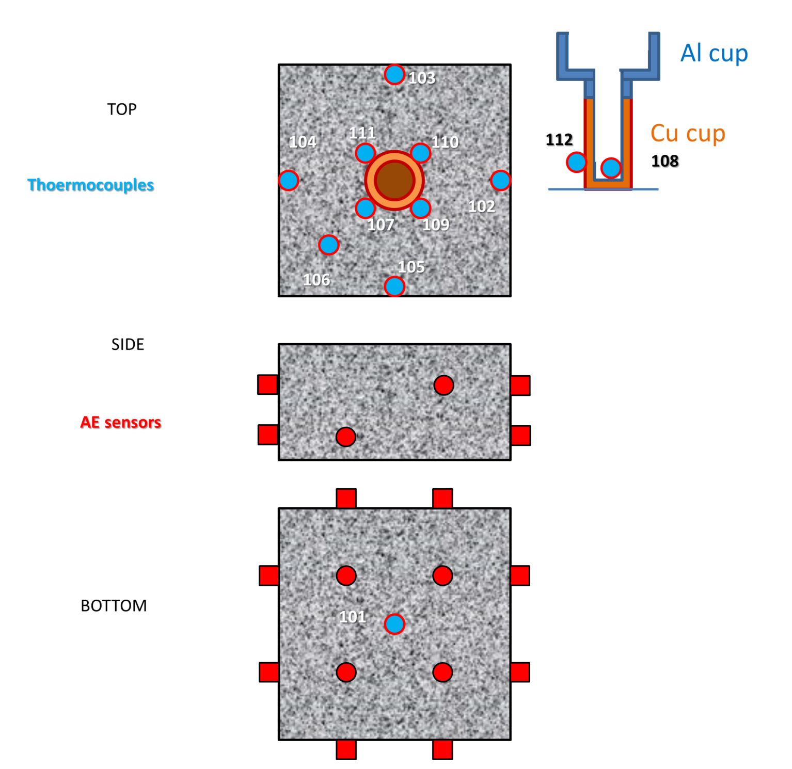
DCIF_Task3-0_BiaxialStressVsVelocityAllDamagedSamplesAveVelocity.TIF
Graphical presentation of the measured average P-wave velocities in the samples as a function of the applied biaxial stress. Different curves are for samples with different pre-heating temperatures which were used to induce a range of microcrack damage
DCIF_Task3-0_Time vs AE rate and Cumulative Count summary.TIF
Graphical presentation of the time vs AE rate and cumulative AE counts
DCIF_Task3-0_PreCrackingTvsOnsetCuCupTemp.TIF
Graphical presentation of the identified AE onset temperature as a function of the pre-test heating temperature which induced microcrack damage in the sample

