Modeling and Efficiency Study of Large Scale Underground Thermal Battery Deployment

Yingqi Zhang¹, Xiaobing Liu², Christine Doughty¹ and Peter Nico¹
¹ Energy Geosciences Division, Lawrence Berkeley National Laboratory
² Oak Ridge National Laboratory

Keywords
Energy Storage, Underground Thermal Battery, Long-Term Efficiency

ABSTRACT
A novel ground heat exchanger design, namely, the Underground Thermal Battery (UTB) was invented at Oak Ridge National Laboratory as a low-cost alternative to the conventional vertical bore ground heat exchanger (VBGHE) for the application of ground source heat pumps (GSHPs). The UTB is comprised of a tank of water, a helical heat exchanger in the center of tank and connected to a water source heat pump, and a phase change material (PCM). Compared to a conventional VBGHE, the UTB is designed to be installed at a much shallower depth, therefore, with a cheaper cost. In addition, the GSHP efficiency is improved due to natural convection of water and additional load capacity provided by PCM. The goal of this study is to explore factors that may affect the efficiency of large-scale UTB deployment. To achieve the goal, we implement an existing one-dimensional (1D) radial model of the UTB into iTOUGH2, which is part of the TOUGH family that provides three-dimensional numerical simulations for the coupled transport of water, vapor, air, and heat in heterogeneous porous media. In addition, iTOUGH2 provides inverse analysis capabilities (e.g. uncertainty quantification, and sensitivity analysis). The 1D model of the UTB was previously validated with the measured performance data of a small-scale UTB. It was also compared to the simulation results of a more detailed three-dimensional (3D) UTB model and is considered a good approximation of 3D representation with large computational time savings. The next step is to use the coupled model to understand what factors have the most influence on the efficiency of large scale deployment of UTB and provide guidance on the layout of multiple UTBs, as well as insights for field characterization, monitoring and operation.

1. Introduction
A conventional vertical bore ground heat exchanger (VBGHE) can be used to capture heat from and/or dissipate heat to the ground by taking advantage of the relatively constant temperature of the sub-surface of the ground. A main consideration for the VBGHE is the balance between the cost and efficiency. A small size can preclude achieving targeted efficiency, even with various enhanced designs (for example, Jensen, 2014; Tiedje and Guo, 2014); a large size is often impractical due to the high installation cost. As a result, a novel ground heat exchanger design, namely, the Underground Thermal Battery (UTB) was invented at Oak Ridge National Laboratory as an alternative to VBGHE but at a lower cost.
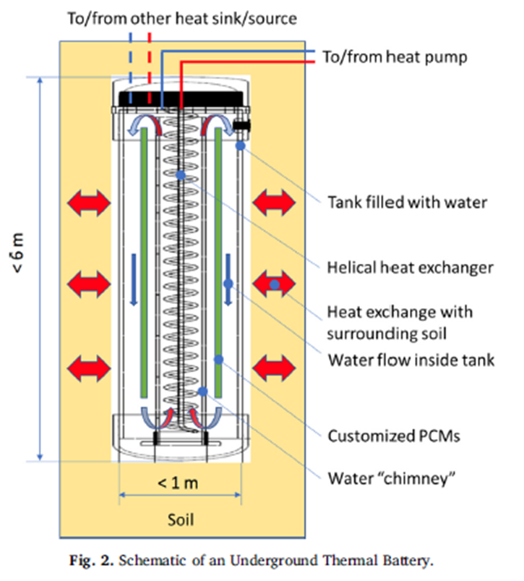
Figure 1: Schematic of an Underground Thermal Battery (from Warner et. al, 2020)
Figure 1 shows a schematic of the UTB. It consists of three main components: a water-filled tank buried in the shallow subsurface; a helical heat exchanger in the center of the tank and connected to a water source heat pump; and a phase change material (PCM) suspended in the annulus between the heat exchanger and the tank wall to provide additional thermal capacity to the tank. The water promotes natural circulation within the tank by utilizing the vertical temperature gradient of the heat exchanger coil to increase the heat transfer between the heat exchanger coil, PCM and surrounding soil. In addition, the water circulation helps maintain a relatively uniform tank temperature.
Previously, a one-dimensional (1D) numerical model has been developed by Warner et. al. (2020) to predict UTB performance. The model results have been compared to a three-dimensional (3D) model by Zhang et al. (2019) and experimental data, as well as to a 2D model (Shi et. al., 2021). The conclusion is that although the 1D model is not as accurate as a 2D or 3D model, the computational saving could be very attractive. In certain circumstances, the error from a 1D model may be insignificant and acceptable given the significant computational time savings.
The goal of this study is to couple the 1D code for the 1D representation of the UTB with the iTOUGH software to study the long-term performance of large-scale (multiple) deployment of UTB with a variety of soil conditions. The TOUGH (“Transport Of Unsaturated Groundwater and Heat”) suite of software codes are multi-dimensional numerical models for simulating the coupled transport of water, vapor, non-condensable gas, and heat in porous and fractured media (Pruess et. al., 2012). iTOUGH2 provides inverse modeling capabilities for the TOUGH codes (Finsterle.et al., 2014). TOUGH codes contain accurate equation of state modules to describe liquid and heat flow in soils. By coupling with TOUGH family code, it is possible to include the feedback from soil to batteries when soil conditions vary over time, and the impact of heterogeneous soil properties and potential regional groundwater flow on large-scale UTB deployment performance.

2. Method
To be able to use the 1D UTB model directly, by design, the UTB model needs to be fit in one layer of TOUGH model, which means the layer where the UTB model resides needs to have a minimum thickness of the UTB’s height. Figure 2a shows how the 1D UTB model developed by Warner et. al. (2020) fits in a regular rectangular 3DTOUGH grid. The 1D model includes a UTB (tank, water and PCM) and surrounding soil in radial geometry. The UTB wall, PCM and soil are discretized into cylindrical elements, as illustrated in Figure 2b. Very fine discretization is used for these components to have an accurate description of phase change behavior, and thermal front propagation. The 1D UTB model uses an explicit scheme to go forward in time. A small time step (i.e., 1 minute) is used to ensure numerical stability and accuracy.
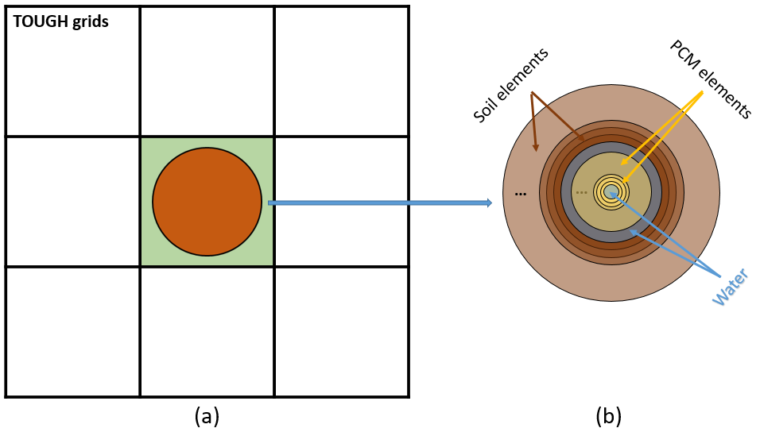
Figure 2: The figures show: (a) how the 1D UTB model is embedded in the TOUGH grids; (2) enlarged look of the 1D UTB model components.
In the original UTB model, the soil extends to 10 times the UTB radius to represent a far field soil temperature boundary condition. When it is included in this coupled model, the quantity of soil included in the UTB model (i.e., the radius of the UTB model in orange color in Figure 2a) becomes an input from the user. The temperature at the soil boundary between the UTB model and the TOUGH model is provided by the adjacent TOUGH element (shaded by green) at each TOUGH model time step. Typically, within one TOUGH time step, the 1D UTB model calculates temperature evolution using a much smaller time step (i.e., a minute) and provides a heat flux to the green shaded element. The heat flux will then be included in the TOUGH model as a heat source sink term for that element. However, if a TOUGH time step is smaller than a minute, the code will skip the 1D UTB calculation until the accumulated TOUGH time step is more than a minute.
Time stepping of the coupled code is further explained in Figure 3. The interaction between the two codes in the flowchart is between the outer-most soil element, the upper side, and the lower side of the UTB, and the green-shaded TOUGH element, i.e., the TOUGH element provides temperature to the UTB soil boundary temperature and the heat flux from the UTB model surfaces are passed to the green-shaded element.
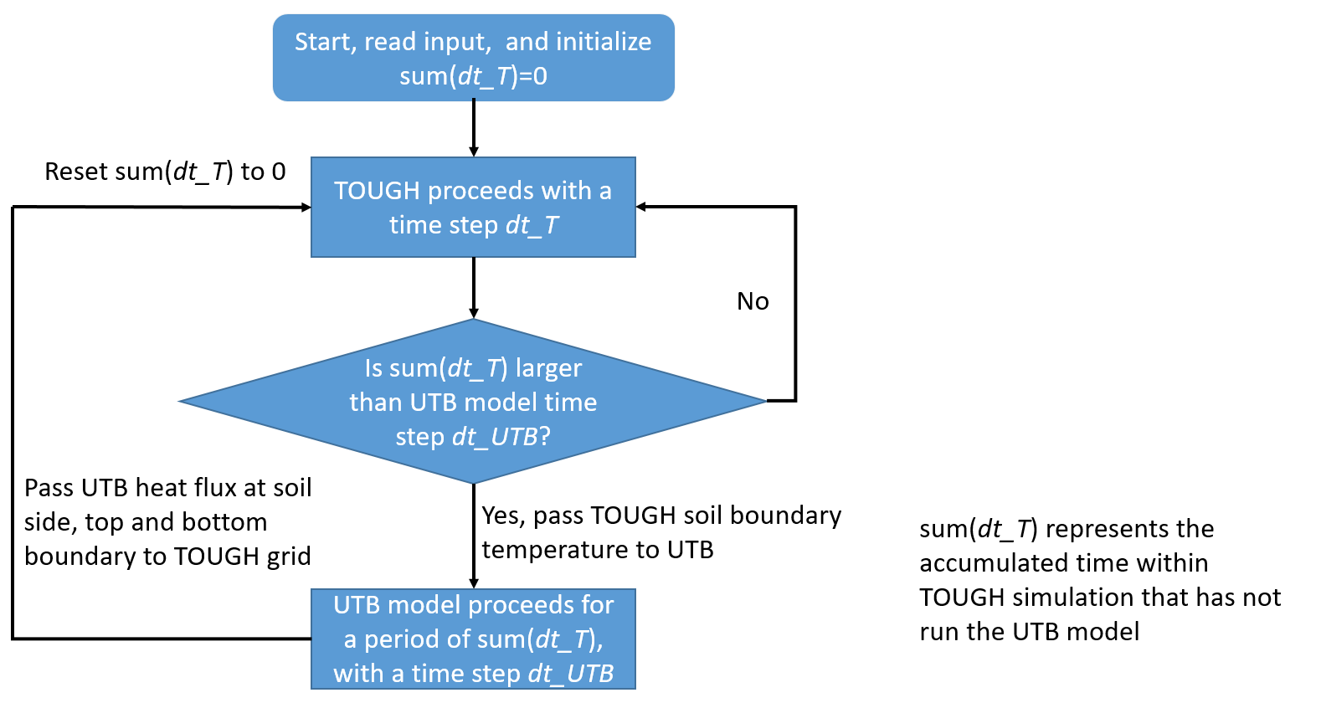
Figure 3: Flowchart shows the time stepping of the coupled code

3. Results
Simulating the same problem described in Section 4.1 (Validation against a detailed 3D model) from Warner et al, 2020), the coupled iTOUGH2 UTB model generates the same results as the original 1D Matlab model, as shown Figure 4. Because the coupled model is written in Fortran and runs as a compiled code, it runs very fast. The coupled model would be suitable for long-term UTB performance prediction.

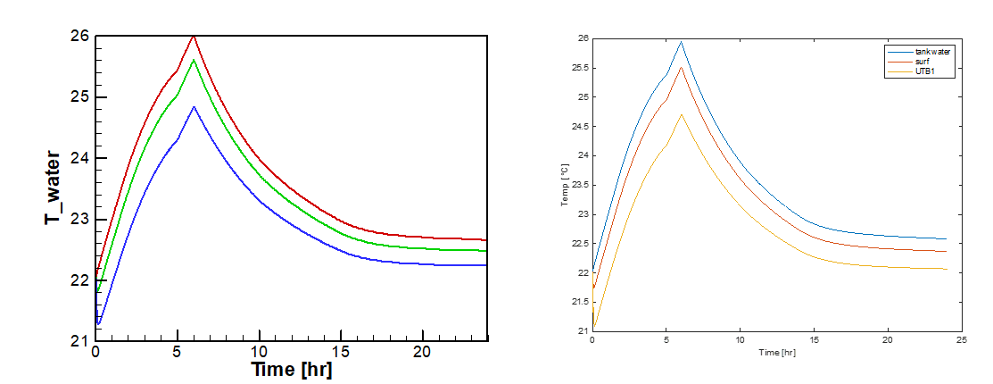
Figure 4: Comparison between the coupled model results (left) and the original 1D model results (right), showing tank water temperature (top), UTB inner surface temperature (middle), and UTB wall temperature (bottom).

4. Conclusion
This paper describes a coupled iTOUGH-UTB code that can be used to simulate long-term performance of the innovative, low cost UTB. The TOUGH family code is famous for its accurate and detailed description of how fluid and heat flow in the soil with potential heterogeneous properties. The coupled code is fast enough to study how large-scale (multiple) deployment of UTBs may impact soil over a long time period, and in turn, how that impact may affect future performance of UTBs, which will be the next step of this study. The future work will also focus on the impact of heterogenous subsurface conditions across an installed array of UTBs on the overall performance of the system.

Acknowledgement
This work was supported by Lawrence Berkeley National Laboratory (LBNL) under with funding from the Geothermal Technologies Office and under Department of Energy Contract No. DE-AC02-05CH11231. The authors would like to thank Joseph Warner, Liang Shi, and Ming Qu for developing and providing the 1D UTB MATLAB code for the UTB.

REFERENCES
Finsterle, S., Sonnenthal, E.L., and Spycher N., Advances in subsurface modeling using the TOUGH suite of simulators, Computers & Geosciences, (2014) doi:10.1016/j.cageo.2013.06.009, 65, 2-12.
Jensen R., “TWISTER high efficiency geothermal heat exchanger”, Annual Conference of International Ground Source Heat Pump Association. Baltimore, Maryland, (2014).
Pruess, K., Oldenburg, C., and Moridis, G., TOUGH2 User’s Guide, Version 2.0, Report LBNL-43134, Lawrence Berkeley National Laboratory, Berkeley, Calif., (2012)
Shi, L., Qu M., Liu X., Zhang, M. and Wang, L., “Impact of soil model complexity on the long-term thermal performance prediction of a new shallow bore ground heat exchanger”, Science and Technology for the Built Environment, . (2021), DOI:10.1080/23744731.2021.1908038
Tiedje, E., and Guo, P., “Thermal conductivity of bentonite grout containing graphite or chopped carbon fibers”, J. Mater. Civil Eng. 26 (7) (2014), https://doi.org/10.1061/ (ASCE)MT.1943-5533.0000977.
Warner, J., Liu, X., Shi, L., Qu M., Liu X., and Zhang, M. “A novel shallow bore ground heat exchanger for ground source heat pump applications—Model development and validation”, Appl. Therm. Eng. 164 (2020) 114460. https://doi.org/10.1016/j.applthermaleng.2019.114460
Zhang, M., Liu, X., Biswas, K., and J. Warner, “A 3D numerical investigation of a novel shallow bore ground heat exchanger integrated with phase change material”, Appl. Therm. Eng. 162 (2019) 114297, https://doi.org/10.1016/j. applthermaleng.2019.114297.

