READ ME Pason EDR Data
The attached file (28044193-Pason EDR.csv) is the EDR data acquired by Pason. These data are from April 14 to April 24, 2022. The important information in this file is the flowback rate and cumulative flowback rate, and the pressure. The fracturing service company would only record pressure for a short period after each stage. The Pason pressure data were monitored continuously.
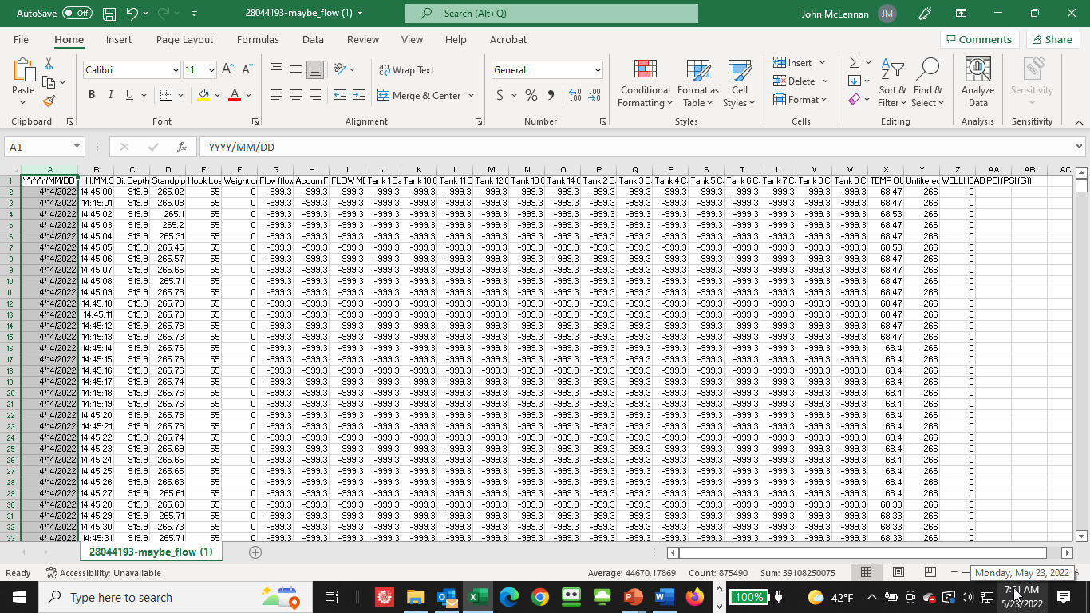
The columns in the file are as follows.
Column | Title | Explanation
A | YYYY/MM/DD | Date
B | HH:MM:SS | Time
C | Bit Depth (feet)
D | Standpipe Pressure (psi)
E | Hook Load (klb_{f})
F | Weight on Bit (klb_{f})
G | Flow (%)
H | Accum Flow (Gal) | Cumulative Flowback Volume (gallons)
I | FLOW METER (GAL) | Flowback rate (gpm)
J | Tank 1 Capacity (barrels) | Frac Tank Water Volume (tanks numbered consecutively from north to south
K | Tank 10 Capacity (barrels) | Frac Tank Water Volume
L | Tank 11 Capacity (barrels) | Frac Tank Water Volume
M | Tank 12 Capacity (barrels) | Frac Tank Water Volume
N | Tank 13 Capacity (barrels) | Frac Tank Water Volume
 | Tank 14 Capacity (barrels) | Frac Tank Water Volume
 | Tank 2 Capacity (barrels) | Frac Tank Water Volume
 | Tank 3 Capacity (barrels) | Frac Tank Water Volume
 | Tank 4 Capacity (barrels) | Frac Tank Water Volume
 | Tank 5 Capacity (barrels) | Frac Tank Water Volume
 | Tank 6 Capacity (barrels) | Frac Tank Water Volume
 | Tank 7 Capacity (barrels) | Frac Tank Water Volume
 | Tank 8 Capacity (barrels) | Frac Tank Water Volume
 | Tank 9 Capacity (barrels) | Frac Tank Water Volume
 | TEMP OUT (DEGREES F) | Flowback Fluid Temperature (°F)
 | Unfiltered SPP (psi) | Standpipe Pressure
 | WELLHEAD PSI (PSI (G)) | Wellhead Pressure

