SUPPLEMENT S2
MT INVERSION CONSTRAINED BY CROSS-GRADIENTS WITH LIN ET AL. (2014a) VP/VS MODEL
In addition to carrying out conventional smoothness-constrained MT inversions, we also examined the effect of constraining the inversion by incorporating a cross-gradient constraint using fixed reference gradients from a Vp/Vs model derived from velocity tomography. This is similar to the algorithm described in Mackie et al. (2020), but in that work the reference gradients were derived from a seismic reflection volume. In this work we use an apriori Vp/Vs model from Lin et al. (2014a). The concept of cross-gradients for joint inversion of different types of geophysical data was introduced by Gallardo and Meju (2003, 2004), initially for the joint inversion of 2D direct current (dc) resistivity and seismic data. The idea is to enforce structural similarity between different co-located physical models of the subsurface, especially in situations where no direct intrinsic relationship exists, by adding a boundary shape similarity condition (∇m₁(x,y,z) × ∇m₂(x,y,z) = 0) to the inversion for two model vectors m₁ and m₂. For the work described here, model m₁ represents the inverse resistivity model and m₂ represents the a priori gradients from the external seismic Vp/Vs volume that are fixed during the inversion.
Conventional smoothness-constrained geophysical inversion uses iterative regularized least-squares in which the solution is taken to be the minimum of an objective function of the form
$Ψ\left(m\right)={\left(d-F\left(m\right)\right)}^{T}W\left(d-F\left(m\right)\right)+ λ{\left(m-m_{0}\right)}^{T}K\left(m-m_{0}\right),$ (S1)
where d is the observed data vector, F is the forward modeling function, m is the unknown model vector, W is a weighting matrix (usually the inverse data variance or covariance), λ is the regularization parameter, K is a discrete form of a stabilizing function, the superscript T denotes the transpose operation, and m₀ is an (optional) a-priori model vector. In our algorithm, the stabilizing function is defined as K = L^{T} L where L is chosen to be a second-difference operator approximating a depth-weighted Laplacian. Minimizing this objective function is commonly done by using gradient-based methods, which directly use the sensitivity (Jacobian) matrix, relating model and data perturbations, for minimizing Ψ. However, because the problem is nonlinear, we must linearize around the current model, update the model parameters, and iterate until the minimum is reached. The proprietary inversion software used here is based on the method of nonlinear conjugate gradients which directly minimizes a non-quadratic objective function (Mackie et al., 2020; Rodi and Mackie, 2001).
The cross-gradient constraint is incorporated by adding an additional term, with Lagrange multiplier $τ$ to S1 as,
$Ψ\left(m\right)={\left(d-F\left(m\right)\right)}^{T}W\left(d-F\left(m\right)\right)+ λ{\left(m-m_{0}\right)}^{T}K\left(m-m_{0}\right)+ τm^{T}C_{xg}^{T}C_{xg}m,$ (S2)
where $C_{xg}$is a finite-difference approximation to the boundary shape similarity condition represented by the cross product of the gradients of the two model vectors, m₁ and m₂. The influence of the cross-gradient term is controlled by the weight τ. If we define C_{x}, C_{y}, and C_{z} to be the components of the cross-gradient in the x-, y-, and z-directions respectively, then we can write C_{xg} as
$C_{xg}^{T}C_{xg}=C_{x}^{T}C_{x}+C_{y}^{T}C_{y}+C_{z}^{T}C_{z},$ (S3)
where we have used simple forward finite-difference approximations to C_{x}, C_{y}, and C_{z} as given in Meju et al. (2019).

Lin et al. (2014b) proposes a secondary magma chamber centered at -9 km elevation just below bend #4 on our rift zone traverse line (see the high Vp/Vs anomaly shown in Figure 13c of the main text) where the stand-alone MT inversion finds only high resistivity in this elevation range within our sensitivity volume (Figure 13a in main text). Forward modeling in Section 6 of the main text demonstrates the presence of a conductive body at the proposed elevation would have a small impact on the data that would be within the assigned errors but would be consistent with the presence of a conductor.

For the cross-gradient constraining model (m₂ above), the Lin et al. (2014a) Vp/Vs model had the mean value removed and cosine tapers from 4 to 6 km and -9 to -12 km elevations applied so that there are no gradients outside of the tapers. This choice preserves the MT sensitivity in the near surface where the Vp/Vs model is least accurate and strengthens the effect of the Vp/Vs model in the -6 to -9 km elevation range where MT sensitivity is reduced by the surface conductors and the Vp/Vs model has maximum sensitivity. A large value of 100 for τ in equation 2 was used to maximize the structural correlation between the depth filtered version of the Vp/Vs model and the resistivity. Hoversten et al. (2021) examines the effects of a range of τ values. In general, as τ is increased the spatial changes in resistivity are forced closer to the spatial changes in Vp/Vs at the expense of increasing MT data misfit. The sign of the gradient constraint does not affect the sign of the resistivity change. That is, the resistivity change can be positive or negative where the Vp/Vs gradients exist. The intention here is to determine if there is enough sensitivity in the MT data to allow a resistivity model that has spatial gradients that are coincident with gradients in the Vp/Vs model and still fits the MT data. Figure S2-1 shows the results where gradients of the Vp/Vs model are used to constrain the inversion along the rift zone traverse.

The RMS data misfit without gradient constraints was 1.4, adding the Vp/Vs constraints resulted in the same RMS of 1.4. The two models fit the MT data equally well. The effects of applying the gradient constraint from the depth filtered Vp/Vs model can be seen by comparing Figures S2-1a and S2-1b (no constraints) with Figures S2-1c and S2-1d (with constraints). The upper 4 km are not affected by the constraints because all gradients in this range were filtered to zero. Between -4 and -12 km elevations the high resistivities of the original MT inversion have been reduced. Although, the resistivity does not show a conductor at the proposed magma chamber location the slight sensitivity in the MT data, demonstrated in the forward models, has allowed the constrained inversion to lower the resistivity around the proposed magma chamber. It is possible that a full joint inversion of the MT, gravity and earthquake travel time data could improve on these results and lead to a more robust conclusion. Additionally, the synthetic model inversions showed that adding additional frequencies at all sites also reduced the inverted resistivities at the magma chamber location.

SUPPLEMENT S2 FIGURES
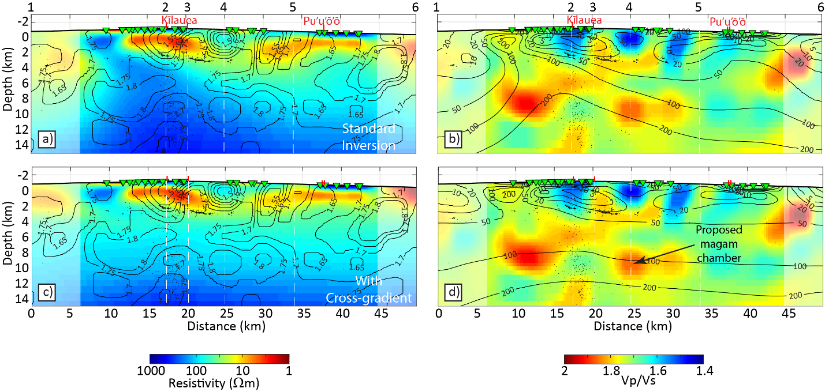
Figure S2-1. Comparison between standard 3D MT inversion and inversion using the cross-gradient constraint with the depth filtered Vp/Vs model as a reference and the original Vp/Vs from Lin et al. (2014a). Small black dots on all panels are earthquake hypocenters from Lin et al. (2014a) from the time range 2001 through 2004 that lie within 2 km perpendicular distance from the section lines. a) is the stand-alone 3D resistivity along the rift zone traverse. b) is the Vp/Vs along the rift zone traverse from Lin et al. (2014a) with resistivity from the stand-alone MT inversion from a) overlaid. c) is the resistivity from MT inversion using the cross-gradient constraint with Vp/Vs from Lin et al. (2014a) overlaid. d) is Vp/Vs from Lin et al. (2014a) along the rift zone traverse with resistivity contours from c) (cross-gradient constraint) overlaid.

