As illustrated in Figure 1, there is a tail-like formation of the particle accumulation behind the bridging location in addition to the forward movement of the bridging location. Finally, at the end of 1 second, the bridging pack further moves away and takes an inverted v shape, as shown in Figure 64. This change in shape from the tail like particle accumulation to inverted v shape can be attributed to the fracture wall expansion.
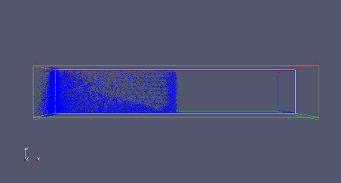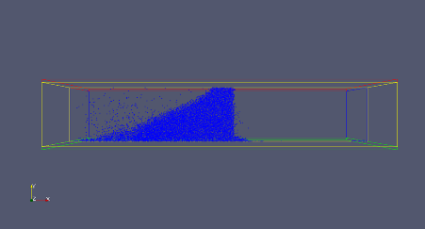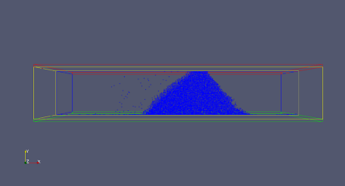
Figure 1: Initial plugging, fracture expanded 0.044 mm (right), Later bridging; fracture expanded 0.08 mm (middle), Bridging location moves forward; fracture expanded 0.2 mm (left).
After building the model, the coupled CFD-DEM simulations were used to generate about 100 cases that have different size distributions. We have determined that the best fracture sealing results come from the bimodal distribution designs. By comparing the fluid reduction of the mono-modal distribution against the bimodally distributed particle sizes, fluid loss could be significantly minimized with a bimodal design. Figure 65 illustrate the importance of the sealing ability between single-sized particle and a mixture of two different sizes. Fracture sealing can be better achieved with proper large and small particle size mixtures.
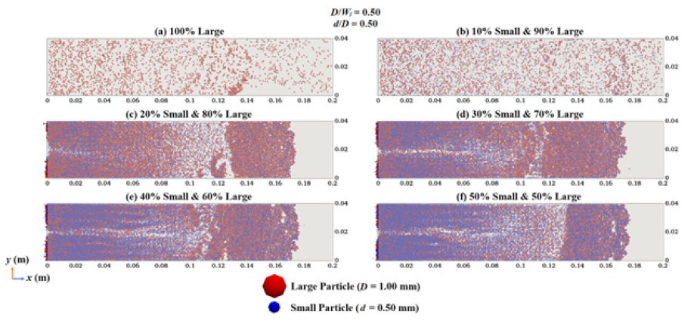
Figure 65: 1–Cross-sectional representation of effectiveness in fracture sealing for D/W_{f} = 0.5 and d/D = 0.5.

