The coupled CFD-DEM model is used to simulate the flow of SMP in drilling fluid and modeling of cohesive expandable lcms for fractures with large apertures. The simulation domain is a wellbore-geometry setup (1) to mimic the downhole scenario. There are one inlet and two outlets. The SMP are inserted at the inlet with constant 400 psi of pressure. One outlet is at the other end of the cylindrical pipe with 390 psi while the other one with 0 psi at located at the fracture outlet. The 368.3 mm long cylindrical pipe has a diameter of 25.4 mm, whereas the fracture is 342.9 by 25.4 by 3 mm (length by height by width). Chemical reactions and emulsions were not considered. The fluid is a heavy brine 2,000 kg/m³ with shearing-thinning rheological property as shown in Figure 2.
The sealing results show that the SMP accumulate at the fracture entrance, where violent particle collisions occur. A small plug forms and then gradually invade deeper into the fracture as shown in Figure 3. The dimensionless time is used to scale up the simulation results to compare to the laboratory experiments. The fluid loss results from both simulation and lab are compared against each other. A flow loop design that is similar to the wellbore geometry is used in the lab. A 6 vol% SMP mixture with fiber LCM does not seal the 3 mm fracture. On the other hand, by increasing the SMP concentration to 12 vol%, a 3 mm fracture can be sealed with a great reduction in fluid loss. Although the simulation does not incorporate the fibrous SMP, the same degree of fluid reduction is shown with 10 vol% SMP. A further decrease in fluid loss can also be seen in the batch of 15 and 20 vol% SMP.

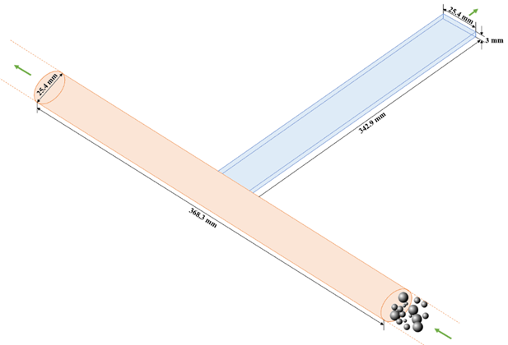
Figure 1: Wellbore geometry for simulation setup.

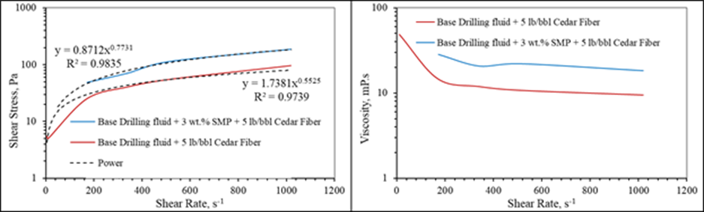
Figure 2: Drilling fluid rheology with the SMP mixture.

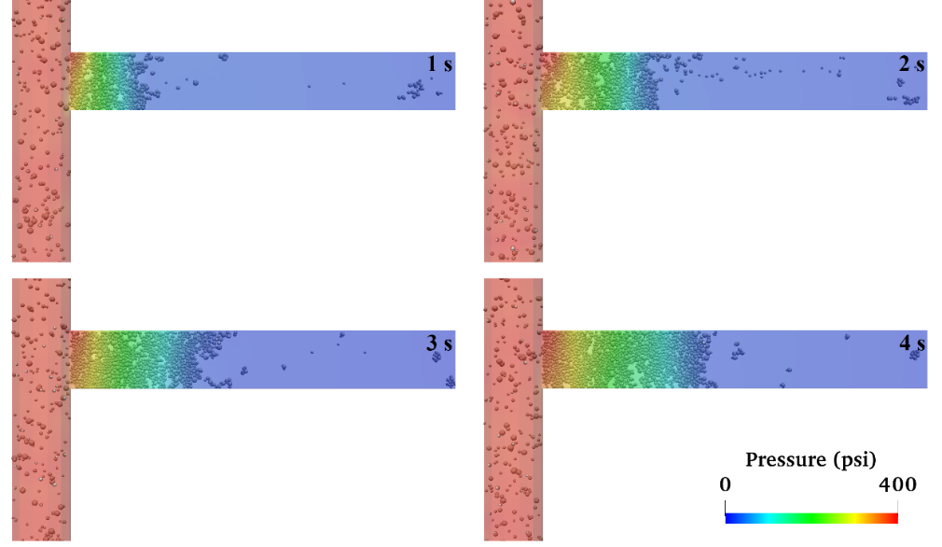
Figure 3: Snapshots of the plug formed by the LCMs in the simulation system.

