Dynamic Mechanical Analysis (DMA) test was conducted on the specimen, as shown in Figure 1. From Figure 1, the glass transition range is between 250° and 300°C. This suggests that the polymer has a very high glass transition temperature. We can also see that the storage modulus at room temperature is about 4,200 MPa, suggesting a very stiff polymer. Also, based on our previous experience, we believe that this polymer will not only have an excellent shape memory effect but will also have huge recovery stress due to its high storage modulus at a rubbery state. Based on our knowledge and experience, this new type of polymer is adjustable based on the formulation.
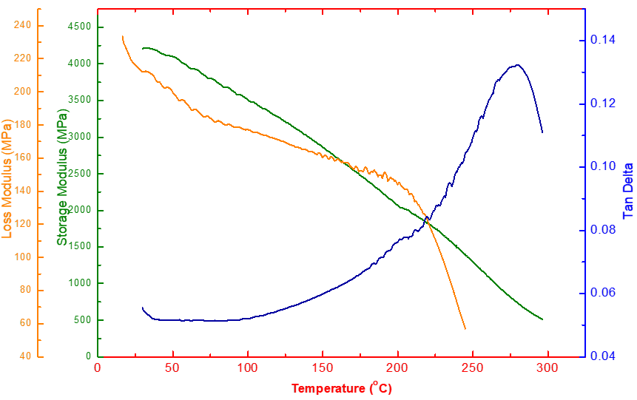
Figure 1: The DMA test results of the temperature scan for the new polymer.
The shape memory effect of the new shape memory polymer was confirmed by a free shape recovery experiment. One transparent cylindrical sample was fabricated, as shown in Figure 2 (A). The sample was put into an oven for post-curing at 280°C for 3h to achieve full curing of the acrylate monomer. The compression programming was conducted at 200°C. The pre-strain was around 30%. About 22% strain was fixed after cooling the sample down to room temperature and load removal; see Figure 20 (B). The free shape recovery test was also conducted at 200° C. The oven was at equilibrium at 200°C for one hour, and then the programed sample was placed in the oven. After half an hour, the shape was almost fully recovered, as shown in Figure 20 (C). This shows that this new high glass transition temperature SMP has a perfect shape memory effect.
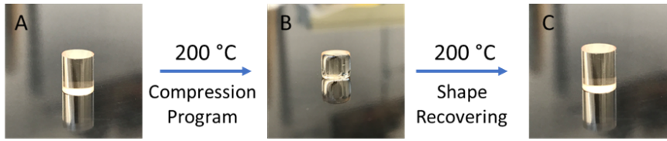
Figure 2: The hot programming and the free shape recovery experiment for the new shape memory polymer.

