The SMP was synthesized out of a readily available commercial epoxy resin (EPON 826, a bisphenol-based resin) cured by an isophorone diamine (IPD) crosslinker. Each 100g EPON 826 was bonded with 23.2 g IPD to balance out the stoichiometry. The reagents were blended by a mechanical mixer for two minutes at ambient temperature and then placed inside a cylindrical silicone mold with a diameter of 1 inch and a height of 0.5 inches. The air bubbles were separated by vacuum at room temperature. After one hour of curing at a temperature of 300°F (150ºC), a thermoset network was achieved. Each cylindrical sample was uniaxially compressed at 320°F (160ºC) until some crack appeared (around 45% of compressive strain), and the strain was held constant while cooling down to room temperature, followed by removal of the compressive load. This completed the hot programming of the SMP. After that, the SMP was shattered into pieces and crushed again by a press into smaller-sized grains. These crushed grains were milled by the PQ-N2 planetary ball mill machine (Across international). For every half hour, the ball milling machine was halted and sieved into obtaining different-sized particles, ranging from a few millimeters to fine powders. The particle sizes were 0.6 mm to 2.14 mm.
In order to understand the chemical reaction mechanisms of the HTSMP under the two-step curing, we conducted FTIR characterization. The details are as follows. The FTIR spectra of the monomer and the HTSMP under various curing conditions are shown in Figure 1.
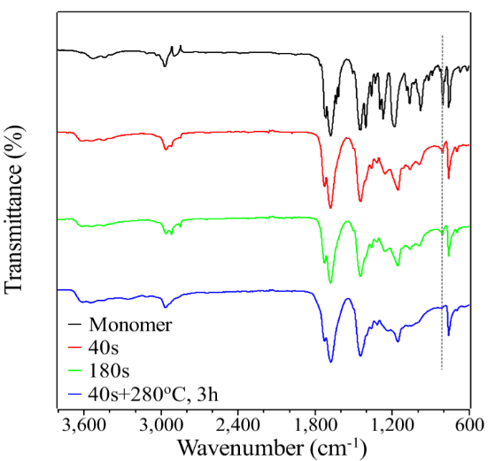
Figure 1: FTIR spectra of the triacrylate monomer with thermally stable isocyanurate structure (TAI) and the samples prepared under different curing conditions.
From Figure 8, it is seen that similar FTIR spectra between the monomer the polymer are obtained. The major interest is in the change of the intensity at about 810 cm⁻¹, which is a fingerprint of the C=C double bonds. The change of the intensity signifies the change of the amount of C=C double bonds in the TAI monomer, or the polymerization of the monomer to the SMP. It is seen that, after 40 s UV curing, the peak intensity of the C=C double bonds at 810 cm⁻¹ is much decreased, indicating polymerization of the majority of C=C groups. When extending the UV exposure to 180 s, the peak intensity slightly decreased, suggesting further curing of the TAI monomer, but at a much slower speed. However, even with 180 s UV curing, the C=C groups cannot be completely converted, suggesting UV alone cannot fully cure the TAI monomer. Notably, the absorption peak of the C=C double bonds for the two-step cured sample almost disappeared, suggesting the sample was fully cured after the second step thermal curing. The conversion ratios of C=C groups were calculated by the absorption peak area ratio of the cured sample to that of monomer. The results are shown in Figure 2. It is seen that both 40 s and 180 s UV cured samples have conversion ratios lower than 80 %, while the two-step cured sample reached 94.3 % conversion ratio, suggesting that the C=C groups were almost fully reacted after the two-step curing. In other words, the TAI monomer was almost fully polymerized.
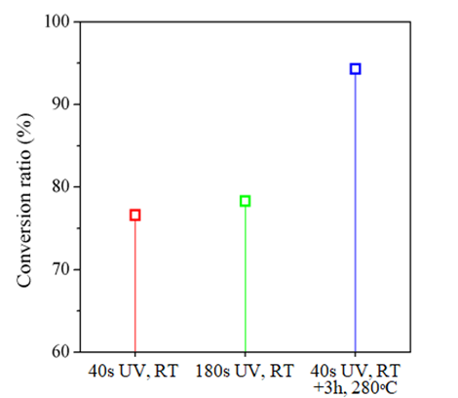
Figure 2: The carbon-carbon double bond conversion ratios with respect to various curing conditions.

