Collab Testbed 2 Water Balance Calculations

Water recovery from the production wells and major ceiling and wall weeps in the drift accounted for ~30% of the 3.4 liters per minute injected water at the TU interval. Additional water was noted along the drift through disperse weeps and from underneath the drift ballast supporting the tracks. This additional water was not included in the 30% recovery calculations due to the difficulty of measuring these flow rates. This paper describes an attempt to estimate this water flow rate was made near the end of the Collab testbed 2, two-month water injection from TU interval in July and August 2022.

Well stimulation date?

Injection start data rate?

May 23 noted damp floor, ceiling, walls, added tarp at site C and corner

Recorded wet locations 5/23 in field book,

5/24 increased flow rate from 2 to 3 l/m?

5/26 increased flow rate to 3.2, 3.4?

5/26 initial saltwater test of quizix

5/31 noted more wetness in drift closer to Site B

5/31 NaCl test to TNI

6/01 Fluorescein #1, issue with fraction collector, (Site c, Site a, corner tarp)

6/02 Rhodamine #1 in afternoon

6/5? Triplex failure

6/15 Triplex fixed injection re-established at 3.4 l/min

6/21 another note that wetness is moving towards site b, floor wet

6/21 TCI shut-in, TCI-TNI pressure cycling (no immediate improvement of flow)

6/22 Packer pressure flow test vs rate

6/22 Fluorescein #2

6/23 Rhodamine #2

7/18? Power outage did injection stop?

7/22? Injection Restarted? Or just access reestablished?

7/26 Fluorescein #3

7/26 ERT NaCl injection (afternoon)

7/27 TLI Fluorescein packer test

7/27 Biocide Injection (no immediate improvement)

7/27 first attempt to measure water free surface

7/28 Moved TN packer up ~10.5 feet to capture high flow

7/28 second attempt to measure water free surface

7/29 first attempt to est drift flow

7/29 Fluorescein #4, (new TNI location)

8/10 Stopped chilled water

8/12 Stopped RO cycling

8/15 Low production zones shut-in

8/16 TNI shut-in

8/17 Injection stopped

8/24 All wells opened to drain

8/26 Last drift flow measurement

9/07 remote monitoring stopped

On July 27th and 29th, a laser level (\*\*) was brought to the 4100 level to measure the free water surface along the drift. In some locations the water surface was above the gravel surface whereas other places a hole was dug in the drift ballast to find the water surface.

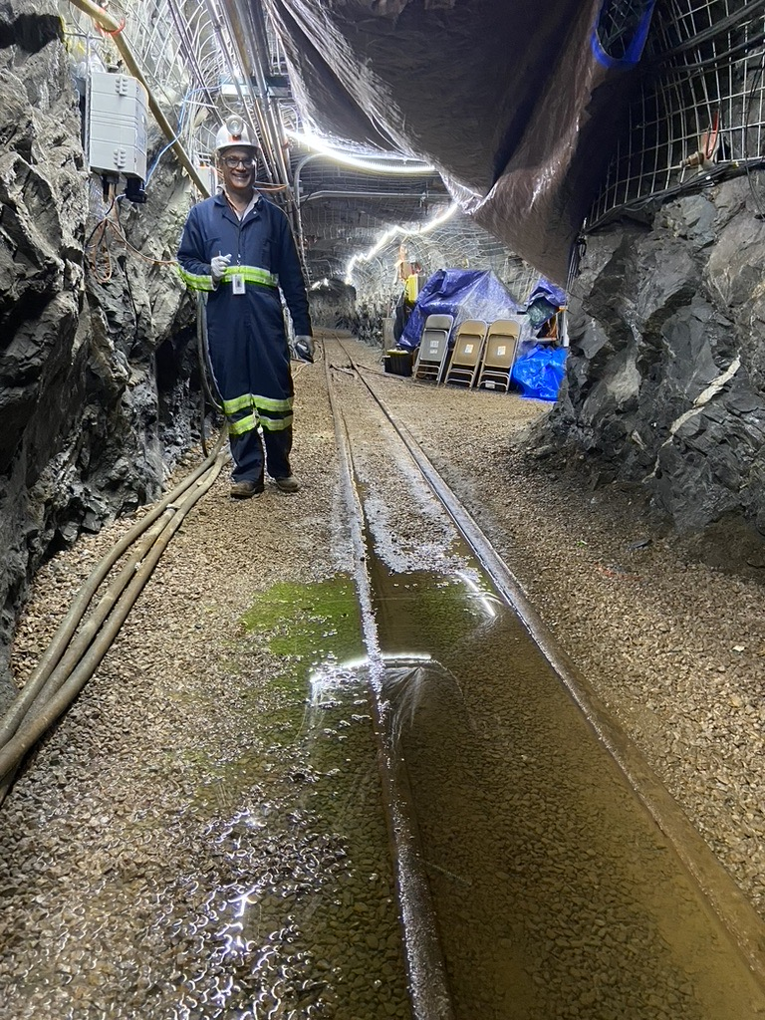

The July 27th results suggested that water was flowing laterally both north and south in the drift rubble from a location near the Site A alcove/drift intersection. On July 29th, the drift free water surface was remeasured at a finer detail determining that the drilling well ditch north of the Site A alcove was a water sink due to the trash pump located in this ditch. It was also discovered that the Site B sump (which collects water from the production wells and waste water from the reverse osmosis system) did not contain an impermeable bottom and therefore was also a water sink of standing water in the drift. The free water surface in the ballast further south of Site B in the drift was near horizonal suggesting little lateral movement.



It was hypothesized that by measuring the volume of water pumped from each water sink (the north ditch and the Site B sump) along with the cycle time of the pump, an estimate of the water recovery rate from the TU injection could be determined.

Attempts to measure North ditch flow rate were made on July 29, August 15, and 17 (also on August 24 and 26 after the TU injection was terminated (August 17th)). Uncertainty in the data results from; inconsistent trash pump float switch operation, time between pumping cycles, storage of water in drift ballast. The July 29 had the longest pumping times where the initial 2 measurements were made at ~ 3-hour intervals and the last three measurements had a pump cycle time of ~ 1 hour. Since the instantaneous water flow rate into the ditch is a function of the water level of the ditch, a long pump cycle will result in the ditch filling up and underestimating the water recharge rate into the ditch. Measurements from August 15th and 17th had a shorter pump cycle interval (27 and 19 minutes) an average water recharge rate of 2.2 l/m. The initial drainage cycle was ignored due to potential drainage from stored water in the drift near the ditch. The last data point on August 17 was also ignored due to a 4-minute pumping cycle.



The Site B flow rate was measured July 29 and August 15th during times when the reverse osmosis system was off. Measurement of this water discharge system is somewhat easier since the sump volume is much less than the ditch volume. Therefore, the pump in the Site B sump cycled much more frequently keeping this water level in this area in a pseudo steady state condition. July 29th measurement included 3 sets of measurements of 10.75 liters pumped every 7.06 minutes for a discharge rate of 1.52 l/min (includes 0.985 l/min from production wells). August 15th measurements also included 3 sets of measurements of 11.6 liters pumped every 2.4 minutes for a discharge rate of 4.8 l/min. This rate is higher than the injection rate which suggests the sump had an additional unknown source of water (leaking EC probe?) during these measurements. Therefore, we will assume the July 29th measurements are correct.

Total water recovery from the production wells, ceiling and wall weeps, and flow through the flow can be estimated from summing the August north ditch and the September Site B sump discharge rates (2.2 l/m + 1.5 l/m = 3.7 l/m). This value is slightly higher (< 10%) than the TU injection rate of 3.4 l/min. This slight overestimate may be due to the more frequent operation of the North ditch pump which would have released some water stored in the drift ballast.

In conclusion, I think we can say;

1. that the production wells capture approximately 30% of the flow whereas the drift (ceiling drips, wall weeps, and water egress through the drift floor into the ballast) accounted for the remaining ~70%.
2. Based on measurements of the major ceil and wall weeps (~3%), most of the water entered the drift ballast through the drift floor (~67%).
3. Based on the tracer initial breakthrough and location of the drift free water divide, most of that water entered the drift floor just south of the Site A alcove intersection with the main 4100 drift (~11-33 feet from the midline of Site A alcove).
4. Sidenote: If most of the flow is through the floor, it doesn’t match the location of the measured MEQs from Tom’s analysis.
5. Sidenote: it would be interesting to see Tim’s ERT results to see if flow within the monitoring wells

