Large-Scale Testing Setup

Dated
31st January 2023
Table of Contents
1 Introduction 1
2 Setup preparation 1
2.1 Testing container 1
2.2 Telescopic Gantry Cranes 2
2.3 Induction unit and induction coils 3
2.4 Air compressor 4
2.5 Hoist chain 5
3 Schematic Diagram 5
4 Health and Safety 5
4.1 Personal Protective Equipment 8

List of Figures
Figure 1: Container for the testing setup 1
Figure 2: Flapping door installed on container 2
Figure 3: Two gantry cranes installed for the setup 2
Figure 4: Interpower Induction Unit 3
Figure 5: Induction coils 3
Figure 6: Two railings for the movement of the induction unit 4
Figure 7: Air Compressor 4
Figure 8: Hoist chain installed inside the container 5
Figure 9: Schematic diagram of the setup 5

List of Table
Table 1: Health and safety precaution 6

Large Scale Testing Setup in WCTC

Introduction
This report highlights the activities performed at Well Construction Technology CENTRE(WCTC) to prepare the setup for testing of packers at high temperatures (300°C) and pressures (10,000 psi).

Setup preparation
The equipment used for the preparation of the setup are:
- Test Container
- Telescopic Gantry Cranes
- Induction unit and induction coils
- Air Compressor
- Hoist Chains

Testing container
The container is part of the testing setup and the dimension of the container is 491”*114” . A square hole was cut in the middle of the container in order to facilitate the movement of the
induction unit. The container will be hosting all the equipment in it.

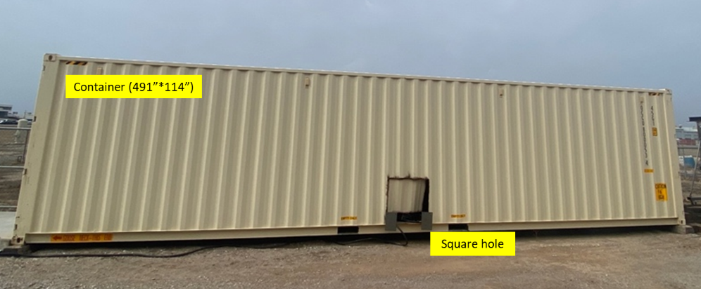
Figure 1: Container for the testing setup
After the hole was made flapping door was installed that can be seen in Figure 2.

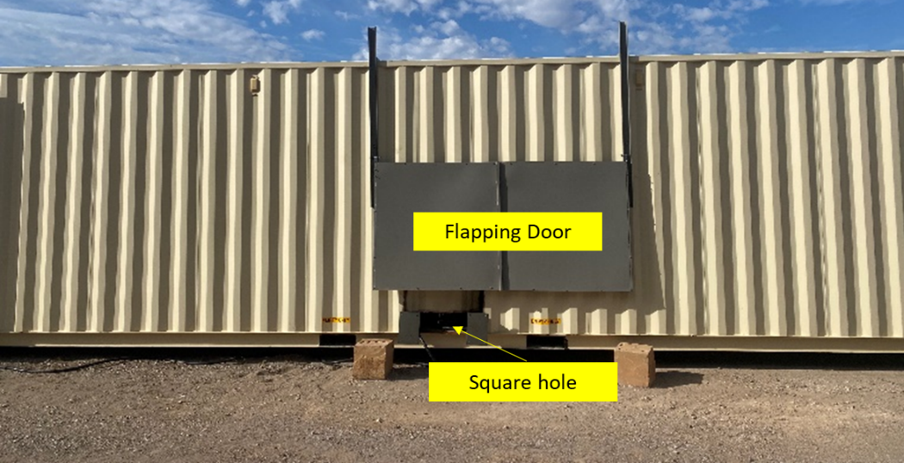
Figure 2: Flapping door installed on container

Telescopic Gantry Cranes
Two gantry cranes were installed (Figure 3) and each has the capacity to lift 1 ton of weight and will be used for the hoisting of heavy pipes and preparation of the samples.

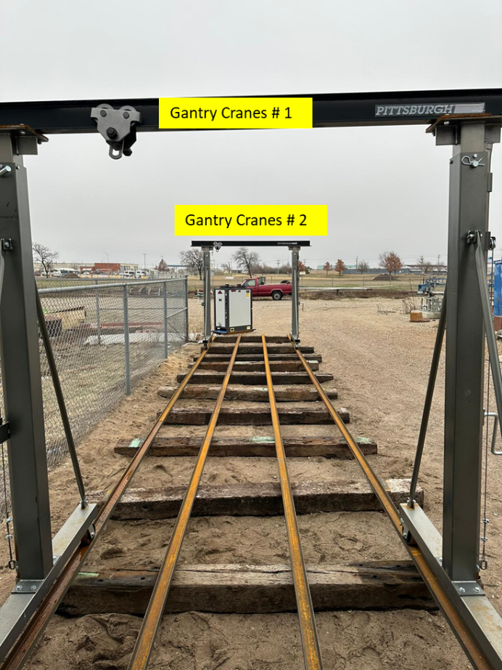
Figure 3: Two gantry cranes installed for the setup

Induction unit and induction coils
The induction unit will be used to heat up the setup through the induction process. For the movement of the induction unit, two railings are installed inside the container.

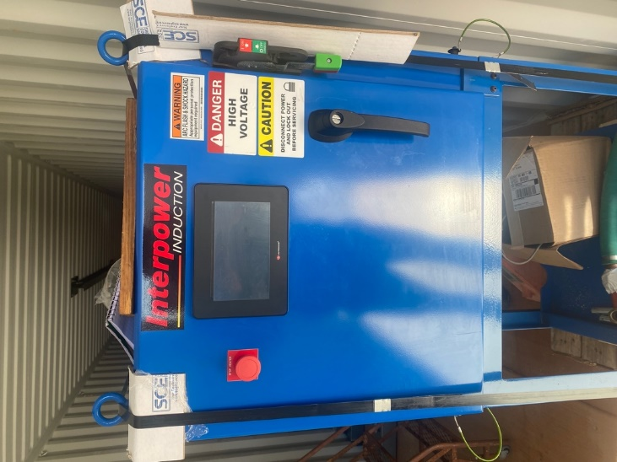
Figure 4: Interpower Induction Unit

Figure 5: Induction coils

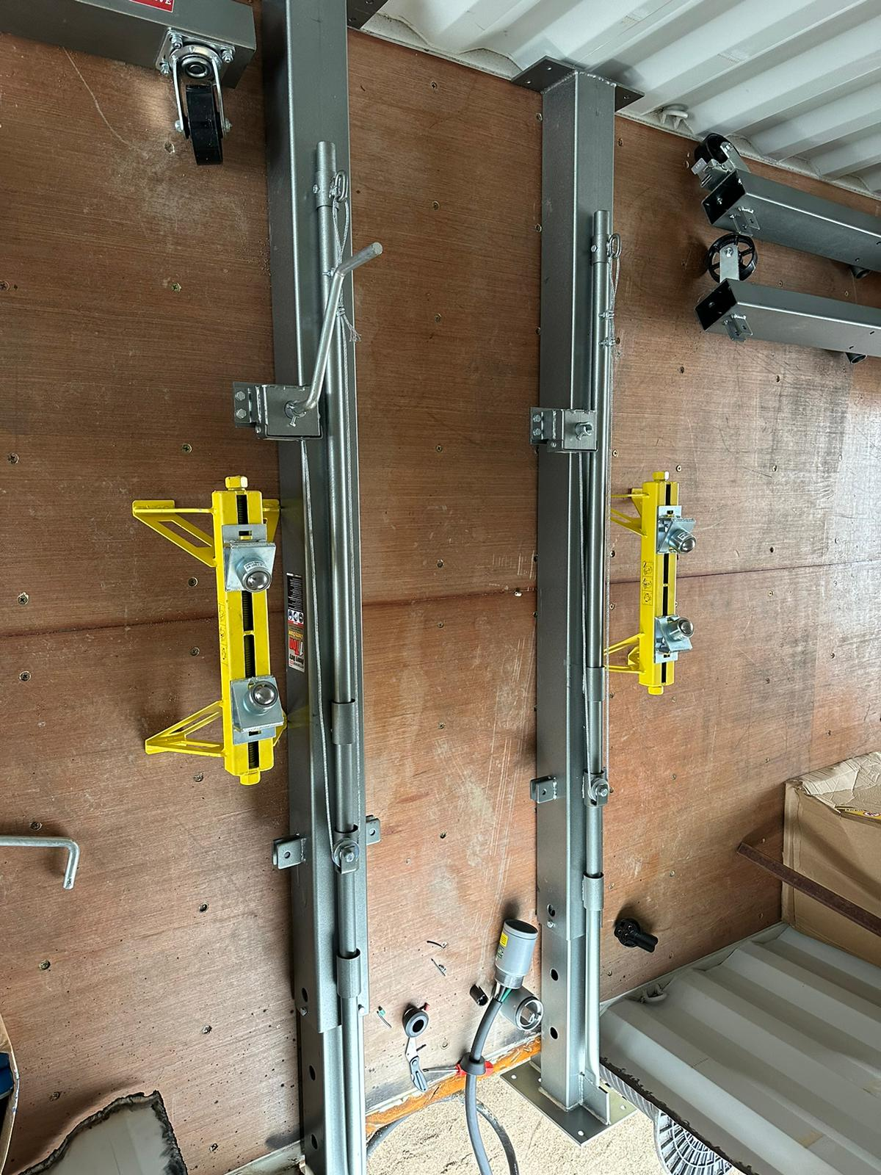
Figure 6: Two railings for the movement of the induction unit

Air compressor
For the local supply of air, an air compressor will be used (Figure 7). The compressor has a capacity of 200 psi.

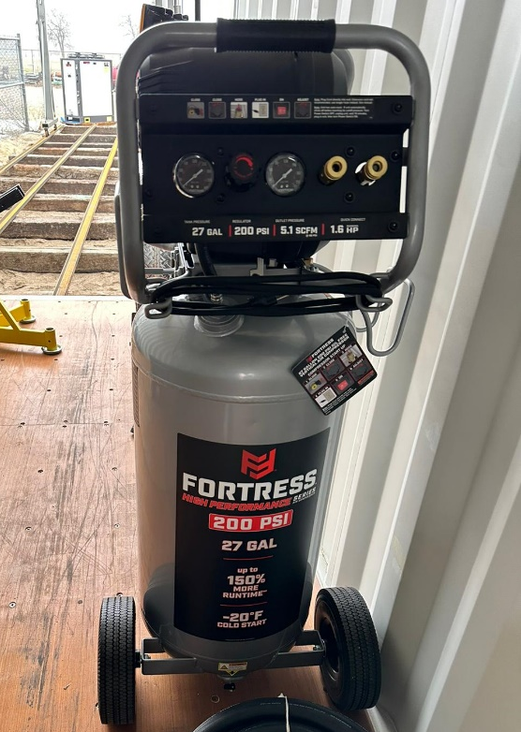
Figure 7: Air Compressor

Hoist chains
Two hoist chains were installed inside the container for the lifting of the pipes and adjustment of the induction unit.

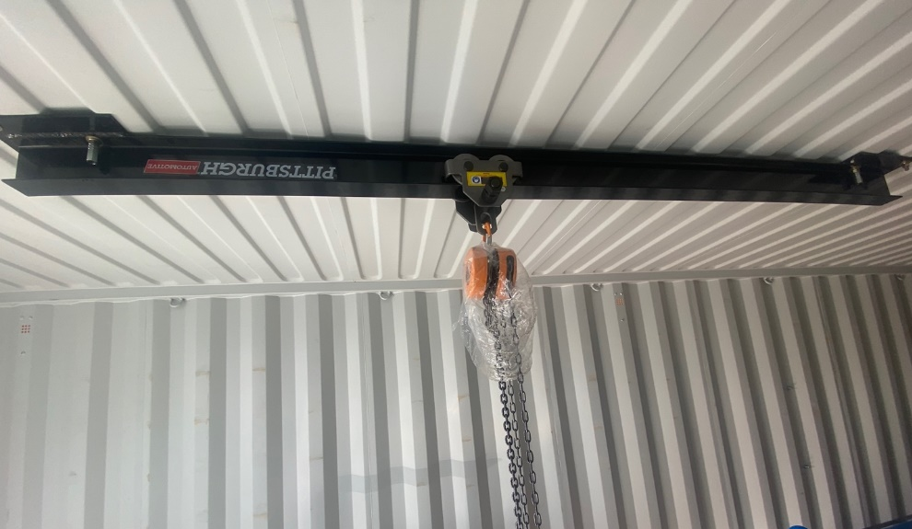
Figure 8: Hoist chain installed inside the container

Schematic Diagram
The schematic diagram of the setup is given in Figure 9.

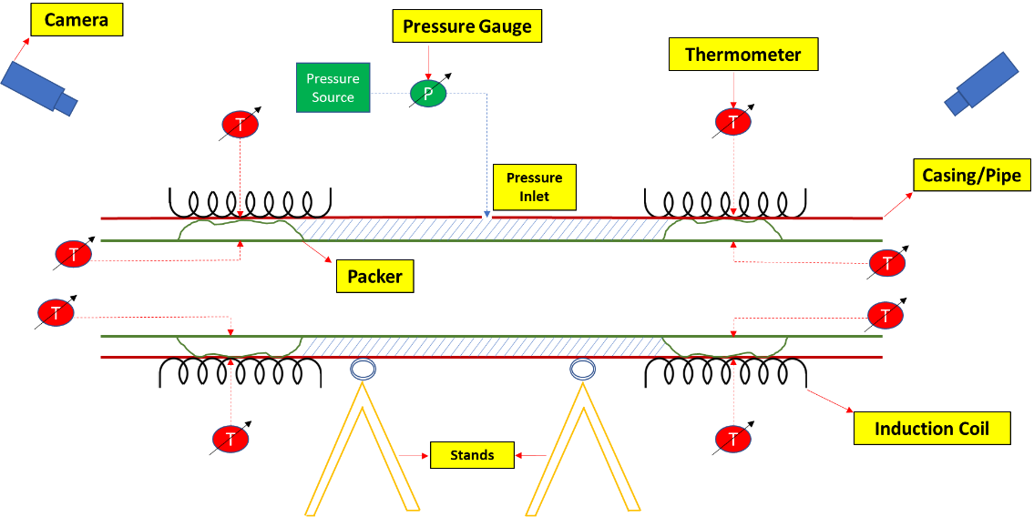

Figure 9: Schematic diagram of the setup

Health and Safety
The health and Safety of the team will be a top priority in this project during the testing operations of the equipment.
At the Well Construction Technology Centre (WCTC), the following HSE plan is implemented for the safety of the team:

• Daily safety meetings to be held before each shift, addressing the need for adherence to proper safety rules.
• Operation safety risks to be identified and addressed by the team at the beginning of specific operations.
• Job Safety analysis to be reviewed and understood by all participating teams.

Below are the hazards and the safety precautions that the team will adhered to at WCTC:

Table 1: Health and safety precaution
**Required**
Step # | Step Description & Required Tools | Hazards | Controls | Highest Level of Existing Controls (HoC)
 |  |  | List All Controls
1 | Calibration and pressure test | Pinch points, pressure release, equipment failure | Ensure to wear hand gloves, inspect equipment before use, ensure to secure all pressure lines with whip check, avoid approaching equipment under pressure. | Administrative
2 | Gas room temperature test | Pressure release, equipment failure, | Ensure to secure all pressure lines with whip check and chains,  Do not pressurize beyond the given pressure, Do not approach equipment under pressure  Inspect equipment and ensure full tightening before testing, bleed down when there is leakage. | Engineering
3 | Temperature test | Pressure release, equipment failure | Ensure to secure all pressure lines with whip check and chains. Do not approach equipment under pressure, inspect equipment before testing, bleed down when there is leakage. | Engineering
4 | Movement of Pipes | Struck by a moving object | Stay away from the path of moving objects  Ensure no loose clothing is worn  Ensure helmets are worn at all times | Administrative
5 | Operation of Crane | Drop Object | Put on Safety Helmets  Ensure items are secured when placing at height  Do not move underneath cranes while lifting operation is been performed. | PPE
6 | Contact with Electricity | Electrical Shocks & Electrical line Trips | Ensure electrical lines are properly isolated  Ensure electrical lines are isolated from wet substances | Engineering
7 | Equipment assembling and Lifting | Cuts | Ensure safety gloves are worn at all times | PPE
8 |  | Ergonomics (Poor lifting postures, Frequent lifting and Awkward movements ) | Perform reverse motion once in a while on work  Take intermittent breaks for water and stretching  Ensure proper lifting postures when lifting equipment. | Administrative
9 |  | Lone Worker | Ensure to work in teams / Inform your supervisor before performing work alone. | Engineering
10 |  | Exposure to High Temperatures | Ensure proper ventilation  Hydrate  Take intermittent breaks for air | Engineering

Personal Protective Equipment
The following protective equipment will be used during the course of testing
- Safety Glasses
- Safety Footwear
- Protective Clothing
- Glove (Latex and High Impact Gloves)

