Large-Scale Testing Setup (Pipe Preparation)

Dated
31st March 2023
Table of Contents
1 Preparation of the pipe 2

List of Figures
Figure 1: Flow chart for the preparation of the pipe 2
Figure 2: Picture of the steps taken for the preparation of the pipe 2
Figure 3: Dimensions of the pipe 6
Figure 4: Schematic of the pipe inside the container 6

List of Tables
Table 1: Initial measurement of the pipe 3
Table 2: OD measurement with vernier caliper at each point of radial section 3
Table 3: OD measurement with pi tape at each point of radial section 4
Table 4: Wall thickness each point of radial section 5

Preparation of the pipe
Figure 1 and 2 shows the steps taken for the preparation of the 10 ¾” casing for testing. While table 1 to 4 shows the OD and thickness of the given pipe

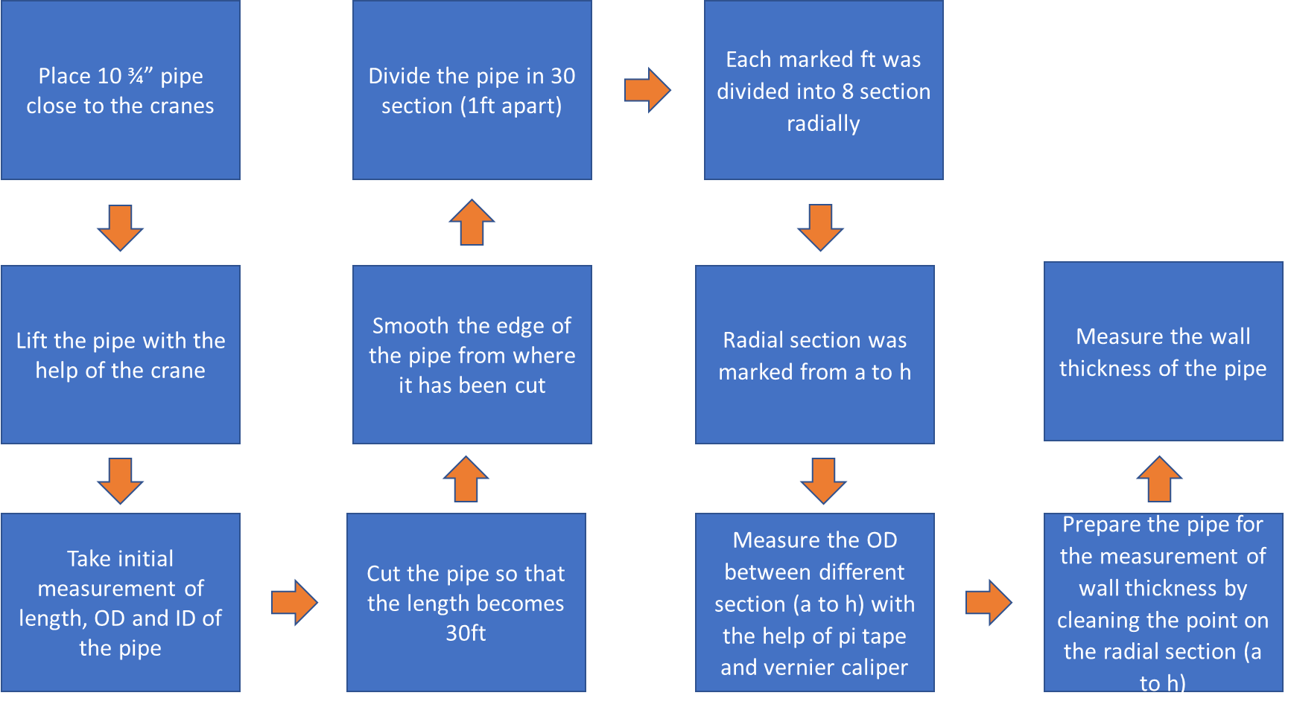
Figure 1: Flow chart for the preparation of the pipe
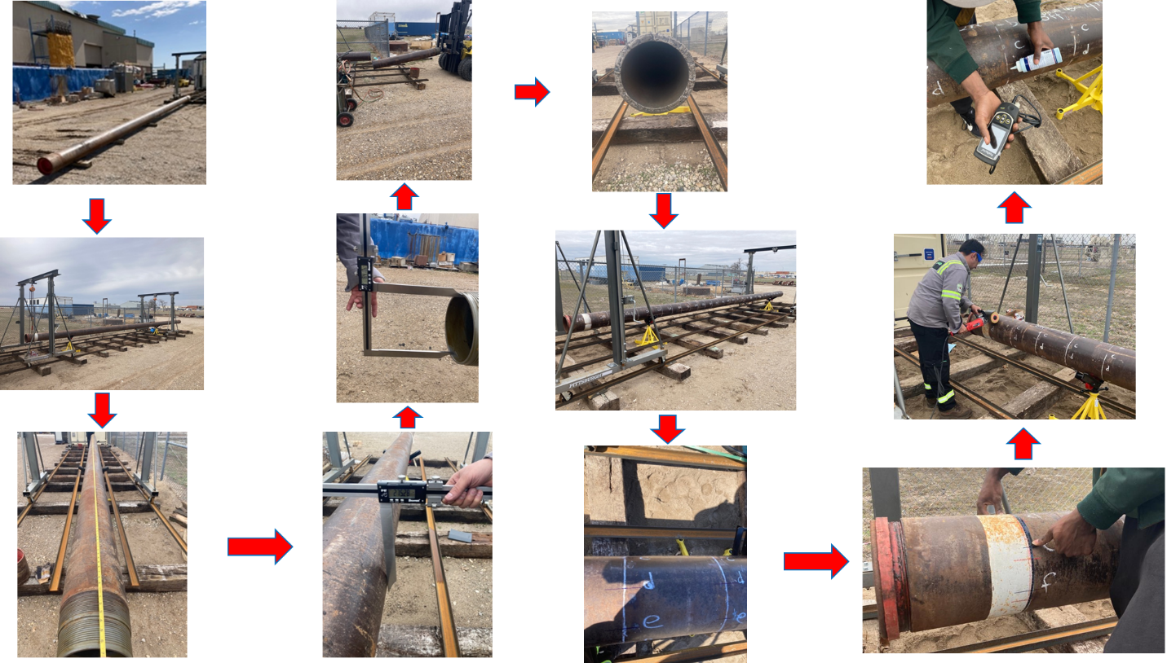
Figure 2: Picture of the steps taken for the preparation of the pipe
Table 1: Initial measurement of the pipe
Length (ft) | OD (mm) | ID (mm)
37.57 | 275.28 | 213.76

Table 2: OD measurement with vernier caliper at each point of radial section
Section # | CALIPER (mm)
 | OD (A-E) | OD (B-F) | OD (C-G) | OD (D-H) | AVERAGE (mm)
1 | 276.20 | 275.86 | 275.94 | 275.92 | 275.98
2 | 275.93 | 275.57 | 275.52 | 275.62 | 275.66
3 | 276.05 | 275.60 | 275.49 | 275.70 | 275.71
4 | 275.97 | 275.78 | 275.64 | 275.60 | 275.75
5 | 275.97 | 275.85 | 275.50 | 275.51 | 275.71
6 | 275.92 | 275.95 | 275.50 | 275.42 | 275.70
7 | 275.89 | 275.88 | 275.46 | 275.41 | 275.66
8 | 275.80 | 275.91 | 275.71 | 275.48 | 275.73
9 | 275.82 | 275.92 | 275.41 | 275.56 | 275.68
10 | 276.14 | 275.97 | 275.33 | 275.45 | 275.72
11 | 276.14 | 275.90 | 275.33 | 275.48 | 275.71
12 | 275.77 | 276.00 | 275.69 | 275.73 | 275.80
13 | 275.88 | 275.60 | 275.48 | 275.57 | 275.63
14 | 275.87 | 275.76 | 275.35 | 275.50 | 275.62
15 | 275.90 | 275.98 | 275.18 | 275.35 | 275.60
16 | 275.64 | 275.93 | 275.60 | 275.16 | 275.58
17 | 275.59 | 275.58 | 275.38 | 275.51 | 275.52
18 | 275.60 | 275.56 | 275.33 | 275.19 | 275.42
19 | 275.93 | 275.90 | 275.25 | 275.40 | 275.62
20 | 275.63 | 275.89 | 275.38 | 275.17 | 275.52
21 | 275.61 | 275.48 | 275.21 | 275.22 | 275.38
22 | 275.78 | 275.93 | 275.51 | 275.12 | 275.59
23 | 275.75 | 275.89 | 275.20 | 275.31 | 275.54
24 | 275.39 | 275.67 | 275.46 | 275.07 | 275.40
25 | 275.63 | 275.55 | 275.49 | 275.07 | 275.44
26 | 275.26 | 275.50 | 275.27 | 275.18 | 275.30
27 | 275.75 | 276.00 | 275.06 | 275.15 | 275.49
28 | 275.47 | 275.40 | 275.31 | 275.20 | 275.35
29 | 275.71 | 275.88 | 275.26 | 275.43 | 275.57
30 | 275.71 | 275.63 | 275.27 | 275.31 | 275.48

Table 3: OD measurement with pi tape at each point of radial section
Section # | PI TAPE (mm)
 | A | B | C | D | E | F | G | H | W. AVERAGE (mm)
1 | 276.17 | 275.62 | 275.62 | 276.05 | 275.87 | 276.07 | 276.07 | 276.07 | 275.94
2 | 275.74 | 275.92 | 275.79 | 275.62 | 275.77 | 275.62 | 275.84 | 275.97 | 275.78
3 | 275.89 | 275.62 | 275.62 | 276.05 | 275.84 | 275.62 | 275.74 | 276.05 | 275.80
4 | 276.05 | 275.97 | 275.62 | 276.56 | 276.78 | 275.95 | 276.05 | 275.95 | 276.11
5 | 275.62 | 275.84 | 275.62 | 275.95 | 275.97 | 276.12 | 276.12 | 276.05 | 275.91
6 | 276.15 | 276.07 | 275.89 | 276.02 | 276.00 | 275.64 | 276.07 | 275.87 | 275.96
7 | 275.97 | 276.02 | 275.62 | 275.92 | 275.79 | 275.92 | 275.95 | 276.02 | 275.90
8 | 275.87 | 276.05 | 275.95 | 275.89 | 275.92 | 276.15 | 276.07 | 275.95 | 275.98
9 | 275.84 | 275.89 | 275.74 | 275.92 | 276.02 | 275.95 | 275.97 | 275.87 | 275.90
10 | 275.87 | 276.05 | 275.87 | 276.05 | 276.05 | 276.05 | 276.12 | 276.07 | 276.02
11 | 276.00 | 275.97 | 276.15 | 275.89 | 276.17 | 276.15 | 276.05 | 275.84 | 276.03
12 | 276.05 | 275.95 | 276.10 | 275.84 | 275.95 | 275.95 | 276.15 | 275.87 | 275.98
13 | 276.05 | 275.84 | 276.15 | 275.82 | 275.84 | 275.62 | 275.84 | 275.77 | 275.87
14 | 275.95 | 275.77 | 275.84 | 275.92 | 275.92 | 275.62 | 275.77 | 276.00 | 275.85
15 | 275.87 | 275.87 | 275.84 | 276.05 | 275.77 | 275.97 | 276.05 | 275.95 | 275.92
16 | 275.95 | 275.64 | 275.97 | 275.84 | 275.95 | 275.84 | 275.87 | 275.95 | 275.88
17 | 276.12 | 275.92 | 275.97 | 276.00 | 275.67 | 275.64 | 275.74 | 275.72 | 275.85
18 | 275.74 | 276.07 | 275.72 | 275.72 | 275.72 | 275.72 | 275.84 | 275.74 | 275.78
19 | 275.74 | 275.87 | 275.97 | 275.89 | 275.82 | 275.72 | 275.72 | 275.72 | 275.81
20 | 275.72 | 275.62 | 275.62 | 275.69 | 275.84 | 275.87 | 275.62 | 275.62 | 275.70
21 | 275.62 | 275.87 | 276.23 | 276.20 | 276.20 | 276.15 | 275.62 | 275.97 | 275.98
22 | 275.97 | 275.64 | 275.72 | 275.72 | 276.10 | 276.23 | 275.62 | 275.67 | 275.83
23 | 275.74 | 276.10 | 275.74 | 275.92 | 275.64 | 275.62 | 275.72 | 275.84 | 275.79
24 | 275.64 | 275.72 | 275.67 | 275.72 | 275.84 | 275.84 | 276.17 | 275.72 | 275.79
25 | 275.62 | 275.64 | 275.69 | 275.62 | 275.64 | 275.64 | 275.62 | 275.69 | 275.64
26 | 275.72 | 275.56 | 275.51 | 275.62 | 275.82 | 275.62 | 275.62 | 275.77 | 275.65
27 | 275.62 | 275.54 | 275.56 | 275.01 | 275.01 | 275.54 | 275.62 | 275.62 | 275.44
28 | 275.62 | 275.64 | 275.62 | 275.62 | 275.84 | 275.64 | 275.62 | 275.64 | 275.65
29 | 275.97 | 275.82 | 275.62 | 275.74 | 275.62 | 275.77 | 275.77 | 275.97 | 275.78
30 | 275.44 | 275.34 | 276.05 | 275.56 | 275.62 | 275.62 | 275.77 | 275.95 | 275.67

Table 4: Wall thickness each point of radial section
Section # | WALLTHICKNESS (mm)
 | A | B | C | D | E | F | G | H | W. AVERAGE (mm)
1 | 23.31 | 23.18 | 23.40 | 23.40 | 23.49 | 23.31 | 23.65 | 23.17 | 23.36
2 | 23.29 | 23.31 | 23.58 | 23.64 | 23.79 | 23.27 | 23.53 | 23.17 | 23.45
3 | 23.31 | 23.18 | 23.40 | 23.86 | 23.67 | 23.15 | 23.45 | 22.94 | 23.37
4 | 23.53 | 23.65 | 23.33 | 23.46 | 23.40 | 23.18 | 23.36 | 23.29 | 23.40
5 | 23.49 | 23.73 | 23.16 | 23.37 | 23.45 | 23.21 | 23.38 | 23.41 | 23.40
6 | 23.20 | 23.56 | 23.04 | 23.45 | 23.54 | 23.23 | 23.30 | 23.56 | 23.36
7 | 22.86 | 23.44 | 23.15 | 23.73 | 23.60 | 23.28 | 23.18 | 23.11 | 23.29
8 | 23.27 | 23.64 | 23.44 | 23.36 | 23.38 | 23.21 | 22.77 | 23.45 | 23.32
9 | 23.54 | 24.14 | 23.37 | 23.30 | 23.18 | 23.15 | 22.66 | 23.83 | 23.40
10 | 23.89 | 23.67 | 22.87 | 23.01 | 23.05 | 23.46 | 23.21 | 24.08 | 23.41
11 | 23.57 | 23.13 | 22.56 | 22.71 | 22.94 | 23.97 | 23.49 | 24.23 | 23.33
12 | 23.15 | 22.94 | 22.74 | 23.03 | 23.43 | 23.71 | 23.71 | 24.15 | 23.36
13 | 23.65 | 22.76 | 22.97 | 23.34 | 23.89 | 23.46 | 23.79 | 23.73 | 23.45
14 | 23.10 | 22.84 | 23.08 | 23.26 | 23.67 | 23.45 | 23.59 | 23.69 | 23.34
15 | 22.96 | 22.65 | 23.00 | 23.09 | 23.41 | 23.53 | 23.55 | 23.45 | 23.21
16 | 23.08 | 22.39 | 22.98 | 23.48 | 23.68 | 23.30 | 23.88 | 23.59 | 23.30
17 | 22.76 | 22.36 | 22.95 | 23.69 | 23.73 | 23.31 | 23.57 | 22.91 | 23.16
18 | 22.51 | 22.48 | 23.08 | 23.63 | 23.73 | 23.09 | 23.07 | 22.43 | 23.00
19 | 22.70 | 22.74 | 23.14 | 23.49 | 23.39 | 22.86 | 22.90 | 22.51 | 22.97
20 | 22.57 | 22.97 | 22.83 | 23.29 | 23.37 | 22.84 | 22.59 | 22.28 | 22.84
21 | 22.66 | 22.91 | 22.90 | 23.08 | 23.36 | 22.63 | 23.15 | 22.41 | 22.89
22 | 22.34 | 22.81 | 23.03 | 23.14 | 23.48 | 22.70 | 22.61 | 22.30 | 22.80
23 | 22.12 | 22.78 | 22.90 | 23.18 | 23.40 | 22.68 | 22.65 | 22.24 | 22.74
24 | 22.21 | 22.91 | 23.09 | 22.74 | 23.03 | 22.33 | 22.37 | 22.19 | 22.61
25 | 22.07 | 22.80 | 22.84 | 22.75 | 22.90 | 22.26 | 22.46 | 22.34 | 22.55
26 | 22.39 | 22.65 | 22.70 | 22.41 | 22.39 | 22.29 | 22.41 | 22.64 | 22.49
27 | 22.26 | 22.27 | 22.29 | 22.31 | 22.75 | 22.64 | 22.90 | 22.93 | 22.54
28 | 22.16 | 22.29 | 22.45 | 22.55 | 22.69 | 23.10 | 22.71 | 22.83 | 22.60
29 | 22.15 | 22.39 | 22.61 | 23.16 | 22.85 | 22.93 | 22.71 | 22.64 | 22.68
30 | 22.19 | 22.46 | 22.85 | 23.11 | 23.03 | 22.90 | 22.37 | 22.46 | 22.67

Figure 3: Dimensions of the pipe

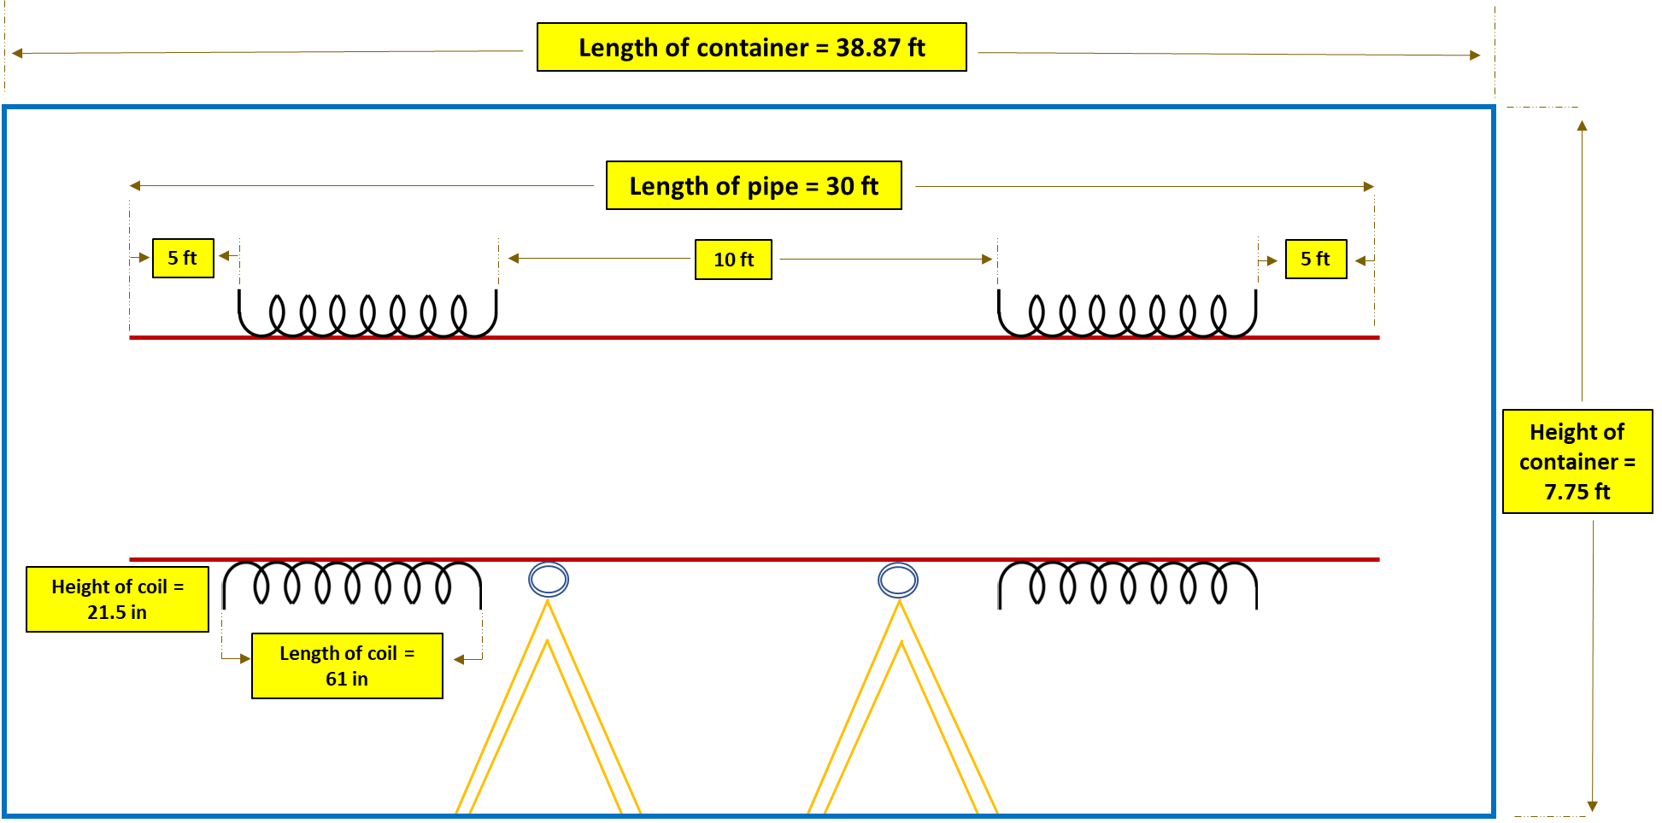
Figure 4: Schematic of the pipe inside the container

