**Milestone 7.3.1 - Borehole EM data Collection and Imaging at the FORGE site; Report for Field activities with the VEMP field system**

Introduction

The Frontier Observatory for Research in Geothermal Energy or (FORGE) site is an experimental facility in southern Utah for development of tools and processes associated with Enhanced Geothermal Systems or EGS (Figure 1). The site is being used for an EGS demonstration where deviated wells are drilled into hot dry rock and hydraulically fractured to provide an underground reservoir of high temperature fluids to produce geothermal energy (Moore et al., 2020).

**Figure 1.** FORGE field site in southern Utah

As part of the FORGE team Lawrence Berkeley Laboratory has been tasked with applying a borehole-to-borehole electromagnetic (EM) technology to image the fracture network from the conductivity changes associated with a change in porosity and water and steam saturation.

This document describes the results of a field survey using the Vertical Electromagnetic Profiling system (VEMP) at the FORGE site for the purpose of imaging the newly created induced fracture network. The report provides information about the borehole transmitter and the VEMP downhole receiver tool. We also give the deployment details of both transmitter and receiver stations, the logging plan and the results of the field survey conducted in May 2024.

**VEMP System**

The VEMP system was designed and built at the Berkeley company Electromagnetic Instruments Inc (EMI) for the Japanese company Geothermal Energy Research and Development (GERD) in 1995. The borehole tool was intended for subsurface electrical resistivity imaging for high temperature geothermal wells, but also for mining applications (Muira et al., 1996).

**Tool Characteristics**

The VEMP system features separate transmitter and receiver sections for surface to borehole or cross-borehole logging in a high temperature environment. The system operates with separate stations logging independently but linked by a system clock (Figure 2).

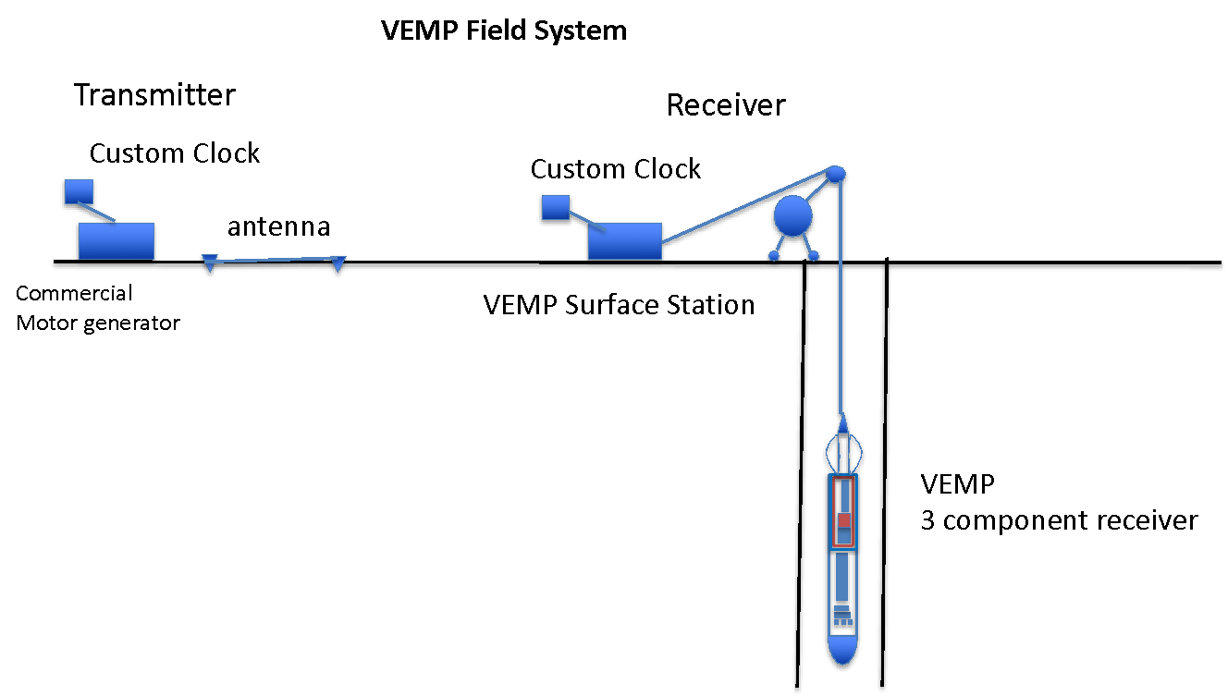

**Figure 2.** VEMP surface to borehole EM system

**Receiver**

The VEMP receiver is a three component magnetic induction sensor intended for borehole deployment at depths up to 4 km and temperatures up to 260oC. The tool was designed for imaging geothermal reservoirs and associated fracture networks from boreholes using a surface or borehole based transmitter (Figure 3).

The three component sensors are placed within an oil compensated housing that will withstand pressures at depths up to 4 km. The axial sensor is 1.5m long with a 1 cm core of high magnetic permeability steel (mu-metal). It is wrapped with around 50,000 turns or wire and connected to a down hole amplifier using a magnetic feedback configuration. The horizontal component is measured by an array of trans-axial orthogonal sensors. This consists of a series of 2.5” coils with magnetic cores connected in series/ parallel. These 3-component coils provide impressive sensitivity for such a small package. All sensors have excellent sensitivity from 0.5-200 Hz. The tool also has a three-component fluxgate magnetometer which is used for tool orientation.

The VEMP tool is a 6m (20 ft) long package and 14 cm in diameter (5”) with an upper bow spring centralizer. It is deployable in boreholes of 6” or larger. The tool was ahead of its time for sensitivity and for temperature and pressure tolerance.

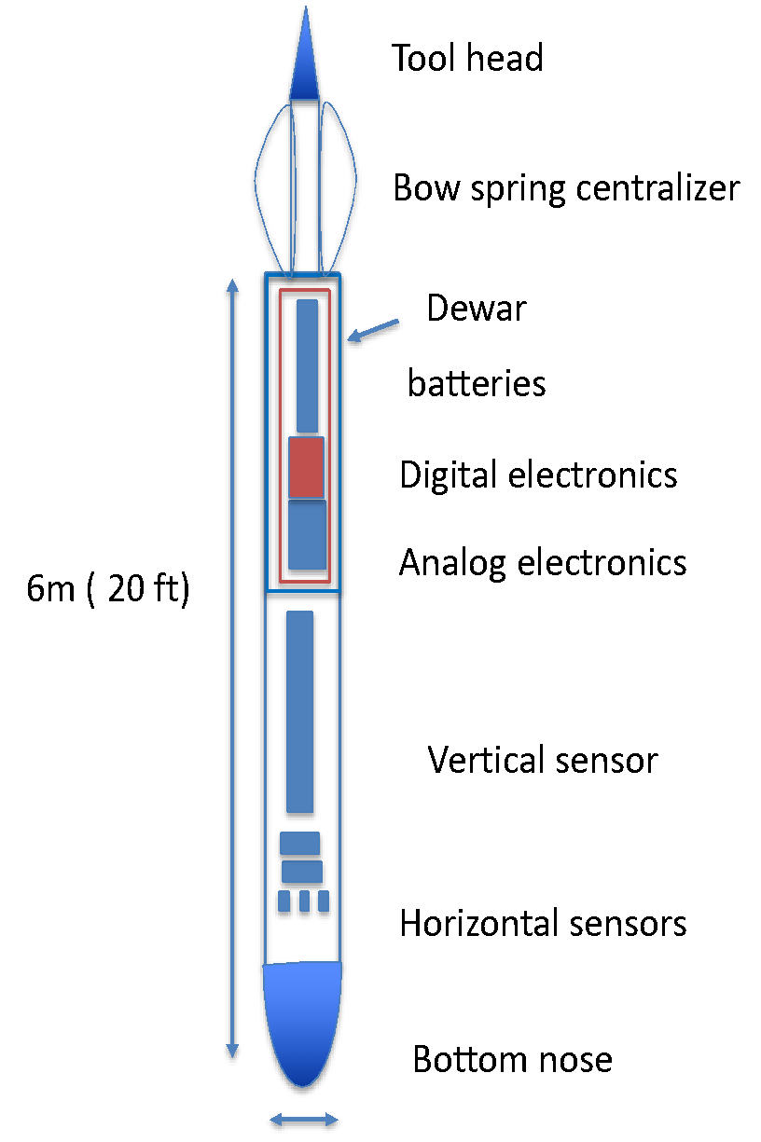

20cm

**Figure 3** Schematic of the VEMP borehole receiver.

Below is a sample plot from a successful high temperature logging test in Dixie Valley, Nevada in 2001 (Figure 4). In that deep test the tool logged 300m of open hole and 200m of cased hole at temperatures up to 215oC using an array of transmitters from 200m to 1km from the vertical receiver well (Mallan et al., 2001).

**Figure 4** VEMP Vertical field profile in a Dixie Valley, Nevada well from a surface bipole transmitter 200m away.

**Tool reconditioning**

The VEMP system was last deployed in 2001 and stored in Japan since then. It was sent to LBNL on loan in 2021 for the potential deployment at FORGE. As part of the initial testing it was found that all mechanical parts were sound but due to its age, the downhole digital electronics needed to be updated or replaced. It was decided to replace the digital electronics with a combination analog/digital system where the main sensor signals are sent up the wireline analog, and orientation temperature and power level signals are sent up the wireline on a digital circuit. The power is supplied by a small collection of lithium batteries that should maintain operations for up to 30 hours. The concept was validated with laboratory and local field testing in 2022-23.

**Transmitter Tool**

A custom borehole electrode (figure 5) was developed for deployment into the vertical section of injection well 16A-78(32). This electrode will be grounded against the well casing at a depth of 1.2 km. The electrode is attached in parallel to the 7-conductors of high temperature wireline cable. This wiring is routed to the metallic lower section of the electrode and connected to the well by contact with the 1.3m bronze electrode.

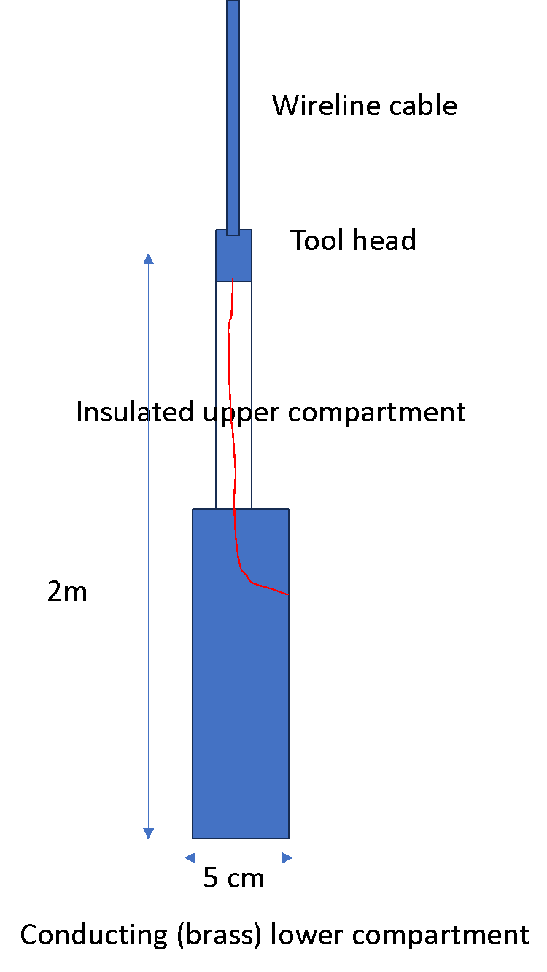

**Figure 5.** Schematic diagram of the downhole transmitter electrode

The transmitter will impart 2-4 Amp of current at frequencies from 1-100 Hz into the casing. The signal recorded at the VEMP tool will be generated from casing and surface wire current and “leak off” currents from the electrode into the formation and induced fracture network.

The signal is developed using one of a pair of GPS-synchronized clocks, which provides a square wave signal synchronous with a sister clock located at the receiver. The sister clock at the receiver is used as a phase reference. The square wave is amplified and connected to a load consisting of the surface and downhole electrodes and accompanying wire. The system can handle up to 500 ohms of load and still provide a current of 1 amp.

**Deployment and Logging Operations**

VEMP is operated using separate transmitter and receiver deployments. For surface-to-borehole operations, the transmitter is deployed by first installing the antenna, a large coil of wire or a pair of grounded wires. Although the coil deployments are straightforward the grounded wire deployments require some preparation on electrode sites, including adding moisture and/or salt to reduce the contact resistance. For borehole operations the transmitter can employ a borehole coil or a casing grounded electrode. A single bipole from an electrode at 1200 m depth in well 16A-78(32) inside the casing and a return set of electrode stakes 1.5 km NE of the well.

The receiver system requires wireline deployment and a crane for moving the tool in an out of the borehole. The considerable length (6m) and weight of the tool (>100kg) requires careful treatment and an experienced crew. Once in the well the tool is lowered to the logging depths and operations commence. The holding time is roughly 20 hours at 220o C and the battery life is expected to be roughly 30 hours. Since borehole deployment to 2km or more requires several hours in transit to the depths of interest, the operations must be carefully planned.

Once the logging depth is reached the transmitter is switched on the and signal level adjusted for a good signal to noise ratio. Phase connection is established using a set of high-performance clocks that also generate square wave signals as the source waveform. In optimal conditions, data are collected in profiles consisting of 20 or more stations, spaced at 10 or 20 m intervals. Each station is recorded while the receiver tool is stationary. Signals are averaged at a depth until a low error level is reached, then the tool is moved to a different depth in the profile. A typical station should require roughly 1-3 minutes of stacking time and an additional 2-3 minutes to move to the next station and stabilize the tool. A 300-meter profile using a 10 m station spacing should require roughly 2-4 hours.

Receiver data are logged at the surface within the wireline truck, using a multi-channel digital seismic recording system (GEODE manufactured by Geometrics) and a laptop computer. The data consists of a depth file, sensor amplitude and phase data and magnetic orientation recordings for each depth as well as temperature, power levels and other housekeeping data. A survey may consist of several depth profiles, one for each transmitter position. Multiple receiver wells can be used if available.

**Deployment at FORGE**

VEMP was deployed at FORGE following the stimulation operations, which concluded in the spring of 2024. The receiver tool was deployed in the open and steel-cased sections of well 78B-32 using a transmitter electrode in the vertical portion of well 16A-78(32). The data will be used to image the induced fracture network in the reservoir (Figure 6). The survey took place from May 20-27, 2024.

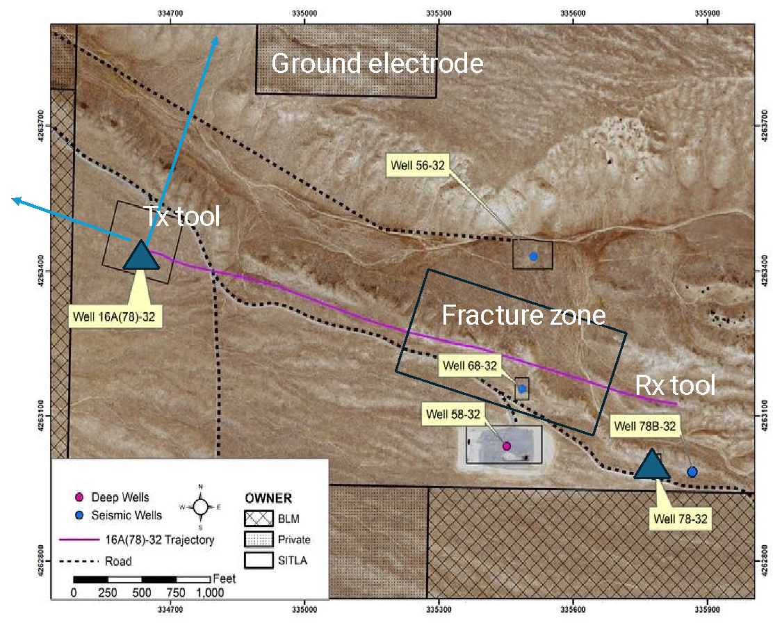

**Figure 6.** Tool deployment at FORGE.

The 6-man crew consisted of the following personnel

* Michael Wilt Crew chief. (LBNL)
* Ed Nichols System engineer (LBNL)
* Keith Pickett Wireline engineer
* Noah Perkovich Intern from (Colorado School of Mines)
* Masami Hyodo Logging engineer from GERD
* Kodai Ariyama Logging technician from GERD

The first three crew members had some experience with high temperature wells, the first two also with the VEMP tool, in earlier deployments in Nevada and Japan. Noah Petrovich is a Colorado school of Mines graduate student intern and Masami Hyodo and Kodai Ariyama were logging engineers with extensive experience sent by GERD to learn how to operate their tool and to help with the deployment and data collection.

**Schedule and Set-up**

Prior to logging the steps required include setting up the transmitter and receiver tools as well as preparing the wells for logging.

The transmitter Set-up consisted of the following:

* Installing a ground electrode for the transmitter
* Installing a pack-off on well 16A-78(32)

The ground electrode was installed 1.5 km north-east of well 16A-78(32 (Figure 6). The electrode consisted of 5 galvanized steel pipes connected in parallel and pounded into the ground, through a slurry of mud and salt water. The goal is to a achieve good ground coupling so the total resistance of the transmitter circuit, including ground wire, logging cable and the surface and casing grounding points would be less that 200 ohms. This was achieved on the first field day after some fairly tough physical labor.

The transmitter well (16A-78(32)) was pressurized and we needed to bleed off the pressure before a pack-off at the wellhead could be installed. This required about 3 hours and work to install a surface hose to divert the produced water into a surface pond.

For the transmitter deployment we used the small wireline “bread” truck which has 1.4km of high temperature cable installed on the internal drum (Figure 7). The electrode was deployed via the truck’s self-contained boom and crane. The tool was then deployed in the vertical section of the deviated well, at a depth of 1.2km without incident. We then switched on the current and were able to transmit 2A of 10 Hz current reliably into the well casing.

**Figure 7** Deploying the transmitter tool into Bread Truck at well 16A-78(32)

**Receiver Deployment**

The VEMP system was deployed into well 78-32B. This well is a vertically oriented observation well of 6” diameter with a cased hole section to a depth of 2600m and 300m of open-hole section beneath. We note that the open hole section was found to be inaccessible during an earlier logging run. We planned to try to enter this section of the well on this field survey.

The following was required prior to logging

* Validating the “no pressure” condition on well 78B-32
* Run a dummy tool in the well to verify accessibility
* Testing the VEMP receiver on the ground surface

Well 78B-32 was opened and we lowered the dummy tool to a depth of 1.5 km without incident. The VEMP tool was assembled on the surface and initial testing was unsuccessful due to a number of loose connections that occurred during shipping. These were found and repaired after some troubleshooting and the tool began working. We also found that the system clocks were not initially operational due to loosened connections, and these were also repaired. After several hours of troubleshooting the system was operational and we could begin logging.

**Logging and Data Collection**

The original plan called for logging in a vertical observation well 78-32B, located 400m southwards from the tip of the deviated well where fractures were induced. Data would be collected from depths of 1900-2600m to measure fields associated with induced currents in the fractures. We would use frequencies of 10 and 50 Hz and two surface grounding points for the transmitter.

Due to the high temperatures in well 78B-32 the VEMP could only operate 8-10 hours before exceeding the 70oC temperature range within the electronics cartridge. At these temperatures, communication with the housekeeping electronics was unreliable on the RS485 link, and we noted problems in signal quality of the receiver signals. This was less than expected (Figure 8). Several separate logging runs were therefore required to complete the spatial and frequency coverage. Also note that about 1.5 hours was required to lower the tool to logging depths and another 1.5 hours to bring it to surface each time.

**Figure 8.** Temperature profiles for wells at the FORGE site.

**Deployment and Data Acquisition**

On the second field day VEMP was tested at the surface and lowered into the well and initially positioned at 300m, well above the high temperature zone. The transmitter was switched on and the signal was easily visible at this depth thus logging was set to begin (Figure 9).

**Figure 9**. Deployment of the VEMP tool in well 78B-32.

The initial time series and spectral plots are shown in Figure 10. The left panel of the figure shows the condensed time series for the three channels, the center panel selects a short time series segment and the right panel provides the spectrum for the short segment. The time series is intermittently noisy, and this was one of the better stations recorded. We note that on the spectral plots the supplied signal, 10 Hz is evident on all three components.

The initial data point at 300m was somewhat noisy, but the signal was coming through clearly although 10 minutes was required, which is well is excess of the 3 minutes planned for. In our experience data collection within steel cased wells is somewhat noisier than open holes due to the transmission of noise down the casing and the amplification of motion-induced noise by the casing, although the noise here was higher than expected.

**Figure 10.** Full time series (left) partial time series (center) and field spectrum for the VEMP measurements at 300m ( blue the vertical field, and the yellow and red transverse field components).

The first few data points were collected at 300m increments and data collection proceeded smoothly with each point requiring 10-15 minutes to stabilize then record data. The data stream got noisier with time and increasing temperature. We also noticed that the tool battery voltage was falling quicker than anticipated.

After several hours we brought the tool to the surface and replaced the batteries. This process, which was repeated several times during the survey, required more than 3 hours including transit time in the well.

Over the next several days we struggled to maintain our data collection schedule having issues with tool batteries, inconsistent communication with the downhole computer, and a steady wind which induced noise in the data via motion in the wireline cable. Noise in the data persistently increased throughout the operation. Data was still coming in, but 20-30 minutes of recording was required to obtain a single measurement. Typically, in low wind, once the tool was positioned to the measurement depth more than 5 minutes was required for the signals to settle down before any measurement was possible. A clamp was installed at the well head at several measurement depths to minimize the wind noise with some improvements, but the data would still be intermittently noisy, requiring 15 minutes before a reliable estimate could be made. With a limited holding time at high temperature, this was problematic. At the surface however the tool usually reverted to normal operating conditions after cooling. We show several representative time series in the figures below which highlight the nature of the noisy data stream.

In Figure 12 we show a data set where the Y component had stopped working. The other components seemed to be live so we kept recording. Later that same session the Y channel returned to “normal”. The reason is likely that the Y signal channel developed an intermittent DC offset that was over-range for the GEODE system, which had a limited input range.Initially, this offset was intermittent but towards the end of the survey all three components developed this condition. Note, that when the input stage saturates, the digital output is corrupted.

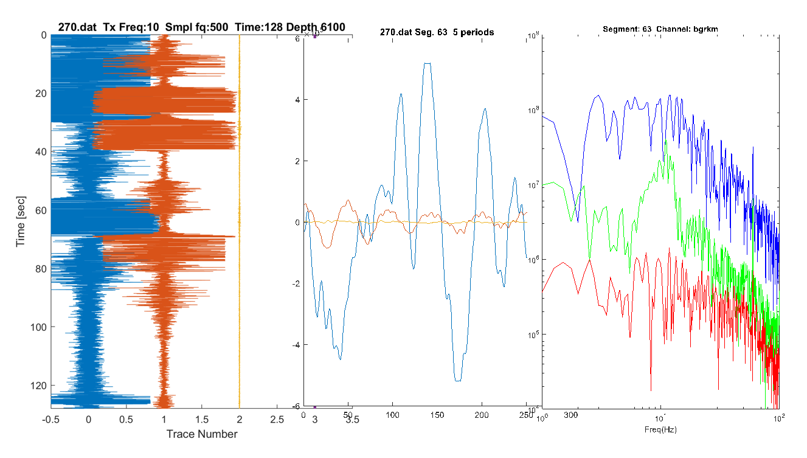**Figure 12.** Full time series (left) partial time series (center) and field spectrum for the VEMP measurements at 6100 ft.

In Figure 13 we show a station that developed an internal oscillation at a frequency near 80 Hz. Note that this was only on the horizontal components, the vertical field seemed unaffected. The cause of the oscillation is not known and it was not always at the same frequency. It may be related to the preamplifier and changing coil impedance values with temperature or component change at temperature in the 25-year -old analog electronics or both. More testing is needed to determine the cause. We noticed the oscillation on all three components at the end of the survey. As the coils all operate with magnetic feedback, these oscillations may corrupt other components.

**Figure 13.** Noisy station, with high-noise vertical field at left and self-oscillating signals from the horizontal coils at center and right.

We note that when the tool was brought to the surface and cooled it would usually revert to normal operating conditions and work well. With higher temperature it quickly degraded into a noisier operation. In the final days of the survey however the tool developed DC offsets on all three components and it was no longer possible to record on the GEODE system. Fortunately, we had a 2-channel spectrum analyzer on site that could handle signals as high at +/- 20 V. We used this device on the final day recording the vertical field and using the system clock as a phase reference. We collected the data by reading the screen and manually recording the amplitude phase and coherence value.

Below is a summary of the most predominant sources of noise identified.

* Wind noise
  + Blustery weather conditions at the FORGE site would often shake the wireline cable above the well head, transmitting vibrations to the tool at depth and making downhole measurements quite noisy. We were able to apply a cable lock at the wellhead which reduced this somewhat, but in general the data quality in windy conditions was poor. It was windy perhaps 30% of the time.
* DC offset
  + Over time in the high temperature well the tool developed DC offsets on all three sensor channels. This condition is very problematic for the surface digital recording which had a 1 V maximum input. That is, any signal with a DC level above 1 Volt would appear as a static level of 1 V. At the end of the survey we used a commercial spectrum analyzer, with a +/-10 V input range, to collect data.
* Internal Oscillations
  + After several days logging the tool began to exhibit internal higher frequency oscillations, likely due to a malfunctioning tool amplifiers (Figure 13). The oscillation occurred at several frequencies and were intermittent.

**Data Recovery and processing**

In total more than 25 hours of data were collected over 4 days on the GEODE and spectrum analyzer, although much of the data is very noisy. Due to the large volume of data collected, we are still able to process the signals and at a number of stations we obtained a stable estimate, of the vertical field component at least. The horizontal field components are noisier and there are only useful at a few stations.

The data processing was often a laborious process undertaken by our chief engineer Ed Nichols. Ed developed MATLAB software to divide the time series into 50% overlapping 2000 pt sections, and then use the median of the set of transfer function estimates to identify a “robust” estimate. He then sorted them according to coherence with the source waveform and plotted the results. Sample plots are shown below.

In Figure 14 we show the results from a good station. Here we see a good coherence and stable amplitude and phase estimates for all three field components. We note that when the coherence exceeds .95 the data scatter is typically quite low. Each Geode run typically consisted of 16000-64000 pts, with 3-8 runs being taken at each depth for a total acquisition time of ~10 min per depth. Some depths were repeated on different profiles.

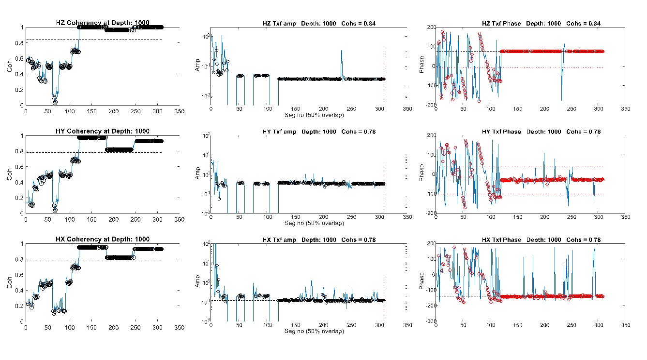**Figure 14** VEMP data reduction for a good station.

In Figure 15 we show results from a more typical station. Here the vertical field seems good but the horizontal components are quite noisy and unstable. We struggle here to get a good estimate of the horizontal fields.

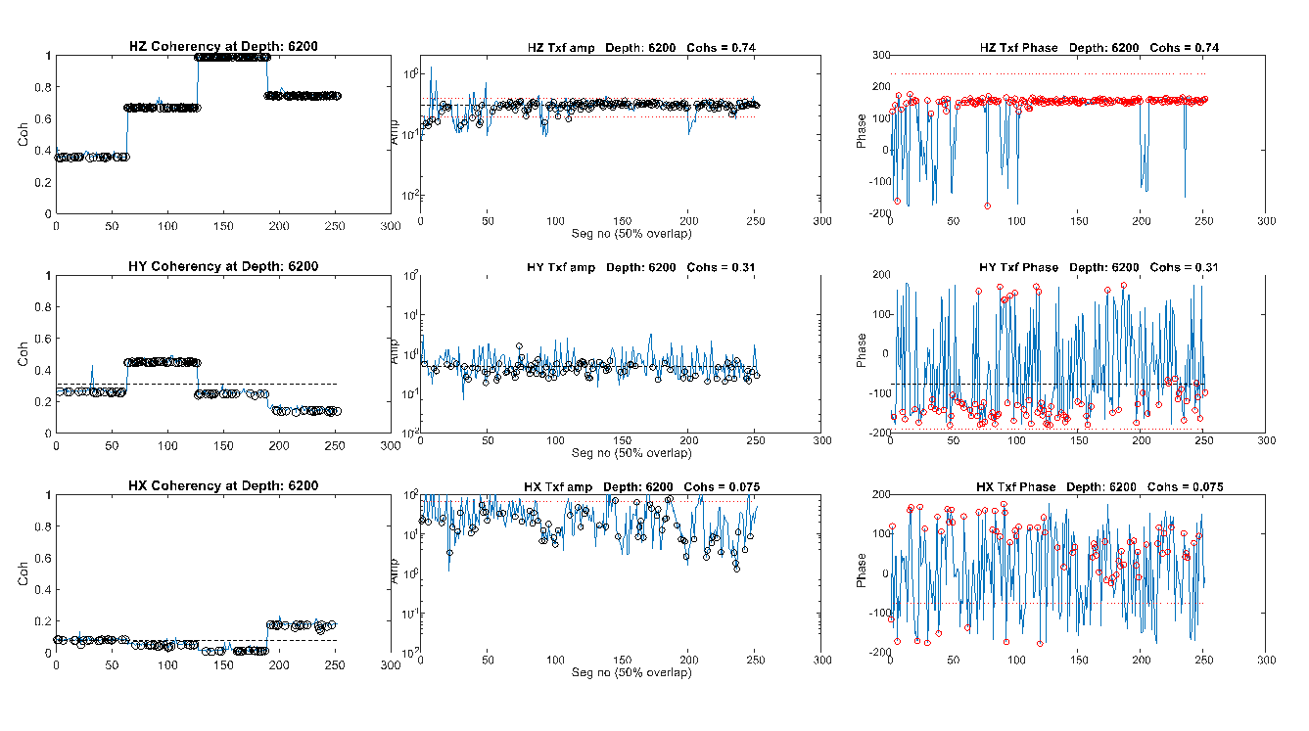

**Figure 15**. Data reduction for an average station

In Figure 16 we show a poor station. Although the recording times were long we don’t see a convergence on any field to a stable value. This is especially true of the phase.

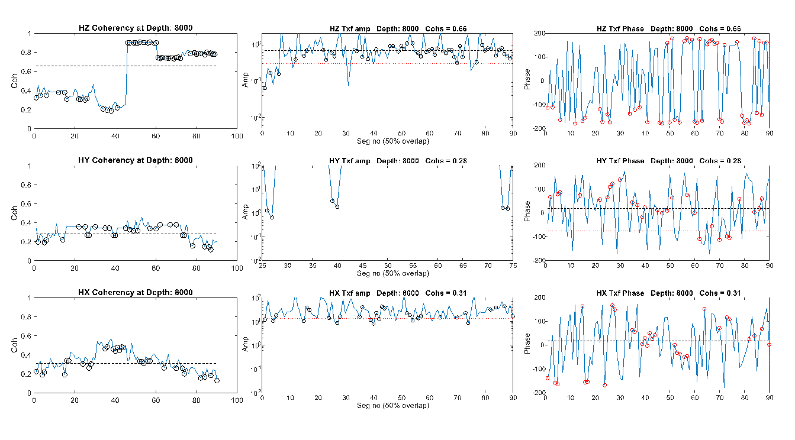**Figure 16.** Data reduction for a poor station

We note that the vertical component was usually better in quality than the horizontal components. This is because it has more sensitivity due to its axial orientation and is less susceptible to motion induced noise (tool rotation)

We averaged together the best estimates of the vertical field for all profile stations and compiled them into the table shown below.

Table 1. 78B-32. VEMP Field Profile

Depth (m) Hz relative amplitude Hz Phase (deg)

|  |  |  |
| --- | --- | --- |
| 1890.0 | 1.0 |  |
| 1945 | .6 |  |
| 2073.1 | 1.39 |  |
| 2164.6 | 1.33 |  |
| 2225.6 | .93 | -33.6 |
| 2256.1 | .944 | -38.8 |
| 2286.6 | 1.27 | -47.1 |
| 2317.1 | 1.17 | -49.1 |
| 2347.0 | 1.32 | -56.6 |
| 2378. | 1.03 | -52.8 |
| 2408.5 | 1.56 | -64.6 |
| 2439.0 | 1.39 | -68.6 |
| 2469.5 | 1.03 | -68.6 |
| 2500 | .923 | -81 |
| 2530.5 | .978 | -72.6 |
| 2561. | .912 | -18.9 |
| 2573 | .56 | -70.6 |

**Field Profiles**

Below is our best estimate of a vertical field amplitude and phase profile. Based on a combination of GEODE and Spectrum Analyzer data (Figure 17). The data are plotted as relative amplitude where the data are normalized by a single point. In the profile This presentation is typical for data collected within a steel cased well, because the casing attenuation constants are now known. The phase data are with respect to the system clock.

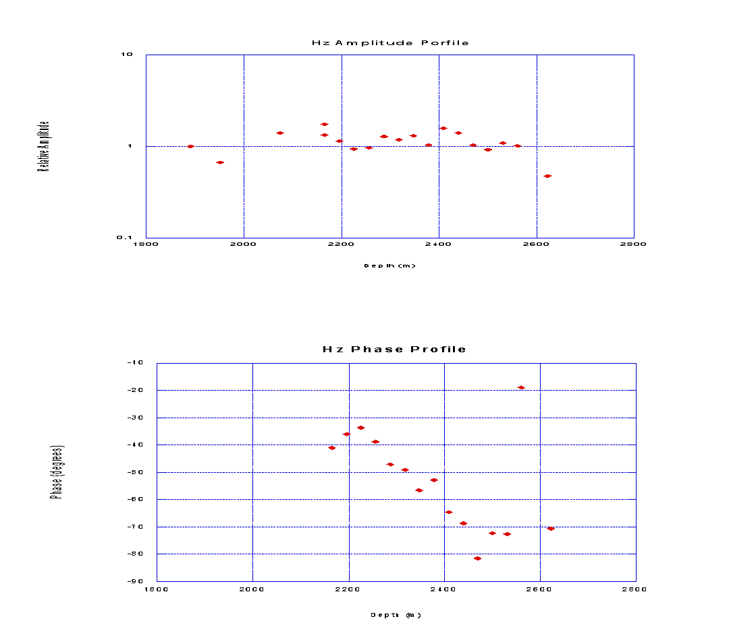

**Figure 17.** Field Profile in well 78B-32.

The amplitude plot is fairly widely scattered although largely flat-lying. The phase data show a clear downward trend with depth. We are uncertain as to how much of the scatter is due to the casing effect and how much is due to the challenge of evaluating a noisy data stream.

In Figure 18 we show 32 Hz data from the earlier Dixie Valley survey plotted at a similar scale. These data clearly show a similarly noisy vertical field in the steel-cased section of the well and much quieter data in the open hole. Note that these data were of very good quality so the scatter was not due to the signal scatter and more likely shows the effect of the casing. From these plots we suggest that much of the scatter in the FORGE data is due to the casing effects.

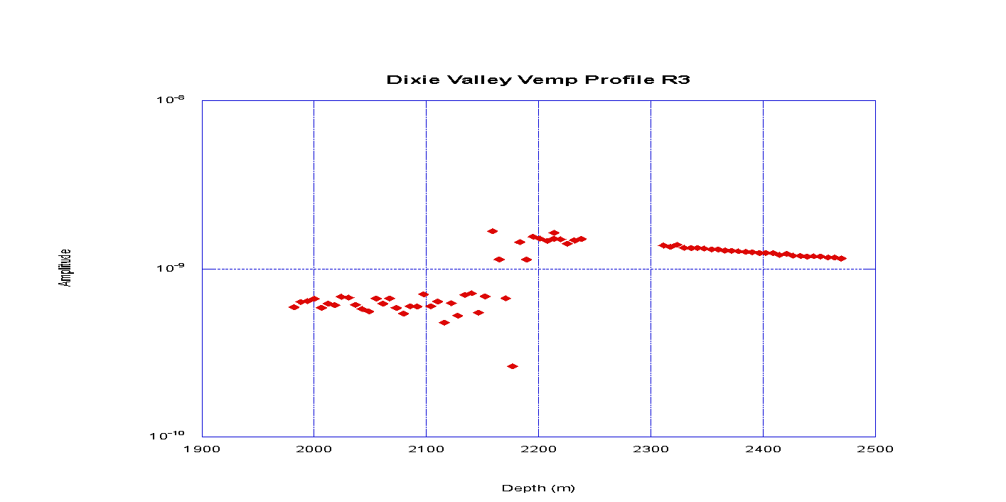

**Figure 18.** VEMP profile data from the Dixie valley survey

**Summary and Conclusions**

There are positive and negative conclusions from the survey. First the tool worked and we collected data at depth in high temperatures. In addition, the tool survived; it endured through many hours at depths exceeding 2600m and temperatures exceeding 2200C.

However, the data collection was slow due to a lot of internally generated noise. The tool seemed to get noisier with high temperature exposure. We suspect there are issues related to the vintage analog electronics that we can only uncover after further lab testing. In addition, it has become clear that digital telemetry is the best path to good quality data at high temperature.

The VEMP remains a one-of-its-kind tool, and the sensors and housing seem intact after the field experiment at FORGE. What is causing the noisy data stream and the subsequent failure of the electronics is the subject for trouble shooting this fall. We are confident that with an improved data acquisition system many of these problems will be solved.

**Acknowledgement**

We acknowledge excellent support and assistance from the FORGE staff on site. Leroy Swearingen, who was stationed on site provided a daily report and was always there to help. Garth Larsen provided the safety briefing and Joe Moore also visited the logging site. John McClennan and Sean Lattice were helpful in arranging the field survey.

We also found on-site facilities to be excellent and complete.

**References**

Alumbaugh, D., Um, E., Wilt, W., Nichols, E., & Osato, K., 2023. Deep Borehole EM Deployment for Fracture Mapping at the FORGE Geothermal Site. In Proceedings of the 48th Workshop on Geothermal Reservoir Engineering (pp. 6-8). Stanford, California.

Mallan, R., Wilt, M., Kirkendahl B., and Osato K., 2001, Subsurface Electrical Measurements at Dixie Valley, Nevada using Single Well and Surface to Well Induction Logging, Proceedings, Twenty-Sixth Workshop on Geothermal Reservoir Engineering Stanford University, Stanford, California, January 29-31, 2001

Miura, Y., Osato, K., Takasugi, S., Muraoka, H., and Yasukawa, K., 1996. Development of the Vertical Electro Magnetic Profiling (VEMP) method. Journal of applied geophysics, 35(2-3), pp.191-197.

Moore, J., McLennan, J., Pankow, K., Simmons, S., Podgorney, R., Wannamaker, P., Jones, C., Rickard, W., and Xing, P., 2020, February. The Utah Frontier Observatory for Research in Geothermal Energy (Forge): a laboratory for characterizing, creating and sustaining enhanced geothermal systems. In Proceedings of the 45th Workshop on Geothermal Reservoir Engineering. Stanford University.