A circulation test was conducted at the Red Raider #2 at the Oil Field Technology Center (OTC) of Texas Tech University, where the main objective was to pump hot water at 1 STB/M into the tubing and produce through the casing to produce heat transient and analyze thermal slugs, taking measurements of temperature of the fluid from a thermocouple close to the wellhead and DTS measurements from fiber optics that is tapered into the tubing. The injection process was repeated three times, with the following step-by-step:

1. Injection of hot water at 60°C at 1 STB/M until reached a steady state condition.
2. Stopped pumping for 1 hour to reach a thermal equilibrium.
3. Water Re-injection at 70°C at 1 STB/M for 30 minutes.
4. Stopped pumping for 20 minutes.
5. Water injection at ambient temperature (around 20°C) for 30 minutes.

The DTS was used to analyze temperature over time and space (to analyze thermal slug velocity), while the thermocouple was mainly used to analyze fluid temperature at a fixed point over time to serve as input into the model. The flow rate was measured by a Coriolis meter, and it was able to record any flow rate fluctuations. The flow rate over time is in the table below. At 10:09, the circulation test was interrupted, thus a null flow rate. In addition, the bulk velocity was calculated using Eq 1, with a cross-sectional area of the tubing (2 7/8’’) with an inner diameter of 2.441’’.

The experimental bulk velocity was calculated as the average of the 12 velocities obtain for each flow rate. The value obtained was 0.800 m/s

|  |  |  |  |
| --- | --- | --- | --- |
| Time | L/min | STB/M | Bulk velocity (m/s) |
| 9:49 | 95 | 0.601 | 0.528 |
| 9:50 | 105 | 0.665 | 0.583 |
| 9:51 | 106 | 0.671 | 0.589 |
| 9:52 | 158 | 1.000 | 0.878 |
| 9:53 | 158 | 1.000 | 0.878 |
| 9:54 | 157.7 | 0.998 | 0.876 |
| 9:55 | 157.7 | 0.998 | 0.876 |
| 9:56 | 157.7 | 0.998 | 0.876 |
| 9:57 | 158 | 1.000 | 0.878 |
| 9:58 | 158.5 | 1.003 | 0.880 |
| 9:59 | 158.5 | 1.003 | 0.880 |
| 10:00 | 158.4 | 1.003 | 0.880 |
| 10:01 | 158.4 | 1.003 | 0.880 |

Table 1. Flow rate over time during the 12 minutes (first warm up) of the well and calculated bulk velocity (experiment)

|  |  |
| --- | --- |
| $${\overline{V}}_{flow}\frac{m}{s}=\frac{Q}{A}=\frac{Q \frac{bbl}{min}×\frac{0.1590{ m}^{3}}{1 bbl}×\frac{1 min}{60 s}}{\frac{π}{4}\left({2.441}^{2}{in}^{2}×\frac{{0.0254}^{2}m^{2}}{1{in}^{2}}\right)}$$ | (1) |

A fiber optic cable was installed along Red Raider #2 behind the tubing to monitor temperature variations. Figure 1 shows the fiber optic waterfall data plot along the well obtained from the circulation test. The DTS measurement started at 9:38:20 and ended at 14:08:30 (total circulation time: 270 minutes 10 seconds). The slopes of orange arrows deliver the estimated average thermal slug velocities from two different injection processes.

Figure 1. Fiber optic waterfall data plot obtained from the circulation test

To accurately determine the thermal slug velocity for the first warm-up process, the fiber optic waterfall data plot (Figure 1) was calibrated as shown in Figure 2. In this new waterfall plot, the DTS measurement starts at 9:48:31 and ends at 10:00:44 (total circulation time: 12 minutes 13 seconds). Additionally, the measurement points were reduced from the original points 1605 to 254 points.

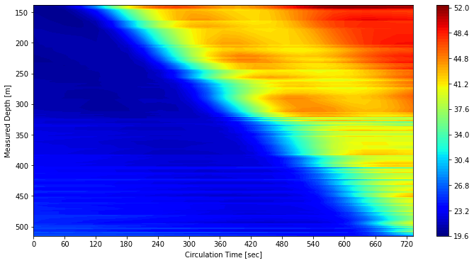

Figure 2. Calibrated fiber optic waterfall data plot for the first warm-up phase obtained from the circulation test

The thermal slug velocity was determined through linear regression, using the results obtained from the calibrated circulation test. Figure 3 shows the thermal slug velocity at a threshold temperature of 30°C obtained by linear regression. As a result of the calculation, the thermal slug velocity for the first warm-up injection process becomes 0.649 m/s.

Figure 3. Thermal slug velocity at threshold temperature of 30°C

To model the thermal transient and the thermal slug velocities, Schlumberger’s OLGA Multiphase Fluid Flow Simulator was used. Red Raider #2 was modeled as a 457.3 meters (1500 ft) vertical well with a constant tubing diameter of 2 7/8’’. The well was discretized into 450 sections of 1.016 meters each.

Furthermore, for the heat transfer calculations by the fluid and the tubing wall, and for the tubing wall to the other components of the Red Raider #2 (nitrogen, water, cement and formation), OLGA works with materials, which are defined by their thermal components: heat capacity, conductivity, density, thermal expansion and viscosity (if fluids). The thickness of the wall used for each component of the Red Raider #2 was defined by the 2 7/8’’ tubing – 5 1/2’’casign – 9 5/8’’ casing and its annuli.

To be consistent with the DTS data in which 12 minutes of data was collected and the analysis of the thermal velocities were made in a temperature threshold of 30°C, the numeric model simulated only the first warm-up transient period (12 minutes), from 9:49 to 10:01. The desired outputs for the calculation of the thermal velocities are temperature over time in a known position of the well in order to calculate the velocity. The selected sections of the well to plot temperature over time were:

1. Section 1: the wellhead
2. Section 75: 76.2 meters from the wellhead
3. Section 150: 152.4 meters from the wellhead
4. Section 225: 228.6 meters from the wellhead

For each of these sections, in the Temperature over Time plot, it was analyzed at which time the section’s temperature has arrived at 30°C (Figure 1). Finally, the thermal velocity was calculated using:

$$V_{thermal}=\frac{{Position}_{i}-{Position}_{1}}{{Time}_{i}-{Time}_{1}}, i=75, 150, 225$$

with the position being calculated as: ${\text{Position}}_{\text{i}}\text{=i×1.016}$.

The final thermal velocity considered was the average between the thermal velocities obtained for the three sections. The following table was generated:

|  |  |  |  |
| --- | --- | --- | --- |
| **Section** | **Time (s)** | **Velocities (m/s)** | **Average velocity (m/s)** |
| 1 | 94.4247 | - | 0.603 |
| 75 | 226.826 | 0.568 |
| 150 | 341.7 | 0.612 |
| 225 | 456.152 | 0.629 |

Table 2. Thermal velocities calculation in three points and average value for a temperature threshold of 30°C

Figure 1. Plot of Temperature vs Time for Section 1, 75, 150 and 225. In the boxes: time at which each section reaches 30°C

The calculation of the bulk velocity from the numerical model considered the average flow rate used in the numerical model. To calculate the average flow rate, a weighted average between the initial input flow rate of 0.6 STB/M and the final flow rate of 1 STB/M, considering the time that these flow rates were exposed to the flow. For 0.6 STB/M, a total of 4 minutes was used and for 1 STB/M, a total of 8 minutes was used. The results are on the table below.

|  |  |
| --- | --- |
| Time (minutes) | Flow rates model (STB/M) |
| 4 | 0.6 |
| 8 | 1 |
| Average (model) | 0.867 |
| Bulk velocity model (m/s) | 0.761 |

Table 3. Calculation of the bulk velocity from model data

The comparison between bulk velocities from model data and the experiment can be found on Figure 2. The relative and absolute errors are in Table 4

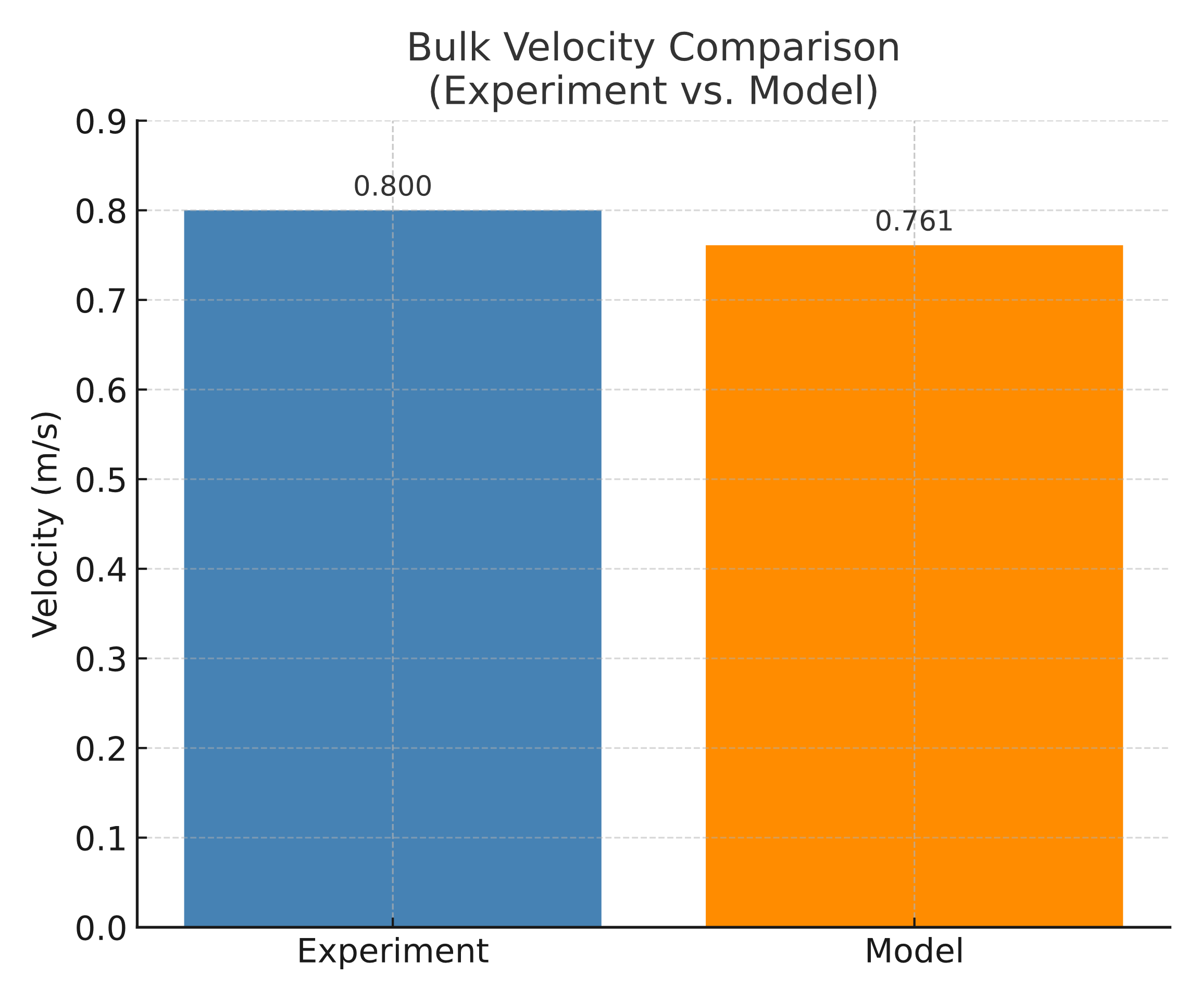

Figure 2.Bulk velocity comparison between experiment and modeling

|  |  |
| --- | --- |
| **Metric** | **Value** |
| Bulk velocity (experiment) | 0.800 |
| Bulk velocity (model) | 0.761 |
| Relative error (%) | 4.935 |
| Absolute error (%) | 3.949 |

Table 4. Comparison of experimental and modeled bulk velocity with associated errors.