**Test Series Overview**

A series of tests were conducted to determine reaction rate and general behavior of aluminum (AL) and magnesium (MG) powder mixtures with Bullseye double-base smokeless propellant. Given the indeterminate sensitivity and unknown potential behavior of the mixed material, mixing and subsequent charge placement was performed remotely. The basic test setup is shown in Figure 1.

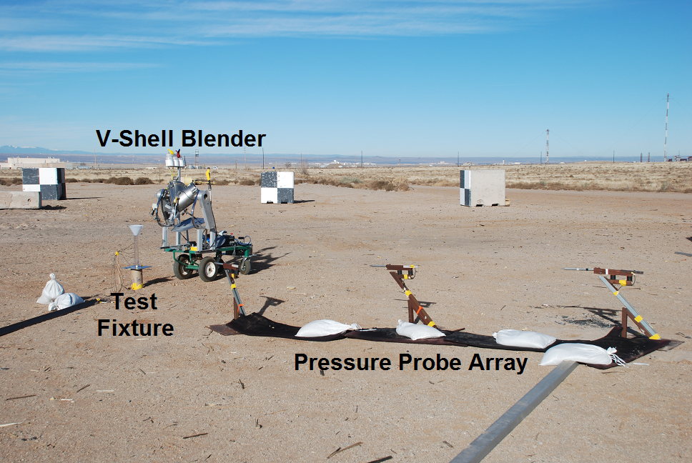

**Figure 1: Test Setup**

PCB incident pressure gauges were also placed at 10, 15, and 20 feet from the charge center. A remotely operated v-shell blender was utilized to mix the material and subsequently place it in the column for testing.

To determine the reaction rate of the material, test fixtures were assembled with Dynasen piezo time of arrival gauges as shown in Figure 2. 5 pins were positioned on the column, with pin 1 in contact with the 17 gram C4 booster’s top surface (booster dimensions were 1”x1”). Pin 2 was positioned 5 inches above the booster surface, with pins 3-5 positioned at 2.5” intervals. A Reynolds RP-83 EBW detonator was utilized to initiate the C4 booster

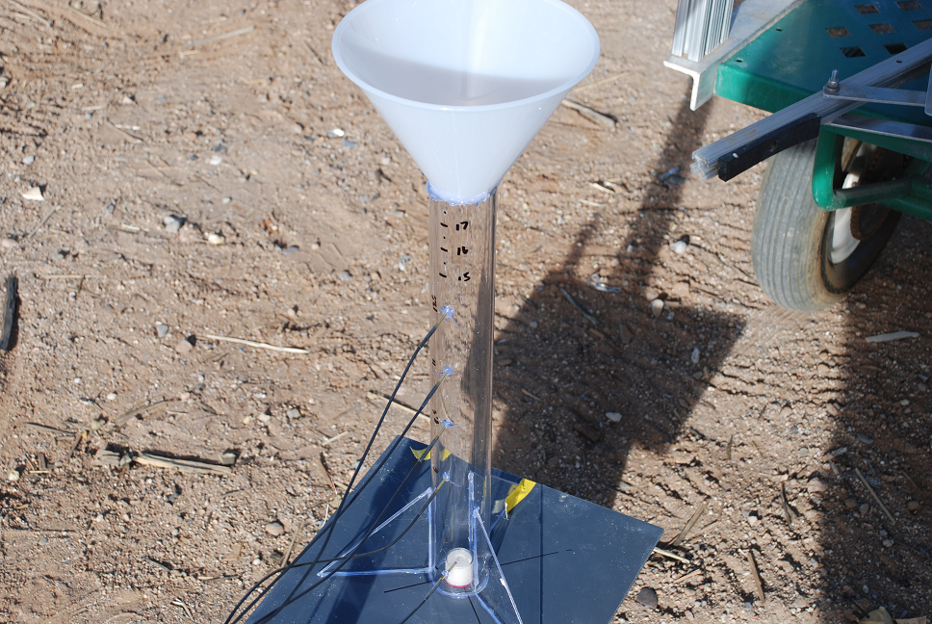

**Figure 2: Test Fixture**

13 tests were performed using various ratios of Eckhart 5413H aluminum powder at both tamped and untamped densities. 4 additional tests were performed with MG powder (bag house fines) at untamped densities. High speed video was also recorded during each test

**Test Results**

Table 1 summarizes the average reaction velocities and measured overpressures for each test. High metal loading densities result in relatively low shock pressures and piezo output signals that are less instantaneous and much noisier, increasing measurement error. This was quite evident in the 60% loading test results. As a result it is highly unlikely that testing AL loading densities higher than 60 % would yield useful data using this type of gauge array. Note the indicated densities are approximate numbers as the final fill height was determined visually from the control point.

**Table 1: Test Matrix and Results**



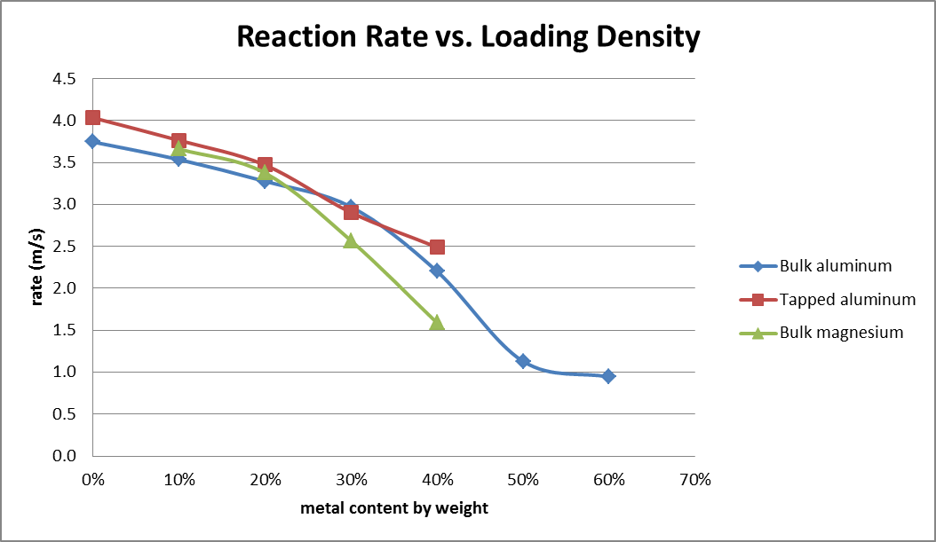

Figure 3 is a qualitative comparison of pure Bullseye versus the highest tested load that exhibited steady state reaction velocity. Substantial pieces of test fixture material can be seen resulting in the 50% ratio test as a result of the lower reaction rate and resulting lower strain rate.

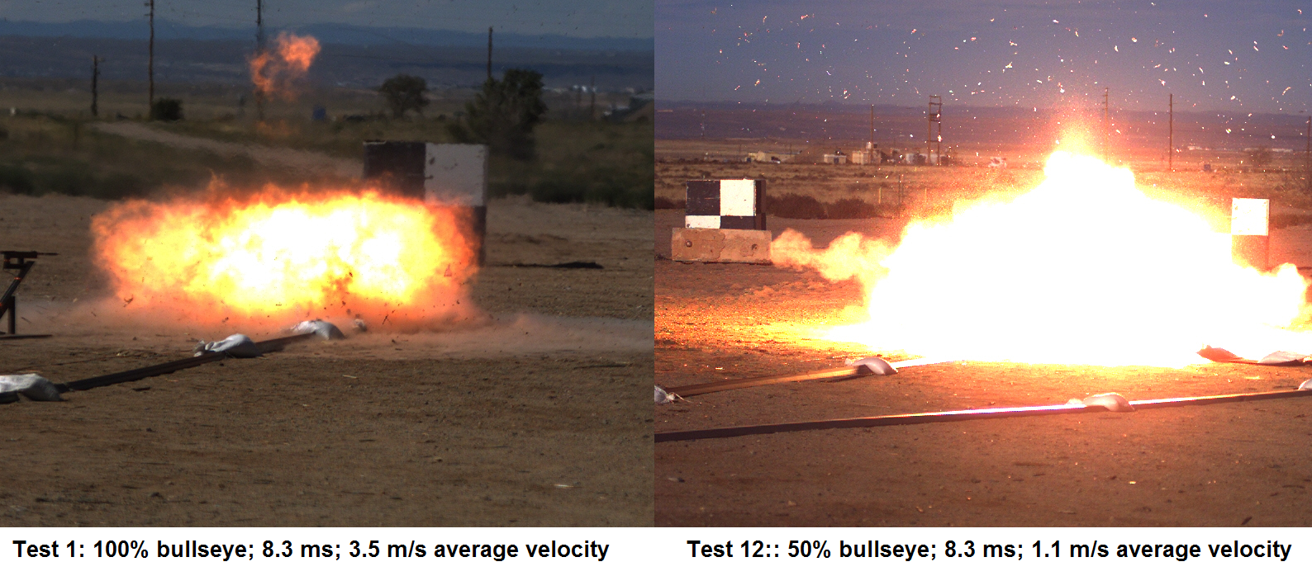

**Figure 3: Images from HS video (8.3 ms)**