Images from 3D seismic reflection survey across a geothermal field.

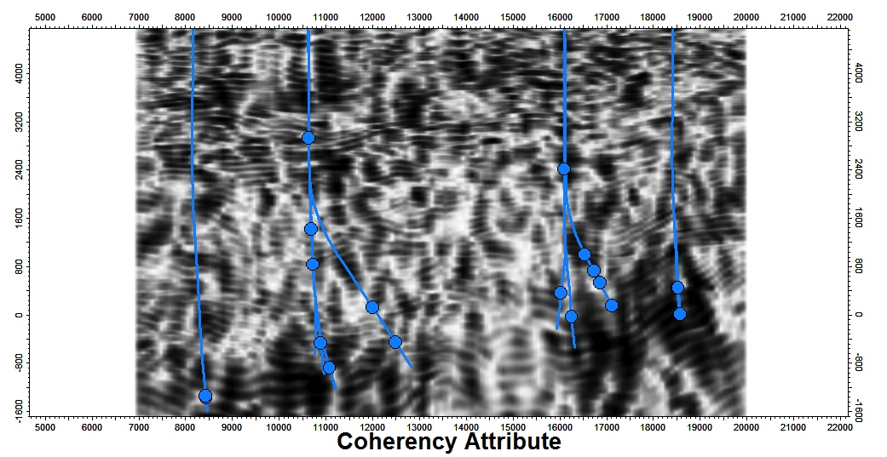

Inline showing coherency across the 3D dataset. Blue lines indicate well tracks that will be used for validation. Vertical axis is depth. White indicates relatively high coherency and dark low coherency. Wellbores (Blue) are projected on to the section.

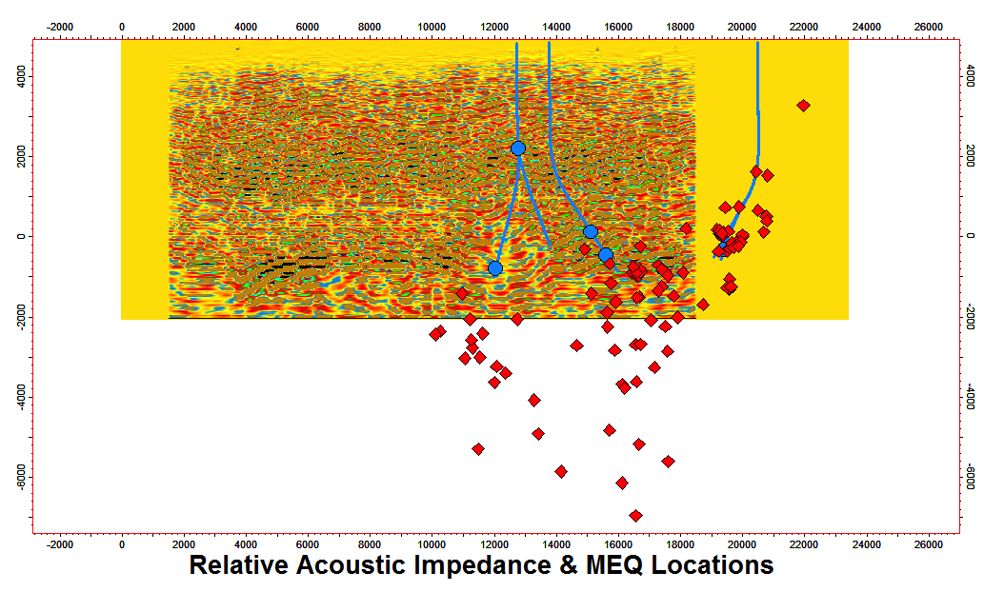

Figure showing acoustic impedance, well tracks (blue) and micro-earthquake locations plotted using hypocenters from the LBL catalog. Wellbores (Blue) are projected onto the section.



Perspective view of the 3D coherency cube of the geothermal area with well tracks shown in blue.