Thermoelectric Materials Development Summary for GDR

Organization: Southern Research Institute
Recipient Address: 2000 Ninth Avenue South, Birmingham, AL 35205-2708
Award Number: DE-EE0006746
Project Title: Geothermal Thermoelectric Generation (G-TEG) with Integrated Temperature Driven Membrane Distillation and Novel Manganese Oxide for Lithium Extraction

Improved thermoelectric materials can result in significant improvements in the performance and efficiency of thermoelectric generation (TEG) modules. Under this program, a goal of improving TE materials to allow for the development of a low cost, efficient TEG module was addressed through development of both p- and n-type TE materials.
The goal of producing 25 mm diameter TE material compacts by mechanical alloying and hot pressing was achieved, Figure 1. Even in their present thin form, these materials were found to possess sufficient strength to survive multiple impact events and a tape test - forces that would have fractured conventional solidified alloys.
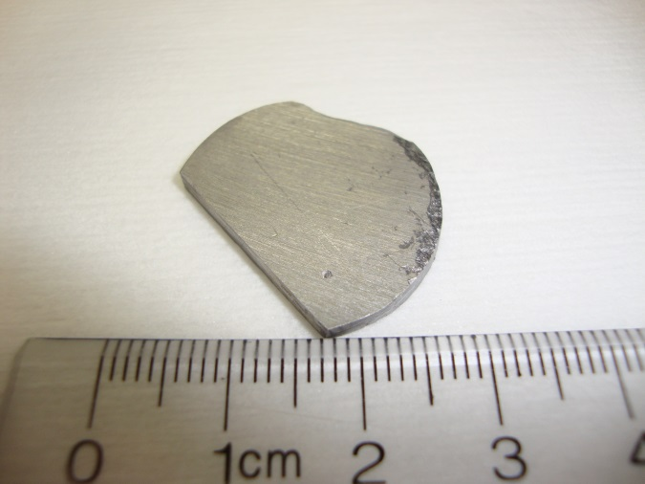 | 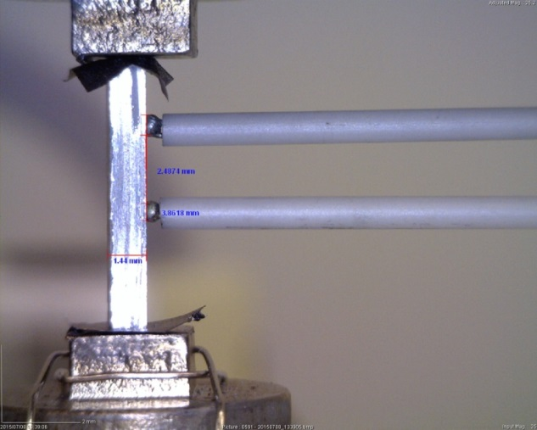
Figure 1: Lapped Compact of p-type BiSbTe: JH-1-47AB with ZEM-3 sample removed | Figure 2: ZEM-3 test of p-type BiSbTe: JH-1-13AB

Rectangular bars were cut from the hot pressed compacts for resistivity and Seebeck coefficient testing in an ULVAC ZEM-3. Results from this analysis are summarized in along with a baseline (golden) sample made previously (see separate Excel file uploads in GDR).
The electrical resistivity for both the n-type and p-type samples is higher than expected, with the n-type samples being the highest. For the p-type samples, it is believed that the presence of oxygen, incorporated as metal-oxides in the solid solution is responsible for the increased resistivity, especially for the first two runs JH-1-3AB and 13AB. Second phase oxygen can have a significant impact on electrical resistivity by increasing the potential barriers at grain boundaries. Oxygen is also a donor in Bi2Te3, having the effect of compensating the hole density in p-type alloys and increasing the carrier concentration in n-type materials, both of which will result in reduced Seebeck coefficient values. Moreover, the presence of oxygen raises the activation energy barrier for sintering, making it more difficult to achieve fully-dense compacts by hot pressing and resulting in densities < 95% of theoretical.
We believe the lots of antimony and bismuth powders purchased for this project contained relatively high amounts of oxygen and are responsible for the high resistivity and lower than expected Seebeck coefficient values. The materials chosen were of the highest purity available which was stated as 99.999%. However, the stated purity of these materials is based on a “metals only” analysis and hence the presence of non-metals, such as oxygen, is neither assessed nor guaranteed. Between the two precursors, the antimony source appears to be the primary source of oxygen as evidenced by the high resistivity of the first two p-type compositions. These samples also failed to densify beyond 95% of theoretical density, another manifestation of high oxygen contamination in the commercial starting material.

After utilization of new precursor materials (non-powder from a separate vendor), improvements in material performance are observed. Note that the p-type resistivity has improved dramatically with the use of new chunk source materials that doesn’t have the oxygen contamination problem that the raw Bi₂Te₃ powder does.

