Impact of loaded media on apparent sorption from new REE7 loaded brine
The purpose of this experiment was to explore the characteristics of partially loaded media for removal of REEs from fresh doped geothermal brine simulant at quantities well below capacity. Model experiments using the microcosm shaker test method were completed. This was accomplished by decanting partially depleted brine from media and replacing the brine with fresh REE loaded brine. Apparent capacity for this media in these brine simulants has previously been determined to be 1 % wt./wt.
Two different brine models were used. The brine simulants were doped with a mixture of 7 REEs. The total sorption and ratios for each of the 7 REEs are very similar for new media in both brines. This is also true for partially depleted media and fresh brine. However, the ratio of the REEs to each element is different between the fresh media/fresh brine and partially loaded media/fresh brine.
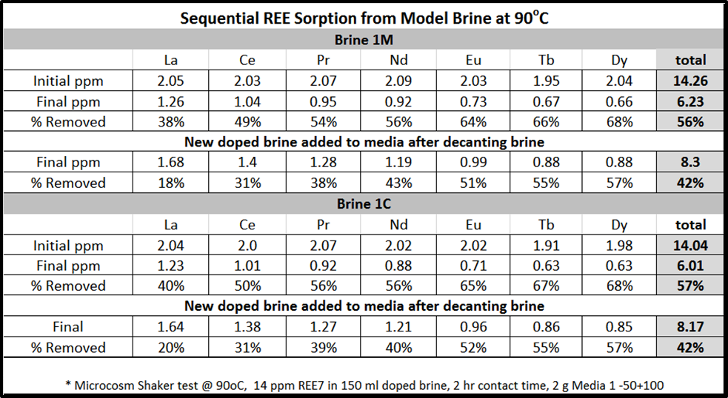
This data suggests that there is preferential REE media sorption between fresh media and partially loaded media when total loading is significantly below the apparent media capacity.

