**Characterizing U.S. Heat Demand**

**for Potential Application of Geothermal Direct Use**

**Kevin McCabe, Michael Gleason, Tim Reber, Katherine R. Young**

**National Renewable Energy Laboratory**

**Keywords:** direct use, low-temperature, geothermal, heat demand, thermal demand, residential, commercial, manufacturing, agricultural, Geothermal Vision Study

**Abstract**

In this paper, we assess the U.S. demand for low-temperature thermal energy at the county resolution for four major end-use sectors: residential buildings, commercial buildings, manufacturing facilities, and agricultural facilities. Existing publicly available data on the U.S. thermal demand market are characterized by coarse spatial resolution, with assessments typically at the state level or larger. For many uses, these data are sufficient; however, our research was motivated by an interest in assessing the potential demand for direct use (DU) of low-temperature (30° to 150°C) geothermal heat. The availability and quality of geothermal resources for DU applications are highly spatially heterogeneous; therefore, to assess the potential market for these resources, it is necessary to understand the spatial variation in demand for low-temperature resources at a local resolution. This paper presents the datasets and methods we used to develop county-level estimates of the thermal demand for the residential, commercial, manufacturing, and agricultural sectors. Although this analysis was motivated by an interest in geothermal energy deployment, the results are likely to have broader applications throughout the energy industry. The county-level resolution thermal demand data developed in this study may have far-reaching implications for building technologies, industrial processes, and various distributed renewable energy thermal resources (e.g., biomass, solar).

**Introduction**

In 2015, the Geothermal Technologies Office (GTO) at the U.S. Department of Energy (DOE) began the Geothermal Vision Study (GVS) to conduct analysis of potential growth scenarios across multiple market sectors (geothermal electric generation, commercial and residential thermal applications) for 2020, 2030, and 2050. The first phase of the GVS focuses on the electricity sector and is divided into specific topic areas and task forces led by GTO team members. The Thermal Applications Taskforce is divided into two parts: geothermal heat pumps, led by Oak Ridge National Laboratory, and geothermal direct use (DU) (a.k.a. “deep direct use”), led by the National Renewable Energy Laboratory (NREL). The heat demand analysis presented in this paper is one of several planned for DU for the GVS. Additional planned topics include: low-temperature resource assessment and technical potential, and cost and market potential analyses for geothermal DU in the United States.

Our focus in this paper on thermal demand in the range of 30° to 150°C was designed to avoid duplication with related GVS studies focused on the electric power sector, which focus on resources above 150°C. For the residential and commercial sectors, we focused on low-temperature thermal demand for space heating and water heating. In the manufacturing and agricultural sectors, we assessed end-use demand for low-temperature resources for space, water, and process heating. The data developed through this analysis will be combined with locally resolved low-temperature geothermal resource data (Mullane et al. 2016) in NREL’s distributed geothermal systems (dGeo) model to assess the market potential for DU applications in these end-use sectors. Data are available for download on the Geothermal Data Repository (GDR - https://gdr.openei.org), the submission point for data collected from researchers funded by the DOE’s Geothermal Technologies Office.

In this paper we discuss:

* Background information on the U.S. heat market
* Available datasets for assessing the U.S. heat market
* The methodology used for disaggregating the heat demand data to the county level for each of the four sectors: residential, commercial, manufacturing and agriculture
* Results and next steps for future analysis.

**Background**

Data on the U.S. heat market is very limited, with the majority of current data coming from the Energy Information Administration’s (EIA’s) periodic surveys of energy consumption (EIA 2003, 2009, 2010, 2012). These surveys estimate that the total heat consumption in the United States for the residential, commercial, and manufacturing sectors is approximately 12 quadrillion Btu, or quads (Figure 1). Using EIA data and a separate analysis, Fox et al. (2011) estimated that 31.7 quads of thermal energy in the range of 0°–260°C were consumed in the United States in 2008. Approximately 80% (25.4 quads) of this total was used to provide heat for end uses at temperatures less than 150°C, including space and water heating, process heating, and refrigeration and cooling. In our analysis, heat is characterized by space and water heating demand in the residential and commercial sectors, process heat demand in the manufacturing sector, and space heating demand in the agricultural sector. One important detail to consider is that the data for each survey were released in different years. In particular, note that the Commercial Buildings Energy Consumption Survey (CBECS) has a 2003 release of granular data and a 2012 release of high-level demand data (with granular data forthcoming). Due to the complexity in extrapolating data to a single year, the demand in each sector is only reported with respect to the year its specific survey was released.

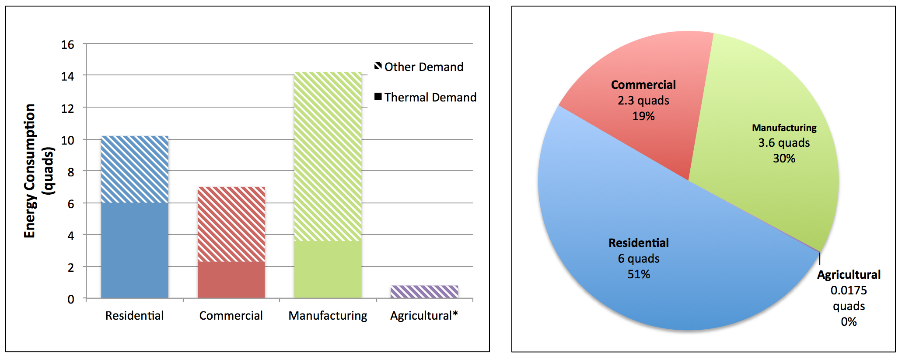

(a) (b)

Figure 1: (a) Total energy demand in the United States by sector (~32 quads). Thermal demand is shown in solid colors in each bar. (b) Total thermal demand in the United States by sector. Source: EIA 2009, 2010, 2012.

Thermal demand in the residential sector constitutes about half (6.0 quads) of the 12 quads of thermal energy consumption in the United States (Figure 1b). In addition, natural gas was the most utilized fuel for thermal energy in the residential sector, supplying 70% of the thermal demand (EIA 2009). In the commercial sector, space and water heating consume roughly 2.3 quads annually, accounting for roughly one-third of the total commercial energy consumption (7 quads) in 2012 (Figure 1a). Despite a 14% increase in total building count and a 22% increase in total building size (i.e., floor space) between 2003 and 2012, total commercial energy consumption increased by only 7% in the same period (EIA 2012), reflecting increased building and appliance efficiency.

Total energy consumed in the manufacturing sector in 2010 totaled just over 14.2 quads, with process heating and facility heating/ventilating/air conditioning (space heating assumed to be included) constituting approximately 3.6 quads, or about 25% of the total energy consumed for manufacturing (EIA 2010) (Figure 1a). In the agricultural sector, an estimated 0.8 quads of total direct energy were consumed in 2012 (EIA 2014). This excludes indirect energy consumption, which is typically characterized as fertilizer and pesticide inputs. Despite the lack of energy data in the agricultural sector, specifically regarding heat consumption, our analysis estimated the thermal demand of greenhouses to be approximately 0.02 quads (Figure 1b).

The total thermal energy consumption across these sectors (an estimated 11.9 quads) represents a significant opportunity for the adoption of geothermal DU heat. However, the spatial resolution of the currently available data is too coarse for a more detailed geo-spatial technical potential analysis. In the residential sector, demand data are available at the resolution of individual states or small multi-state regions comprising two to five states each. In the commercial and manufacturing sectors, data are only available at the level of Census Divisions and Census Regions, respectively. In the agricultural sector, demand data are not explicitly reported; instead, fuel consumption data are given at the Farm Production Region level, which consists of groups of between six and 16 states. An initial unpublished analysis completed by NREL in 2015 was performed at the census division level, which resulted in the very coarse thermal energy demand map shown in Figure 2.

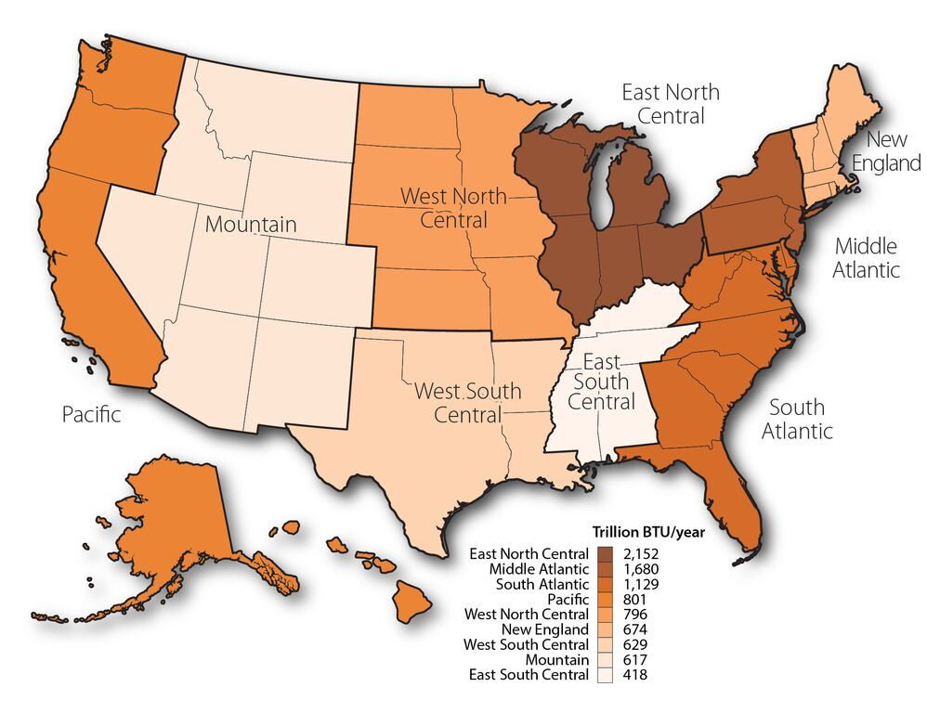

Figure 2: U.S. Heat Demand. Includes residential, commercial, and industrial heat demand. Industrial heat demand for each division was estimated from the regional data based on population. Note that this map does not include estimates of manufacturing heating/ventilating/air conditioning or any analysis of agriculture, resulting in energy totals less than the ~12 quads reported by EIA. Data source: EIA 2009, 2010, 2012. Map made by Billy Roberts NREL.

Our interest in the heat demand market is motivated by the potential demand for DU of low-temperature (30° to 150°C) geothermal heat. The highly localized variation in the availability and quality of geothermal resources for DU applications, coupled with limitations on our ability to transport thermal energy long distances, necessitates an equally localized understanding of patterns of thermal demand. Therefore, our initial regional assessment of thermal demand in the United States was insufficient. To capture the full potential of geothermal DU technology, we performed an analysis to assess the U.S. demand for low-temperature thermal energy at the county resolution for each of four major end-use sectors: residential buildings, commercial buildings, manufacturing facilities, and agricultural facilities. This involves looking at each sector individually and supplementing the EIA surveys along with additional data to disaggregate the demand totals to a finer resolution (e.g., county level).

**Datasets**

For the analyses of the thermal demand in each of the four sectors, we started with data from the EIA’s periodic consumption surveys as well as sources from the U.S. Department of Agriculture (USDA). Several other datasets and publications were added to these to supplement the analysis, as outlined in Table 1, and detailed further below.

Table 1: Data used in the Analysis of U.S. Heat Market Demand

| **Sector** | **Source** | **Vintage** | **Data Available** | **Geospatial Resolution** |
| --- | --- | --- | --- | --- |
| Residential | EIA | **2009** | **Space** **heating** and **water** **heating** demand totals | **Reportable domain** – individual states or aggregates of states (27 total domains)  **Climate regions** – residential entries categorized based on geographical location |
| U.S. Census Bureau – American Community Survey (ACS) | **2009–2013** (5-year survey) | **Housing unit totals** for each county in the United States | **County level** |
| Commercial | EIA | **2003 & 2012** | **Space** **heating** and **water heating** demand totals | **Census division** – Nine total divisions in the United States, each consisting of between three and eight states |
| Federal Emergency Management Agency (FEMA) | **2013** | **Total area (sq. ft.)** of each building type for each county | **County level** |
| Industrial | EIA | **2010** | **Process heat** and **space heating** demand totals for manufacturing industries only | **Census region** – Four total regions in the United States, each consisting of between nine and 17 states |
| *Energy Analysis of 108 Industrial Processes* (Brown et al. 1985) | **1985** | **Energy usage** of 108 most energy-intensive processes in manufacturing;  **Fluid temperatures** of processes | N/A |
| U.S. Census Bureau – County Business Patterns (CBP) | **2013** | **Number of establishments** (by 6-digit NAICS code) in each county | **County level** |
| Agricultural | USDA – Farm Production Expenditures | **2012** | **Fuel expenditures** for individual and aggregates of states | **Region level** (individual states and aggregates of states) |
| USDA – Census of Agriculture | **2012** | **Number of farms** in each county, for 15 agriculture NAICS codes | **County level** |

**Residential Sector**

EIA’s Residential Energy Consumption Survey (RECS): The most recent data for end-use demand totals for space and water heating come from EIA’s 2009 RECS survey (EIA 2009). Data are reported at the EIA-defined *reportable domain level*, consisting of either individual states or aggregates of states.[1] The RECS also includes climate region distinctions for each residence based on its geographical location. The definitions of these regions are based on the DOE’s Building America program (DOE 2010). Fluid temperatures for space and water heating are assumed to be within the study temperature bounds (30° to 150°C).[2]

U.S. Census Bureau – American Community Survey (ACS): Five-year survey data for the 2009–2013 period were extracted from the National Historical Geographic Information System (Minnesota Population Center 2011) for the count of housing units at the state and county levels. Totals were used to disaggregate residential thermal demand totals at the EIA reportable domain level (states, aggregates of states) to the county level.

**Commercial Sector**

EIA’s CBECS: The most recent granular data for end-use demand totals for space and water heating come from 2003 CBECS survey (EIA 2003). Fluid temperatures for space and water heating are assumed to be within the study temperature bounds. Data are reported at the EIA-defined *census division* level, of which there are nine in the United States, each consisting of between three and eight states. Note that a more recent CBECS was performed in 2012 (EIA 2012), for which granular data has yet to be released, but can be incorporated in a data update relatively easily once it becomes available.

FEMA’s Comprehensive Data Management System (CDMS): The CDMS (FEMA 2013) is a complementary tool to FEMA’s Hazus-MH, a risk-assessment and loss-estimation methodology. The CDMS contains facility-specific information on several different building-type definitions and gives estimates of total square footage of each type on a countywide basis. These data were used to disaggregate commercial thermal demand totals at the EIA reportable domain level (census division) to the county level.

**Manufacturing Sector**

EIA’s Manufacturing Energy Consumption Survey (MECS): The most recent data for end-use demand totals for process steam and space heating in only the manufacturing industries come from the 2010 MECS survey (EIA 2010). Agricultural uses—also classified as “industrial”—are not included in the MECS. Process steam temperatures are variable and not are reported in the MECS. Data are reported at the EIA-defined *census region* level, of which there are four in the United States, each consisting of between nine and 17 states.

*Energy Analysis of 108 Industrial Processes* (Brown et al. 1985): This report, prepared by researchers at Drexel University for the DOE, gives detailed information about the 108 most energy-intensive processes, based on energy consumption reported in the 1976 Annual Survey of Manufacturers. The report provides data for fluid temperatures, mass flows, and energy usage per industry-specific unit (e.g., Btu/lb.-product). These data were used to identify which industry processes could use geothermal resources in the range of 30° to 150°C as a heat source.

U.S. Census Bureau – County Business Patterns (CBP): The CBP is an annual series that provides subnational economic data by industry (e.g., employment and payroll statistics). The 2013 CBP (U.S. Census Bureau 2013) report provided data on the number of establishments of each industry (by 6-digit NAICS code[3]) at the county level. These data were used to disaggregate the manufacturing sector thermal demand from the national level to the county level.

**Agricultural Sector**

USDA – Farm Production Expenditures: USDA produces an annual summary released through the National Agricultural Statistics Service that contains annual estimates of farm production expenditures such as feed, farm services, and labor. This study used the reported fuel expenditures for farm production regions to estimate energy consumption. Data from the 2012 release (USDA 2013) was used in conjunction with the 2012 Census.

USDA – Census of Agriculture: This USDA report is a comprehensive source of U.S. agricultural data, including statistics on land use and ownership, operator characteristics, and expenditures. The relevant data from the most recent census (USDA 2012) were the farm totals at the county level, which were used to disaggregate demand at the regional and state level.

**Methodology**

The demand analyses for the residential and commercial sectors include disaggregating thermal demand totals at higher levels of reporting (e.g., state, census division) to the county level. This allows for more localized technical and market potential analyses to be carried out by NREL’s geo-spatial analysis team using dGeo; these analyses will be key products of the GVS. The manufacturing analysis follows a similar approach, with nationwide totals for process heat being disaggregated to the county level. However, the manufacturing analysis must undergo an intermediate step to combine available data on process heat temperatures to filter industries based on the temperature bounds of the study. The agricultural analysis uses fuel expenditure data combined with fuel prices and energy density values to estimate total energy consumption at the county level. Further analysis of the greenhouse subsector utilizes typical greenhouse energy consumption statistics to estimate the thermal demand. Research into energy consumption in other subsectors (e.g., aquaculture, poultry production) is suggested as future work to supplement the analysis in this paper.

**Residential Sector**

The ACS housing-unit totals at the state and county levels were used to disaggregate the thermal demand totals using a weighting process (Table 2). County weights were calculated based on the proportion of each *county’s* housing unit total to the *state/reportable domain* total. For example, ACS reported that Autauga County, Alabama, had 1.02% (22,220 housing units) of the total Alabama housing units (2,178,116 houses). Therefore, 1.02% (0.91 trillion Btu) of the residential thermal demand for Alabama (69.59 trillion Btu) would be attributed to Autauga County.

However, initial analysis indicated that the thermal demand might not be properly allocated by disaggregating from the reportable domain level (states) alone, especially in areas where climate plays a more substantial role. For example, demand in the greater Los Angeles area appeared to be unnaturally high for a region with a warmer climate. Intuition would dictate that regions with warmer climates would require less space heating and potentially less water heating as well.

To rectify this, demand totals were disaggregated from a cross-section of both *reportable domain* and *climate region* distinctions. These totals were then further disaggregated to the county level for further analysis. For example, California as an individual state is a reportable domain and is composed of two climate regions, “Hot-Dry/Mixed-Dry” and “Marine.” Our procedure grouped the counties within each climate region and summed the county demand in each group. The demand for the counties within the “Hot-Dry/Mixed-Dry” climate region summed to 141 trillion Btu. Similarly, the demand for the counties within the “Marine” climate region summed to 58 trillion Btu. The housing unit totals within each climate zone are then summed and used in conjunction with individual county totals in the disaggregation procedure.

The simplified expressions below help to illustrate the procedure used to calculate weighting factors for each county. The ACS data give housing unit totals for each county in the United States. These values are summed within their *reportable domain-climate region* (RD-CR) distinction to give the RD-CR total housing units. Then, the county-level total is divided by this RD-CR total to calculate a county weight (Eq. 1). This weight can then be multiplied by the demand from the RECS for the corresponding RD-CR to give the estimated county-level demand (Eq. 2).

|  |  |  |
| --- | --- | --- |
|  | $${\left(\frac{County}{RD\text{-}CR Total}\right)}_{Housing Units}=County Weight$$ | (1) |

|  |  |  |
| --- | --- | --- |
|  |  | (2) |

The application of the above method results in a list of every county in the United States with disaggregated demand values for space and water heating, a sample of which is shown in Table 2.

Table 2: Excerpt from the data table showing the data and results of the disaggregation of residential thermal demand.

*Full data table is available on the GDR.*

| **EIA Reportable Domain** | **County** | **Climate Region** | **Housing Units** | | | **Residential Thermal Demand** | | | | |
| --- | --- | --- | --- | --- | --- | --- | --- | --- | --- | --- |
| **Space Heating** | | **Water Heating** | | **Total Space & Water** |
| **County** | **RD-CR** | **County Weight** | **RD-CR** | **County** | **RD-CR** | **County** |
|  |  | *EIA* | *ACS* | *NREL calc.* | *NREL calc* | *EIA* | *NREL calc* | *EIA* | *NREL calc.* | *NREL calc.* |
|  |  |  | *# of units* | *# of units* | *weight* | *trillion Btu* | *trillion Btu* | *trillion Btu* | *trillion Btu* | *trillion Btu* |
| **AL-KY-MI** | **Autauga** | Hot-Humid | 22220 | 1202293 | 0.0102 | 14.5 | 0.45 | 14.2 | 0.26 | 0.91 |
| **AL-KY-MI** | **Baldwin** | Hot-Humid | 104648 | 0.048 | 2.12 | 1.22 | 3.34 |
| **AL-KY-MI** | **Barbour** | Hot-Humid | 11790 | 0.0054 | 0.24 | 0.14 | 0.38 |
| **AL-KY-MI** | **Bullock** | Hot-Humid | 4468 | 0.0021 | 0.09 | 0.05 | 0.14 |
| **AL-KY-MI** | **Butler** | Hot-Humid | 9931 | 0.0046 | 0.2 | 0.12 | 0.32 |
| **•••** | **•••** | **•••** | **•••** | **•••** | **•••** | **•••** | **•••** | **•••** | **•••** | **•••** |
| **AL-KY-MI** | **Bibb** | Mixed-Humid | 8939 | 4183503 | 0.0041 | 94.5 | 0.18 | 49.3 | 0.1 | 0.28 |
| **AL-KY-MI** | **Blount** | Mixed-Humid | 23767 | 0.0109 | 0.48 | 0.28 | 0.76 |
| **AL-KY-MI** | **Calhoun** | Mixed-Humid | 53192 | 0.0244 | 1.08 | 0.62 | 1.7 |
| **AL-KY-MI** | **Chambers** | Mixed-Humid | 16928 | 0.0078 | 0.34 | 0.2 | 0.54 |
| **AL-KY-MI** | **Cherokee** | Mixed-Humid | 16180 | 0.0074 | 0.33 | 0.19 | 0.52 |
| **•••** | **•••** | **•••** | **•••** | **•••** | **•••** | **•••** | **•••** | **•••** | **•••** | **•••** |

**Commercial Sector**

The commercial sector demand analysis required a similar disaggregation to the county level as the residential analysis.

EIA’s CBECS database provided two types of information: total thermal demand (trillion Btu) and thermal demand intensity (mBtu/sq. ft.). Demand totals and intensity are provided at the EIA census division level (nine divisions in the United States) and by principal building activity (PBA), and are further broken down into more detailed building activity (PBA-PLUS) categories (Figure 3).

Figure 3: Examples of PBAs and subcategories (PBA-PLUS)

To disaggregate these data into usable county-level information, we used FEMA’s CDMS data, which provide information on the total area of each building type for each county, using the formula described in Equation 3.

|  |  |  |
| --- | --- | --- |
|  | $$Building Type 1 \left(EIA\right) Thermal Demand Intensity\left(\frac{mBTU}{sq ft}\right)× Building Type A \left(FEMA\right)Total Area \left(\frac{sq ft}{county}\right)=Total County Thermal Demand for Building Type 1/A \left(\frac{mBTU}{county}\right)$$ | (3) |

This exercise was not quite as straightforward as shown in the equation, however, since EIA building activities and FEMA building types do not directly align and therefore had to be manually reconciled. Figure 4 demonstrates a portion of the mapping procedure and shows an example of the building types that matched between PBA-PLUS and CDMS categories.

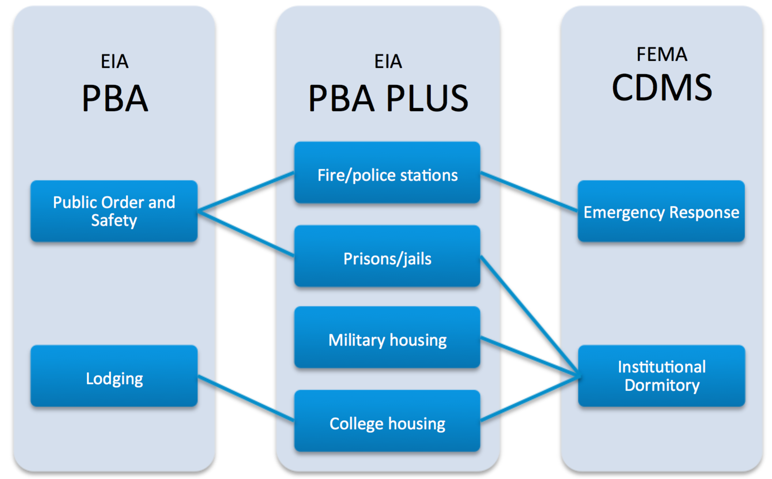

Figure 4: Example mapping of EIA PBAs to FEMA's building types

To verify our results, we summed the total estimated demand for each county across building types and compared the sums to the total thermal demand values provided by EIA at the census division levels. Where results differed from the EIA regional totals, we linearly recalibrated the estimates for each county and building type to ensure an aggregate sum matching the reported total from EIA. Figure 5 illustrates the overall workflow of the analysis.

Figure 5: General workflow for reconciling commercial analysis datasets

The result of this analysis is partially shown in Table 3, which displays a subset of counties in Alabama and their space heating totals, as well as a subset of the 18 total CDMS building types.

Table 3: Space heating demand totals (billion Btu) by county and CDMS building type

|  |  |  |  |  |  |  |  |  |  |
| --- | --- | --- | --- | --- | --- | --- | --- | --- | --- |
| **State** | **County** | **Retail Trade** | **Wholesale Trade** | **Personal and Repair Services** | **Professional/ Technical Services** | **Banks** | **Hospitals** | **Grade Schools** | **Colleges/ Universities** |
| **Alabama** | **Autauga** | 22.11 | 1.70 | 10.22 | 75.74 | 1.03 | 2.57 | 5.27 | 0.23 |
| **Alabama** | **Baldwin** | 136.08 | 11.39 | 41.01 | 522.30 | 4.46 | 53.08 | 17.32 | 25.20 |
| **Alabama** | **Barbour** | 19.00 | 1.86 | 7.50 | 46.96 | 1.14 | 2.59 | 5.28 | 2.01 |
| **Alabama** | **Bibb** | 9.26 | 0.71 | 3.86 | 26.98 | 0.51 | 4.02 | 3.07 | 0.00 |
| **Alabama** | **Blount** | 23.01 | 2.45 | 9.60 | 98.26 | 2.26 | 6.48 | 4.48 | 0.43 |
| **Alabama** | **Bullock** | 3.33 | 0.39 | 1.51 | 12.71 | 1.09 | 0.00 | 1.47 | 0.89 |
| **Alabama** | **Butler** | 14.55 | 1.07 | 4.66 | 34.13 | 0.63 | 6.79 | 2.85 | 0.29 |
| **Alabama** | **Calhoun** | 80.94 | 10.36 | 33.92 | 227.92 | 3.45 | 17.29 | 15.74 | 6.60 |
| **Alabama** | **Chambers** | 21.19 | 1.27 | 9.10 | 44.16 | 0.55 | 12.43 | 6.19 | 2.41 |
| **Alabama** | **Cherokee** | 14.91 | 4.01 | 4.85 | 43.20 | 0.82 | 2.91 | 2.16 | 0.15 |
| **Alabama** | **Chilton** | 22.40 | 1.78 | 7.82 | 51.78 | 1.01 | 0.00 | 4.29 | 2.08 |
| **Alabama** | **Choctaw** | 8.38 | 1.35 | 3.08 | 17.77 | 0.53 | 0.50 | 2.33 | 0.79 |
| **Alabama** | **Clarke** | 23.93 | 1.14 | 11.64 | 40.30 | 0.74 | 1.61 | 5.99 | 2.18 |
| **Alabama** | **Clay** | 7.45 | 0.34 | 2.62 | 14.85 | 0.39 | 3.76 | 2.04 | 0.36 |
| **Alabama** | **Cleburne** | 6.39 | 0.33 | 2.71 | 9.14 | 0.32 | 0.25 | 2.20 | 0.00 |
| **•••** | **•••** | **•••** | **•••** | **•••** | **•••** | **•••** | **•••** | **•••** | **•••** |

**Manufacturing Sector**

For the manufacturing subsector analysis, EIA’s MECS database provides demand data on two low-temperature end-uses: process steam and facility heating, ventilating and air conditioning (not explicitly space heating). For process heat, the variability of the fluid temperatures between industries complicates the analysis. The use of the publication *Energy Analysis of 108 Industrial Processes* (Brown et al. 1985) allows us to filter the most energy-intensive processes based on their operating temperatures. The resulting list of processes can then be evaluated for thermal demand that fits the study’s temperature bounds. Figure 6 illustrates the general workflow of the analysis.

Figure 6: General workflow of manufacturing sector analysis

We digitized the information contained in Brown et al. (1985), allowing us to filter the fluid temperatures and analyze only the industries that utilize process steam within the temperature bounds of the study. This resulted in a list of 49 industries, a sample of which is shown in Table 4. The energy use for each process in this document is based on industry-specific units (e.g., Btu/lb. of meat products), rendering cross-industry comparison of aggregate intensity difficult without further analysis.

It is important to note that some industries reported multiple steam temperatures required for distinct processes. If a single industry contained any process above 150°C, the entry was discarded; it is expected that such a facility would simply invest in a higher-rated boiler for its higher temperature needs instead of employing a combination of DU for lower temperatures and boilers for higher temperatures.

Table 4: Sample list of processes including steam and space heating (Sp Ht) energy demand per industry-specific unit.

|  |  |  |  |  |  |  |  |  |
| --- | --- | --- | --- | --- | --- | --- | --- | --- |
| **SIC Code** | **Detailed SIC** | **NAICS Code** | **Process** | **Unit Operation** | | **Outlet** | | |
| **Desc.** | **Temp (°C)** | **Flow** | **Temp (°C)** | **Energy (Btu)** |
| 2011 | 2011 | 311611 | Meat Packing Plants | Boiler | 120 | Steam | 120 | 895.5 |
| Sp Ht | 120 | 46 |
| 2026 | 2026 | 311511 | Fluid Milk | Boiler | 120 | Steam | 120 | 127.5 |
| Sp Ht | 120 | 28.7 |
| 2033 | 2033-1 | 311421 | Canned Fruits and Specialties | Boiler | 120 | Steam | 120 | 16,500 |
| Sp Ht | 120 | 8,200 |
| 2033 | 2033-3 | 311421 | Canned Fruits and Specialties | Boiler | 120 | Steam | 120 | 8,000 |
| Sp Ht | 120 | 5,600 |
| 2046 | 2046 | 311221 | Wet Corn Milling | Boiler | 120 | Steam | 120 | 1,420 |
| Sp Ht | 120 | 125 |

SIC – Standard Industrial Classification

The data from Brown et al. (1985) was then merged with MECS thermal demand data, based on the 6-digit NAICS codes that were common between the two datasets. While MECS reported a total of 83 industries at various levels, 47 had data at the 6-digit level and only 14 codes were common between the two datasets. This analysis resulted in fewer industries and thus less national coverage than we initially expected due to the temperature bounds of the study. Figure 7 ranks the down-selected industries by thermal demand (trillion Btu), with the bar colors corresponding to the remaining two steam temperatures utilized by the 14 industries. Note that entries with zero demand represent industries that withheld data to preserve facility-specific anonymity.



Figure 7: Thermal demand totals (trillion Btu) by industry; color coded by process steam temperature.

Finally, these thermal demand data were disaggregated to the county level using a combination of additional data from MECS and the U.S. Census Bureau’s CBP. In addition to energy data, MECS also reports the number of establishments that responded to the survey, categorized by the same NAICS codes as reported in the energy end-use data. This allowed us to calculate an energy “intensity” value for each 6-digit NAICS code by dividing the total thermal demand by the number of establishments for that specific code, resulting in a unit of trillion Btu per establishment. Table 5 lists the 14 industries in the analysis and their calculated demand intensity values.

Table 5: Listing of 6-digit NAICS codes and the calculated demand intensity values (trillion Btu/establishment)

|  |  |  |  |  |
| --- | --- | --- | --- | --- |
| **NAICS Code** | **Description** | **Thermal Demand (trillion Btu)** | **Establishment Count** | **Demand Intensity (trillion Btu/est.)** |
| 325193 | Ethyl Alcohol | 100 | 185 | 0.541 |
| 325199 | Other Basic Organic Chemicals | 89 | 476 | 0.187 |
| 322121 | Paper Mills, except Newsprint | 67 | 203 | 0.330 |
| 322130 | Paperboard Mills | 38 | 177 | 0.215 |
| 311221 | Wet Corn Milling | 37 | 59 | 0.627 |
| 325312 | Phosphatic Fertilizers | 26 | 65 | 0.400 |
| 322110 | Pulp Mills | 12 | 41 | 0.293 |
| 321113 | Sawmills | 5 | 1,659 | 0.003 |
| 325120 | Industrial Gases | 4 | 486 | 0.008 |
| 325412 | Pharmaceutical Preparation | 3 | 609 | 0.005 |
| 322122 | Newsprint Mills | 2 | 26 | 0.077 |
| 325992 | Photographic Film, Paper, Plate, and Chemicals | 1 | 138 | 0.007 |
| 325110 | Petrochemicals | 0 | 40 | 0.000 |
| 325212 | Synthetic Rubber | 0 | 126 | 0.000 |

Combining the demand intensity values with the number of establishments in each county (reported by the CBP), we were able to calculate the thermal demand for the 14 filtered industries at the county level. Table 6 gives a subset of counties and their corresponding total thermal demand, calculated by summing the demand for each 6-digit NAICS code; the full list of counties will be uploaded to the GDR. By using establishment counts as the disaggregation metric, we inherently assume that each manufacturing facility with the same NAICS code uses an equal amount of energy. While this assumption is not ideal, the available data are not sufficient to accurately capture intra-industry variation in demand intensity. This initial analysis represents a first cut in resolving local variation in industrial manufacturing thermal demand across the United States, and further analysis will be conducted once more specific data become available.

Table 6: Total county demand (trillion Btu) for process steam

|  |  |  |
| --- | --- | --- |
| **State** | **County** | **Total County Demand (trillion Btu)** |
| **Alabama** | **Autauga** | 0.21 |
| **Alabama** | **Baldwin** | 0.39 |
| **Alabama** | **Barbour** | 0.60 |
| **Alabama** | **Bibb** | 0.01 |
| **Alabama** | **Calhoun** | 0.21 |
| **•••** | **•••** | **•••** |
| **Colorado** | **Adams** | 0.01 |
| **Colorado** | **Arapahoe** | 0.63 |
| **Colorado** | **Boulder** | 0.83 |
| **Colorado** | **Broomfield** | 0.01 |
| **Colorado** | **Denver** | 0.46 |

**Agricultural Sector**

For the agricultural sector analysis, no source was identified that reports agricultural energy consumption directly. Instead, data on farm production expenditures were obtained, with expenses for fuels by type reported at the regional level. These data were combined with price data (EIA 2016a; 2016b; 2016c; 2016d) and energy content values (DOE 2014) for each fuel type, which included gasoline, diesel, LP gas (propane), electricity, and “other” fuels (natural gas, coal, fuel oil, kerosene, wood, etc.). This resulted in an estimation of energy consumption by fuel type for each farm production region. We assumed that 100% of the expenditures in the “other” fuels category were for natural gas due to the lack of clarification as to the proportion that each “other” fuel represented. Equation 4 illustrates the procedure used to estimate total energy consumption, which was applied to all fuel types in each region, with values then summed for total consumption in that region.

|  |  |  |
| --- | --- | --- |
|  | $$Fuel Expenditure \left(\$\right)*Fuel Price \left(\frac{volume}{\$}\right)*Energy Content \left(\frac{BTU}{volume}\right)=Consumption (BTU)$$ | (4) |

This procedure estimated total energy consumption at the regional level. The USDA defines five regions, each containing between 6 and 16 states. While the 2012 USDA Farm Production Expenditures report (USDA 2013) included data for some individual states, disaggregation from the regional level to the state level was still required as an intermediate step. This was completed by using the total number of farms in each state as a weighting factor to disaggregate regional energy consumption to individual states.

The second publication utilized for the agricultural analysis was the USDA’s “2012 Census of Agriculture” (USDA 2012). The census reports data at the state and county levels, including statistics on various farm characteristics, inventory, expenses, and land use. For this analysis, the county-level totals of farms were used to disaggregate the state-level energy consumption totals to the county level. Both the disaggregation procedure discussed above and the procedure outlined here follow the residential sector disaggregation strategy, and are illustrated in Equations 5 and 6.

|  |  |  |
| --- | --- | --- |
|  | $${\left(\frac{County}{State Total}\right)}_{Farms}=County Weight$$ | (5) |

|  |  |  |
| --- | --- | --- |
|  |  | (6) |

The procedure to this point in the analysis has resulted in county-level demand estimates for *total* energy consumption from fuel, with no distinction made regarding the end-use portion of this total (e.g., tractors/machinery, space heating, drying, on-site electric generation, etc.). The lack of agricultural consumption data does not allow us to further calculate these proportions.

To include the agricultural sector, we chose to further analyze greenhouses, which are often considered as potential facilities for DU adoption. Analyses of other areas within the agricultural subsector, such as aquaculture or poultry production, require further time and resources to research in depth and could be considered for future inclusion.

In addition to the information discussed above, the “Census of Agriculture” also reports farm totals at the county level with respect to 15 different agriculture-related NAICS codes. The relevant sub-industry for greenhouses is described as “Greenhouse, nursery, and floriculture production (1114)” (USDA 2012). The county-level demand was further proportioned into the various NAICS categories, again based on the number of farms reported in each category. Finally, additional sources were consulted to determine the energy consumption in a typical greenhouse and the proportion that is allocated for heating. Greenhouses on the Cornell University campus were estimated to use approximately 65% of the total consumption for heating (Cornell University 2014), and an Illinois utility company estimated that 70%–80% of energy use is allocated to heating in a typical greenhouse (Brinker 2012). Therefore, we assumed that 70% of the total energy consumption for greenhouses is allocated for heating purposes.

The result of this strategy was a list of counties that contained farms under the “Greenhouse, nursery, and floriculture production (1114)” NAICS distinction and their corresponding thermal demand.

**Results**

The primary results of the above analyses are the preliminary demand maps for the residential (Figure 8), commercial (Figure 9), manufacturing (Figure 10), and agricultural (Figure 11) sectors for use in future technical, economic, and market potential modeling with dGeo. In addition, Table 7 ranks the top three counties for total thermal demand in each sector, and Table 8 ranks the top three counties for “thermal demand density” in each sector, a metric that reports demand per square foot of land within the county.

Many of the top counties by demand, especially in the residential and commercial sectors, are also those with large populations, reflecting the strong linkage between thermal energy consumption and population centers. While these counties may potentially represent strong candidates for geothermal DU applications, further analysis is required to determine whether and to what degree these thermal demand centers are co-located with suitable geothermal resources.

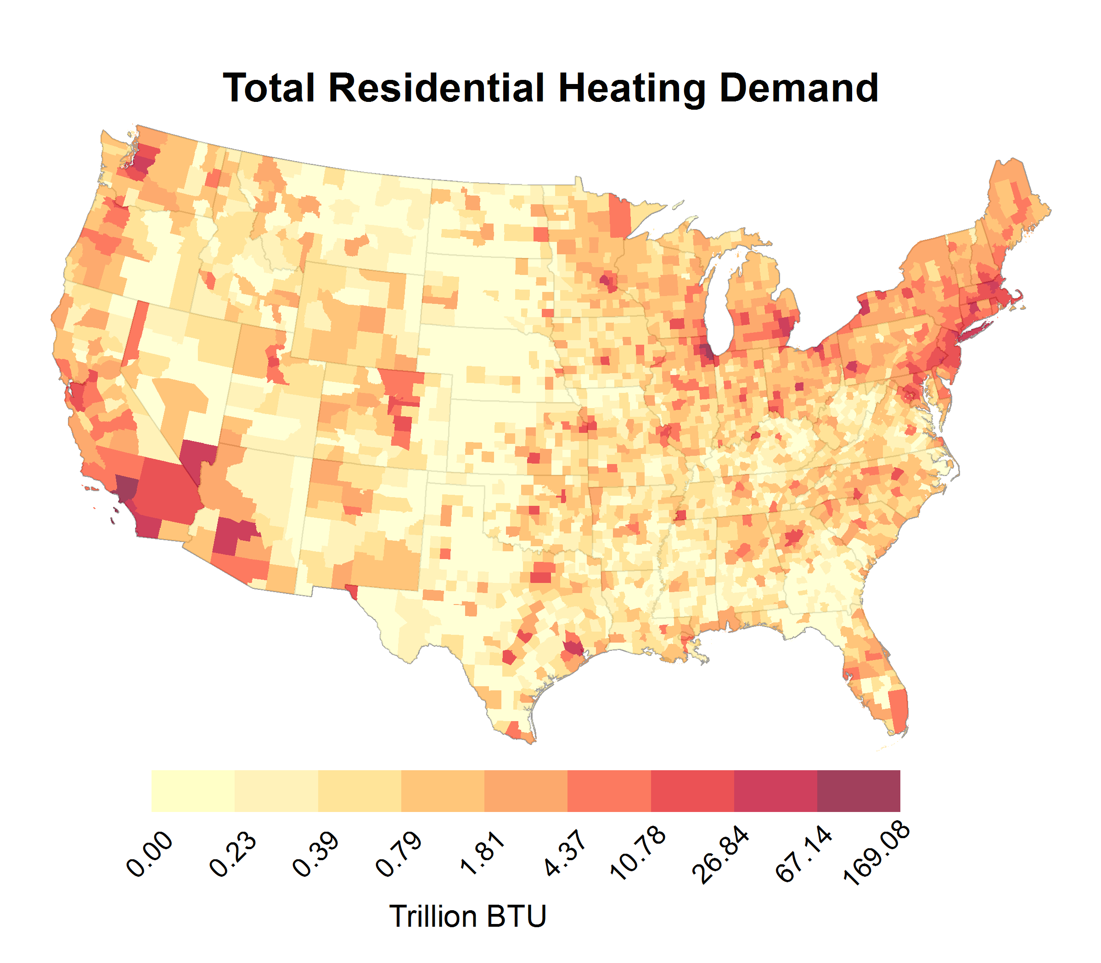

Figure 8: Residential sector thermal demand map of United States

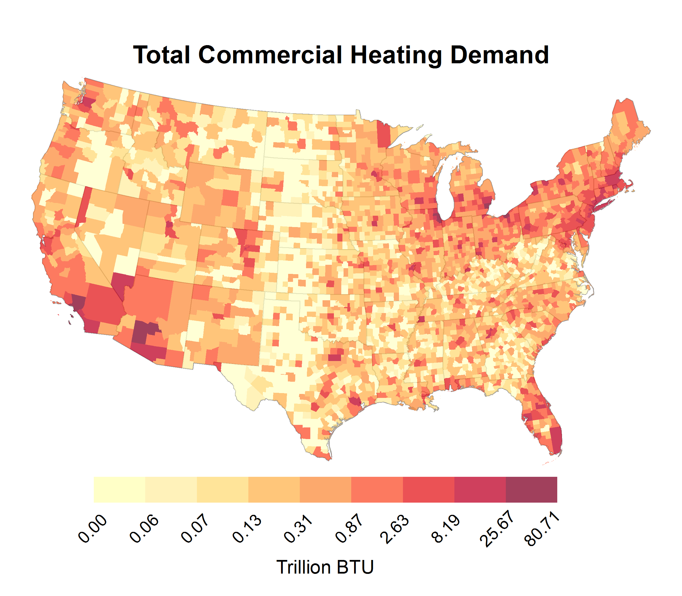

Figure 9: Commercial sector thermal demand map of United States

In the manufacturing sector, the lack of nationwide data renders further discussion of the results difficult. Nonetheless, an interesting result from Table 7 is the top county for thermal demand, Harris County, Texas, in which the city of Houston is located. The prevalence of chemical manufacturing operations associated with this city also corresponds to the total demand in the county, where a high number of “basic organic chemical manufacturing” (EIA 2010) facilities contribute to the overall consumption. In fact, the number of facilities with this NAICS distinction in Harris County (58) is nearly four times greater than the next closest county (15, in Cuyahoga County, Ohio). Additionally, a regional trend can be discerned from the map, where many of the areas of high demand in the Midwest may be attributed to corn ethanol manufacturing and wet corn milling operations. As with the residential and commercial sectors, the manufacturing sector thermal demand will be considered in parallel with the location of geothermal resources in future geothermal DU potential studies.

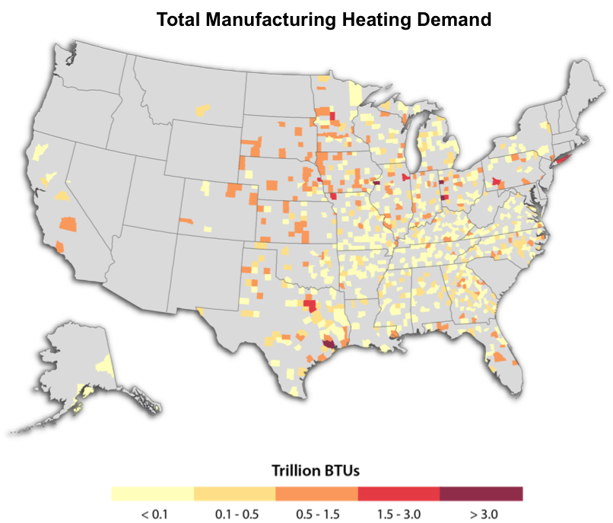

Figure 10: Industrial (manufacturing) sector thermal demand map of United States

In the agricultural sector, the demand map shows clear distinctions where greenhouse space heating is most prevalent, including the west coast and much of Florida. While California and Florida, to some extent, are certainly states with well-known records of agricultural and farming operations, further analysis is necessary to understand the existence of greater demand in the less well-known areas, such as the Pacific Northwest. In addition, further research would allow for a better understanding of the lack of demand in the central United States, where the climate would seemingly require greenhouses for those specific types of agricultural operations.

As a final result, the data used to create the maps and tables in this paper have been uploaded to the GDR for public use in future studies.

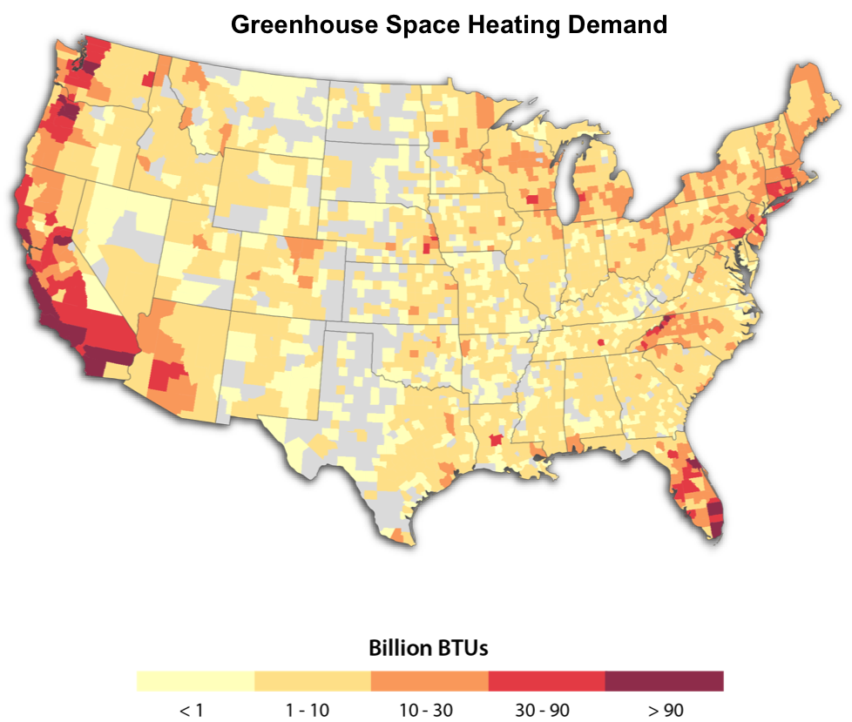

Figure 11: Greenhouse space heating demand map of United States

Table 7: Top three counties by sector for total thermal demand

|  |  |  |
| --- | --- | --- |
| **State** | **County** | **Total County Demand (trillion Btu)** |
| **Residential Sector** | | |
| Illinois | Cook | 169.08 |
| California | Los Angeles | 95.83 |
| Michigan | Wayne | 61.30 |
| **Commercial Sector** | | |
| Illinois | Cook | 80.71 |
| New York | New York | 41.28 |
| California | Los Angeles | 41.05 |
| **Manufacturing Sector** | | |
| Texas | Harris | 13.48 |
| California | Los Angeles | 6.52 |
| Illinois | Cook | 3.95 |
| **Agricultural Sector** | | |
| California | San Diego | 0.60 |
| Oregon | Clackamas | 0.32 |
| Florida | Miami-Dade | 0.26 |

Table 8: Top three counties by sector for thermal demand density (mBtu/sq. ft.)

|  |  |  |
| --- | --- | --- |
| **State** | **County** | **Thermal Demand Density (mBtu/sq. ft.)** |
| **Residential Sector** | | |
| New York | New York | 869.2 |
| New York | Kings | 328.4 |
| New York | Bronx | 282.6 |
| **Commercial Sector** | | |
| New York | New York | 703.3 |
| New York | Bronx | 119.2 |
| New York | Kings | 114.4 |
| **Manufacturing Sector** | | |
| Virginia | Hopewell City | 24.0 |
| Virginia | Covington City | 15.2 |
| Virginia | Bristol City | 11.9 |
| **Agricultural Sector** | | |
| North Carolina | Avery | 0.23 |
| North Carolina | Ashe | 0.14 |
| California | Santa Cruz | 0.10 |

**Conclusion and Future Work**

To date, we have completed a thorough analysis of available data, disaggregation of data to the county-level, and preliminary presentation of these data. Further data processing of the data is underway, including research into the use of geothermal DU to meet these heating demands, such as retrofitted district heating systems. According to a 2010 study (Thorsteinsson and Tester), there are an estimated 21 geothermal district heating systems in the United States, operating with a total capacity of about 100 MWt. In addition, carbon dioxide emissions from space and water heating (as well as cooking activities) in the residential and commercial sectors in 2006 amounted to about 470 million metric tons, representing an even greater opportunity for low-temperature geothermal DU deployment in reducing carbon emissions.

Planned work by NREL in the progression of the GVS includes integrating the resource potential analysis (Mullane et al. 2016) that was completed in parallel with this heat demand analysis. This will give a collocated resource-demand map for use in future economic and market potential studies. Note that these future studies will incorporate costs and market effects of geothermal DU integration. The study presented here does not include any economic implications.

In future analyses of the heat market, the weighting strategies utilized in the study could be improved. The current strategies of assigning county weights based on housing units (residential), establishments (manufacturing), and farms (agricultural) have an inherent assumption that each unit within the county uses the same amount of heat. We know this to be an overly simplified assumption. However, these metrics do provide an intuitive and transparent way to proceed with the analysis. A more rigorous assessment would involve finding the most statistically significant attributes of a residence or manufacturing/agricultural facility that determine the amount of heat usage, such as the tenancy status (rented/owned) or construction year for the residential analysis and emissions totals (e.g., of carbon dioxide) or outputs (by dollar or product) for the manufacturing/agricultural analysis. These factors could be decided using statistical methods, such as regression analysis.

In the manufacturing sector, a distinct lack of data rendered the analysis difficult. Future studies that expand on this work would benefit from increased coverage of manufacturing industries that included data on both process heat temperatures within each NAICS category as well as the corresponding thermal demand. The combination of the publication by Brown et al. (1985) with the MECS dataset resulted in an analysis that included only 14 industries at the 6-digit NAICS code level. Additionally, the Brown et al. work, while widely referenced in literature, is rather outdated, and it could be posited that technological advances in the past 20 years have created more efficient industrial processes with different temperature needs.

In the agricultural analysis, future analyses could focus on a bottom-up approach of each of the listed NAICS categories to determine improved estimates of heat consumption. A similar approach was taken in this study for the greenhouse subsector, where typical consumption values were calculated based on individual facilities.

Finally, much more work could be completed in the broader industrial sector, as the current analysis only examines the manufacturing and agricultural subsectors. Other subsectors not considered in the current analysis include the mining, oil and gas, and construction industries. While this is due primarily to the available data, further analysis could work to integrate other data sources to include more of the industrial sector.

To our knowledge, this assessment of locally resolved heat demand in the United States represents the first study of its kind. It has applications to a wide variety of technologies and domains beyond geothermal, including building technologies, industrial processes, and various distributed renewable energy thermal resources (e.g., biomass, solar). The county-level and sector-specific heat demand totals developed in this study contribute to U.S. research in renewable heat energy and work toward facilitation of a similar type of market transformation for the heat market that the electricity sector has done with great success for years.

**Acknowledgements**

This work was supported by the U.S. Department of Energy, Office of Energy Efficiency and Renewable Energy (EERE), Geothermal Technologies Office (GTO) under Contract No. DE-AC36-08-GO28308 with the National Renewable Energy Laboratory. The authors wish to thank the NREL review team, including Koenraad Beckers, Kendra Palmer, Emily Newes, Maggie Mann, and David Mooney. Any remaining errors or omissions are the responsibility of the authors.

**Acronyms**

ACS American Community Survey

Btu British thermal units (mBtu = 1,000 Btu; quad = 1 quadrillion Btu)

CBECS Commercial Buildings Energy Consumption Survey

CBP County Business Patterns

CDMS Comprehensive Data Management System

DOE U.S. Department of Energy

DU direct use

EIA Energy Information Administration

FEMA Federal Emergency Management Agency

GDR Geothermal Data Repository

GVS Geothermal Vision Study (GeoVision)

MECS Manufacturing Energy Consumption Survey

NAICS North American Industry Classification System

NREL National Renewable Energy Laboratory

PBA Principal Building Activity

PBAPLUS Principal Building Activity PLUS (subcategories)

RECS Residential Energy Consumption Survey

RD-CR reportable domain-climate region cross-section

USDA United States Department of Agriculture

**References**

Brinker, J., 2012. “Aquaponics and Greenhouse Energy Efficiency.”

<http://www.actonenergy.com/portals/0/business/forms/aquaponics-handout.pdf> (accessed April 27, 2016).

Brown, Harry, B. Hamel, and B. Hedman, 1985. “Energy Analysis of 108 Industrial Processes.”

The Fairmont Press, Inc.

Cornell University, 2014. “CUAES Greenhouses - Energy Consumption and Equivalents.”

<https://cuaes.cals.cornell.edu/sites/cuaes.cals.cornell.edu/files/shared/documents/Greenhouse-energy-consumption-2014-03-21.pdf> (accessed April 27, 2016).

DOE, 2010. “Guide to Determining Climate Regions by County.”

<http://apps1.eere.energy.gov/buildings/publications/pdfs/building_america/ba_climateguide_7_1.pdf> (accessed March 15, 2016).

DOE, 2014. “Alternative Fuels Data Center – Fuel Properties Comparison.”

<http://www.afdc.energy.gov/fuels/fuel_comparison_chart.pdf> (accessed April 15, 2016).

DOE, 2016, “Geothermal Vision Study” website. <http://energy.gov/eere/geothermal/geothermal-vision-study> (accessed May 10, 2016).

EIA, 2003. “Commercial Buildings Consumption Survey (CBECS) – Microdata.”

<http://www.eia.gov/consumption/commercial/data/2003/index.cfm?view=microdata> (accessed February 17, 2016).

EIA, 2009. “Residential Energy Consumption Survey (RECS).”

<http://www.eia.gov/consumption/residential/> (accessed February 11, 2016).

EIA, 2010. “Manufacturing Energy Consumption Survey (MECS).”

<http://www.eia.gov/consumption/manufacturing/> (accessed February 22, 2016).

EIA, 2012. “Commercial Buildings Consumption Survey (CBECS) – Energy Usage Summary.”

<http://www.eia.gov/consumption/commercial/reports/2012/energyusage/index.cfm> (accessed March 22, 2016).

EIA, 2014. “Energy for growing and harvesting crops is a large component of farm operating costs.”

[https://www.eia.gov/todayinenergy/detail.cfm?id=18431#](https://www.eia.gov/todayinenergy/detail.cfm?id=18431) (accessed April 14, 2016).

EIA, 2016a. “Gasoline and Diesel Fuel Update.” <http://www.eia.gov/petroleum/gasdiesel/> (accessed April

15, 2016).

EIA, 2016b. “Table 2.4. Average Price of Electricity to Ultimate Customers.”

<http://www.eia.gov/electricity/annual/xls/epa_02_04.xlsx> (accessed April 15, 2016).

EIA, 2016c. “United States Natural Gas Industrial Price.”

<http://www.eia.gov/dnav/ng/hist/n3035us3M.htm> (accessed April 15, 2016).

EIA, 2016d. “Weekly Heating Oil and Propane Prices (October – March).”

<http://www.eia.gov/dnav/pet/pet_pri_wfr_a_EPLLPA_PWR_dpgal_w.htm> (accessed April 15, 2016).

FEMA, 2013. “Comprehensive Data Management System (CDMS) version 2.5.”

<http://www.fema.gov/media-library/assets/documents/16975> (accessed June 6, 2016).

Fox, D., D. Sutter, and J. Tester, 2011. “The thermal spectrum of low-temperature energy use in

the United States.” *Energy & Environmental Science* 4.10 (2011): p. 3731-3740

Minnesota Population Center, 2011. *National Historical Geographic Information System: Version 2.0*.

Minneapolis, MN: University of Minnesota.

Mullane, M., M. Gleason, K. McCabe, M. Mooney, K. Young, and T. Reber, 2016. “An Estimate of the Resource Potential within Shallow, Low Temperature Geothermal Resources of the United States for Direct Use Applications.” Planned for Vol. 40, GRC *Transactions*.

Thorsteinsson, Hildigunnur, J. Tester, 2010. “Barriers and enablers to geothermal district heating

system development in the United States.” *Energy Policy* 38.2 (2010): p. 803-813.

U.S. Census Bureau, 2013. American Community Survey, 2013 County Business Patterns; generated by

Kevin McCabe; using American FactFinder. [http://factfinder2.census.gov](http://factfinder2.census.gov/) (accessed February 22, 2016).

USDA, 2012. “2012 Census of Agriculture.” <https://www.agcensus.usda.gov/Publications/2012/>

(accessed April 26, 2016).

USDA, 2013. “Farm Production Expenditures – 2012 Summary.”

<http://usda.mannlib.cornell.edu/usda/nass/FarmProdEx//2010s/2013/FarmProdEx-08-02-2013.pdf> (accessed April 18, 2016).

1. EIA selected certain geographic domains to allow for “geographic control of the sample allocated to the Census Divisions and selected states.” The individual states were chosen (as opposed to those that were grouped) based on factors such as population and climatic or geographic diversity. There are nine total aggregates, with the number of states in each ranging from two to five.
2. We can safely *assume* space and water heating in residences/commercial buildings is well under 150°C; however, no single temperature represents space/water heating for an entire sector.
3. NAICS is the North American Industry Classification System. It is the standard used by federal statistical agencies in classifying business establishments. These classifications are reported at varying levels of detail from 3- to 6-digit codes that describe sub-industries in detail.