An Estimate of Shallow, Low-Temperature

Geothermal Resources of the United States

Michelle Mullane, Michael Gleason, Kevin McCabe,
Meghan Mooney, Timothy Reber, and Katherine R. Young

National Renewable Energy Laboratory (NREL), Golden CO
Michael.Gleason@nrel.gov

Keywords: direct use, low temperature, geothermal, hydrothermal, EGS, sedimentary basin, convection, conduction, coastal plain, isolated, delineated area, NREL, SMU, bottom-hole-temperature, hot dry rock, megawatts thermal, beneficial heat

Abstract
Low-temperature geothermal resources in the United States potentially hold an enormous quantity of thermal energy, useful for direct use in residential, commercial, industrial, and agricultural applications such as space and water heating, greenhouse warming, pool heating, aquaculture, and low-temperature manufacturing processes. Several studies published over the past 40 years have provided assessments of the resource potential for multiple types of low-temperature geothermal systems (e.g., hydrothermal convection, hydrothermal conduction, enhanced geothermal systems) with varying temperature ranges and depths. This paper provides a summary and additional analysis of these assessments of shallow (≤ 3 km), low-temperature (30°–150°C) geothermal resources in the United States that are suitable for use in direct-use applications. This analysis considers six types of geothermal systems, spanning both hydrothermal and enhanced geothermal systems (EGS). We outline the primary data sources and quantitative parameters used to describe resources in each of these categories and present summary statistics of the total resources available. In sum, we find that low-temperature hydrothermal resources and EGS resources contain approximately 8 million and 800 million TWh of heat-in-place, respectively. In future work, these resource potential estimates will be used for modeling of the technical and market potential for direct-use geothermal applications for the U.S. Department of Energy’s Geothermal Vision Study.

1 Introduction
In 2015, the Geothermal Technologies Office (GTO) at the U.S. Department of Energy (DOE) began the Geothermal Vision Study (GVS) to conduct analysis of potential growth scenarios across multiple market sectors (geothermal electric generation, commercial and residential thermal applications) for 2020, 2030, and 2050. The GVS is divided into specific topic areas and task forces led by GTO team members. The Thermal Applications analysis is divided into two parts: geothermal heat pumps, led by Oak Ridge National Laboratory, and geothermal direct use (a.k.a. “deep direct use”), led by the National Renewable Energy Laboratory (NREL).

The low-temperature (low-T) geothermal resource potential analysis presented in this paper is one of several analyses planned for direct use for the GVS. The main goals of this preliminary analysis are to prepare aggregate datasets suitable for future modeling of technical potential and to establish a functional database that is able to quickly and precisely accommodate updated geothermal resource data as it becomes available. This study provides an assessment of the total thermal energy stored in shallow (≤ 3 km), low-T (30°–150°C) geothermal resources across the United States. Our focus on this temperature range was designed to avoid duplication with related GVS studies focused on the electric power sector, which focus on resources above 150°C. Additional planned analyses for the direct-use topic of the GVS include: a 2016 heat demand analysis (McCabe et al. 2016) and future (2017) technical potential, cost, and market potential analyses for geothermal direct use in the United States.

2. Background
Low-t geothermal resources in the United States potentially hold an enormous quantity of thermal energy, useful for direct use in residential, commercial, industrial, and agricultural applications such as space and water heating, greenhouse warming, pool heating, aquaculture, and low-T manufacturing processes. Several studies published over the past 40 years have provided assessments of the resource potential for multiple types of low-T geothermal systems (e.g., hydrothermal convection, hydrothermal conduction, and enhanced geothermal systems) with varying temperature ranges and depths. In this study, we have consolidated and analyzed the resources identified in those previous studies into a single assessment of the shallow (≤ 3 km), low-temperature (30°–150°C) geothermal resource potential of the United States.

The U.S. Geological Survey (USGS) has published multiple reports summarizing the resource potential of low-t geothermal systems, with a focus on hydrothermal resources (i.e., those containing flowing water with recharge sources) (e.g., White and Williams 1975, Muffler 1979, Reed et al. 1983). These studies provide detailed overviews of the energy potential of low-T geothermal systems in the United States while also formalizing the methods and models used in subsequent studies by other organizations (Lineau and Ross 1996, Schuster and Bloomquist 1994).

In comparison to previous low-T hydrothermal assessments, published assessments of the shallow, low-T resources available from enhanced geothermal systems (EGS) are less comprehensive. While the EGS systems for the deep lithosphere (e.g., > 3 km depth) have been studied in substantial detail (Tester et al. 2006, Blackwell et al. 2011), the shallow (< 3 km) lithosphere has not been studied in similar detail. In 2012, NREL published a study of the potential heat energy within sedimentary basins of the United States (Porro et al. 2012), revealing a huge potential resource within systems that we classified as EGS systems due to their low intra-basin permeability, porosity, and transmissivity values. Studies by the USGS also suggest significant energy potential stored in the low-permeability Appalachian and Illinois basins of the central and eastern regions of the United States (Sorey et al. 1975). This study adds to previous deep EGS resource assessments by offering an estimate of the energy potential accessible by EGS at shallower depths—from near-surface to a maximum depth of 3 km.

The analysis here provides a coarse, geospatial estimate of low-T geothermal resource potential in the United States. More detailed geologic analyses and reservoir modeling are needed on a location-specific basis to provide a more accurate estimate of geothermal potential on a scale meaningful for resource development—work that is far beyond the scope of this initial assessment. As a result of these limitations, the estimates provided in this analysis are not intended for site-specific applications. Instead, they are meant to provide a first-cut, high-level assessment of the quality and quantity of resources across the United States and to help inform the direction of future research priorities in this domain.

3 Methodology
The following steps summarize the general workflow resulting in resource estimates for low-T geothermal systems:

- Perform thorough literature reviews to identify the most comprehensive data sources for the depth and temperature ranges of interest
- Define conceptual models for low-T geothermal system types for consideration and supporting studies/datasets for each
- Determine the key parameters required to quantitatively describe each resource and inform technical and market potential analyses
- Review applicable studies/datasets and extract the required parameters/metrics
- Identify gaps in available datasets and resolve those gaps through additional literature review, assumptions, and analysis
- Standardize compiled datasets and summarize findings.

The results of this preliminary analysis are aggregate datasets suitable for future modeling of technical potential and a functional database that is able to quickly and precisely accommodate updated geothermal resource data as it becomes available. The analysis heavily focused on widely cited publications providing geothermal resource information at the national scale.

For both hydrothermal and EGS datasets, we identified a set of key parameters required for describing resource availability in a manner compatible with future assessments of technical and market potential (see Section 3.2 Collected Resource Parameters). Several conceptual models of geothermal system types were also identified and defined (see Section 3.1 System Types and Data Sources). Based on the fundamental differences and available parameters for these conceptual models, we divided our research into separate assessments of two categories of systems: hydrothermal systems and EGS.

After establishing the system types and target parameters, available data were then compiled from published sources and aggregated by system type. Parameters were collected from multiple data tables across several studies and from within the text of the studies. These data were evaluated for completeness based on the target parameters necessary for resource estimate calculations or future technical potential modeling. Often, key information was missing (e.g., depth, flow rate, etc.) that had to be compiled from additional literature review. In total, we aggregated 18,000 pieces of numerical data into tabular format. After exhausting the available literature, several important parameters, such as location, reservoir boundaries, and depths, were still missing and had to be derived via assumptions based on model interpretation. With the finalized datasets, resource estimates were summed for each system type (see Section 4 Results).

3.1 System Types and Data Sources
As discussed, we classify resources into two models: hydrothermal and EGS. Each category is then subdivided into multiple system types (Figure 1).

Figure 1. Categorization of low-T geothermal systems explored in this analysis.

We define a hydrothermal system as a reservoir with the following characteristics:

- Porosity and/or permeability levels permitting the flow of water
- Higher than average regional thermal gradients
- A source and recharge system of flowing water.

We classify hydrothermal systems into four model types, following the convention of Sorey et al. (1983):

- Isolated springs and wells – one or a group of nearby wells or springs producing geothermal fluid; generally have a reservoir volume of less than 1 km³.
- Delineated area convection systems – characterized by an upwelling of geothermal water with subsequent lateral flow into shallow aquifers larger than 1 km; with or without surface manifestations.
- Sedimentary basins – thermal sedimentary aquifers overlain by low thermal-conductivity lithologies; contain trapped thermal fluid and have flow rates sufficient for production without stimulation.
- Coastal plains sedimentary systems – similar to sedimentary systems, though typically occur along coastlines and may be underlain by an intrusive igneous body producing heat by radioactive decay; natural flow rates are sufficient for production without stimulation.

In contrast to hydrothermal systems, we define EGS systems as geologic systems that would require additional stimulation and enhanced recovery methods for extraction of the available heat content. This category includes two primary subtypes:

- Sedimentary basins – differ from “hydrothermal” sedimentary systems mentioned above in that they may lack water and/or permeability.
- Low conductivity, hot dry rock (HDR) – hot rock that lacks one or more of the above stated characteristics; in theory, may be accessed in any location given sufficient depth and reservoir stimulation.

For all four of the hydrothermal system types, we primarily relied upon data from three USGS studies, including (in descending order of contribution to this study): USGS Circular 892 (Reed et al. 1983), USGS Circular 790 (Muffler 1979), and USGS Fact Sheet 2008-3082 (Williams et al. 2008). We chose these studies due to their comprehensive, nationwide coverage, as well as their internal consistency in terminology and methods.

In comparison to hydrothermal resources, very few previous studies have focused on shallow EGS resources. For EGS sedimentary basins, we drew from work by Porro et al. (2011). For EGS HDR resources, we performed an original analysis to provide a rough estimation of resources available in the shallow subsurface, relying on datasets from Southern Methodist University (SMU) (Blackwell et al. 2011, Blackwell et al. 2014) and the Association of American State Geologists (AASG) Geothermal Data Repository (AASG 2012).

3.2 Collected Resource Parameters
We defined a set of parameters for describing and quantifying the resource. These parameters were selected to be consistent with conventions used in the literature, thereby enabling comparisons to previous studies and integration of future datasets following similar conventions. In addition, we needed to ensure the dataset supported future modeling of technical and market potential. Therefore, we selected the following six parameters:
- Location: point (for isolated resources) or polygon defining location of each resource
- Area: estimated planar area of the spatial extent of the resource
- Depth: average or range of depths to the reservoir
- Reservoir thickness: vertical thickness of the reservoir
- Temperature: average temperature of the resource
- Area required per production well: where available, estimated area per production well that would be required to allow for sustained production by the reservoir over a 30-year production period.

In addition to these primary parameters, we selected three additional parameters for quantifying the thermal energy available from each resource:

- Accessible resource base
- Resource
- Beneficial heat.

An accessible resource base is defined as the total heat energy stored within a reservoir without regard to the portion of that energy that can be extracted at a well head and used for end-use applications. It is synonymous with several other terms used in the literature, including “thermal energy (heat) in place” and “thermal energy (heat) content.” Resource is the portion of the accessible resource base that can be extracted at the wellhead. Beneficial heat is also based on the portion of the accessible resource base that can be extracted at the surface; in addition, it accounts for the efficiency of the energy when applied to a specific process. In our case, we calculated beneficial heat for space heating; additional calculations would need to be made for other processes. Due to data limitations, resource and beneficial heat were only estimated for hydrothermal system types, and were not calculated for EGS systems.

These three parameters were selected for consistency with the USGS studies used in this assessment (Sorey et al. 1983, Muffler 1979) and follow the calculations defined in those studies. These calculations are derived from the volumetric method first introduced by Muffler (1979), applied and refined by Sorey et al. (1983), and re-assessed by Williams et al. (2008a). As they are thoroughly described in those documents, only a short description of each will be provided here.

Accessible resource base is consistent with Equation 1 of Sorey et al. (1983):
$$Accessible Resource Base= ρcad(t-t_{ref})$$

where $ρc$ is the volumetric specific heat of rock plus water (2.6 J/cm³ • ° C), $a$ is the reservoir area, $d$ is the reservoir thickness, $t$ is the reservoir temperature, and $t_{ref}$ is the reference temperature (15°C). This equation was used for all six types of systems assessed in this study.

The calculation of resource used in this study also follows the convention of Sorey et al. (1983). For hydrothermal delineated areas, sedimentary basins, and coastal plain reservoirs, resource is defined as:

$$Resource={\left(ρc\right)}_{f}\left(\frac{ka_{r}}{a_{w}}\right)Q P \left(t-t_{ref}\right)$$

where ${\left(ρc\right)}_{f}$ is the volumetric specific heat of water (4.1 J/cm³ • °C), k is a constant correcting for non-uniform water flow within the system (0.5), $a_{r}$ is the area of the reservoir, $a$_{w} is the area per well, Q is the average volumetric discharge (31.5 L/s), P is production time (30 years), t is the temperature of the reservoir, and $t_{ref}$ is the reference temperature defining the reservoir as a geothermal resource (15°C). Use of this equation requires knowledge of the required area per well that could sustain a 30-year production period for the resource. This information was provided for each hydrothermal delineated area, sedimentary basin, and coastal plain resource presented by Reed et al. (1983); however, similar information is not available for the other three system types (hydrothermal isolated systems, EGS sedimentary basins, and EGS HDR). Therefore, we only applied the equation described above to calculate the resource for the hydrothermal delineated areas, sedimentary basins, and coastal plain reservoirs.

For the final type of hydrothermal system (isolated systems), we used a simplified estimation of resource based on the convention used by Sorey et al. (1983) for isolated systems:

$$Resource= R*q_{r}$$

where $q_{r}$ is the accessible resource base and R is a recovery factor. For isolated hydrothermal systems, we used a recovery factor of 0.125, consistent with Williams et al. (2008b). This recovery factor is also consistent with the average recovery factor represented by the more detailed resource calculations for small (< 10 km) delineated areas, sedimentary basins, and coastal plain reservoirs. For EGS sedimentary basins and HDR systems, recovery factors are likely to be far more variable and poorly understood (Porro et al. 2011); therefore, we did not estimate the resource for EGS system types and instead relied on the accessible resource base.

We calculate values of beneficial heat for space heating for hydrothermal delineated areas, sedimentary basins, and coastal plains based on Equation 5 from Sorey et al. (1983):

$$Beneficial Heat= {\left(ρc\right)}_{f}\left(\frac{ka_{r}}{a_{w}}\right)QP × 0.6(t- t_{ref})$$

where all variables are consistent with the equation for resource, except for $t_{ref}$, which is set to 25°C. To maintain consistency with Sorey et al. (1983), in the case of hydrothermal isolated systems, a simplified equation is used:

$$Beneficial Heat= ρcadR × 0.6\left(t-t_{ref}\right)$$

where $ρc$ is the volumetric specific heat of rock plus water (set to 2.6 J/cm³ • °C), $a$ is the reservoir area, $d$ is the reservoir thickness, $R$is the recovery factor (0.125), $t$ is the reservoir temperature, and $t_{ref}$ is the reference temperature (25°C). As with resource, due to the variability and lack of understanding in recovery factor, we did not estimate beneficial heat for EGS systems.

3.3 Hydrothermal Methodology
For hydrothermal systems, we compiled data from three primary sources: USGS Circular 892 (Reed et al. 1983), USGS Circular 790 (Muffler 1979), and the data supporting the USGS 2008 Fact Sheet (Williams et al. 2008). USGS Circular 892 focuses on resources in the range of 15° to 90°C, while the latter two studies include additional resources in the range of 90° to 150°C. Using these studies, we were able to compile data for resources covering our temperature range of interest (30° to 150°C).

For most sites, data for most of the parameters (e.g., temperature, depth, thickness, area per production well) were available directly from the original studies or a detailed review of the associated primary sources; however, in several cases, we had to fill gaps in the data by searching for supplemental, site-specific studies. Data gaps most commonly occurred in location and reservoir area. Table 1 illustrates the complexity of this effort, showing an example of aggregated data for hydrothermal sedimentary basins in Wyoming with applicable references for the various parameters.

Table 1. Selected sedimentary basin systems in Wyoming, showing both the data and the sources used. The variety of sources listed in this table highlights the need for ensuring consistency of data across sources and types of systems.
Geothermal Area | Location | Unique ID | Min/Max Depth (m) | Temperature (°C) | Volume (km³) | Resource (10¹⁸ J) | Beneficial Heat (MW_{t})
Madison aquifer in Powder River Basin | Fig 14, Sorey et al., 1983 | DA187 (assigned by the authors) | 610/3200 (Downey & Dinwiddie, 1988) | 69  (Table 7, Sorey et al., 1983) | 4104 (calculated from values in Sorey et al., 1983) | 4  (Table 7, Sorey et al., 1983) | 2100  (Table 7, Sorey et al., 1983)
Dakota aquifer in Powder River Basin | Fig 14, Sorey et al., 1983 | DA188 (assigned by the authors) | 305/1525 (Downey & Dinwiddie, 1988) | 70  (Table 7, Sorey et al., 1983) | 2184 (calculated from values in Sorey et al., 1983) | 2  (Table 7, Sorey et al., 1983) | 1070  (Table 7, Sorey et al., 1983)
Dakota aquifer in Denver Basin | Fig 14, Sorey et al., 1983 | DA189 (assigned by the authors) | 910/2440 (Nelson & Santus, 1988) | 80  (Table 7, Sorey et al., 1983) | 801 (calculated from values in Sorey et al., 1983) | 1  (Table 7, Sorey et al., 1983) | 480  (Table 7, Sorey et al., 1983)
Tensleep aquifer in Big Horn Basin | Fig 14, Sorey et al., 1983 | DA 185 (assigned by the authors) | 180/305 (Cooley, 1986) | 43  (Table 7, Sorey et al., 1983) | 732 (calculated from values in Sorey et al., 1983) | 0.4  (Table 7, Sorey et al., 1983) | 158  (Table 7, Sorey et al., 1983)
Tensleep aquifer in Wind River Basin | Fig 14, Sorey et al., 1983 | DA186 (assigned by the authors) | 3000 (Keefer, 1970) | 65  (Table 7, Sorey et al., 1983) | 525 (calculated from values in Sorey et al., 1983) | 1  (Table 7, Sorey et al., 1983) | 430  (Table 7, Sorey et al., 1983)

3.3.1 Location
Most of the locations for hydrothermal systems were derived directly from USGS Circular 790 (Muffler 1979), USGS Circular 892 report (Reed 1983), and the data supporting the USGS 2008 Fact Sheet (Williams et al. 2008). A few locations required additional research (Korosec et al. 1983) in order to locate wells from known coordinates or township and range grids.

All isolated systems from these reports were treated as point source reservoirs and compiled to a point shapefile using the latitude and longitude. All other system types (delineated areas, sedimentary basins, and coastal plains) were compiled to a polygon shapefile using a variety of methods. For some larger sedimentary basins and coastal plain reservoirs, we were able to digitize boundaries from paper maps provided in the source studies. For most other features, we performed a combination of supplemental literature searches and geospatial analyses to approximate reservoir boundaries. For any polygon-type system where only point well locations were given, polygons were created around the known well and spring points to represent the boundaries of the resource area. These boundaries were generated using a variety of geospatial methods, including square buffer grids and buffered convex hulls, depending on the resource type and known characteristics. Where necessary, slight adjustments were made to constrain locations to the reported counties or cities and within the boundaries of a single aquifer.

3.3.2 Reservoir Area
Reservoir area is used to calculate the accessible resource base, resource, and beneficial heat for each reservoir. For all isolated systems derived from USGS Circular 892, this study assumes a constant area of 1 km, depth of 1 km, and volume of 1 km³. These assumptions are consistent with the methods of the source studies. For all isolated systems derived from USGS Circular 790, which does not document the resource areas, we applied the same assumptions of area, depth, and volume. Isolated systems extracted from Williams et al. (2008) included estimated volumes, but not areas. Nearly all of these systems were reported to have volumes less than 10 km³, with the vast majority below 2 km³. Due to the lack of area information, and for consistency with other isolated systems, we treated the isolated systems from Williams et al. (2008) as single point locations, but used the reported volumes rather than the generic assumption of 1 km³.

For all other hydrothermal systems, different methods were used to determine the area of a given system, depending on the nature of the data collected. For the sedimentary basins and coastal plain boundaries that were digitized directly from source maps in USGS Circular 892, new geographic information system-derived areas were calculated from the digitized data, replacing the values originally reported (which were estimated based on 1:250,000-scale maps) with precise values derived from the digitized geographic information system polygons. In contrast, for those sedimentary basins and coastal plains whose boundaries were created from point locations, enveloping boundaries were buffered at various intervals and then constrained to the boundaries of aquifers until the areas created aligned with the areas reported in the source USGS Circular 892 report. A similar approach was taken for delineated areas, whereby a convex hull was generated from the wells comprising each system and then buffered incrementally until the area was within ±10% of the original reported area. It is important to note, however, that there were a few cases where the reported well locations created convex hull boundaries with significantly larger areas than those originally reported. For these locations, we adjusted the approach and investigated the effects of different methods, such as deleting apparent outlier well locations, creating concave hulls as opposed to convex hulls, and constraining generated boundaries to the boundaries of aquifers—until we could appropriately emulate the areas reported within a larger margin of ±25%. In many cases, adopting this new approach resulted in areas that approximate the source reported values; however, there are a few instances where delineated area systems were excluded altogether from the analysis due to large differences in the areas calculated versus those reported.

3.4 EGS Resource Methodology

3.4.1 EGS Sedimentary Basins
For EGS sedimentary basins, we focused solely on the study by Porro et al. (2011), which assessed the accessible resource (i.e., heat-in-place) for 15 large sedimentary basins in the United States. Although the authors did not explicitly identify their focus on EGS resources, language in the report indicates that recovery of heat from basins in the study would require “injection and extraction of fluid” and potentially “stimulation and enhanced recovery methods.” Therefore, we treated this study as an EGS resource assessment.

We acquired data from the study, including existing polygon shapefiles of basin boundaries. Porro et al. (2011) focused on temperatures above 100° C, with no upper bound. Therefore, for consistency with our focus on low-T resources, we filtered the resources identified by the authors to consider only those in the range of 100° to 150°C. Furthermore, Porro et al. (2011) used a specific heat constant of 2.876 J/cm³ • ° C. For consistency with the rest of our assessments, we recalculated the accessible heat for each reservoir using the slightly lower specific heat constant of 2.6 J/cm³ • °C presented in Sorey et al. (1983).

3.4.2 EGS HDR
As noted previously, the geothermal resources available from shallow (≤ 3km) EGS HDR systems have not been studied in the same detail as either low-T hydrothermal systems or deeper EGS systems. Though SMU has produced reliable, high-quality temperature-at-depth maps for the deep lithosphere (≥ 3 km) (Blackwell et al. 2011), equivalent studies have not been performed at shallower depths, due at least in part to uncertainties regarding water intrusion and aquifer effects at these depths. Despite these uncertainties, we addressed the lack of existing data for shallow EGS resources by developing a preliminary, basic resource assessment from readily available datasets. Specifically, we applied geostatistical interpolation methods to publicly available bottom hole temperature (BHT) data from oil, gas, and water wells to infer approximate temperature at depth contours for the United States at multiple depth intervals. From these contours, a rough estimate of the shallow (≤ 3km), low-T (30°–150°C) accessible resource was estimated for the a spatial grid covering the continental United States at a resolution of approximately 4 km by 4 km.

It is important to note that previous EGS assessments have omitted resources shallower than 3 km because vertical and horizontal extrapolations at shallow depths are prone to significant error and uncertainty. Therefore, we selected geostatistical techniques that produced uncertainty maps associated with each temperature-at-depth map. These uncertainty maps highlight the variation in statistical confidence of our temperature estimates and emphasize the challenges in quantifying shallow EGS resources. The assessment described here fills an important gap by providing preliminary estimates of the shallow geothermal resources, which can be used to help identify areas to target additional research.

The process of EGS HDR resource estimation involved three major components:

- Collection, cleaning, and standardization of datasets
- Estimates of temperature at depth from BHT and ancillary datasets
- Estimates of total resources to depths of 3 km from the temperature maps.

Each of these components is described in the following subsections.

3.4.2.1 EGS HDR Datasets
Our assessment of EGS HDR resources was based on two primary datasets:

- A gridded temperature-at-3.5-km map developed by SMU (Blackwell et al. 2011)
- An NREL compilation of BHT datasets acquired from the AASG Geothermal Data Repository (AASG 2012) and SMU Geothermal Laboratory (Blackwell et al. 2014).

The temperature-at-3.5-km dataset was purchased by NREL from the SMU Geothermal Laboratory (Blackwell et al. 2011). It provides an estimate of the temperature at 3.5 km below the earth’s surface for the continental United States at a spatial resolution of 0.0415 degrees by 0.0415 degrees (~ 4 km x 4 km).

The second dataset, composed of BHT data, required several steps to retrieve, merge, and clean into a standardized and complete format for analysis. The data retrieval effort required downloading 47 datasets from two different sources: the AASG Geothermal Data Repository (AASG 2012) and the SMU Geothermal Laboratory (Blackwell 2014). The AASG repository included borehole temperature information from 46 states in separate files; the SMU repository included a single file representing data from 49 states.

All of the AASG and SMU datasets were downloaded in the standardized format defined by the AASG Borehole Temperature Observation Content Model. As a result, all datasets shared the same column names and descriptions. However, the conventions used to provide values in each column and the completeness of various columns varied substantially across datasets. Therefore, despite the consistent format, significant effort was required to clean and standardize the data before merging into a single compiled dataset. The data was standardized in the following ways:

- All missing data were converted to standardized null values.
- Depth and temperature were converted to standard units (meters and temperature in degrees Celsius).
- Duplicate entries were screened on the basis of latitude/longitude and reported BHT.

Finally, the AASG BHT content model includes multiple columns for reporting depth (DepthOfMeasurement, TrueVerticalDepth, and DrillerTotalDepth) and temperature (MeasuredTemperature and CorrectedTemperature). Therefore, our next step was to consolidate the information from these various columns into a single, standardized column each for the measurement depth and corrected temperature.

As a standard measurement depth, we used the minimum depth reported between the DepthOfMeasurement field and the TrueVerticalDepth field. This rule was based on logical assumptions that the depth associated with each BHT should never exceed the actual vertical depth of the well. For temperature measurements, we targeted corrected temperatures. Because the data did not report the type of correction used to derive the CorrectedTemperature field, we applied the Harrison temperature correction (Harrison et al. 1983) to all MeasuredTemperature values to ensure standardization. The Harrison correction is an empirical correction factor developed to correct temperature values based on the depth of measurement. This correction is necessary due to the temperature-disturbing effects of drilling fluid circulation during well drilling. The Harrison correction equation is given below, where the correction factor (ΔT) is calculated based on depth of measurement (z) and added to the original MeasuredTemperature value.

$$ΔT=\left(-2.3449e^{-6}\right) z^{2}+0.018268 z-16.512$$

In rare cases where MeasuredTemperature was not provided but CorrectedTemperature was, we defaulted to the CorrectedTemperature value without any modifications. As a final step in data cleaning, we removed all BHT observations shallower than 300 m and deeper than 3.25 km to minimize the impacts of near-surface geologic processes and confounding effects of very deep wells.

Through this process of data retrieval, cleaning, and standardization, we compiled a dataset consisting of approximately 300,000 BHT observations, with data describing the latitude, longitude, depth, and temperature for each observation. This was a reduction from the approximate 590,000 original entries, the difference representing the removal of duplicates as well as entries with incomplete information. The spatial coverage of these 300,000 BHT observations is shown in Figure 1.
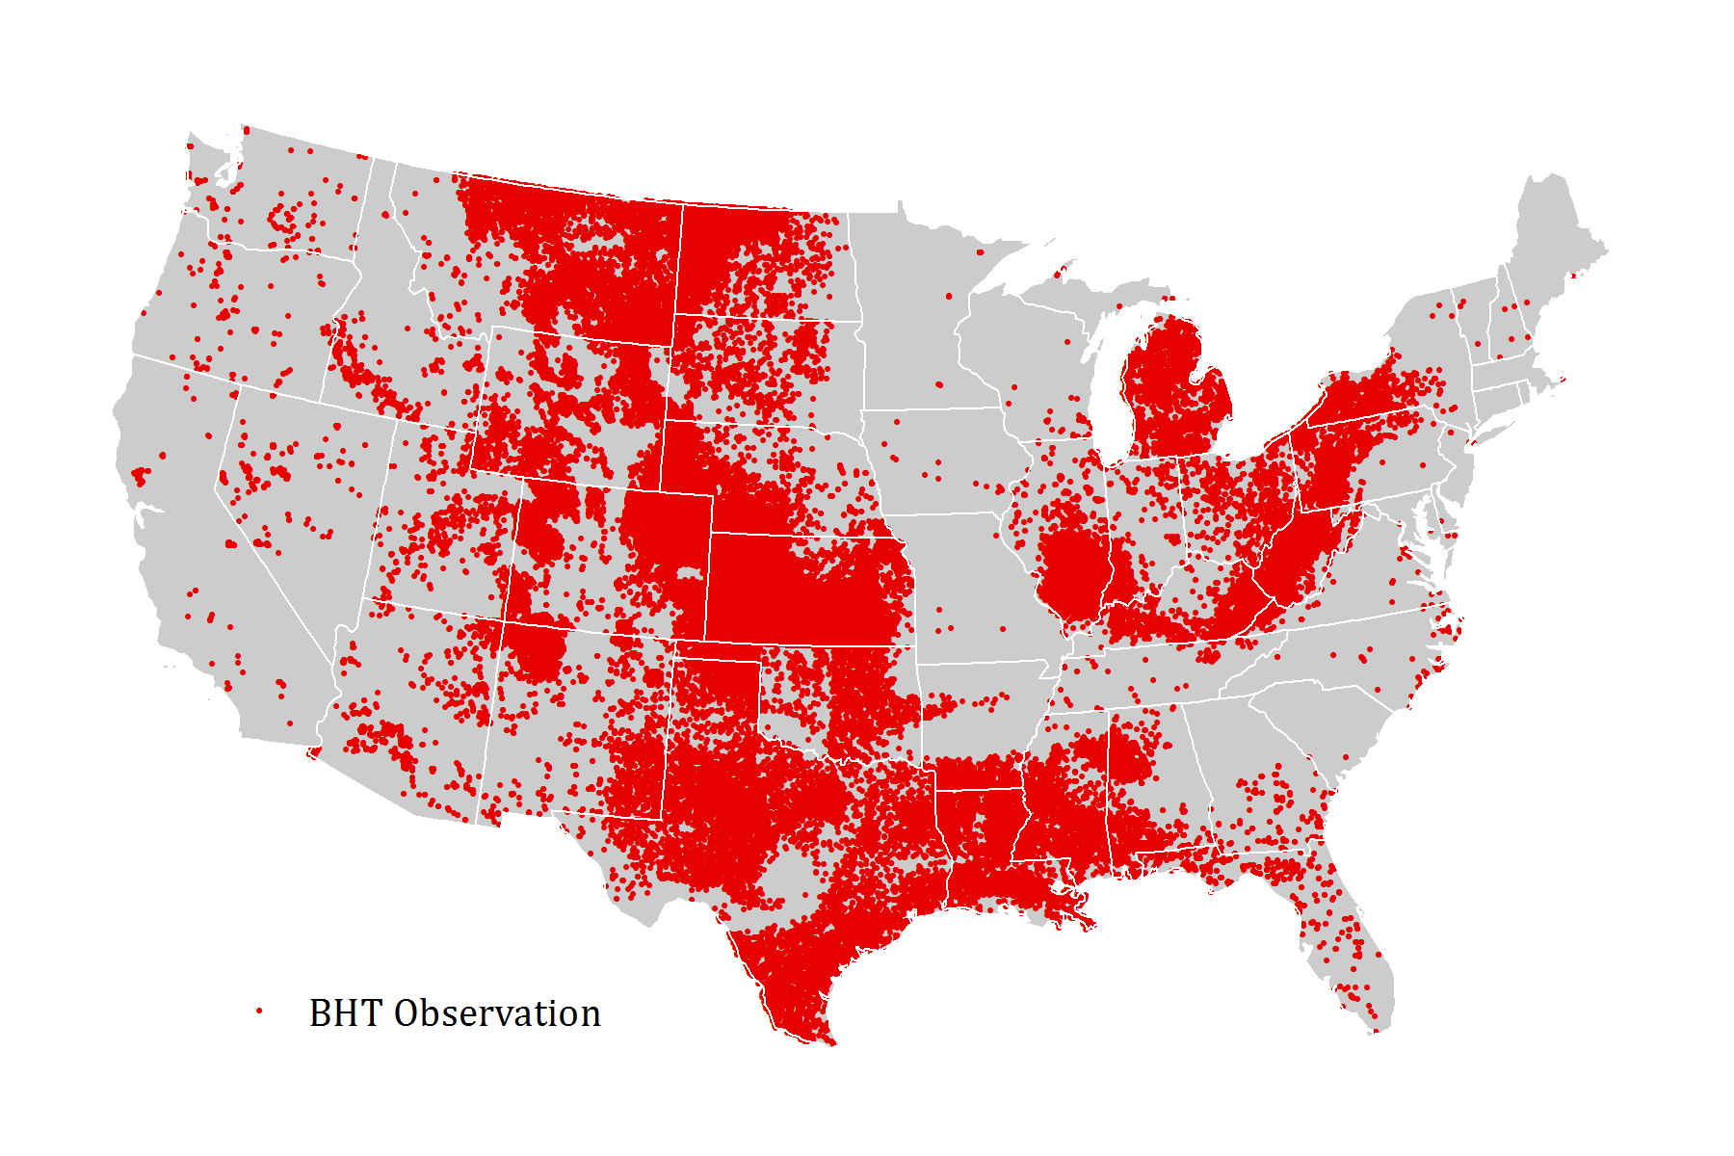
Figure 2. Spatial coverage of ~300,000 BHT observations compiled for EGS HDR analysis.

3.4.2.2 Estimation of Temperature at Depth Maps
We used the SMU 3.5-km-depth temperature map and the BHT data compilation to develop a series of temperature at depth maps at 500-meter intervals (0.5 km, 1 km, 1.5 km, 2 km, 2.5 km, and 3 km). To develop these maps, we used regression kriging, a geostatistical methodology that involves three steps:

- Derive a regression model to predict the variable of interest (temperature) based on data that completely covers the area of interest (in this case, the 3.5-km-depth temperature map covering the continental United States)
- To improve the local fit of the regression model across the local region of interest, apply ordinary kriging to the model residuals to interpolate the regression residuals across the complete area of interest
- Calculate predictions from the regression model for a grid covering the full region of interest and sum the regression predictions with the kriged residuals to derive the final estimates for the variable of interest.

This technique is especially well suited to interpolation of point datasets like the BHT observations where there is (a) some underlying trend in the variable of interest that results in violation of the assumption of stationarity (e.g., underlying geologic structure and differences in well depth); and (b) a secondary dataset with complete coverage across the interpolation region that can be used to help constrain estimates in areas with sparse sampling (e.g., a map of temperatures at another fixed depth and fixed values for the depth intervals of interest). This method improves over simple linear regression alone because it can leverage the model residuals at observed BHT locations to improve the quality of nearby predictions.

Prior to selecting this methodology, we evaluated alternative options, including:

- Simple ordinary kriging of the BHT point locations
- Simple linear regression of temperature at depth as a function of the SMU 3.5 km-depth temperature and the depth of the well.

Simple ordinary kriging proved to be insufficient due to underlying but unobserved geologic trends in the data that resulted in non-stationarity of the data. Simple linear regression also proved equally unsuitable for modeling temperature at depth. Specifically, we observed spatial clustering and spatial autocorrelation in the residuals of simple linear regression, suggesting that regression alone would produce biased results in many regions of the United States. Based on these findings, we chose to apply the two methods in conjunction in the form of regression kriging.

Prior to performing regression kriging, the BHT dataset required some additional processing. Initial experimental analysis with the observed BHT temperatures revealed a very large nugget effect, followed by an initial decrease in semivariance over short distances (<100 km). We interpreted this pattern as an indication of substantial measurement error in the BHT data. To resolve this issue, we first calibrated the temperature values for each BHT observation to the nearest 500 m depth interval (500, 1,000, 1,500, 2,000, 2,500, 3,000 m) using a geothermal gradient calculated relative to the temperature at 3.5 km from the SMU map. Next, we aggregated the individual observations for each depth interval in each 4 km by 4 km grid cell to a median temperature. The effect of this processing was to downscale the 300,000 BHT observations to a de-noised dataset consisting of 71,000 records at regular spacing and depth intervals. The resulting dataset was found to be free from the nugget effect observed in the individual BHT observations.

Next, for the linear regression component of regression kriging, we calculated a simple linear regression model for temperature (t, in °C) as a function of the depth of measurement (z, in meters) and the corresponding temperature at 3.5 km (t_{3.5km}, in °C), as defined in the SMU map. This approach allowed us to control for well depth, while also leveraging a readily available proxy for underlying geologic factors in the form of the estimated temperature at 3.5 km.

The best-fit regression model was specified as:

$$t_{z}= -23.14+0.3345 × t_{3.5km}+0.02994 × z$$

This model yielded strong explanatory power (r² = 0.7899) and proved to be well-specified through an inspection of the model residuals (residuals resemble a normal distribution and were not correlated with the independent variables). The residuals of the model displayed a mean error of zero, indicating a lack of bias, and a standard deviation of 13.6. This latter parameter suggests that, using the regression alone, the average prediction would have a 95% confidence interval of ± 27.3°C However, as noted above, the residuals exhibited spatial clustering and spatial autocorrelation, indicating that the model would likely exhibit local bias (i.e., over or under prediction) in many parts of the United States.

To improve on these estimates, we then applied ordinary kriging to the residuals of the regression model, as measured at each BHT observation location. We fit a spherical variogram model to the experimental variogram, with a nugget of 79.8, sill of 154.3, and range of 593,282.4 (Figure 3).
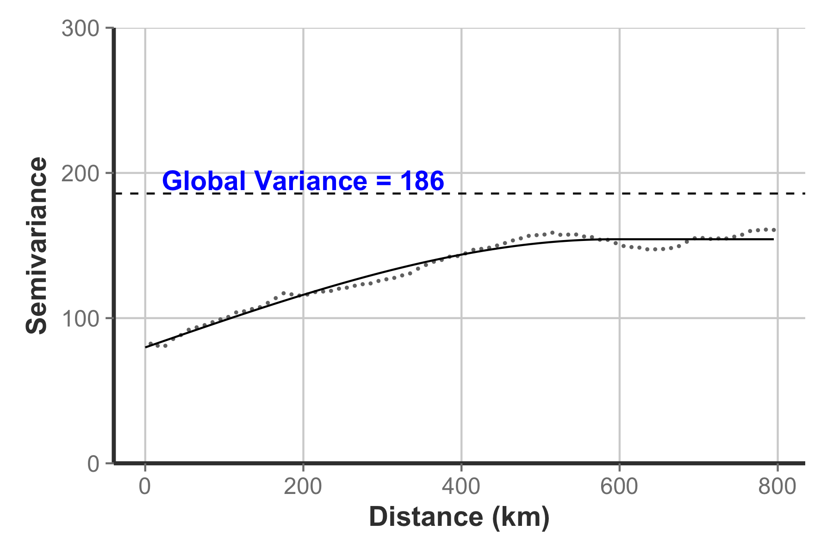
Figure 3. Experimental variogram (points) and fitted variogram model (line) for residuals from regression model.

To test the fit of this model, we ran a 1000-fold kriging cross-validation against the observed regression residuals. This evaluation produced a mean error of -0.005 and a standard deviation error of about 10.3°C, suggesting very minimal model bias and a 95% confidence interval of ±20.6°C. Based on these results, we expect the kriging process to not only minimize local bias in our prediction errors, but also improve our confidence in the temperature at depth predictions by narrowing the confidence interval by a factor of about 1/4, from roughly 27°C (for the regression alone) to about 21°C (for regression kriging).

With confidence in the fit of the regression kriging model, we then produced the temperature at depth map for each depth interval (500, 1,000, 1,500, 2,000, 2,500, and 3,000 m). For each location in the SMU map and each depth interval, we produced an estimate of the temperature at depth by calculating the sum of the regression model predictions and the interpolated residuals from kriging. For each location, we also derived the 95% confidence interval (${CI}_{95\%})$for the corresponding temperature estimates, calculated from the kriging prediction variance ($σ^{2}$) as described below:

${CI}_{95\%}= 2 × \sqrt{σ^{2}}$

The resulting temperature-at-depth maps for each depth interval are presented in Figure 6. As noted at the outset of this section, these maps were intended to provide preliminary, approximate estimates of the shallow, accessible resource base for HDR EGS, rather than accurate temperature values. The confidence interval map shown in Figure 7 reinforces this point. For most of the United States, the confidence intervals indicate that we would expect that the true temperature at depth at each location in the grid is within ±20 degrees of the estimated temperature at depth shown on the maps; however, because uncertainty increases as a function of distance from BHT observations, large confidence intervals in the range of 20 to 26 degrees are found in regions with sparse BHT data.

3.4.2.3 Resource Estimation from Temperature-at-Depth Maps
To estimate the resources available from these temperature-at-depth maps, we applied the methodology for calculating accessible resource base defined in Equation 1 of Sorey et al. (1983), as previously discussed. Using this equation, we calculated the accessible resource base for each grid cell and depth interval, assuming a reservoir thickness of 0.5 km for each interval. For example, for the temperature at 2 km, we assume the reservoir spans the 0.5 km of depth from 1.75 to 2.25 km deep. In the case of the 0.5 km map, which spans depths from 0.3 km to 0.75 km, we assumed the reservoir thickness to be 0.45 km.

For each grid cell, we calculated and integrated the resources across the six depth slices to determine the estimated accessible resource base. Using the 95% confidence intervals for temperature, we also calculated the 95% confidence intervals for accessible resources. In these resource calculations, we excluded temperatures outside of our range of interest (30°–150°C); therefore, the total accessible resource base estimated in this analysis is exclusive of additional warmer and cooler temperatures that may be present in some regions. The resulting estimates, including upper and lower 95% confidence intervals, are presented in Figure 8.

4 Results

4.1 Hydrothermal Assessment Results
Table 2 shows the estimated resource potential for each of the hydrothermal system models while Figure 4 shows their distribution within the United States. While the accessible resource is quite large, the portion that can be extracted given physical and current technological limitations (mean resource) is far less. For comparison, the total low-T thermal demand in the United States is roughly 12 exajoules annually. The beneficial heat—representing the best estimate of how much heat can realistically be utilized for end-uses with current technology—represents roughly half of the mean resource.

Table 2. Resource assessment estimates for all four of the hydrothermal model types.
Resource Model | Accessible Resource (Exajoules = 10¹⁸ J) | Mean Resource (Exajoules = 10¹⁸ J) | Beneficial Heat  (GWh,t)
Isolated Springs & Wells | 180 | 22 | 2.9 million
Delineated Area Convection | 130 | 7 | 0.7 million
Sedimentary Basins | 28,000 | 60 | 7.5 million
Coastal Plains | 80 | 1 | 0.1 million
Total | 28,390 | 90 | 11.2 million

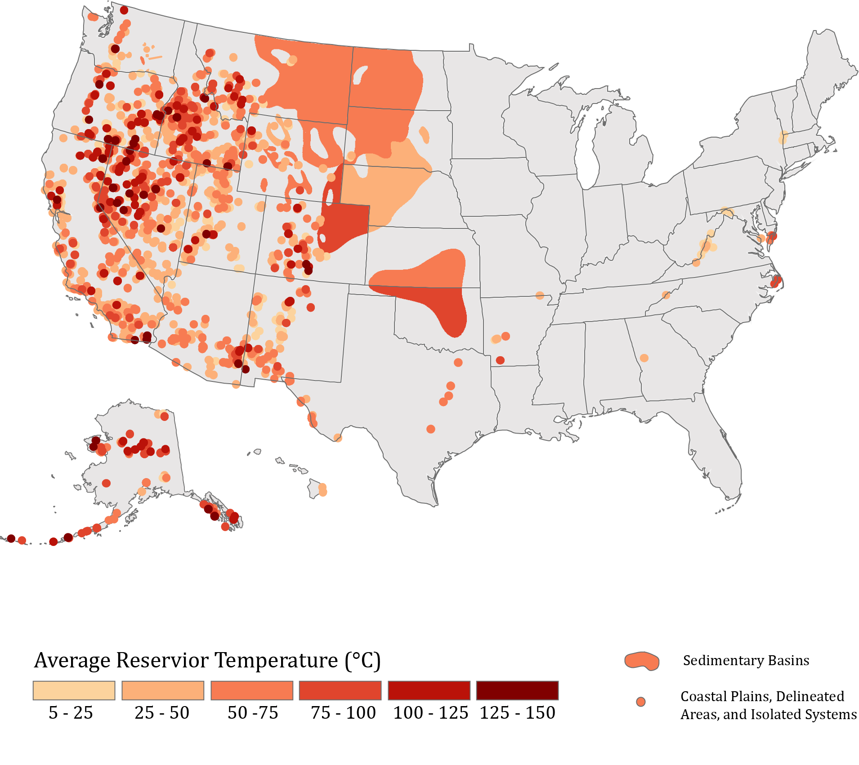
Figure 4. Map of hydrothermal resources at specified temperatures for the United States

Figure 5. Chart of the beneficial heat estimate for each hydrothermal system type by state.
Figure 5 shows the combined estimates for beneficial heat for all hydrothermal system types by state. This figure demonstrates a general trend that larger area systems (i.e., reservoirs within sedimentary basins) have much larger calculated estimates for resource and beneficial heat, even though such systems are highly outnumbered by the more frequently occurring isolated systems. These findings suggest that a properly designed geothermal well field in larger systems can supply significant quantities of low-T thermal energy to support local demand.

4.2 EGS Assessment Results
Table 3 shows the accessible resource base for shallow, low-T sedimentary EGS systems for those portions of the 2012 study that are within the temperature and depth ranges of this study. As noted, the estimates consider only temperatures in the range of 100° to 150°C and to depths of 3 km.

Table 3. Resource estimates recalculated from Porro et al. 2012.
Basin Name | Accessible Resource Base (Exajoules = 10¹⁸ J)
Denver | 5,700
Great Basin | 2,300
Fort Worth | 1,100
Raton | 280
Total | 9,380

The resources available from low-T EGS sedimentary basins are complemented by nationwide estimates of shallow, low-T HDR EGS. Figure 6 shows the estimated temperatures for each of the six depth intervals considered in our assessment (500, 1,000, 1,500, 2,000, 2,500, and 3,000 m). These results should be interpreted in the context of Figure 7, which shows the 95% confidence intervals associated with the temperature estimates for each grid cell. As the latter figure illustrates, the majority of temperature estimates for the United States have a 95% confidence interval of ±18°–20°C; in many areas with low-T estimates, the magnitude of these uncertainties overwhelms the temperatures themselves. In addition, although we would expect the true temperature at depth to be within the confidence intervals approximately 95% of the time, the cross-validation of the regression kriging model demonstrated several very large residuals, on the order of 150°–400°C. Therefore, it is likely that a small percentage of temperature estimates shown in Figure 6 are very large over- or under-estimates of the true temperature at depth.
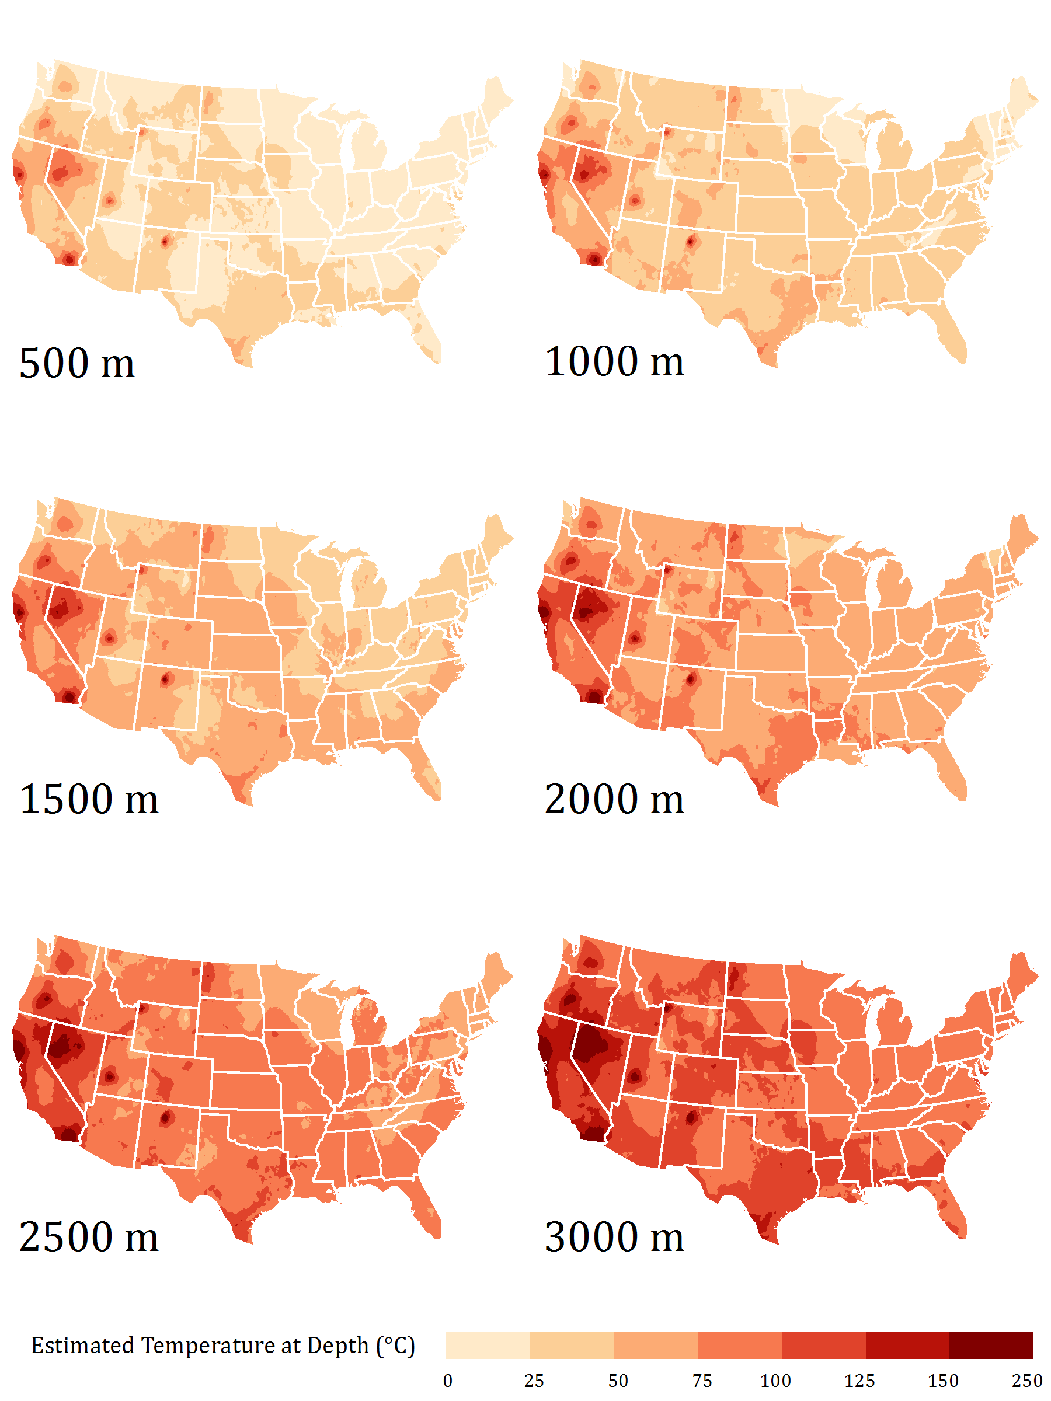
Figure 6. Estimated temperature at depth for shallow (≤3 km) depth intervals.

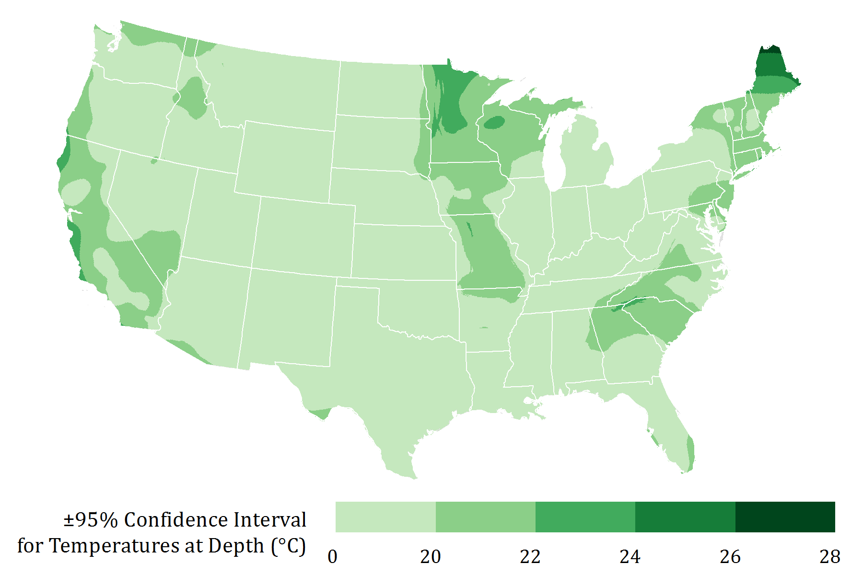
Figure 7. Map of the 95% confidence intervals associated with the temperature estimates.

Figure 8 shows the estimates of accessible resource calculated from the temperature estimates, along with upper and lower estimates based on the 95% confidence intervals. In total, the shallow (≤3 km), low-T (30°–150°C) accessible resource for EGS in the continental United States is estimated to be about 800 million TWh, with 95% confidence bounds of 500 million to 1,100 million TWh. These estimates are roughly consistent with an assessment by Tester et al. (2006), who estimated a total accessible EGS resource for the continental United States in the deep subsurface (3–10 km) of 13 million exajoules, or about 3600 million TWh. Given that our focus was on shallower depths with correspondingly lower temperatures and a total volume of less than half that studied by Tester et al. (2006), it is expected that our estimate should be less than, but of roughly the same order of magnitude as their assessment.
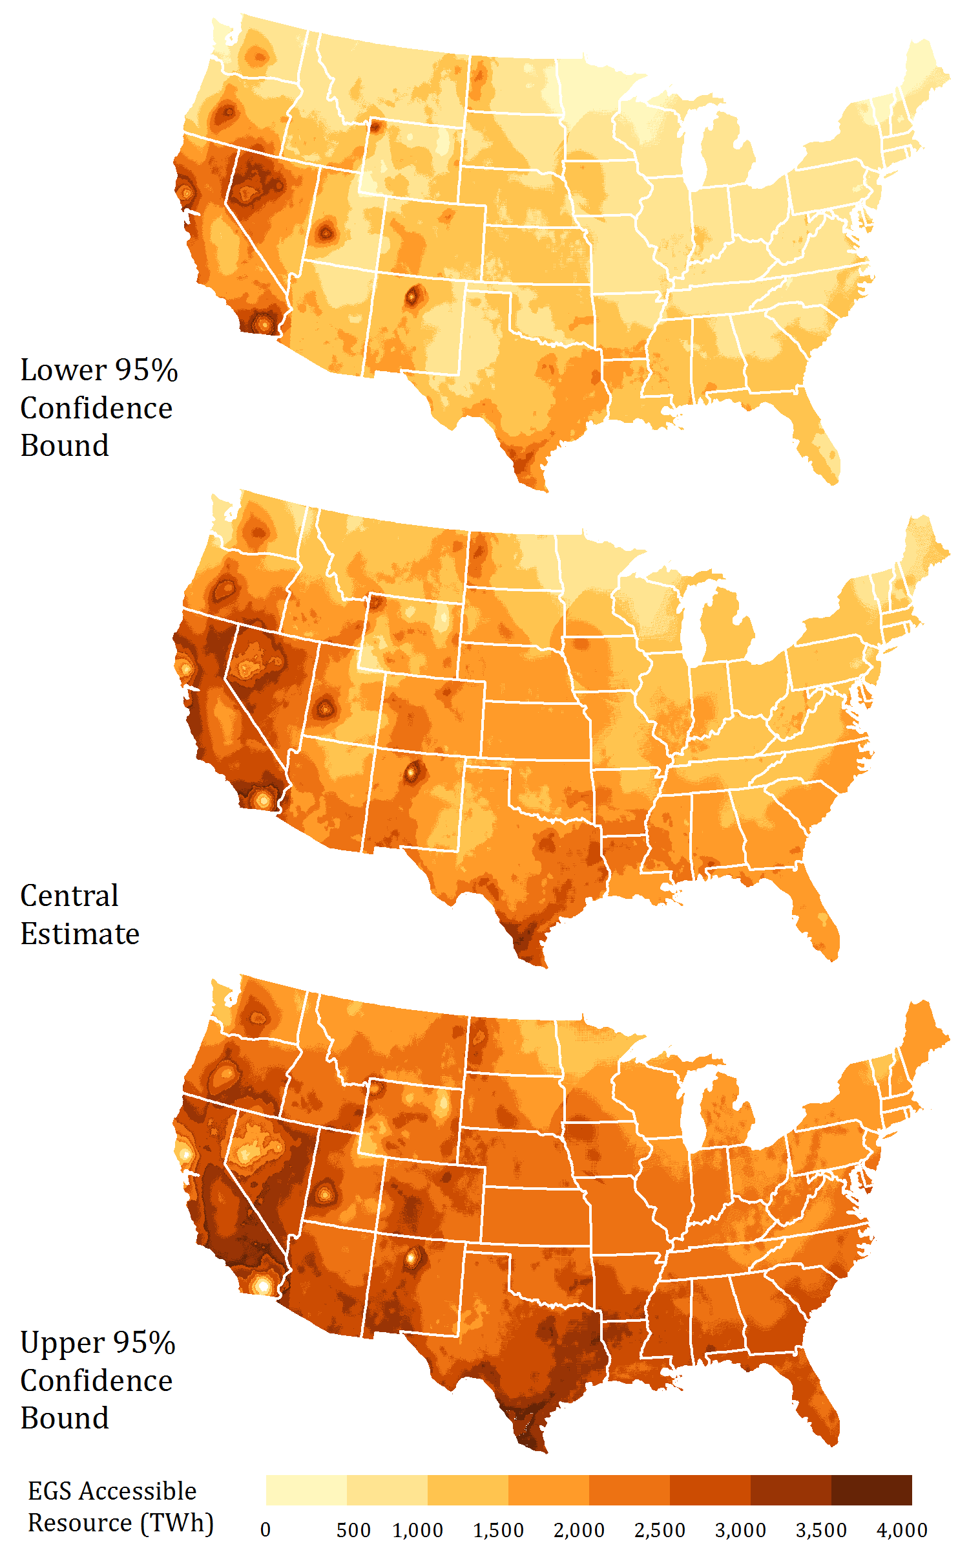
Figure 8. Maps of estimated accessible resource in the shallow subsurface (300 – 3000 m), including central estimate and upper and lower 95% confidence bounds. The estimates presented in this study are meant to provide only preliminary, order-of-magnitude estimates.

Figures 9 and 10 summarize the absolute and area-normalized accessible EGS resource by state, respectively. In absolute terms, the greatest resource tends to coincide with larger states (California, Texas, Nevada, etc.); however, this is not purely a function of area. As shown in the maps in Figure 8, these states also have regions of high-quality resources. The area-normalized resource values reveal other states with high-quality resources, such as Oregon, Colorado, and Louisiana—all of which moved up significantly in the rankings.

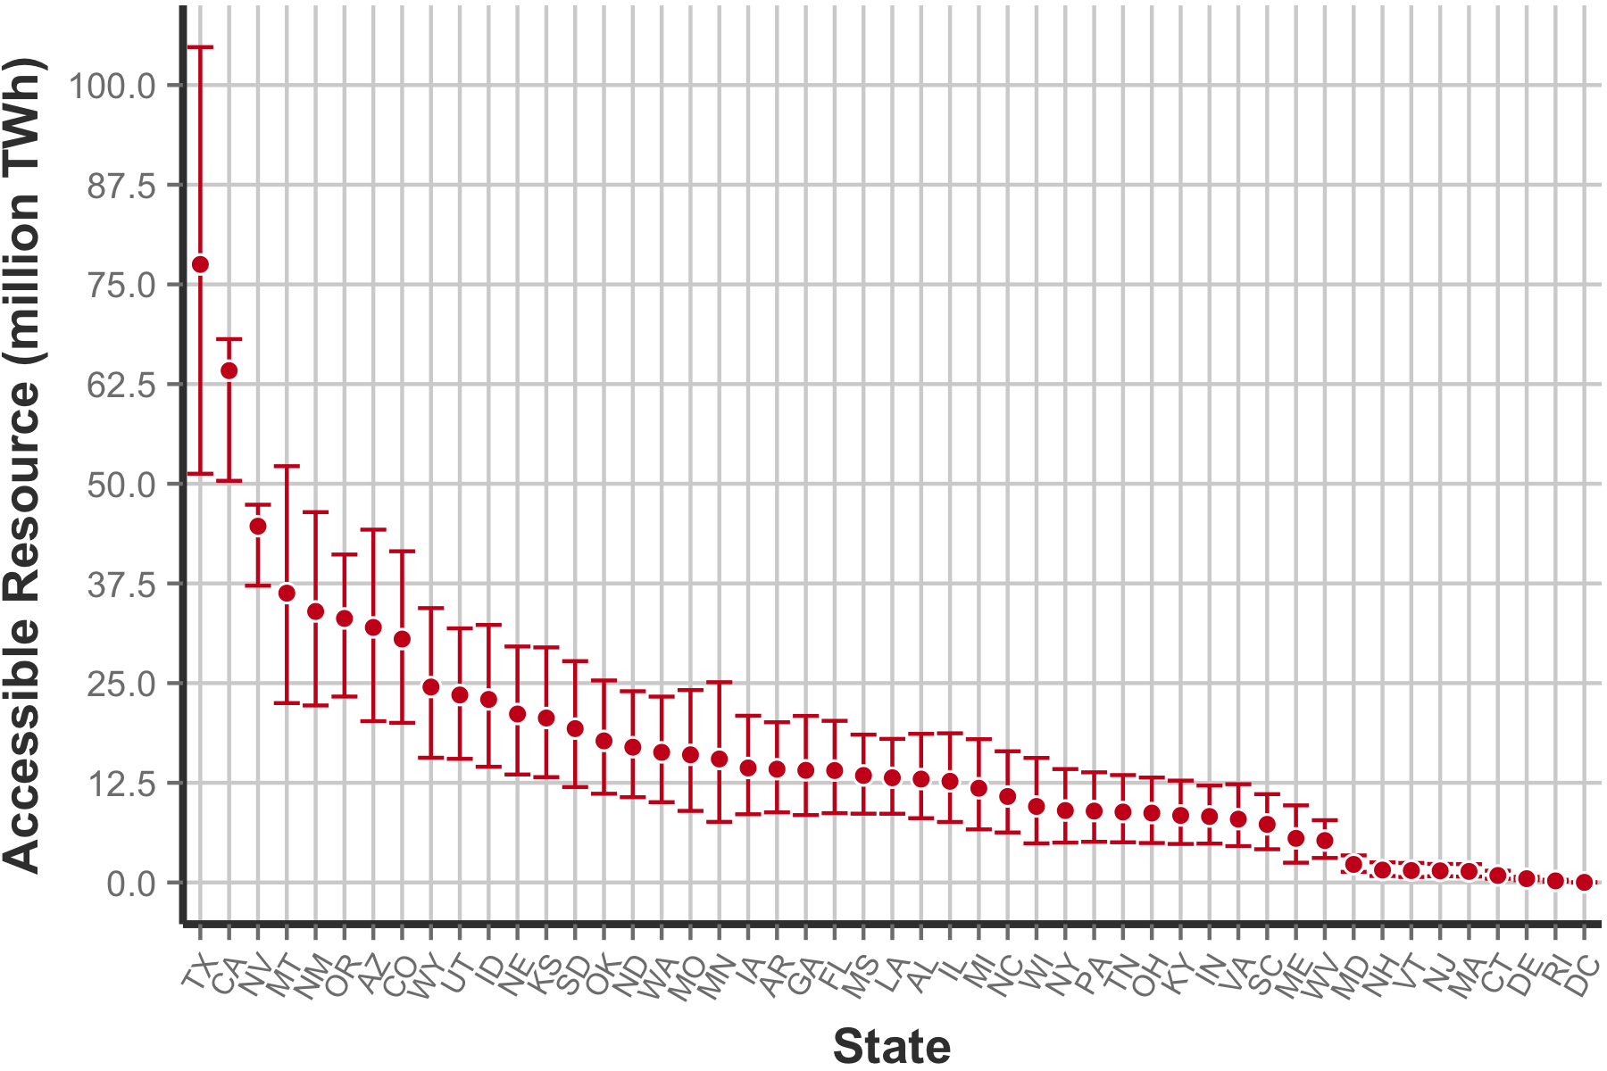
Figure 9. Estimates for total accessible resource by state in the shallow subsurface (300 – 3,000 m), including upper and lower 95% confidence bounds.

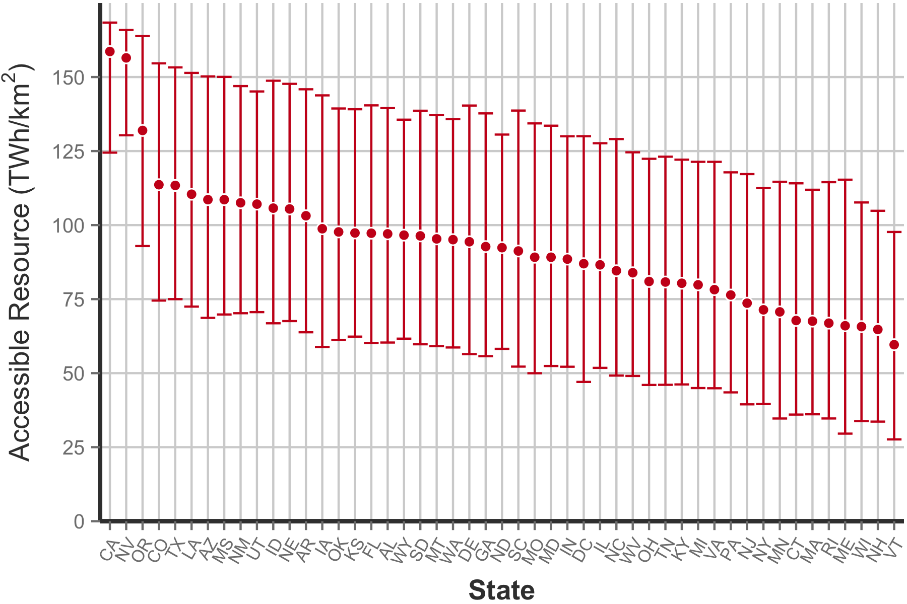
Figure 10. Estimates for accessible resource per square kilometer by state in the shallow subsurface (300 – 3,000 m), including upper and lower 95% confidence bounds.

5 Discussion and Future Work
Low-T hydrothermal system models are relatively well defined and have been analyzed and reported by the USGS. In this study, we have compiled previous datasets into a more easily accessible and functional format, supplemented with additional data to facilitate future technical and market potential modeling by NREL. The dataset used in this study could still be greatly augmented by the inclusion of newer datasets with updated methods. For example, the compiled and reformatted dataset for this study is primarily based on data gathered through 1982. Since then, new geothermometry methods have been developed, which have implications for the reservoir temperatures and related calculated energies (Williams 2016). Furthermore, although we developed a comprehensive, nationwide assessment of resource potential for this study, we did not consider detailed studies focusing on site-specific data at the state and regional levels (such as Lineau and Ross 1996, Schuster and Bloomquist 1994). Integration of such regional studies would be a valuable addition to the national-scale work presented here.

In addition, we expect that a forthcoming update to USGS Circular 892 will provide revised and updated data for low-T hydrothermal systems. The methodology we used here has been carefully considered to facilitate rapid and precise incorporation of this update, as well as other new resource assessments, when they become available.

The estimates for temperature at depth and accessible EGS resources presented in this study are meant to provide only preliminary, order-of-magnitude estimates. The methods applied here closely conform to statistical and geostatistical conventions for spatial interpolation methods; however, no formal geologic modeling was applied and additional geologic factors such as aquifer effects, heat flow, and thermal conductivity were not included in this analysis. Furthermore, previous EGS assessments have ignored resources in the depth range presented here (≤3 km) due to the challenges in modeling location-specific geologic factors that can influence temperature estimates in the shallow subsurface. In light of these limitations, we advise further research in this area and hope that this preliminary assessment can be used to help guide prioritization of regions of the continental United States for more in-depth study and modeling.

Lastly, the resource potential reported here does not indicate the energy available for economic development. While order-of-magnitude estimates for low-T geothermal energy availability have been carefully compiled in this work, the actual amount of energy that can be economically developed depends on numerous factors, including available technologies, thermal demand characteristics, and the efficiency of resource utilization.

6 Conclusion
This report has provided an assessment of the resource potential for shallow (≤ 3 km), low-T (30°–150°C) geothermal resources in the United States while considering both hydrothermal and EGS models. The methodology for developing an estimate of HDR systems for EGS resources in the United States was thoroughly assessed and resulted in an estimate of the resource potential for a system type that has not been previously explored at the depths and temperatures considered here. The total accessible resource base in this assessment was found to be around 8 million TWh for hydrothermal resources and 800 million TWh for EGS resources, although the portion of this resource that can be extracted given physical and technological limitations is significantly less. As expected, nearly all of the highest-quality resources are concentrated in the western United States. However, low-T geothermal direct use may still be viable across portions of the eastern United States with the development of shallow EGS resources.

The large confidence intervals associated with this study—particularly those of the EGS assessment—often overshadow the resource estimates themselves. Hence, site- and system-specific analyses at a much more localized resolution will ultimately be required to identify and confirm promising sites for geothermal exploration and project development. The large scope and scale of this study make these findings useful solely as an initial assessment of low-T geothermal resources to guide future research.

7 Acknowledgements
This work was supported by the U.S. Department of Energy, Office of Energy Efficiency and Renewable Energy (EERE), Geothermal Technologies Office (GTO) under Contract No. DE-AC36-08-GO28308 with the National Renewable Energy Laboratory. The authors wish to thank the US Geological Survey, especially Colin Williams, who supported this research with his invaluable time and insight into past and ongoing geothermal studies. We also thank the NREL review team, including Koenraad Beckers, Kendra Palmer, Emily Newes, Maggie Mann, and David Mooney. Any remaining errors or omissions are the responsibility of the authors.

8 References
AASG, 2012. “AASG State Geothermal Data Repository for the National Geothermal Data System.” http://repository.stategeothermaldata.org/repository/
Blackwell, D.M, Richards, Z. Frone, J. Batir, A. Ruzo, R. Dingwall, and M. Williams, 2011. “Temperature at depth maps for the conterminous US and geothermal resource estimates.” Geothermal Resources Council Transactions. v. 38, p. 1017-1028.
Blackwell, D., C. Pace, and M. Richards, 2014. “Recovery Act: Geothermal Data Aggregation: Submission of Information into the National Geothermal Data System.” No. DOE-SMU-0002852-Final Report. Southern Methodist University; SMU Geothermal Laboratory.
Cooley, Maurice E., 1986. “Artesian Pressures and Water Quality in Paleozoic Aquifers in the Ten Sleep Area of the Bighorn Basin, North-Central Wyoming.,” U.S. Geological Survey Water-Supply Paper 2289, United States Government Printing Office.
Downey, Joe S., and G.A. Dinwiddie, 1988. "The Regional Aquifer System Underlying the Northern Great Plains in Parts of Montana, North Dakota, South Dakota, and Wyoming—Summary,” U.S. Geological Survey Professional Paper 1402-A, United States Government Printing Office, Washington: 1988, pg A6.
Harrison, W., K. Luza, M. Prater, and P. Chueng, 1983. “Geothermal Resource Assessment of Oklahoma.” Special Publication 83-1, Oklahoma Geological Survey.
Keefer, William R., “Structural Geology of the Wind River Basin, Wyoming.” Geological Survey Professional Paper 495-D, United States Government Printing Office, Washington: 1970, pg D30.
Korosec, Michael A., W.M. Phillips, and E.J. Schuster, 1983. “The 1980-1982 Geothermal Resource Assessment Program in Washington.” Washington State Department of Natural Resources, Open-File Report 83-7, 299 p.
Lineau, Paul J., and H. Ross, 1996. “Final Report: Low-Temperature Resource Assessment Program.” Geo-Heat Center, Oregon Institute of Technology, 35 p.
McCabe, Kevin, M. Gleason, T. Reber, and K.R. Young, 2016. “Characterizing U.S. Heat Demand for Potential Application of Geothermal Direct Use.” Geothermal Resources Council Transactions, v. 40.
Muffler, L.P.J., ed., 1979. “Assessment of Geothermal Resources of the United States—1978.” U.S. Geological Survey Circular 790, 163 p.
Nelson, P.H., and S.L. Santus, 2011. Gas, Water, and Oil Production from Wattenberg Field in the Denver Basin, Colorado.” U.S. Geological Survey Open-File Report 2011–1175, 23 p.
Porro, C., A. Esposito, C. Augustine, and B. Roberts, 2011. “An Estimate of the Geothermal Energy Resource in the Major Sedimentary Basins in the United States,” Geothermal Resources Council Transactions, v. 36, p.1359-1369.
Reed, Marshall J., ed., 1983, “Assessment of Low-Temperature Geothermal Resources of the United States—1982.” U.S. Geological Survey Circular 892, 73 p.
Reed, Marshall J., R.H. Mariner, C.A. Brook, Charles M.L. and Sorey, 1983. “Selected data for low-temperature (less than 90°C) geothermal systems in the United States; Reference data for U.S. Geological Survey Circular 892.” U.S. Geological Survey Open-File Report 83-250.
Schuster, J.E., and R. G. Bloomquist, 1994. “Low-Temperature Geothermal Resources of Washington.” Washington Division of Geology and Earth Resources Open-File Report 94-11, 53 p.
Sorey, Michael L., M.J. Reed, D. Foley, and J.L. Renner, 1983, Low-temperature geothermal resources in the central and eastern United States.” In Geological Survey Circular 892, fig. 14, pp. 58-61.
Tester, Jefferson W., et al., 2006. "The Future of Geothermal Energy: Impact of Enhanced Geothermal Systems (EGS) on the United States in the 21st Century." Massachusetts Institute of Technology, 209 p.
White, D.E., and D.L. Williams, 1976. “Assessment of Geothermal Resources of the United States—1975.” U.S. Geological Survey Circular 726, 155 p.
Williams, Colin F., M.J. Reed, R.H. Mariner, J. DeAngelo, and S.P. Galanis Jr., 2008a. “Assessment of Moderate- and High-Temperature Geothermal Resources of the United States.” U.S. Geological Survey Fact Sheet 2008-3082, 4 p.
Williams, C.F., M.J. Reed, and R.H. Mariner, 2008b. “A Review of Methods Applied by the U.S. Geological Survey in the Assessment of Identified Geothermal Resources.” U.S. Geological Survey Open-File Report 2008-1296.
Williams, C. USGS. Personal communication. April 2016.

This process resulted in the removal of over 100,000 entries. However, due to the simplified methodology, some duplicates may still be present in the compiled data and some non-duplicates may have been inadvertently removed.

