Walker Ranch seismic images

Project: Identifying High Potential Well Targets with 3D Seismic and Mineralogy,
2015-2016. Data attribute analysis funded by DOE Geothermal Technologies Office.
PI: R. Mellors

Collaborators: Lawrence Livermore National Laboratory, Optim, Inc, and Agua Caliente.

Note: Data collection and processing funded by Agua Caliente. Original data remains property of Agua Caliente.

Data from a study examining the use of the seismic attributes to identify zones of high permeability. Amplitude images (both vertical and depth slices) extracted from 3D seismic reflection survey over area of Walker Ranch area and includes part of the Raft River geothermal resource. Crossline spacing of 660 feet and inline of 165 feet using a Vibroseis source. Processing included depth migration. Micro-earthquake hypocenters on images. Stratigraphic information and nearby well tracks added to images. Images are embedded in a Microsoft Word document with additional information. Exact location and depth restricted for proprietary reasons. Data collection and processing funded by Agua Caliente. Original data remains property of Agua Caliente.

Associated references:
Casteel, J., S. Pullammanappallil, and R. Mellors, 2016, Estimating Subsurface Permeability with 3D Seismic Attributes: A Neural Net Approach, Proceedings, 41st Workshop on Geothermal Reservoir Engineering Stanford University, Stanford, California, January 26-28.

Mellors, R., N. Marks, S. Pullammanappallil , J. Casteel, T. Yang, J. Moore, and C. G. Jones, 2015, Imaging Geothermal Resources with 3D Seismic Attributes, Proceedings, Fourtieth Workshop on Geothermal Reservoir Engineering Stanford University, Stanford, California, January 26-28.

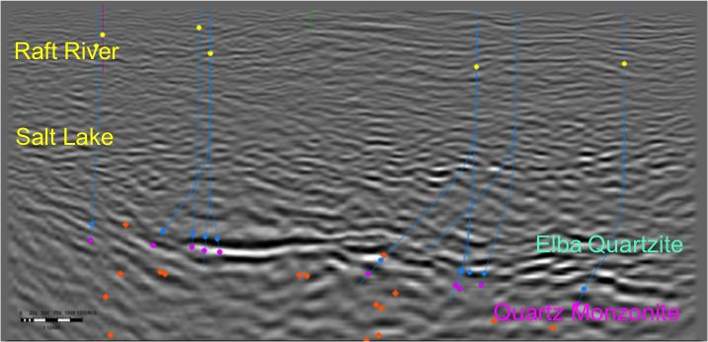
Figure 1. Vertical amplitude slice oriented roughly SW-NE (left to right) across Narrows zone showing strong reflectors typical of the top of basement and Elba Quartzite. Stratigraphic interpretations based on seismic data and well logs. The orange dots indicate micro-earthquakes. Earthquake hypocenters from LBL Raft River catalog. Exact location and depth omitted for proprietary reasons. Blue lines show well tracks within 2000 feet of section.

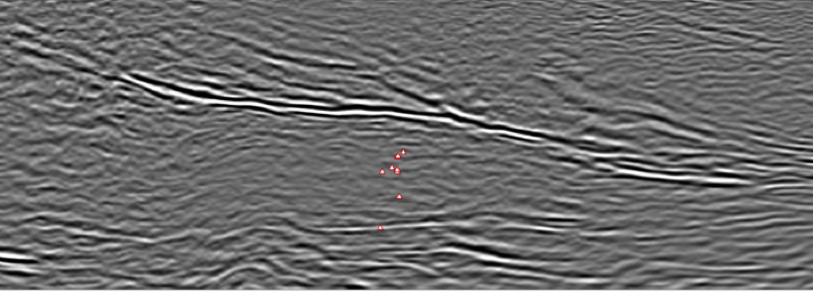

Figure 2. Vertical amplitude slice oriented roughly SW-NE (left to right) across Narrows zone showing strong reflectors typical of the top of basement and Elba Quartzite. The red dots indicate micro-earthquakes within 2000 feet of the section. Exact location and depth omitted for proprietary reasons. Earthquake hypocenters from LBL Raft River catalog.

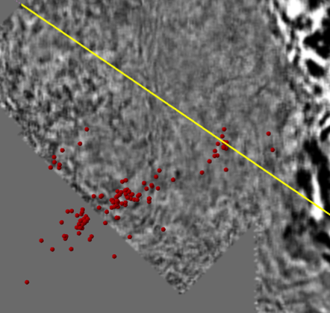

Figure 3. Depth slice of same area. Yellow line indicates location of section in Figure 1. Red dots show locations of micro-earthquakes (from LBL Raft River catalog).

