PoroTomo Experimental Stage Descriptions
The figures below show the definitions of the four stages of the PoroTomo experiment. References and additional text are included for more information.
Please note the following:
- The vibroseis did not operate every day or at local night time.
- There are no DAS data in the vertical borehole for Stage 1 or Stage 2 because the fiber-optic cable was not installed in the borehole until just a few hours before the start of Stage 3.
Cardiff, M., D. D. Lim, J. R. Patterson, J. Akerley, P. Spielman, J. Lopeman, P. Walsh, A. Singh, W. Foxall, H. F. Wang, N. E. Lord, C. H. Thurber, D. Fratta, R. J. Mellors, N. C. Davatzes, and K. L. Feigl (2018), Geothermal production and reduced seismicity: Correlation and proposed mechanism, Earth and Planetary Science Letters, 482, 470-477. https://doi.org/10.1016/j.epsl.2017.11.037
At Brady Hot Springs, a geothermal field in Nevada, heated fluids have been extracted, cooled, and re-injected to produce electrical power since 1992. Analysis of daily pumping records and catalogs of microseismicity between 2010 and 2015 indicates a statistically significant correlation between days when the daily volume of production was at or above its long-term average rate and days when no seismic event was detected. Conversely, shutdowns in pumping for plant maintenance correlate with increased microseismicity. We hypothesize that the effective stress in the subsurface has adapted to the long-term normal operations (deep extraction) at the site. Under this hypothesis, extraction of fluids inhibits fault slip by increasing the effective stress on faults; in contrast, brief pumping cessations represent times when effective stress is decreased below its long-term average, increasing the likelihood of microseismicity.
"During Stage 1 (“normal operations”), pumping at all production and injection wells was consistent with normal site conditions. In this configuration, the production wells extract hot brine from the southern portion of the geothermal field. After passing through the heat exchangers in the power plant, most of the brine (∼80%) is recycled into shallow injection wells at the northeastern edge of the field. A small percentage (∼20%) is re-directed off-site to a well 6 km away in a neighboring basin. During Stage 2 (“site shut- down”), the power plant was taken offline and all production and injection activities ceased at all wells. At the beginning of Stage 3 of the experiment (“increased injection”), all production and injection wells were brought back into operation with the exception of the far-field injection well, which had its valve closed, resulting in all cooled water being re-injected at the northeastern end of the site. Finally, during Stage 4, normal operations of the site resumed."
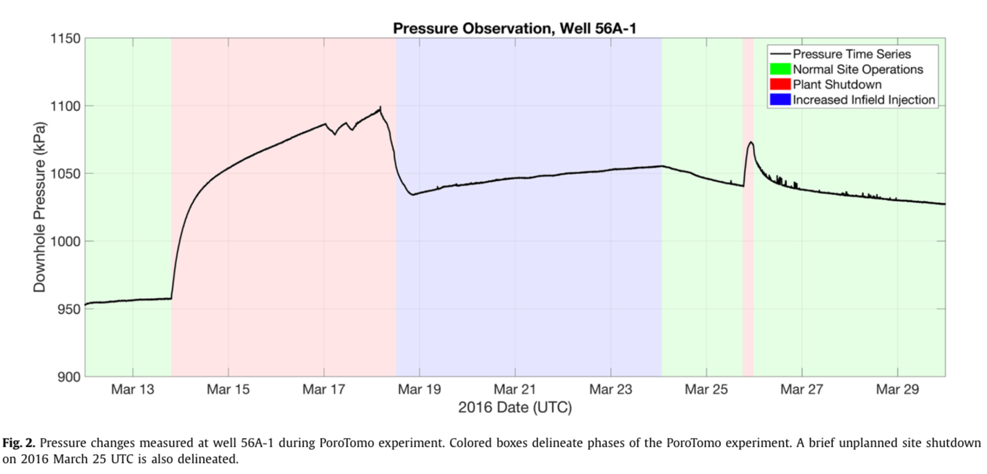
Feigl, K. L., L. M. Parker, and PoroTomo_Team (2019), PoroTomo Final Technical Report: Poroelastic Tomography by Adjoint Inverse Modeling of Data from Seismology, Geodesy, and Hydrology, United States. https://doi.org/10.2172/1499141
This final technical report compiles the results of the PoroTomo project conducted between 1 October 2014 and 31 December 2018.
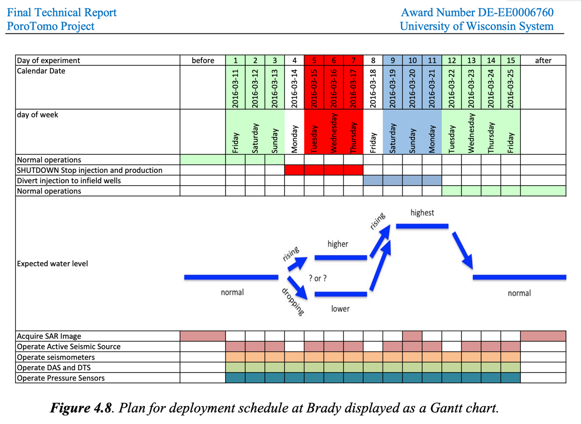
Patterson, J. R., M. Cardiff, T. Coleman, H. Wang, K. L. Feigl, J. Akerley, and P. Spielman (2017), Geothermal reservoir characterization using distributed temperature sensing at Brady Geothermal Field, Nevada, The Leading Edge, 36, 1024a1021 - 1024a1027. http://dx.doi.org/10.1190/tle36121024a1.1
Distributed temperature sensing (DTS) systems provide near real-time data collection that captures borehole spatiotemporal temperature dynamics. Temperature data were collected in an observation well at an active geothermal site for a period of eight days under geothermal production conditions. Collected temperature data showcase the ability of DTS systems to detect changes to the location of the steam-water interface, visualize borehole temperature recovery — following injection of a cold- water “slug” — and identify anomalously warm and/or cool zones. The high sampling rate and spatial resolution of DTS data also shows borehole temperature dynamics that are not captured by traditional pressure-temperature survey tools. Inversion of thermal recovery data using a finite-difference heat-transfer model produces a thermal-diffusivity profile that is consistent with laboratory- measured values and correlates with identified lithologic changes within the borehole. Used alone or in conjunction with complementary data sets, DTS systems are useful tools for developing a better understanding of both reservoir rock thermal properties as well as within and near borehole fluid movement.
